Learning from Home – Brooke Avenue Public School

Stage 1– Week 9, Term 3

The following timetable can be used by students to support learning at home. All tasks have been linked to syllabus outcomes. If technology is available at home, please use the attached links to support learning.

Please upload work marked with the camera icon to Seesaw.
Monday – Week 9, Term 3 – Stage 1
Daily Task – Set and clear the dinner table.
English:

Reading:
Today our reading focus is summarising. To summarise is to put in your own words a shortened version of the book you read. Saying the main points and leaving out the details that are not important.

Choose a book or a PM reader online to read. Remember that the book shouldn’t be too easy or too hard. It should be a little challenging to read. Try to read for 15 or more minutes! After you have read your book, summarise it in speaking to an adult or an older sibling in your home.

Spelling:
The letter/sound combinations for spelling this week are: ou, ow. Watch this video before writing your list: https://video.link/w/pBZ6c
There are also two high frequency (commonly used) words to learn: ‘always’ and ‘because’. Write the spelling list/s into your book. You can choose either list or do both.
List 1 | List 2
out | round
our | mound
loud | ground
shout | grounded
sour | bounce
now | pronounce
cow | power
down | powder
howl | vowel
brown | downtown
High Frequency Words
always | because

Writing:
This week we are going to write another type of informative text, a report. An information report provides readers with information on a chosen topic by providing them with facts. Facts are always true.

We are going to write an information report about dingoes or you can choose to write about another Australian native animal, such as wombats, platypuses, quolls, numbats, red bellied black snakes etc.

The first step in writing an information report is to research information about the topic. Use the internet or books to find information about your chosen Australian native animal. Remember to take notes. To learn more about dingoes, watch this video ‘Dingo’ by Claire Saxby and Tannya Harricks: https://video.link/w/o9h7c

You could take notes while you are watching the video.

After you have learnt some information about your animal, it’s time to write the title of your information report. If you have chosen to write about dingoes, the title could be ‘Dynamic Dingoes’ or just ‘Dingoes’.

Once you’ve written your title, write the first paragraph of your report, the Introduction/Classification (write this as a subtitle - a subtitle is a smaller title that helps the reader to find information). This is the paragraph where you write about the ‘type’ and ‘family’ of the animal. Make this paragraph interesting to hook the reader and make them want to read more!

Below is an example of the title and first paragraph of a report about crocodiles.

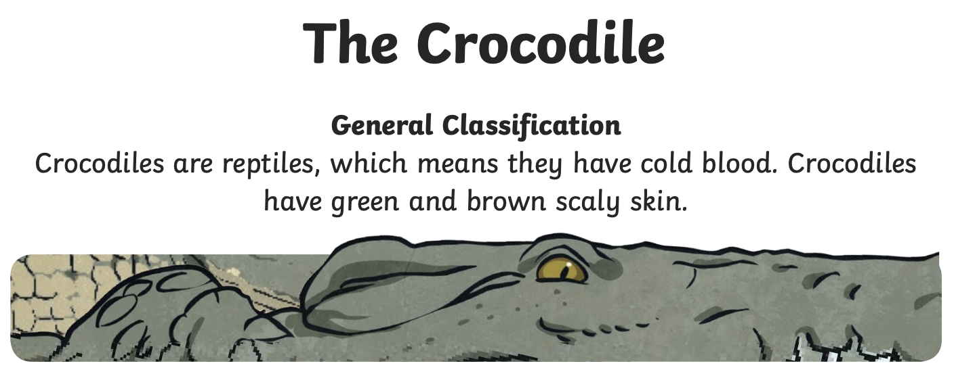

Using this example as a guide, start your own report about Dingoes (or your chosen Australian native animal).
- Write the title.
- Write the first paragraph: including the type and family of the animal and a sentence that will excite the reader.
Break – Time to stop and refuel. Eat, play, have fun. Self-directed outside activities where possible.
Maths:
Warm-up
Play the game “Greedy Pig” with someone in your household.
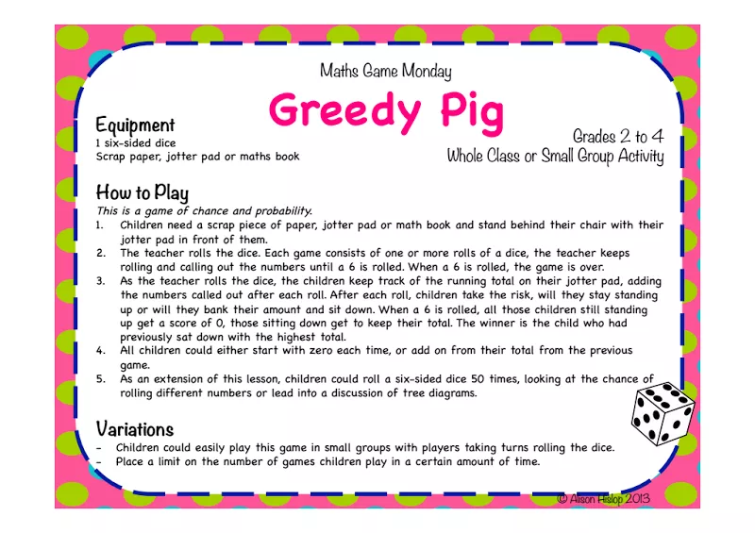

Watch the following video on making equal groups: https://vimeo.com/428004753

Complete the following worksheet on making equal groups (template attached).
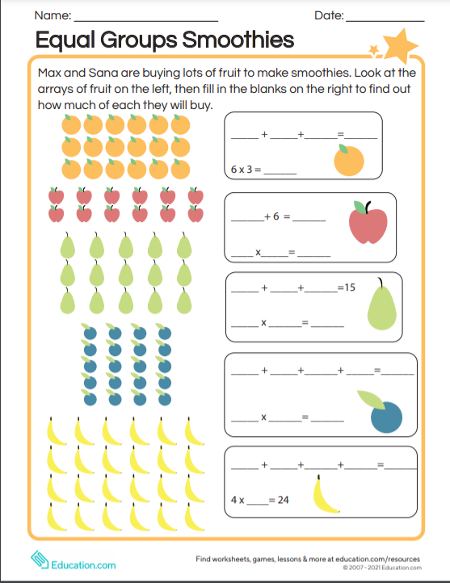

Creative Arts:

Follow the link to create butterfly origami.

Reminder! You will need a piece of paper in the shape of a square.
https://video.link/w/IDp7c
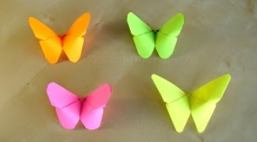

- Break – Time to stop and refuel. Eat, play, have fun. Self-directed outside activities where possible.
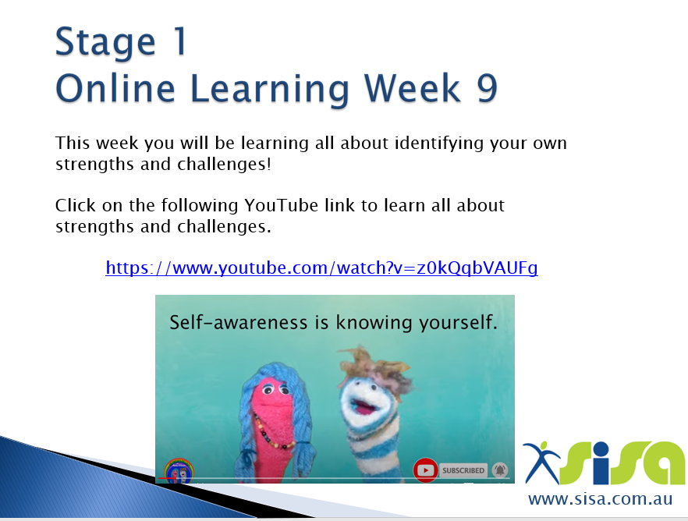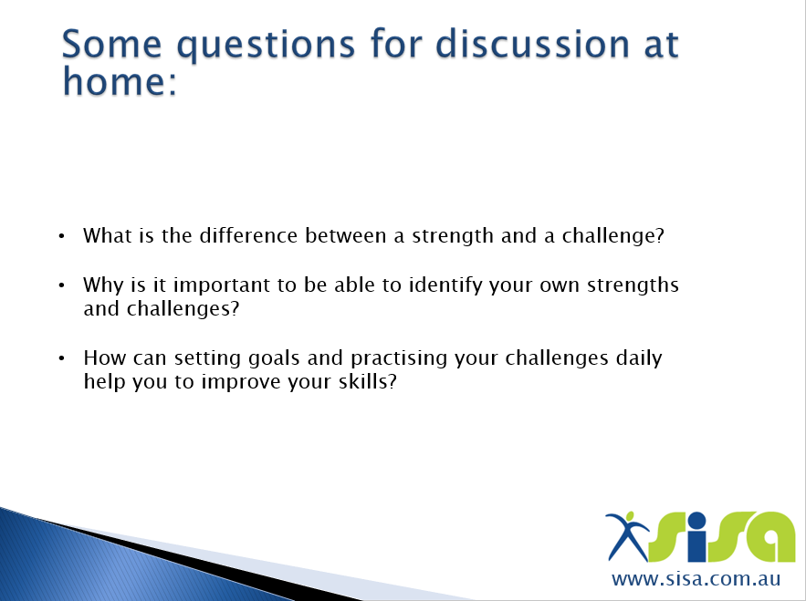
Click this link for the strengths and challenges activity
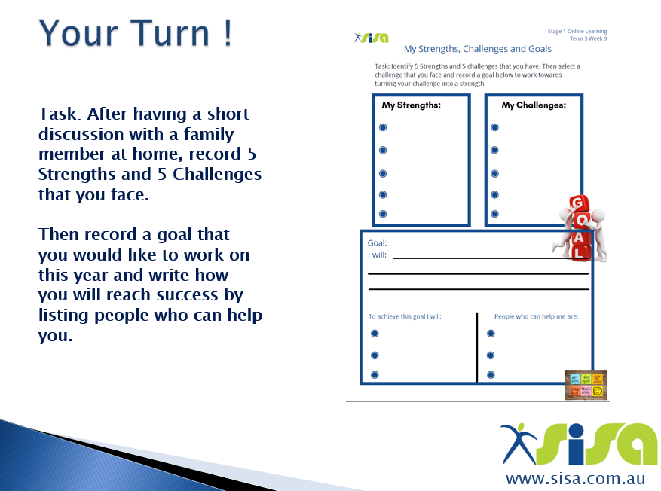 (Worksheet template attached)

Tuesday - Week 9, Term 3 – Stage 1
Daily Task – Wash the dishes.
English:

Reading:
Our reading focus today is summarising again.

Choose a book or a PM online reader to read. The book/reader should be a little challenging to read and always attempt to read unknown words before asking for help. Try to read for 20 or more minutes! After you have read your book, write a summary in a few sentences in your book and then read it to an adult.

Spelling:
Your spelling activity today is going to have untidy handwriting but it will be fun and you’ll learn your spelling words.
Other Handed: Write each spelling word twice but switch the hand you write with for the second time you write it, e.g. The spelling word is ‘brown’. I am right-handed, so I would write ‘brown’ right-handed, then I would write it again but with my left hand! Say the word as you spell it.

Writing and Grammar:
Writing:
Watch Bindi & Robert Irwin talk about dingoes to collect more information: https://video.link/w/Zpi7c

The second paragraph of your Australian native animal report is about the animal’s ‘Appearance’, which means what the animal looks like. Write the subtitle ‘Appearance’ and then describe what a dingo (or your chosen animal) looks like in detail. Remember to use lots of adjectives when writing the ‘Appearance’ paragraph.

Below is an example of a paragraph about crocodiles’ appearance.
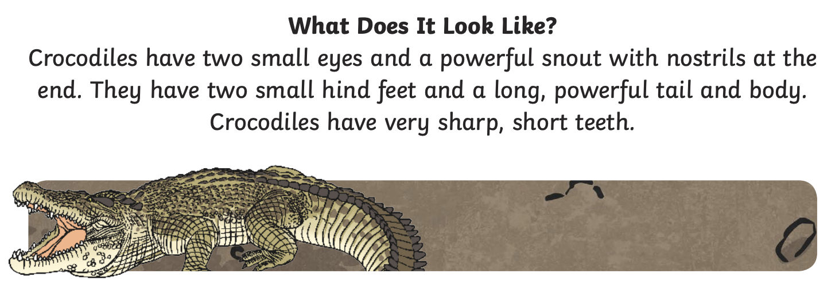

Yesterday you wrote:
- The title.
- The first paragraph: including the type and family of the animal and a sentence that will excite the reader.

Today: Using the example as a guide, continue your own report about Dingoes (or your chosen Australian native animal).
- Write the ‘Appearance’ paragraph. Remember to always write in full sentences.

Grammar:
Watch this video to further your understanding of objectives: https://video.link/w/MCq7c
It is important to use adjectives in the appearance paragraph of the report. Using adjectives in sentences enables the reader to visualise a dingo. Add some more adjectives to the picture below (template also attached), such as the fur colour. A lot are already added for you!
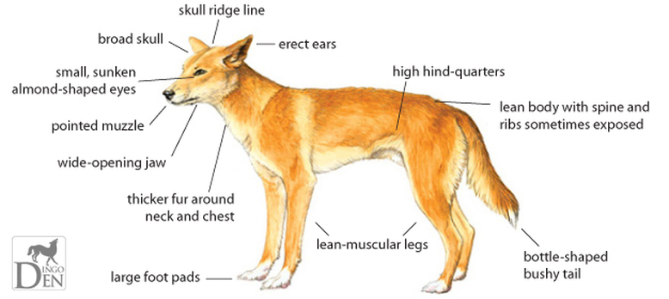

Break – Time to stop and refuel. Eat, play, have fun. Self-directed outside activities where possible.
Maths:
Number of the day:
You have two choices; you can click the link: https://mathsstarters.net/numofthedayjunior/2digit

Or you can complete your own number of the day by writing down everything you know about the number 85.

Making numbers using equal groups:
When you add or multiply numbers, you get the same answer if you swap the numbers around.
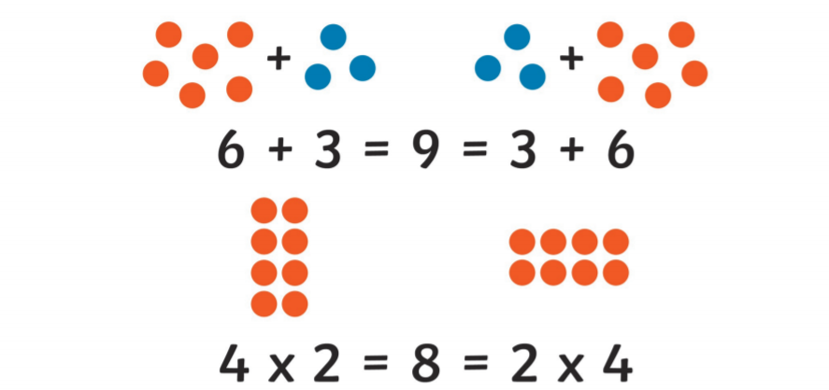
8: For example, to make the number 8 into equal groups we could have 4 groups of 2, think about how you might like to display this, whether that be on paper or using counters if you have them available. Then, represent the same number as a different number of equal groups, in this case it would be 2 groups of 4.
Complete the task using the following numbers:
12
6
14
20
26
8
Extension:
Can you find items around your house and group them equally? An example might be to group some rocks, chocolates, marshmallows or cutlery.
PDHPE:
Complete thirty minutes a day of physical activity. Go for a walk, run or ride with an adult.
Or,
Follow the link for a kids' workout video
https://video.link/w/MFp7c
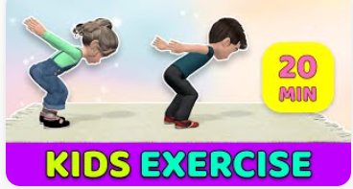
Break – Time to stop and refuel. Eat, play, have fun. Self-directed outside activities where possible.
Creative Arts:
Go outside and collect some leaves, using paint, paint the leaf and press it onto paper to create an artwork. You can use big or small leaves to create your artwork.

Wednesday - Week 9, Term 3 – Stage 1
Daily Task – Make your bed.
English:

Reading:
Choose a book to read, find a story on Seesaw from your teacher or check the PM eCollection. While reading your book, write down any adjectives you find (adjectives are describing words). Then choose adjectives from your book. Write a sentence that includes all 3 adjectives and draw a picture with your sentence. The sentence can be about anything you like!
Spelling: Use your spelling words to create word pyramids. 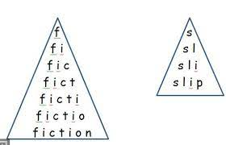

Writing:
View this website https://kids.kiddle.co/Dingo to learn even more information about dingoes!

Today you will be writing the third and fourth paragraphs of your Australian native animal report. The third paragraph is about the animal’s ‘Habitat’,which means where the animal lives. Write the subtitle ‘Habitat’ and then use the information you’ve collected to write about the habitat of a dingo (or your chosen animal). Remember to write in detailed sentences. Include the location (where in Australia does this animal live?) and type of habitat the animal lives in (e.g. desert). You can also describe what the habitat looks like.

Below is an example of a paragraph about crocodiles’ habitat.
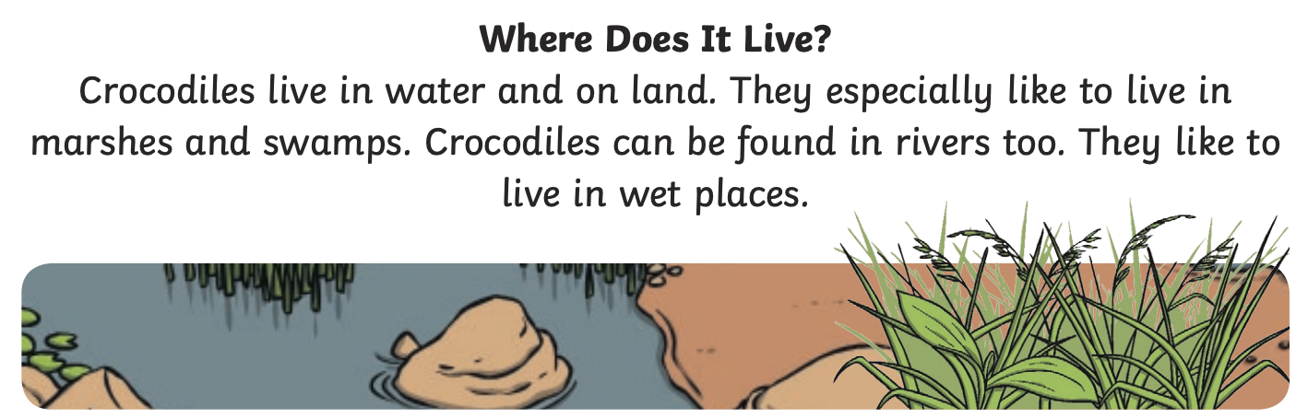
Using this example as a guide, continue your own report about Dingoes (or your chosen Australian native animal).
Write the ‘Habitat’ paragraph.

Repeat the same process as above for the fourth paragraph but this paragraph is all about your animal’s ‘Diet’ (what the animal eats).
Below is an example of a paragraph about crocodiles’ diet.
Using the example as a guide, continue your own report about Dingoes (or your chosen Australian native animal).
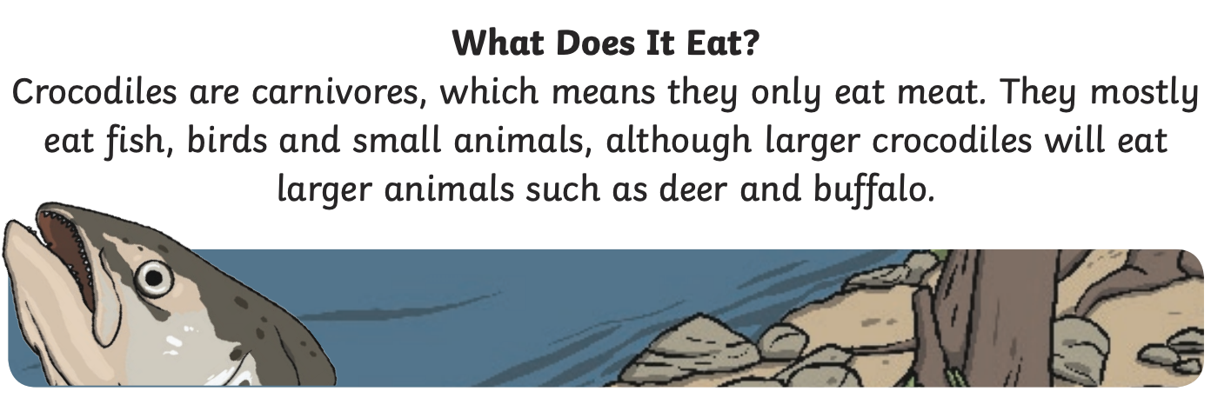
Break – Time to stop and refuel. Eat, play, have fun. Self-directed outside activities where possible.
Maths:
Roll a dice to create a 2-digit or a 3-digit number and complete the Number of the Day (template attached)
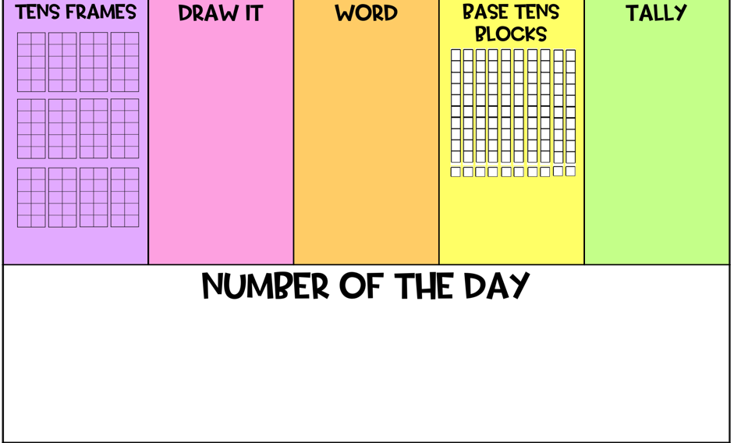

Repeated addition is adding equal groups together. It is also known as multiplication. If the same number is repeated then, we can write that in the form of multiplication.

Follow the link for a mini lesson on repeated addition: https://video.link/w/8ti7c

Complete the following worksheet based on repeated addition (template attached)
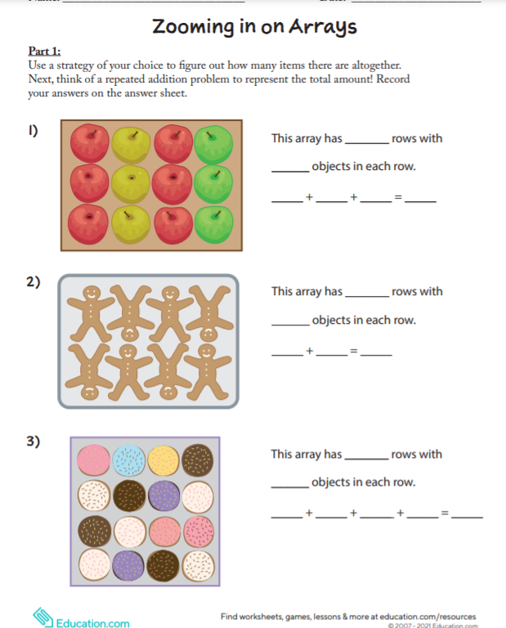

Extension, go on an array hunt around your home (template attached)
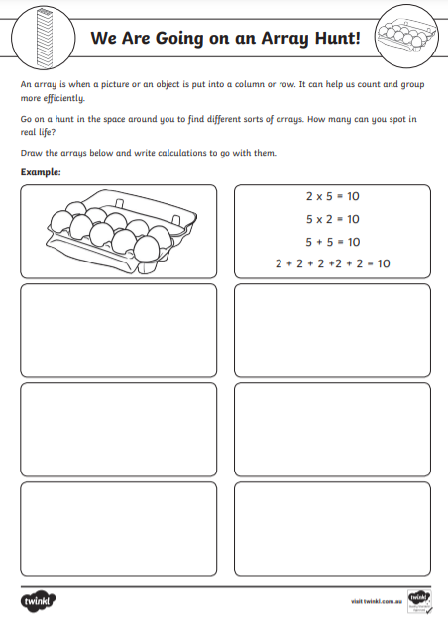

Creative Arts:

Yes, And! Drama Game.
This is a classic improvisation game that teaches the value of accepting each other's ideas and cooperating with one another. The game may be played in pairs or as a group. Maybe, you could play with your family?

Every sentence (except the first one) will need to start with the words “Yes, and…” Additionally, every new statement should become more exaggerated, furthering the scene.

Example:
“The river is full of fish.” (opening statement)
“Yes, and one of them is enormous.”
“Yes, and he’s swimming toward us.”
“Yes, and he looks hungry.”
“Yes, and we are trapped in this boat.”

Continue going, until the scene becomes too difficult to continue. If this happens, begin another game with a different opening statement.
Break – Time to stop and refuel. Eat, play, have fun. Self-directed outside activities where possible.
PDHPE:
Complete thirty minutes a day of physical activity. Go for a walk, run or ride with an adult.
Or,
Complete this kids' workout https://video.link/w/gFp7c
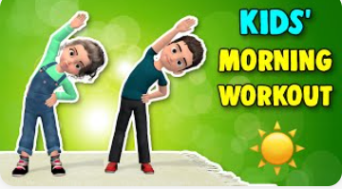

Thursday - Week 9, Term 3 – Stage 1
Daily Task – Help an adult with an outside activity.
English:

Reading
Choose a book to read, find a story on Seesaw from your teacher or check the PM eCollection.
Before reading PREDICT what the story will be about. Use the book title, front and back covers to assist you.
During reading CLARIFY any words you don’t understand. Ask an adult if you are not sure.
After reading SUMMARISE what the happened in the book. This means retell the story! You can write this down OR record yourself speaking so that you can check how well you did.

Spelling:
Hidden Words. Draw and colour a picture. Hide your spelling words inside your picture. Show your picture to someone and see if they can find your hidden words!

Writing:
*If you would like to extend your writing, please see the Extension task below before writing your conclusion.

Conclusion: It’s time to write your fifth and final paragraph of your Australian native animal report. This paragraph is called the ‘Conclusion’ which means it summarises your information and finishes off the report. Write a one or two sentence summary of the animal and if you like, you could add a personal comment about the animal.

Example Conclusion:
Crocodiles are very interesting reptiles that live in Australia. They have existed for so long! Millions of years!

Extension:
You can collect more information and write some more paragraphs about your animal.
This information can be anything you are interested in e.g. Predators, Behaviour, Lifecycle, Other Interesting Facts.
Break – Time to stop and refuel. Eat, play, have fun. Self-directed outside activities where possible.
Maths:
Warm-up

Race to 100. Count to 100 by 2’s and time yourself.
How long did it take you to count to 100? Can you beat your first time by doing it a second time?

What does it mean to divide?

Division is splitting into equal parts or groups and it is the result of ‘fair sharing’.
Watch the following video on sharing equally: https://vimeo.com/428004616
Complete the worksheet (template attached) and share the bears so that each child has the same amount.
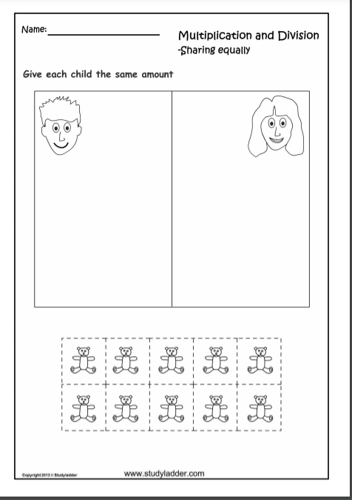
Extension: Work out how many items each child would get in the following fair-sharing (division) problems:
A) 3 children share 15 apples.
B) 5 children share 15 bananas.
C) 2 children share 18 lollies.
D) 4 children share 20 cookies.
E) 3 children share 21 cupcakes.
PDHPE:
Complete thirty minutes a day of physical activity. Go for a walk, run or ride with an adult.
Or,
Follow the link for Cosmic Kids Yoga, https://video.link/w/9fp7c

Break – Time to stop and refuel. Eat, play, have fun. Self-directed outside activities where possible.
Creative Arts:
Follow the link to complete a folding ice-cream surprise artwork. https://video.link/w/Yhp7c

Friday - Week 9, Term 3 – Stage 1
Daily Task – Clean your room.
English:

Reading:
Choose 2 or 3 books to read today! Remember you can read any book from home or on your PM eReaders. After you have read the books, discuss with someone at home which book was your favourite book and why.

Spelling:
Read your spelling words aloud. Then ask someone in your house to read your spelling words aloud. After the person reads each word, write it and try to spell it correctly. A practice spelling test!

Writing and Grammar:
Writing:
Editing your writing. Today you need to read through your information report and make sure all your sentences make sense. Also check that you have used a capital letter at the beginning and a full stop at the end of each sentence.

Detailed diagram. After you have finished editing your writing, draw a detailed picture of your animal in their habitat and label the picture. Make sure you colour the diagram the actual colour of the animal.
Label the parts of the animal and any features of the habitat e.g. long grass, dry sand, gumtrees.

Grammar:
Today our grammar focus is tense. Information reports must be written in present tense. The present tense is used for anything that happens right now or for general information, such as an animal information report. Watch this video to learn more about tense: https://video.link/w/rFq7c

Complete this tense activity (template attached).

Reread your writing as you are editing to make sure it is present tense.
Extension:
Draw a diagram of the lifecycle of your animal.
Break – Time to stop and refuel. Eat, play, have fun. Self-directed outside activities where possible.
Maths:
Warm-up
Follow the link and complete a number of the day.

Number of the day 2-digit: https://mathsstarters.net/numofthedayjunior/2digit

Number of the day 3-digit: https://mathsstarters.net/numoftheday/junior

An array is when a picture or an object is put into a column or row and we use these to allow us to count more efficiently.

Complete the following worksheet based on Arrays (template attached)
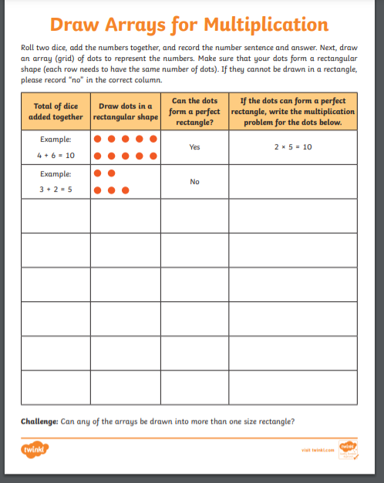

PDHPE:
Complete thirty minutes a day of physical activity. Go for a walk, run or ride with an adult.
Or,

Follow the link for a guided meditation: https://video.link/w/rwx7c

Break – Time to stop and refuel. Eat, play, have fun. Self-directed outside activities where possible.
Take a photo and share with your teacher what you chose to do to celebrate Fri-YAY
.

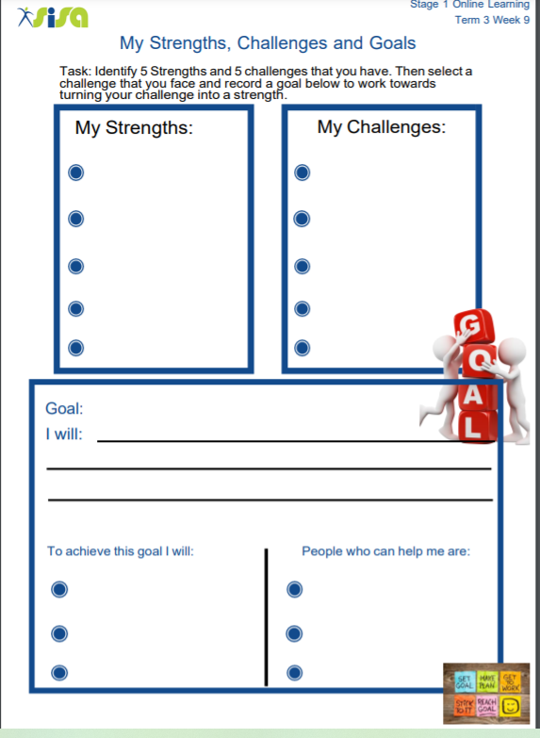

Tuesday – English – Grammar
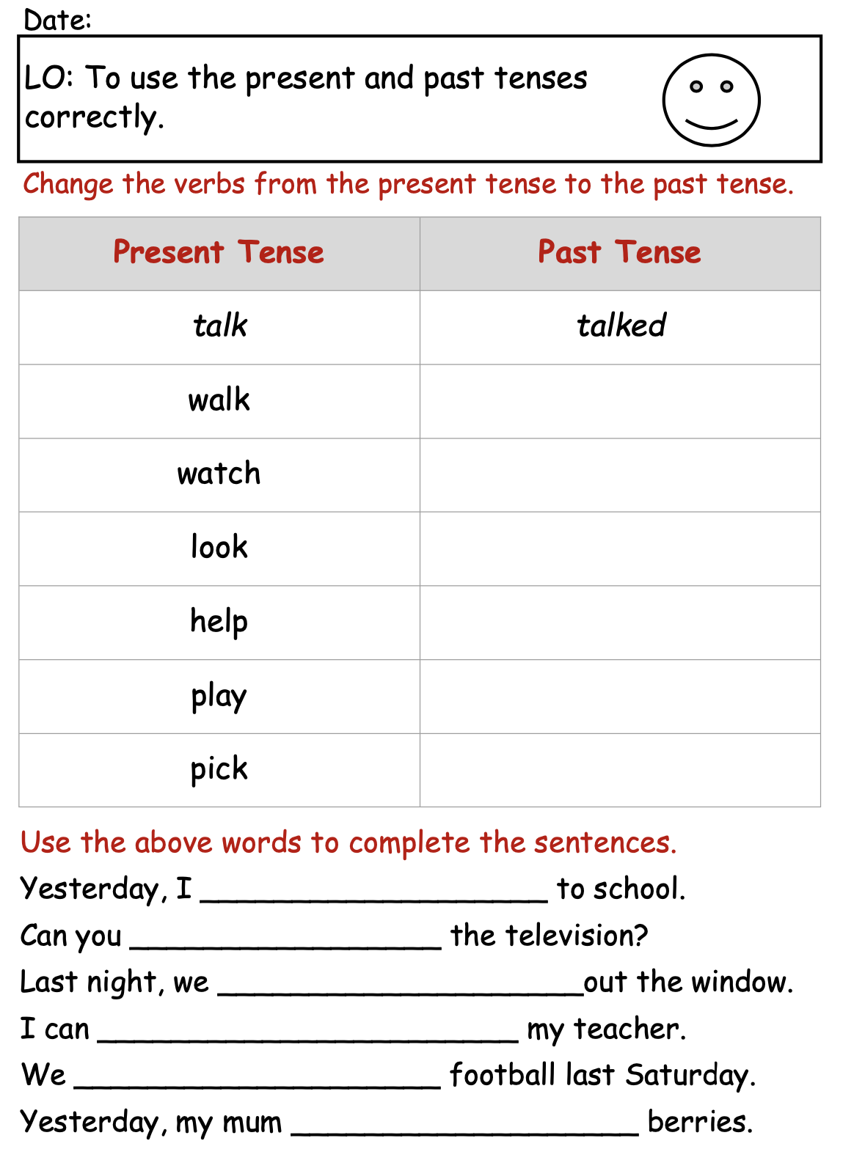
Friday – English – Grammar

