 **Learning from Home – Brooke Avenue Public School**

**K-6J, K-6M and K-6S – Week 9, Term 3**

The following timetable can be used by students to support learning at home. All tasks have been linked to syllabus outcomes. If technology is available at home, please use the attached links to support learning.

***ATTENTION PARENTS:*** *please note that we have tried to vary the learning to give options for all students. Please choose whatever suggested learning activities suit your own child.*

|  |
| --- |
| **Monday - Week 9, Term 3**  Daily Task - Match socks and sort washing. |
| *REVISION – Over the next two weeks, we are going to be going over some activities that we have done at home with our families. It’s a great opportunity to look back on things we’ve learned and extend on them a little.   It is ideal that each student reads from the PM reader app (or books at home) every day, so they remember the strategies they use in reading.*  English: WARM UP - Jolly Phonics Phase 1 <https://www.youtube.com/watch?v=2Xy2e78qxNg> Listen to the song and do the actions. Can you find the  (1 only) sounds 1 on the butterfly card? Can you write the letters too? Maybe you can also write the uppercase letter to match!  I love hearing the ‘e’ sound because it makes me think of eggs! I love eggs.  Jolly Phonics Phase 3 <https://www.youtube.com/watch?v=ZXgfO1jSljQ> Listen to the song and do the actions. Then think of “ch” words.  Jolly Phonics Phase 1-6 <https://www.youtube.com/watch?v=VmMoFbhpFk4> What did you notice about the sounds? Were there silent letters? Can you think of any words with silent letters?  Read: Log in to PM readers with your log in and read one familiar read and a new text, with your parent/carer. Why not try recording your read so that your teacher can give you feedback.  Activity: Nouns – Remember that a noun is a person, place or thing. Go through your book and find at least 5 nouns. Next, see if you can replace those nouns with a different noun. How does that change the story? For example, switch the word ‘balloon’ for ‘flower.’ **CHALLENGE!** See if you can find proper nouns like ‘Kitty Cat’ and replace them with another proper noun e.g., ‘Danny Dog.’ Does that change the story? How? Share your ideas with us on Seesaw.  Spelling: Select at least 5 nouns and 5 sight words. See if you can do “**Look, Say, Cover, Write, Check.**”  **Technology**: Log in to Seesaw and have a go at the nouns activity set. Alternatively, you may log into Reading Eggs and complete an activity there. |
| **Break** – Time to stop and refuel. Eat, play, have fun. Self-directed outside activities where possible. |
| Maths: Week 9 – Focus – Consolidation This week, we are practising a range of mathematical skills and strategies. Let’s start with Addition!  Watch: <https://www.youtube.com/watch?v=hekgNQyP7uU> Can you quickly add the dice together? Say and write the number.  Friends of 10 Ten : FREEBIE : Make A 10 Ten Rainbow by Engaged Little  Learners <https://www.youtube.com/watch?v=QS5w8LRnnp0> How many “Friends of ten can you make?  Activity: Grab some pegs. Put your hand in and pull some out. Count them, then see if you can think of how many more you need to make ten (variation: 20). See if you can complete the “11 ways to make 10” or the “Roll to 20” worksheet below.  *Variation: Choose one of the alternate activities attached e.g. roll to 100*  ***You only need to choose one a day from the topic we are focusing on.***  **Option**: You may also log in to Math Seeds, Studyladder or Prodigy to complete activities set for you. |
| **Break** – Time to stop and refuel. Eat, play, have fun. Self-directed outside activities where possible. |
| **PDHPE**: ***get active at home!***  <https://www.youtube.com/watch?v=7Ypx7PiH6Qs>  Watch this clip and join in! |

|  |
| --- |
| **Tuesday – Week 9, Term 3**  Daily Task - Wash the dishes. |
| English: Writing a letter – What do we need to think about when we write a letter? There are 5 things we need to think about. In particular, we need to consider our audience. Who are we writing to? Do we write the way we would speak to this person or is it different? What words could we use to make our writing exciting to the reader?  Watch: [https://www.google.com/search?q=how+to+write+a+letter+for+kids&rlz=1C1GCEA_enAU958AU958&ei=UrUlYcrEHrCd4- EPjPKvkAs&oq=how+to+write+a+letter+for+kids&gs_lcp=Cgdnd3Mtd2l6EAMyBQgAEIAEOgcIABBHELADO gcIABCwAxBDOgYIABAWEB5KBQg8EgExSgQIQRgBUK9HWIZYYPdYaAFwAHgAgAGnAYgB1wmSAQMwLjiYAQCgAQHIAQ7AAQE&sclient=gws-wiz&ved=0ahUKEwjKtYiQmsvyAhWwzjgGHQz5C7IQ4dUDCA8&uact=5#kpvalbx=_X7UlYfatNOeS4-EPt7yf6As76](https://www.google.com/search?q=how+to+write+a+letter+for+kids&rlz=1C1GCEA_enAU958AU958&ei=UrUlYcrEHrCd4-%20EPjPKvkAs&oq=how+to+write+a+letter+for+kids&gs_lcp=Cgdnd3Mtd2l6EAMyBQgAEIAEOgcIABBHELADOgcIABCwAxBDOgYIABAWEB5KBQg8EgExSgQIQRgBUK9HWIZYYPdYaAFwAHgAgAGnAYgB1wmSAQMwLjiYAQCgAQHIAQ7AAQE&sclient=gws-wiz&ved=0ahUKEwjKtYiQmsvyAhWwzjgGHQz5C7IQ4dUDCA8&uact=5#kpvalbx=_X7UlYfatNOeS4-EPt7yf6As76) .  **Writing:** Today, we are going to write a letter to a friend, a teacher or even Mr Dalkeith, outlining some of the things that you like/don’t like about learning from home. Remember that your writing needs to match your audience, but you can be creative. Draw a picture if you like! Don’t forget to share it on Seesaw.  **Technology**: Log in to Reading Eggs and complete an activity. Post some of your learning on Seesaw to share with teachers and friends. |
| Break – Time to stop and refuel. Eat, play, have fun. Self-directed outside activities where possible. |
| Maths: Week 2 focus – Addition  Warm up: Number Sense – Today, we’re going to have another go at number sense to warm up our brains (see attached). Remember that you can either use dice or cards to make a 2-, 3-, or 4-digit number, then use the template below to demonstrate different ways to show the number.  Challenge: If you have looked at single digit numbers in the past, try looking at numbers between 11-20. If you have done 3-digit, see if you can try 4-digit instead.  Activity: Log into Seesaw and try this addition number sentence activity.   Addition Sort or Dinosaur Addition  Variation: Complete an addition activity on on Studyladder, Math Seeds or Prodigy. |
| Break – Time to stop and refuel. Eat, play, have fun. Self-directed outside activities where possible. |
| **Go Noodle:** Here are some of our favourites for you.  Fabio’s Meatballs:<https://www.youtube.com/watch?v=JU0ETGd5dgk>  Monster Mash: <https://www.youtube.com/watch?v=GxKb_VHCYdc>  Pizza: <https://www.youtube.com/watch?v=Hl5dRW4E9hc>  Dinostomp: <https://www.youtube.com/watch?v=Imhi98dHa5w>  **Draw:** Complete the attached ‘how to draw a stingray below. |
| **Wednesday - Week 9, Term 3**  Daily Task – Make your bed. |
| English - Grammar: Adjectives!  Watch: this clip on adjectives <https://www.youtube.com/watch?v=QxoDGlPUmyU>  Activity: Log into Seesaw and complete the activity below. Variation: Complete the attached worksheet and write a story about your animal using lots of adjectives to describe your animal. Again, consider your audience and make it entertaining.  **Technology**: Log in to Reading Eggs, ABCYA, Studyladder or even Seesaw to complete an activity.  Seesaw Adjectives activity |
| Break – Time to stop and refuel. Eat, play, have fun. Self-directed outside activities where possible. |
| Maths: Dice Addition  Activity: Complete the following Dice Addition Worksheet (same as Week 2).  Variation: Increase the size of the die/dice or the online dice to create 2-, 3- or 4-digit numbers. Think about different strategies you can use i.e. split strategy, jump strategy or compensation strategy.  **Technology**: Log in to Studyladder, Math Seeds or Prodigy and complete an activity on Mass. |
| Break – Time to stop and refuel. Eat, play, have fun. Self-directed outside activities where possible. |
| **HSIE**: Past and Present – what are some of the ways that people used to communicate in the past? Have any types of communication changed or do they even exist any more? Look at some of the ways you communicate every day and tell us which is your favourite and why.  **Watch**: Past and Present Communication: <https://www.youtube.com/watch?v=Mevm1T4MsUM>  **Activity**: Look at these types of communication then answer the questions on the second slide. |
| **Thursday - Week 9, Term 3**  Daily Task – Help an adult with an outside activity. |
| English – Warm up: Play ‘Eye Spy’ and listen for the beginning sound in the word. How many words can you find starting with that letter?  Challenge: Play with blends like *ch, sh, wh, th.*  **Read aloud**: **Spring is here** is a story about friendship. A friendship between the bear and the mole. <https://app.seesaw.me/#/activities/library?search&query=read%2Baloud&promptId=prompt.3b77ddc6-1cf2-4c42-bdfc-95ac5f805cf8>  Discuss: Why does Mole want Bear to wake up so badly? What causes the splash outside Mole’s house? Why is it there? What are some of the things Mole did to try and wake up Bear? Are there things that you would try? Why do you think they are a good idea? Do you think Mole likes Spring? How do you know? What do you like about Spring?  Activity: Take a walk into your garden or somewhere local with your parent/carer and see if you can identify things around you that help you notice Spring. What do you like/dislike about Spring?  Writing: Write a text telling us why you like/dislike Spring. Illustrate your drawing to help support the message you are trying to convey to the audience.  **Technology**: Log in to Reading Eggs and complete an activity. |
| Break – Time to stop and refuel. Eat, play, have fun. Self-directed outside activities where possible. |
| **Maths:** Addition with Lego! Use Lego bricks to create different number sentences. Try adding more than two numbers together e.g., 2+4+6 = or even make 2-, 3-, or 4-digit numbers with the Lego blocks and add them together. Discuss the strategies you used. Then maybe try another strategy.  **Technology:** Try this link for some new activities <https://www.bbc.co.uk/bitesize/primary> |
| Break – Time to stop and refuel. Eat, play, have fun. Self-directed outside activities where possible. |
| **PDHPE:** Kids yoga – Choose on of the yoga sessions from this link. <https://www.youtube.com/user/cosmickidsyoga>  There are so many to choose from! I love the one that takes me to my happy place. |
| **Friday - Week 9, Term 3**  Daily Task – Clean up your room. |
| English: Today, you will need to log in to PM Readers, read a familiar read and a new text. Then name and describe the characters in your story.  Grammar: Log into Seesaw/Reading eggs and complete an activity set by your teacher.  Writing: Write a letter to our Principal, Mr Dalkeith telling him about some things you would like to see in the new classrooms in the school. Tell him why you think they are a good idea. Perhaps you could draw and label your ideas so that he understands exactly what they will look like. |
| Break – Time to stop and refuel. Eat, play, have fun. Self-directed outside activities where possible. |
| **Maths:** Today we are going to practise writing numbers from top to bottom! Alternatively, you may choose to play this game:  Using a deck of cards, place four cards facing up in a row. Collect cards that are make the sum of ten and place them aside. Replace the cards facing up with cards from the deck and repeat. How many different ways can you make ten?    Write your numbers in a thin layer of rice in a tray, in the dirt, in shaving cream on a window, in the sky, in paint with ear cleaners, with your eyes closed! The options are endless, have fun!  Choose any maths activity using:   * Mathseeds, Prodigy, StudyLadder or ABCYA   **Movement Break:** Rock Paper scissors Run! Watch this video and play the game with a family member.  <https://www.yout-ube.com/watch?v=mTqkENcjPmQ&list=PL0H94qyJzFmpTWFyuQ-ruKapQHyNl--zB&index=5> |
| Break – Time to stop and refuel. Eat, play, have fun. Self-directed outside activities where possible. |
| **Creative Arts:** It’s FRIYAY! Choose an activity that you love to do and do it! |

**Number Sense**

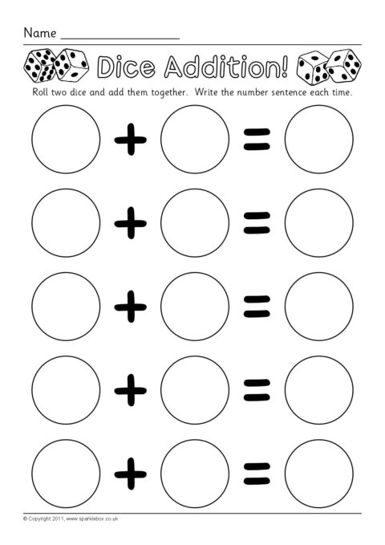

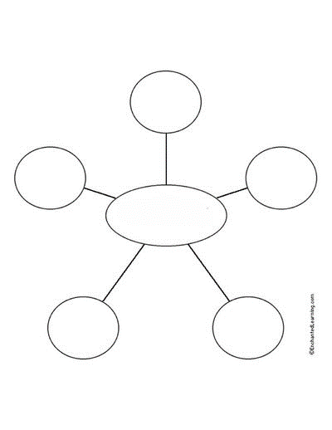

**Adjective Web**

* Draw an animal in the middle bubble.
* Write an adjective in each bubble to describe your animal.

***Note: This activity is also available on Seesaw and you may choose to complete it there instead.***

Name: _______________________________________________________ Date: ___________________________

**Spring is here!**

|  |
| --- |
|  |
|  |
|  |
|  |
|  |
|  |
|  |
|  |

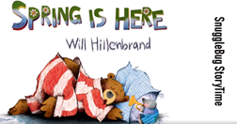



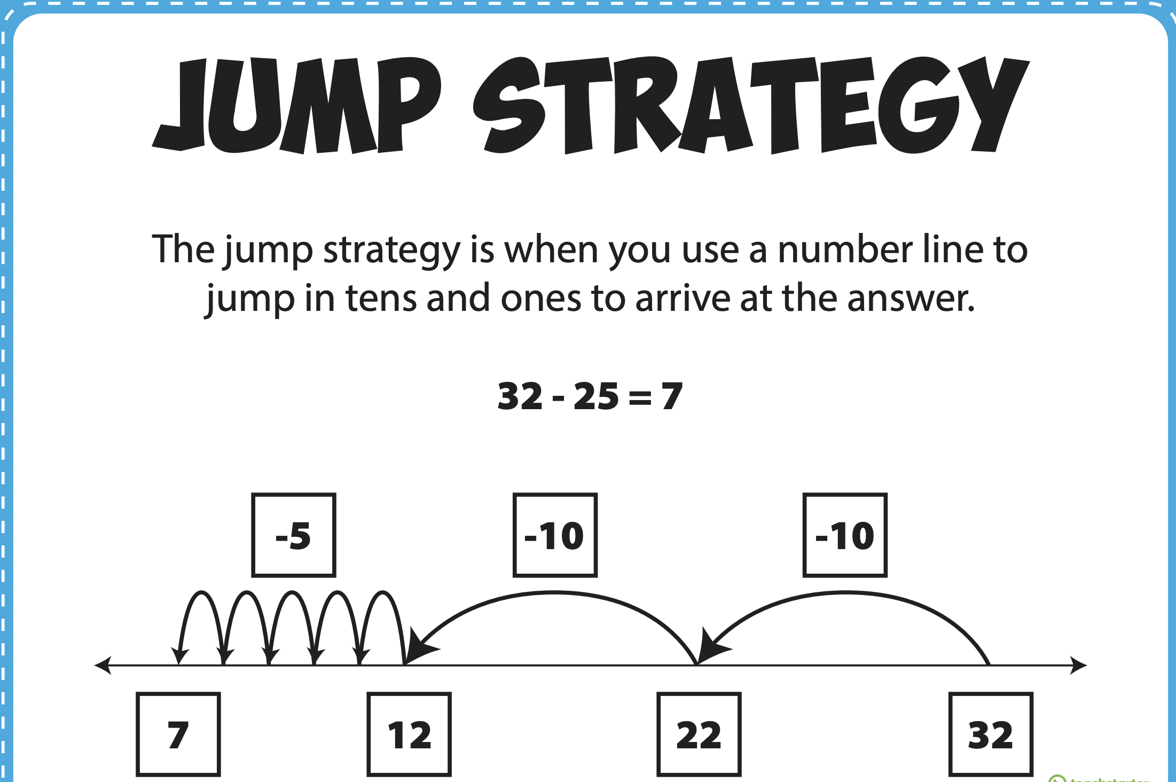

Name: ____________________ Date: ______________

**ADDITION STRATEGY** 

Compensation Strategy

EXAMPLE 2:

84 + 54

84 + **50 (round down)**

= 134

134 + **4 (add)**

= 143

EXAMPLE 1:

84 + 59

84 + **60 (round up)**

= 144

144 – **1 (subtract)**

= 143

1. 25 + 39

25 + ____ (round up)

____ - ____ (subtract)

= _____

1. 49 + 53 =

49 + ____ (round down)

____ + ____ (add)

= _____