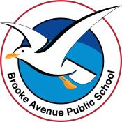
Learning from Home – Brooke Avenue Public School
Kindergarten – Week 9, Term 3
The following timetable can be used by students to support learning at home. All tasks have been linked to syllabus outcomes. If technology is available at home, please use the attached links to support learning.
Monday - Week 9, Term 3 - Kindergarten
Daily Task - Match socks and sort washing.
English
Phonics: Bossy ‘e’ focus for the week. When an ‘e’ is put at the end of mat, it changes it to mate. Have your child write the following words and read them, then add an ‘e’ on the end. Have them read the new words: mad, cap, mat, hat, tap.
Reading: With a family member or by yourself, read a book on https://app.pmecollection.com.au. Use the record tool to record yourself reading and listen to it back.

Writing: You will need a piece of paper and a pencil. Today we will be writing a letter to someone of your choice. This could be another family member, your friend or even your teacher! Remember to write who it is to, something nice about them and something interesting you would like to share with them. Then write who it is from. Ask a family member to help you post your letter. If it is for your teacher, just drop it into the BAPS mailbox. Before you post, take a photo of your letter and post to seesaw.

Sight words: Practise reading your sight words.

Break – Time to stop and refuel. Eat, play, have fun. Self-directed outside activities where possible.
Maths

Warm up: Play a game of Snakes and Ladders with a family member. You will need the dice you created last week, and the Snakes and Ladders game is attached to the resources.

We are learning to: Count on from the largest number.
Draw a large target on the asphalt with chalk. Write numbers ranging from 1-10 in the target (see image).
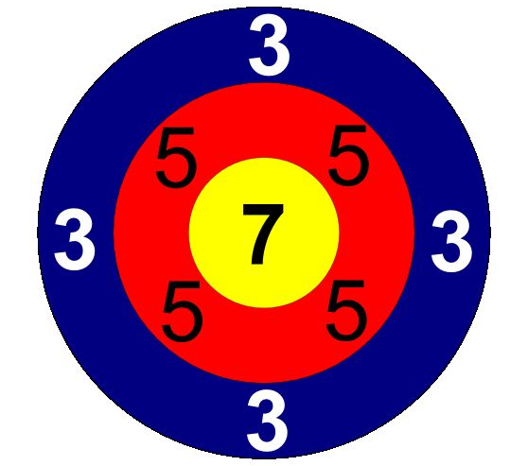
Player 1 - Throw two beanbags or old teddies at the target. Add the total together by counting on from the largest number.
Player 2 - Throw two beanbags or old teddies at the target. Add the total together by counting on from the largest number.
Highest score wins. Repeat. Upload a picture to Seesaw.
Extension: Same as above- Write numbers ranging from 1-20 or multiples of ten.
Break – Time to stop and refuel. Eat, play, have fun. Self-directed outside activities where possible.
PDHPE: Create your own exercise routine at home. Go for a bike ride or bushwalk.

Tuesday - Week 9, Term 3 - Kindergarten
Daily Task - Wash the dishes.
English

Phonics: Bossy ‘e’ focus for the week. When an ‘e’ is put at the end of rip, it changes it to ripe. Have your child write the following words and read them, then add an ‘e’ on the end. Have them read the new words: bit, fin, hid, sit, rid

Reading: Read the story ‘Birthday Party’ and answer the questions by circling the correct answer. Read a book on https://app.pmecollection.com.au. Use the record tool to record yourself reading and listen to it back.

Writing: Edit the sentence ‘i love to eet chocolate because ti tastes so yummy!’. Take a photo and post to Seesaw.

Sight words: Practise reading your sight words.

Break – Time to stop and refuel. Eat, play, have fun. Self-directed outside activities where possible.
Maths

Warm up: Using the teddy and number cards from last week. Play a game of memory. You can use the cards numbered 1-5, 6-10 or 1-10.

We are learning to: describe mathematical situations using everyday language, actions, materials and informal recordings.
Activity: Use the Double-decker Bus sheet (attached). 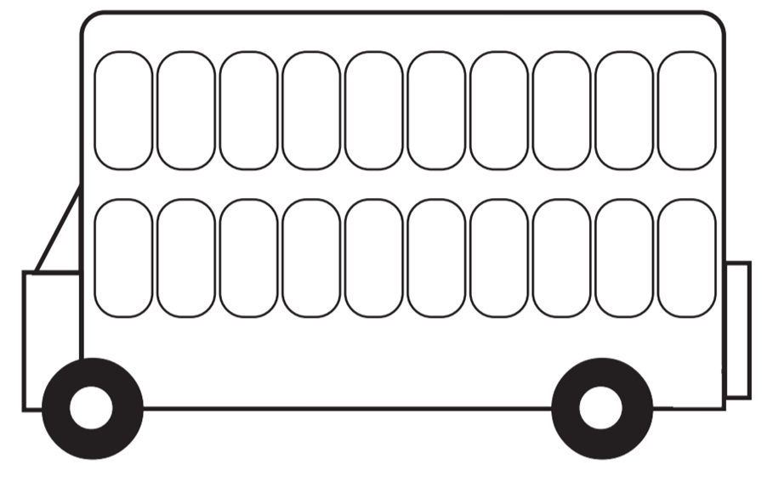Pose mathematical problems. Have your child repeat the instructions as they are problem solving. Upload a picture to Seesaw.
E.g. ‘Eleven passengers got on the bus, three more entered the bus at the next stop. How many are on the bus now?’
Extension: Two or three step instructions. E.g. ‘Eleven passengers are on the bus, three more entered the bus at the next stop two stops. How many are on the bus now?’
Break – Time to stop and refuel. Eat, play, have fun. Self-directed outside activities where possible.
Science & Art: What is an insect? Watch the video in the Seesaw slides on how scientists classify an animal as an insect. Complete a directed drawing of an insect. Label its body parts: head, thorax, abdomen, antennae, legs. https://www.yout-ube.com/watch?v=fdohYdtTIqg
Wednesday - Week 9, Term 3 - Kindergarten
Daily Task – Make your bed.
English

Phonics: Bossy ‘e’ focus for the week. When an ‘e’ is put at the end of hop, it changes it to hope. Have your child write the following words and read them, then add an ‘e’ on the end. Have them read the new words: not, mop, con, rob
Reading: Read a book on https://app.pmecollection.com.au. Use the record tool to record yourself reading and listen to it back. Draw a picture or write a sentence explaining what happened in the story. Post it to SeeSaw for your teacher to see.

Writing: Today we are learning how to tell the difference between a question and a statement. A question is something you ask and need an answer for, and a statement is just telling something. A question needs a ? At the end and a full stop is needed at the end of a statement. Copy the following questions/statements below and finish them with a full stop or a question mark.

I can see a dog
What do you like to eat
How are you going
The little boy was playing with a ball

Sight words: Practise reading your sight words.

Break – Time to stop and refuel. Eat, play, have fun. Self-directed outside activities where possible.
Maths

Warm up: Maths Warm Up Walk – Using the Wednesday Maths Warm Up Sheet (Resources) walk around your house and try and find the items listed. Cross them off your sheet when you have found each item.

We are learning to: describe mathematical situations using everyday language, actions, materials and informal recordings.
Activity: Using a 6-sided die and a ten frame, roll the die. Represent that number on the ten frame and then double it. E.g. Roll and it’s a 3. 3+3=6
Encourage your child to understand doubles. Pose questions each roll. E.g. ‘What is double 3? What’s double three, plus 1? What’s double three, minus 1?
Extension: Use a ten-sided die or numeral cards to ten. Double between 1 and 10.
Break – Time to stop and refuel. Eat, play, have fun. Self-directed outside activities where possible.
Creative Arts – Watch the following short video on the symmetry of butterflies https://www.yout-ube.com/watch?v=3czoTZO1OQ8 Next, you will be drawing your very own butterfly to show the symmetry of their wings. Symmetry is when something is the same on both sides! Draw your butterfly outline. On each wing draw a variety of shapes, making sure that the shapes and colours are the same on both wings. 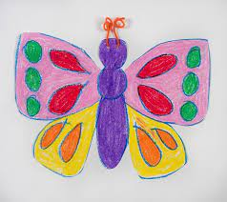 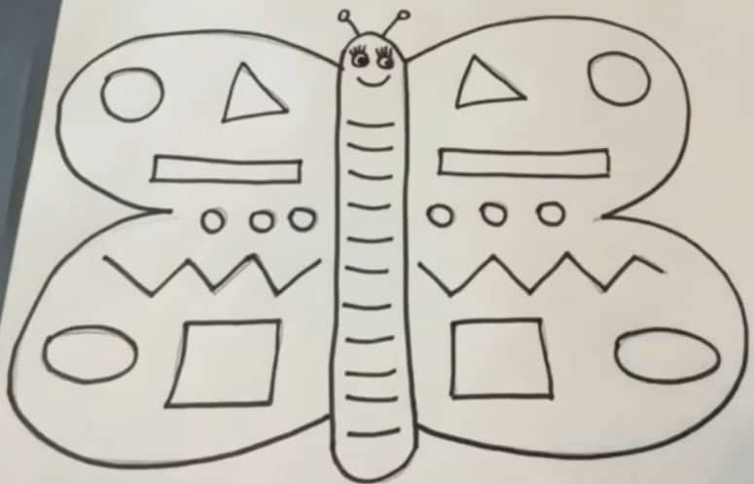

Thursday - Week 9, Term 3 - Kindergarten
Daily Task – Help an adult with an outside activity.
English

Phonics: Bossy ‘e’ focus for the week. When an ‘e’ is put at the end of cub, it changes it to cube. Have your child write the following words and read them, then add an ‘e’ on the end. Have them read the new words: tub, cut, us,

Reading: Read the story ‘James the Pilot’ and answer the questions below by circling the correct answer. Read a book on https://app.pmecollection.com.au. Use the record tool to record yourself reading and listen to it back.

Writing: Look at the picture. Write down 2-3 sentences about when it happened, who is in the picture and what they are doing.

Sight words: Practise reading your sight words.

Break – Time to stop and refuel. Eat, play, have fun. Self-directed outside activities where possible.
Maths

Warm up: Go outside and collect as many sticks or rocks as you can in 5 minutes. Then, count how many items you have found. If you want to challenge yourself, you can make groups of 5 with the items you collected.

We are learning to: describe mathematical situations using everyday language, actions, materials and informal recordings.
Activity: Get a trusted adult (or try yourself) to draw 2D shapes on a piece of paper. Paint or colour it in. Remember to name all the shapes you can. Upload a picture to Seesaw.
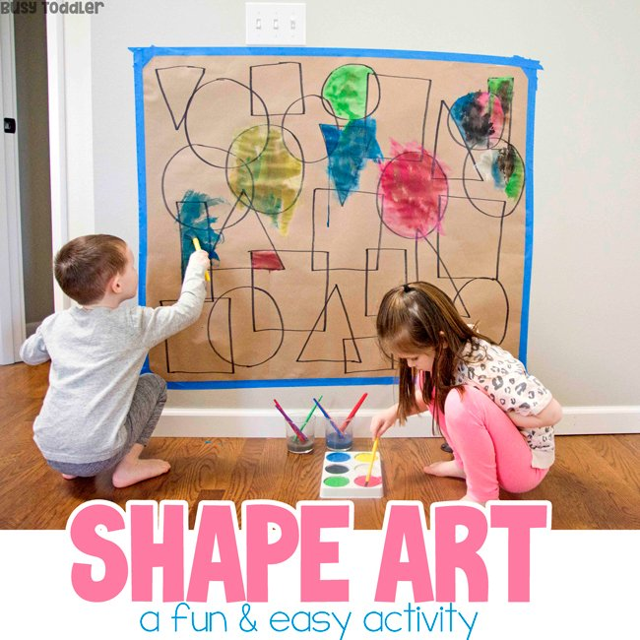

Break – Time to stop and refuel. Eat, play, have fun. Self-directed outside activities where possible.
Science: Today for Science, you will be completing an insect scavenger hunt! (See attached). Search your garden or local park for 7 common insects. Make sure to keep yourself safe by not touching any animals that you find! Draw a tick in the box once you have found the insect. Upload a photo of your completed worksheet to Seesaw.

Extension: take a photo of an insect that you find and use the voice recording function to tell your teacher the name of the insect and how you know it is in fact an insect.

Friday - Week 9, Term 3 - Kindergarten
Daily Task – Clean up your room.
English

Phonics: This week we focused on the bossy ‘e’ rule. Revise this and have students read and write the following words:
rope | gate | bite | time | cute | save | tube | tap | cut | rope
five | hop | nose | vote | late | cube | fine | not | sit | tip

Reading: Pick one of your favourite books or choose a story from the https://app.pmecollection.com.au. Reads the story with a family member or by yourself. Draw a picture of what happened at the beginning, middle and end of the story. Post it to SeeSaw for your teacher to see.

Writing: Handwriting. Today we will be practising doing our neatest writing of the letters b, d and j. You will need lined paper and a pencil. Access Seesaw. Watch the video by Mrs B showing you correct formation of these letters. Take a picture and post to Seesaw.

Sight words: Practise reading your sight words.

Break – Time to stop and refuel. Eat, play, have fun. Self-directed outside activities where possible.
Maths

Warm up: Write down the numbers 1-20 on a piece of paper. You may like to trace over the numbers on the sheet attached to the resources. Cut out the numbers and shuffle them, then place the numbers in order.

We are learning to: describe mathematical situations using everyday language, actions, materials and informal recordings.
Activity: Shuffle numeral cards from 1-10, 1-20 or 1-30. Place in a pile and head somewhere, best if it’s outside, where you can create a long number line. E.g. 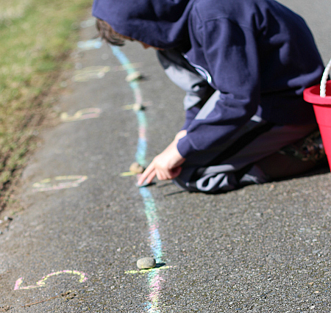 Draw the numbers on the number line or leave it blank. Set a stopwatch and place your numeral cards in ascending or descending order, along the line. Time yourself using the stopwatch. Try three times to improve your score. Upload a photo to Seesaw.
Extension: Write random numbers ranging from 1-100 and have your child arrange them in ascending or descending order.

Optional: Complete the worksheet attached by repeating the patterns. 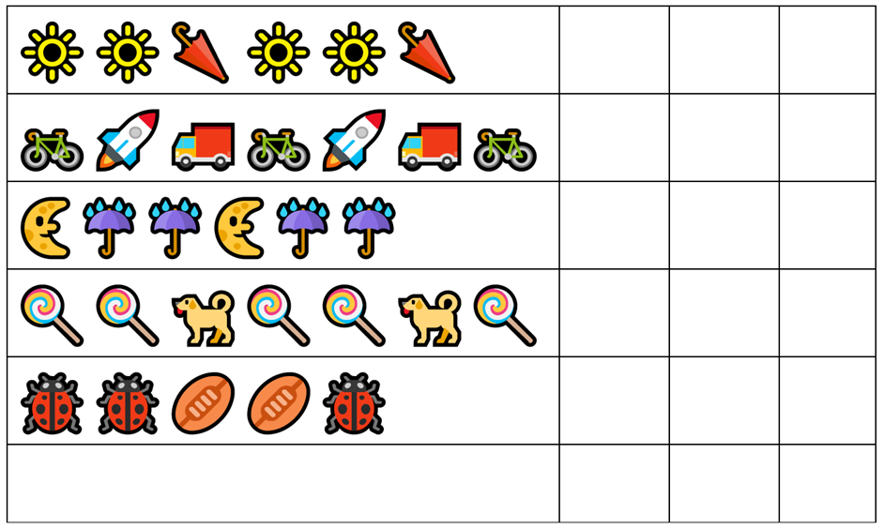

Break – Time to stop and refuel. Eat, play, have fun. Self-directed outside activities where possible.
STEM
Today you will be using your creative mind to invent your own type of insect made from recycled materials. Try and remember what you have learnt this week about what body parts an insect has. Your invented insect should have a head, thorax, abdomen, 6 legs and antennae for it to be classified as an insect. Anything else you add is up to you and your imagination! Does it have wings? A long nose? Spikey toes? Ask a family member to record you with your insect creation. Tell your teacher all about your invented insect. Have you included all the correct body parts for it to be classified as an insect? Have you given your insect species a name? What sorts of crazy things can it do?

