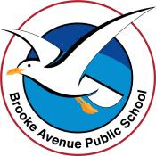
Learning from Home – Brooke Avenue Public School
Stage 2 (Years 3 and 4) – Week 8, Term 3
The following timetable can be used by students to support learning at home. All tasks have been linked to syllabus outcomes. If technology is available at home, please use the attached links to support learning.
The camera symbol shows the work sample we would like to see on Seesaw.
Monday 30th August
Daily Task – Make your bed
Morning -
English:

Reading

Read the ‘Fact File – Elephants’, which includes basic facts across various categories.
Writing
Informative Writing: Plan an informative text on the topic of ‘Elephants’. Use the Writing Sentences Form Dot Points worksheet to create full sentences about each fact. You may like to find out more about elephants by researching on the internet.
Grammar:
Adverbs: What is an adverb? Adverbs describe verbs and adjectives. They tell us when, where, how, how often and how much something is. Examples: She laughed loudly. We are always told to eat healthily. We sometimes went to the shops by car. I will meet them later.
Go through the attached PowerPoint, so that you have a better understanding of how an adverb can be used in your sentences.
Complete the page of adverbs worksheet.
Spelling
Write out your list of spelling words.
Break – Time to stop and refuel. Eat, play, have fun. Self-directed outside activities where possible.
Maths
What is an angle? Read through the worksheet attached.

Watch this short clip to learn:
What is a right angle?
What do you call an angle that is smaller than a right angle?
What do you call an angle that is larger than a right angle?

https://www.youtube.com/watch?v=NVuMULQjb3o

Complete Angles worksheet

Look around your home classroom or playground, see if you can Identify some angles draw them onto your paper and label the angles.

Break – Time to stop and refuel. Eat, play, have fun. Self-directed outside activities where possible.
Science
Record your Science Speech that you prepared in Week 7 and upload it to Seesaw. It should only be 2 – 3 minutes.

Creative Arts
Create an artwork which uses the theme of angles. Notice the different colour combinations that have been used.

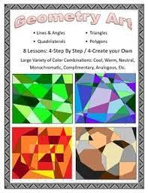

Tuesday 31st August
Daily Task - Match socks and sort washing.
Morning
English:

Reading
Complete half an hour on Reading Eggs or read a book / magazine of your choice.
Writing:
Informative Writing – Fact File – Elephants (continued). You can use the Informative Text Scaffold (attached) to structure your informative writing based on yesterday’s writing task.
Grammar
Adverbs- Complete the attached worksheet ‘Identifying Adverbs’.

Spelling

Write your spelling words out in ‘rainbow’ writing. Choose 4 words from your spelling list to find the dictionary meaning of. Write the meanings and then put each of the words into an interesting sentence.

Break – Time to stop and refuel. Eat, play, have fun. Self-directed outside activities where possible.

Maths
Thinking about types of angles.
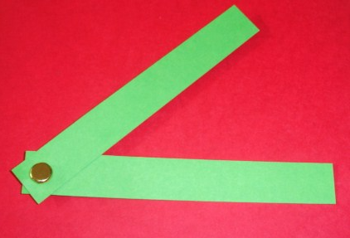
Using strips of paper, create a right angle, acute angle and obtuse angle. (If you don’t have a split pin you could tape or just place one on top of the other)
Label the different parts of the angles (arms, vertex, angle)

Make one with longer arms, does it change the size of the angle?

Compare the size of angles by placing on top of each other.

Order angles from smallest to largest. Write down what you find out.

PDHPE
Fitness Link attached or your choice of fitness.
https://youtu.be/364hLkdOXXc
Break – Time to stop and refuel. Eat, play, have fun. Self-directed outside activities where possible.
Science
Sun Dial Activity – See attached Information and Template

Wednesday 1st September
Daily Task - Wash the dishes.
Morning
English:
Reading
Read ‘Species Snapshot – See Jellies’. This informative text allows you to refine your comprehension skills. After reading the text answer the questions.
1. Why is the term “jellyfish” incorrect?
2. In a sea jelly’s life cycle, which form lays eggs?
3. How long do the tentacles of the lion’s mane sea jelly grow?
4. Other than hunting for prey, why else do you think sea jellies might have stingers?
5. In your own words, explain the relationship between sea jellies and humans.
6. Describe in your own words, the way a sea jelly moves and hunts?
Writing
Publish your information text on Elephants. You may like to publish it digitally.
Handwriting

Complete the attached Handwriting page. Concentrate on the formation of your letters.

Break – Time to stop and refuel. Eat, play, have fun. Self-directed outside activities where possible.
Maths
What is symmetry?
Watch this short clip to learn about Symmetry.

https://www.youtube.com/watch?v=YFzktJNmnPU
Identify and draw the lines of symmetry onto the shapes, using the worksheets provided. What did you find out about the connection between the amount of sides and symmetry lines?

Have a look around you, what things can you see that has symmetry?
Make a table of things that you can see that have Symmetry?

Break – Time to stop and refuel. Eat, play, have fun. Self-directed outside activities where possible.
Wednesday Wellbeing Time
Choose an activity that will put a smile on your mind and make you feel great. For a few minute mediatation session you may like to use the link below.
https://www.youtube.com/watch?v=8NB3ihqPQGw
PDHPE – Yoga Lesson- See attached Link
https://youtu.be/-uKEuikMrRo

Thursday 2nd September
Daily Task – Make your bed.
Morning
Reading
Read ‘Ice Hockey’ and answer the questions in sentence answers.
Writing
Write about a game of your choice. It may be a game that you already know about or a game that you research.
Spelling
Write your words in alphabetical order.
Break – Time to stop and refuel. Eat, play, have fun. Self-directed outside activities where possible.
Maths
Complete worksheet. You may cut and fold the shapes to help assess the symmetry of each.

https://www.twinkl.com.au/resource/au-t2-m-4201-symmetry-in-nature-activity-sheet?sign_in=1

How many lines of symmetry does a circle have?
Break – Time to stop and refuel. Eat, play, have fun. Self-directed outside activities where possible.
Creative Arts - See the attached Dance Link
https://youtu.be/LaB9c3kQkfU

Friday 3rd September
Daily Task – Help an adult with an outside activity.
Morning
English:
Read ‘Back to School Today’. As you are reading, try to visualise what is happening in the poem.
Answer the following questions in sentences.
1. What is it time to do again?
2. What is the teacher doing?
3. What has the poet missed while being away from school?
4. There’s a bustle in the playground as the children dash around. What does the poet mean by this line?
5. What made the poet’s worries disappear?
6. Do you enjoy going back to school after holidays? Give detailed reasons for your answer.
Writing
Write about how you are feeling about returning to school when we are advised to. What are you most looking forward to about it?
Spelling
Ask someone in the house to test you on your spelling words for this week. Practise any words that you make a mistake on. Keep trying your best!

Break – Time to stop and refuel. Eat, play, have fun. Self-directed outside activities where possible.
Maths Angles Game:
Follow the instructions to play the game, see if you can remember the Angles without looking at the key at the top of the page.

See the Attached game.

Break – Time to stop and refuel. Eat, play, have fun. Self-directed outside activities where possible.
PDHPE- See the attached Aerobic Lesson

https://youtu.be/zM3GZ9RjumU

Friyay

Friday Afternoon Free time – Your choice.

