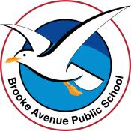
Learning from Home – Brooke Avenue Public School
Stage 1– Week 8, Term 3
The following timetable can be used by students to support learning at home. All tasks have been linked to syllabus outcomes. If technology is available at home, please use the attached links to support learning.
This week is Wellbeing Week. Afternoon sessions have been left free to choose a wellbeing activity from the timetable or another activity of your choice.
Please upload work marked with the camera icon to Seesaw.
Monday - Week 8, Term 3 – Stage 1
Daily Task - Match socks and sort washing.
English:
Reading: Choose a book to read or listen to one of the stories on Seesaw. Remember you can read any book from home or on your PMe Readers. After you have read the book, complete the worksheet ‘My Favourite Character’ to describe your favourite character.
Spelling: Choose list 1, list 2 or you might like to challenge yourself and do both. Write them down in a workbook or on a piece of paper.
This weeks letter/sound combinations are ai and ay. Watch this video before writing your list. https://video.link/w/6nm6c
List 1 – ai,ay | List 2 – ai, ay
rain | draining
plain | raining
train | trained
stain | stained
brain | brainstorm
hay | afraid
lay | fraying
play | sprayed
clay | playing
Writing: This week we are going to be writing a procedure. We thought it might be fun to write our favourite recipe and then maybe at the end of the week, if you are allowed, you might even be able to make it (with the help of your parents/carers)
The first writing activity you need to do today is write a few sentences about what your favourite food/recipe is and why.
Example:
My favourite food is chocolate chip cookies. They are my favourite because cookies are delicious, and I can dip them in my warm cup of milk. I love being able to help make them with my grandma when I visit her.

Break – Time to stop and refuel. Eat, play, have fun. Self-directed outside activities where possible.
Maths:

Optional Game - Strike it Out – Play this game with a partner

Watch a Video on how to play Strike it Out - this link also has further written instructions on how to play this game.

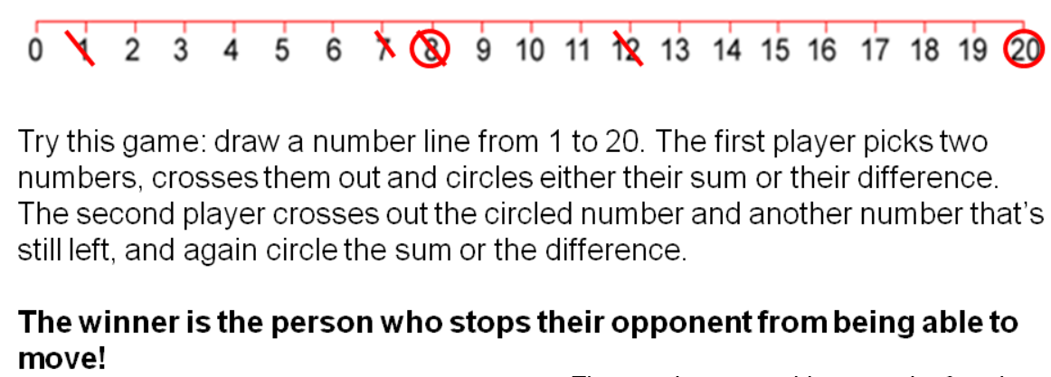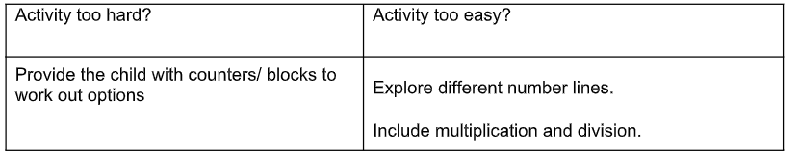

Patterns and Algebra: Patterns
1.
Look at the patterns below. The first one is a ‘two pattern’ because there are two elements that repeat. The second one is a ‘three pattern’ because it has three elements that repeat. The third one is also a ‘three pattern’ because it has three elements that repeat, even though the letter B appears twice in the group of 3 elements.
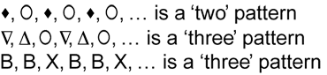

Draw or use objects around your house to make a variety of ‘two patterns’ and ‘three patterns’. Extension: Can you make a ‘four pattern’.

2.
You will need a hundreds chart and colour pencils.
Step 1 – Skip count by 2’s and colour in each number you land on yellow (2, 4, 6, 8, etc).
Step 2 – Skip count by 5s and circle each number you land on with blue.
Step 3 – Skip count by 10s and square each number they land on with red.
Once you have finished, look carefully at the patterns you have created on your hundreds chart? Extension: skip count by 4s and put a green triangle on all numbers you land on.
Break – Time to stop and refuel. Eat, play, have fun. Self-directed outside activities where possible.
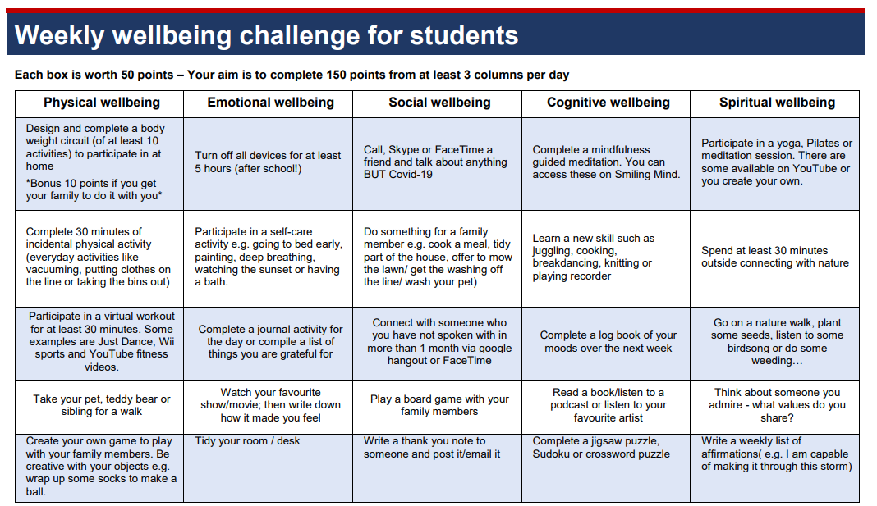
See the Seesaw Activity: BAPS Wellbeing Week Stage 1
Choose a wellbeing activity from the Wellbeing Challenge Timetable attached below.

Tuesday - Week 8, Term 3 – Stage 1
Daily Task - Wash the dishes.
English:
Reading: Choose 2 books to read or listen to 2 of the stories on Seesaw. Remember you can read any book from home or on your PM eReaders. After you have read the book, you need to retell one of the stories to someone at your house or maybe even on a facetime call with a family member. Explain to them what your favourite part was and why.
Spelling: Read your spelling list aloud. Write your list or lists down in a workbook or on a piece of paper. Use a different colour for the sound/rule in each word.
eg. Rain, plain, hay, clay.
Extension: can you think of any other words that have ai or ay in them? If so, add them to your list and send a photo to your teacher.
Writing: Today we are going to write the heading of our recipe at the top of our page and list the ingredients. Make sure you underline your headings, so they stand out to the reader.
Example:
Chocolate Chip Cookie Recipe
Ingredient List: (please note; the recipe below is not correct so please don’t use this to make cookies)
1 cup of flour
1 cup of milk
2 eggs
½ cup of chocolate chips
1 teaspoon of baking powder

Break – Time to stop and refuel. Eat, play, have fun. Self-directed outside activities where possible.
Maths:
Number Busting
Watch a video on how to complete this activity.
Get 26 items (for example, pasta pieces, counters or pencils).
Organise and describe your collection. If using 26 counters you might organise into 2 lots of 10 and 1 lot of 6. 10 + 10 + 6 = 26 (Ask – what can you see? How many are there?
Try to reorganise and describe your collection as many times as you can within the next 5 minutes.
Draw and record all of your ways of thinking about your collection.
Play the game again with another number.
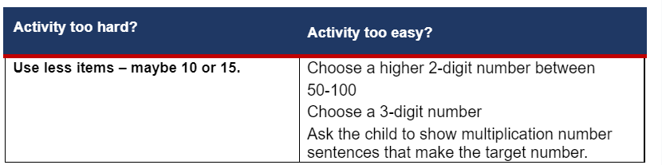

Patterns and Algebra: Number Patterns
1.
Watch this video to learn about number patterns
Create a variety of increasing (going up) and decreasing (going down) number patterns. How many different number patterns can you create? You might like to use your hundreds chart from yesterday to help you.
2.
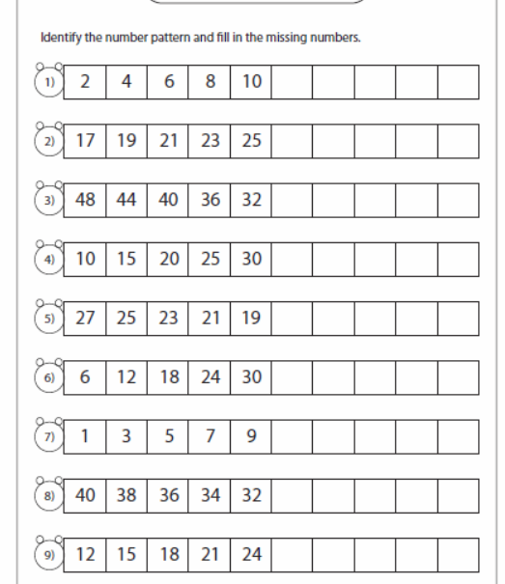
Complete the number pattern worksheet

Break – Time to stop and refuel. Eat, play, have fun. Self-directed outside activities where possible.
See the Seesaw Activity: BAPS Wellbeing Week Stage 1

Choose a wellbeing activity from the Wellbeing Challenge Timetable attached below.

Wednesday - Week 8, Term 3 – Stage 1
Daily Task – Make your bed.
English:
Reading: Choose 2 books to read or listen to one of the stories on Seesaw. Remember you can read any book from home or on your PM eReaders. Before you read the books, have a look at the cover and predict what you think it might be about. After you have finished reading the book, discuss if your prediction was correct.
Spelling: Read your spelling list aloud. Create a ‘Word Search’ by writing your spelling words in the blank word search sheet, that is attached in this week’s plan. Remember once you have put all your words in, you need to fill the blank spaces with all different letters. When you have finished it, give it to someone in your house to see if they can find all the words.
Writing: Today we are going to write down the method of our recipe, so that someone else would know exactly what to do, and in what order, if they wanted to make your favourite food or treat. Make sure you underline your heading, so that it stands out to the reader.
Example:
Method:
1. Pre heat oven to 180 degrees.
2. Line a baking tray with baking paper.
3. get out all the equipment you will need.
4. Sift the flour into the mixing bowl.
5. Add milk and eggs and mix well with a wooden spoon.
6. Stir in the chocolate chips.
7. Roll cookie mixture into balls and place on to the baking tray.
8. Bake for 30 minutes or until golden brown.
9. Place onto a cooling rack to cool down before eating.
10. Enjoy your cookie.

Break – Time to stop and refuel. Eat, play, have fun. Self-directed outside activities where possible.
Maths:
Optional game - Play 101 and You’re Out (This game can be played with a partner or adapted to play individually – how close can you get to 100!)
Watch a video to learn how to play.

Each player needs a copy of this table. There are two additional copies in the resources at the end of this document.
Tens | Ones | Number | Total

Take it in turns, to roll a dice.

Each time you roll the dice, you have to decide whether the number is representing ‘ones’ or ‘tens’. For example, if I roll a 3, I could use it as 3 ones (3) or 3 tens (which we rename as 30). If you choose to use your 3 as 3 ones, record the number in the ones column. If you choose to use your 3 as 3 tens (30), record your number in the left tens column. Each player must record the number rolled in their table.

Continue to play until you have completed the 5 rows in the table.

Once you write a number, you can’t change it.

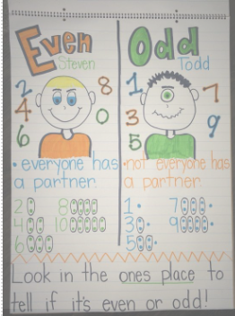
The winner is the player with the sum that is closest to 100 without going over!

Patterns and Algebra: Odd and Even Numbers
Watch this video to learn about odd and even numbers
Even numbers are even because they can be put into groups of 2 without any leftovers.
Odd numbers are odd because they cannot be put into groups of 2. There will be one leftover by itself.
1. Complete the worksheet on odd and even numbers.

Break – Time to stop and refuel. Eat, play, have fun. Self-directed outside activities where possible.
See the Seesaw Activity: BAPS Wellbeing Week Stage 1
Choose a wellbeing activity from the Wellbeing Challenge Timetable attached below.
Thursday - Week 8, Term 3 – Stage 1
Daily Task – Help an adult with an outside activity.
Break – Time to stop and refuel. Eat, play, have fun. Self-directed outside activities where possible.
English:
Reading: Choose a book to read or listen to one of the stories on Seesaw. Remember you can read any book from home or on your PM eReaders. After you have read the book, think about a different ending to the story. Re read the book to someone at home but change the ending and see which ending they liked better.
Spelling: Read your spelling list aloud. Put your spelling words into sentences. Try and challenge yourself by using more than 1 word in each sentence.
Writing: Today we are going to draw and label a picture of all the ingredients that we need to make/cook our favourite recipe. After that, draw a picture of what you think the food will look like after you have made it.

Example:
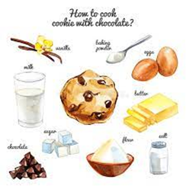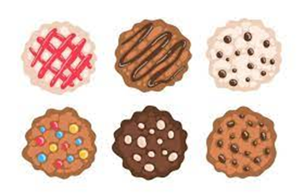

Maths:

Sam and Holly’s Problem

Watch a video on how to complete this activity.
Get ten blocks out. Cover some of the blocks and ask your child how many are missing. (You may like to draw what they can see). You may like to use two cups or two pieces of paper to cover the counters. Write down the number sentence, For eg. 6 + 4 = 10.
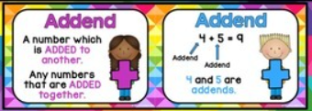
Patterns and Algebra: Missing Addends
Watch this video to learn about missing addends
8 + _____ = 13 You can use addition or subtraction to solve missing addend problems.
Using Addition - you can count on from 8 to 13 to see how many more you need to add to 8 to get 13.
Using Subtraction – you can take 8 away from 13 to find the missing number. You could also count back from 13 to 8 (You will count back 5 so 5 is the missing addend.
Complete the worksheet on Missing Addends

Break – Time to stop and refuel. Eat, play, have fun. Self-directed outside activities where possible.
See the Seesaw Activity: BAPS Wellbeing Week Stage 1
Choose a wellbeing activity from the Wellbeing Challenge Timetable attached below.
Friday - Week 8, Term 3 – Stage 1
Daily Task – Clean up your room.
English:
Reading: Choose a book to read or listen to one of the stories on Seesaw. Remember you can read any book from home or on your PM eReaders.
After you have read your book, please read the worksheet that is labelled “Adjectives”. You need to read each sentence and underline the adjectives in the sentence.
Extension: after you have completed the adjectives worksheet, go back through the book that you read today and see how many adjectives you can find. Were any the same as the ones you underlined on the worksheet?
Spelling: Read your spelling list aloud. Since it is Friyay, you could have some fun and see how many words you have learned to spell. Try using the ‘Look, say, cover, write, check’ method, for each word as a bit of a challenge for yourself. Or you could get an adult to read the words to you and see if you can tell them how to spell them. The choice is yours.
Writing: Today is the day we get to have some extra fun and cook your favourite food or treat that you wrote the recipe for. If you are allowed, and with the help of an adult, make or cook your favourite recipe. After you have done this, you can write a few sentences about how the cooking went and most importantly how the food tasted. Take some photos during and after your cooking experience and post them to your Seesaw journal.
Extra Special Writing/Art Activity: Use one of the templates provided, to write a nice Father’s Day message to your dad, grandpa, uncle or significant male in your life. Write your message on a spare piece of paper first so you can edit it and check for any mistakes, before you write your message on the card. Get someone else at home to check it for you after you have checked it yourself first. Remember to take your time when colouring in and use lots of beautiful, bright colours.

Break – Time to stop and refuel. Eat, play, have fun. Self-directed outside activities where possible.
Maths:

Building Towers - Watch a video on how to complete this activity.

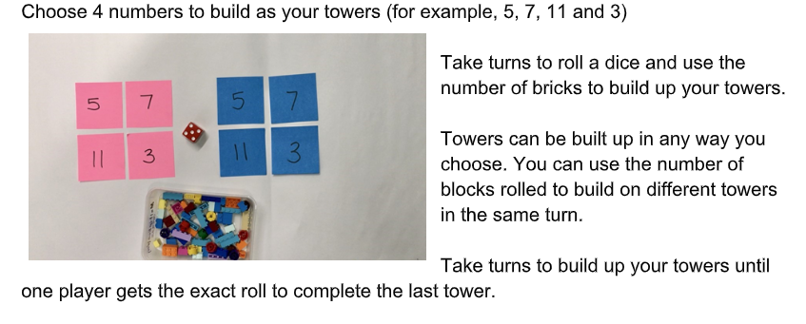

Patterns and Algebra: Matching Word Problems to Number Sentences

Look at the word problems on Maths Worksheet 4
Write a number sentence (eg 15 + 11 = 26) for each problem.
Make sure you solve each problem. You can use drawings, items in your house or an addition strategy to solve the problems.

Write a word problem to match these number sentences: Example: 13 + 11 = 24 Joe has 13 toy cars. He gets another 11 cars. How many
- 22 + 12 = 34 toy cars does Joe have now?
- 14 + 15 = 29
- 28 – 8 = 20
Break – Time to stop and refuel. Eat, play, have fun. Self-directed outside activities where possible.
See the Seesaw Activity: BAPS Wellbeing Week Stage 1
Choose a wellbeing activity from the Wellbeing Challenge Timetable attached below.

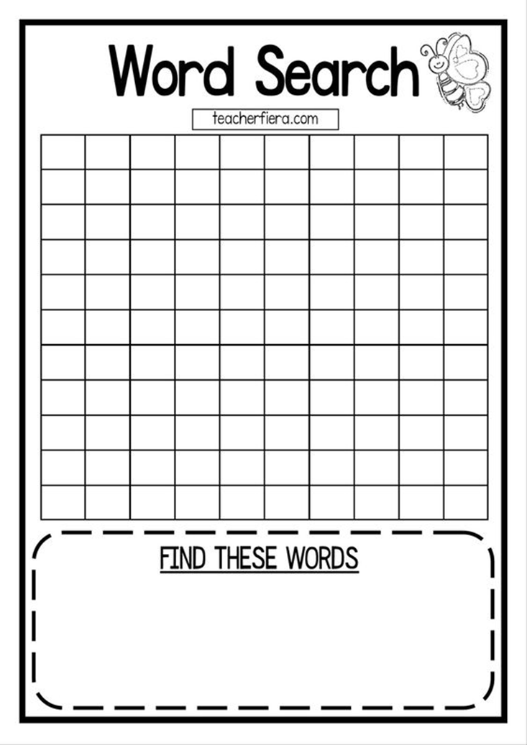
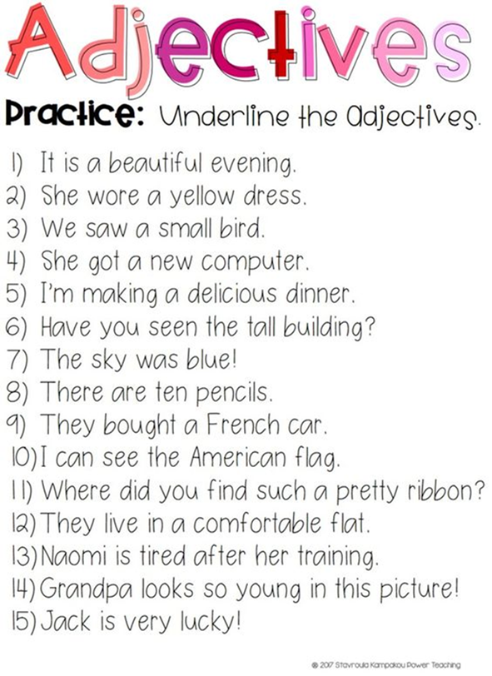

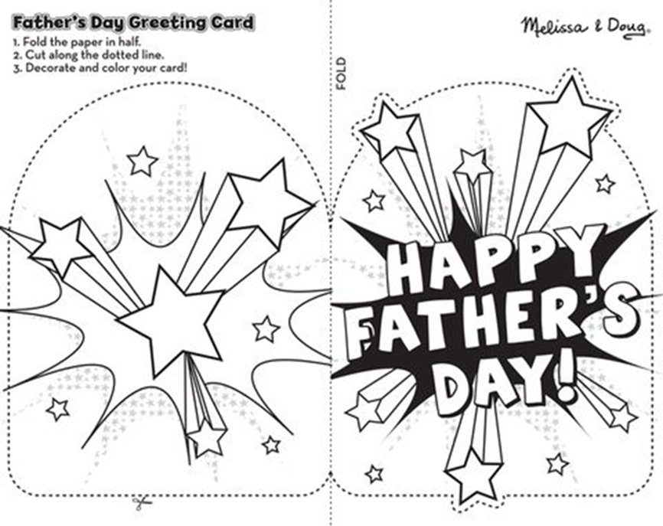
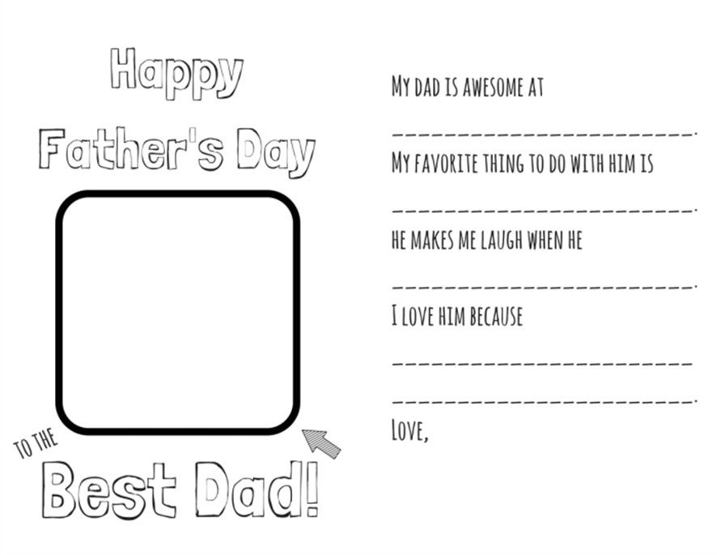
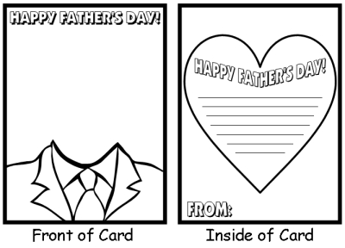

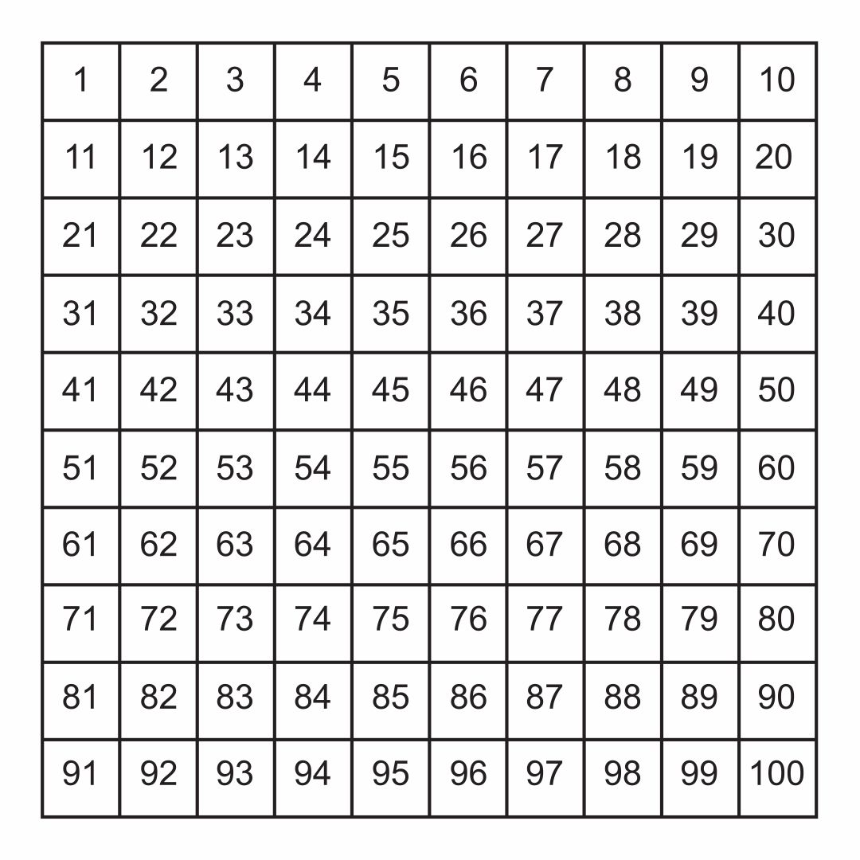

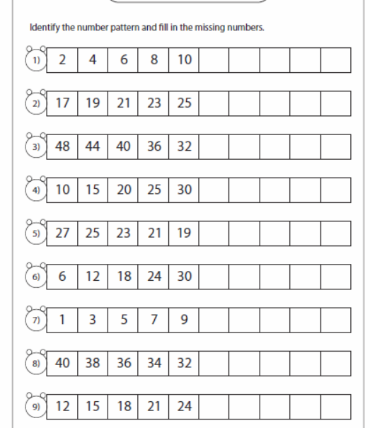

Tens | Ones | Number | Total

Tens | Ones | Number | Total

Recognising Odd and Even Numbers
Look at the sheep being counted below — colour tn the odd numbered sheep (ending in 1, 3, 5, 7 or q) blue and the even numbered sheep (ending in 2, 4, 6, 8 or 0) red.

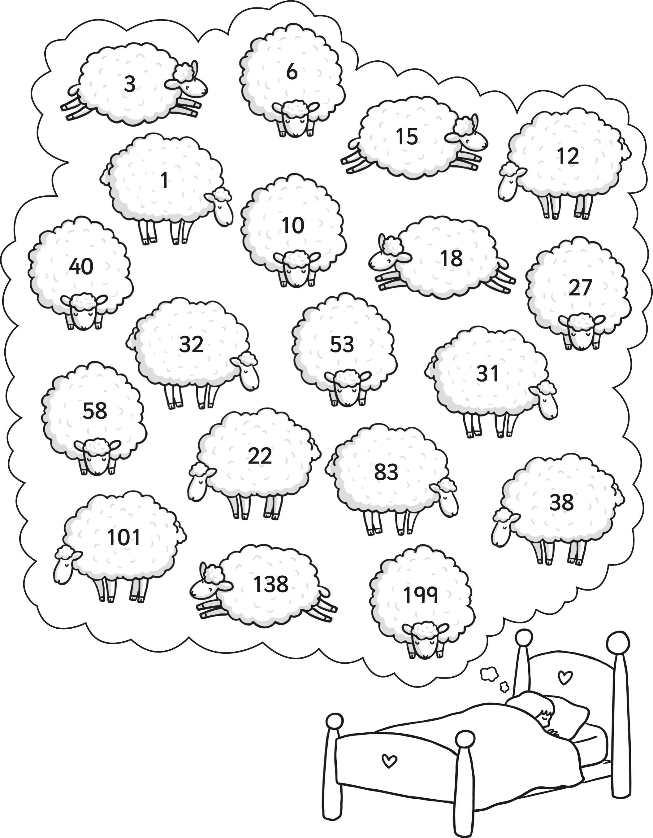

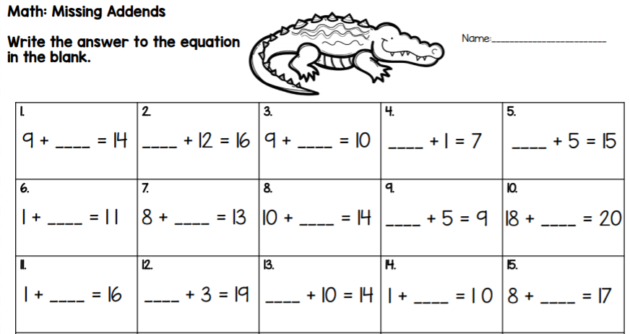
Extension: 32 + ______ = 44 28 + ____ = 40 56 + _____ = 100 49 + ______ = 63 72 + _____ = 95

Maths Worksheet 4 - Friday
