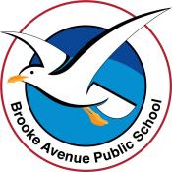
Learning from Home – Brooke Avenue Public School
K-6J, K-6M and K-6S – Week 8, Term 3
The following timetable can be used by students to support learning at home. All tasks have been linked to syllabus outcomes. If technology is available at home, please use the attached links to support learning.
Monday - Week 8, Term 3
Daily Task – Ask if you can water the pot plants or the garden. Make sure you don’t get too wet!
English:
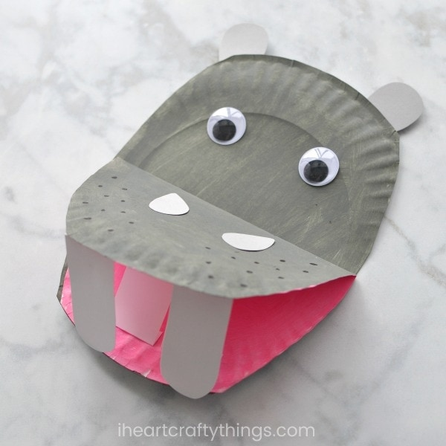
Watch this story called ‘There's a Hippopotamus on Our Roof Eating Cake’ https://www.youtube.com/watch?v=1bwTl5aMRX0 Complete the following activities about this story.
- Draw and label all the characters in this story eg Dad, child, hippo…
- Draw and label the places (settings) in this book eg hospital, roof, bath…
- Choose 10 nouns (names of things) and make a spelling list from them. Can you write your spelling words in rainbow writing? Can you make a word pyramid from them? Can you write them in a sentence?
- Tell somebody what your favourite part of the story was and why. Would you like a hippopotamus on your roof? Why? Why not?
- Look at the image of the paper plate hippo. To create this, you will need two paper plates or pieces of paper. One will need to be folded to create the mouth and glued onto the other plate/paper. Can you make a hippo that looks like this one? Please show us your creation! You could choose to draw the hippo instead or use a paint program on your computer or iPad to create your picture.
- Complete the hippopotamus activity sheet from the resource pack. You may need an adult to help with this. There is an answer sheet attached if you get stuck or if you want to mark your own work.

Logon to your reading eggs https://readingeggs.com.au/ or your ePM reader account PM eCollection | Guided Reading Re-Imagined | Nelson Cengage Learning Australia and enjoy some down time!

Break – Time to stop and refuel. Eat, play, have fun. Self-directed outside activities where possible.
Maths:
Patterns: Today we are going to look at patterns. Watch this pattern clip Patterns! | Mini Math Movies | Scratch Garden - YouTube

- Complete the stripy scarves activity sheet in your resource pack. Can you create your own scarf pattern using two, three of four repeating colours?
- Using the ‘make a pattern’ resource see if you can create an animal pattern, a superhero pattern, a transport pattern and a fantasy pattern using the pictures. Does your pattern repeat? What is the frequency of your pattern? Is it A/B/A/B or AA/BB/AA/BB or A/B/C/A/B/C?

Using the 100’s chart, see if you can continue the following number patterns.
- 2,4,6,8…
- 99,97,95,93…
- 9,12,15,18…
- 10,20,30…
- 35,40,45,50…
- 38,36,34,32…
- Complete the ‘sequence snakes’ activity in your resource pack
- Can you create some number patterns of your own? Please post them onto Seesaw so we can try to carry your number pattern on!

Log on to maths seeds Home - Mathseeds or ABCya ABCya! • Learning Games and Apps for Kids and play some maths games!

Break – Time to stop and refuel. Eat, play, have fun. Self-directed outside activities where possible.
PDHPE: Emotions
Watch this PowerPoint and follow the instructions.
You may need a parent/carer to help you read some of the information and the words. Once you have watched the PowerPoint you can complete the first page of the daily emotions log from your resource pack. There are two additional pages that you can fill in throughout the week. How did your mood change? Why?
Watch and follow along with this Go Noodle clip about managing your emotions and energy. Bring It Down - Flow | GoNoodle - YouTube
Did this make you feel calmer? If you can, go for a walk around the neighbourhood, bike path or beach and take time to notice all the wonderful sights around you. Think of some things that you are grateful for and share them with a family member.

Tuesday - Week 8, Term 3
Daily Task – Can you tidy your room? Can you tidy another room in the house too?
English:
Watch the reading of this comic (it is quite long, but it is read in chapters so you may want to pause it and watch the rest later) Stinky - a read along TOON Book - YouTube
Comics are visual texts that communicate a story in a unique way. Watch this clip on how to create your own comic strip. How to Create a Comic Strip - YouTube
This clip gives you some ideas on how to draw interesting characters for your comic Kids Make Comics#1: Simple Shapes make Super Characters! - YouTube
Using the information, you now know about comics, see if you can create your own comic strip! It can be about anything and anyone! To make a template you can fold and cut piece of paper into a strip or you can use the template from your resource pack. Brainstorm your ideas first and make a basic plan of how you will structure your comic. Keep the text simple and the plot fast moving. If this is too difficult for you, create a picture board effect instead and draw a series of pictures that tell a story in sequence.
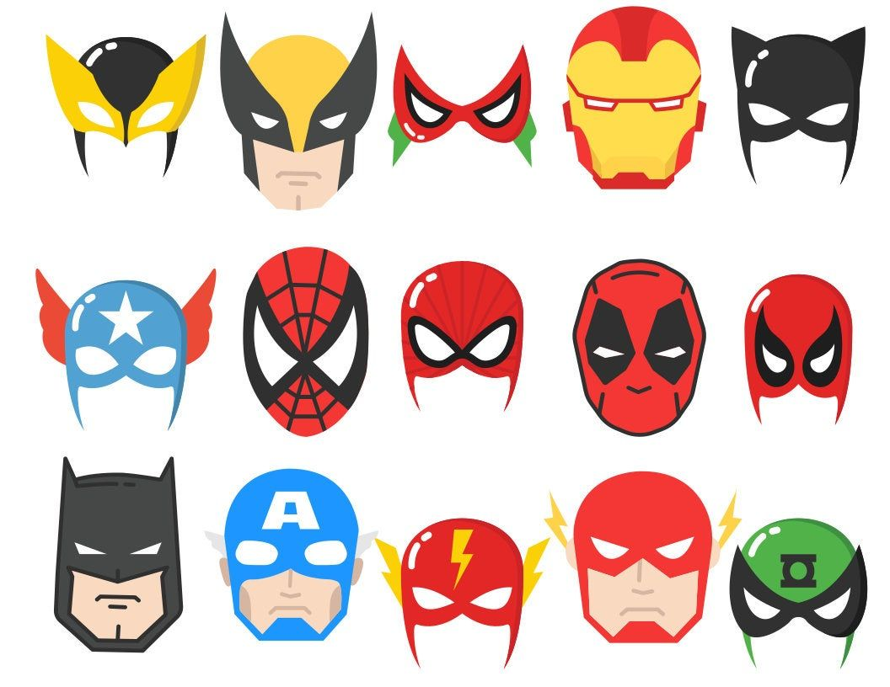
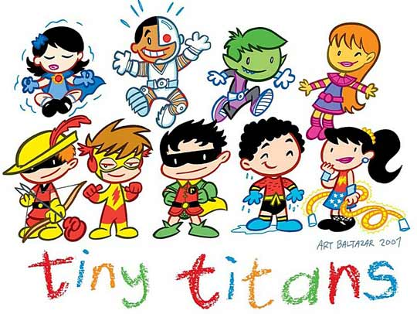
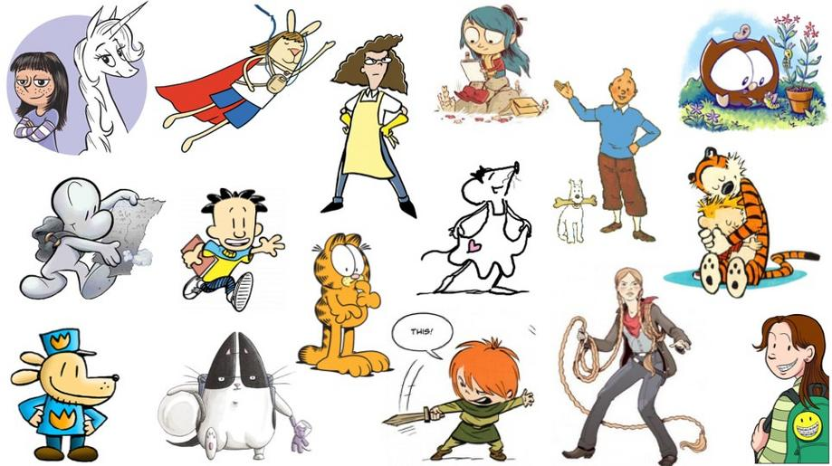

Verbs are action words (or doing words). Cut out the pictures of the verbs in the resource pack and match them to the words. You could use these later for a game of memory or snap. You may need an adult to help you with the cutting and reading but you can do the matching! You can even take photos of you doing something and the write a word to match (eg smiling) or you can draw a picture of a verb and write the word (eg dog drinking)
Practise finding different sounds in this interactive word find Phonic Finder (ictgames.com) Have fun!

Break – Time to stop and refuel. Eat, play, have fun. Self-directed outside activities where possible.
Maths:
Today we are going to work on adding and subtracting numbers using dice or playing cards and a tens frame. If you don’t have these items you can make your own by writing numerals 0-9 on a piece of paper and cutting them out or you can use an online dice roller like this one Online dice - Random dice roll - Virtual dices (online-dice-generator.com)
- Use the blank 10 frame in your resource pack.
- You are going to play a game called ‘first to’.
- You will need some counters (or pebbles, lego pieces, pasta etc) to cover sections on your ten frame.
- For ‘first to 10’ each player will need a 10’s frame, dice and counters. Player one rolls the dice and, using counters, covers the corresponding gaps on the frame. When there are less than 6 spaces left the player must roll under 6 to continue or exactly 6 to win.
- Continue taking turns until there is a winner.
To extend this game using 10 frames you can make the game ‘first to 20 or 30 or more’. Alternatively, you can pick any number eg 79 and play first to 79 using dice and adding and recording numbers as you go. You can use two dice so the child is adding two items before adding to the total.
You can turn the game into a subtraction game by playing ‘first to 0’ by filling the 10 frames with counters, rolling the dice and subtracting the number until the first player removes all the counters.
Complete the addition and subtraction wheels in your resource pack. Use a calculator to check your answers Online Calculator (online-calculator.com) Using the blank wheels, create your own. Make sure if you are making a subtraction wheel, that the middle number is less than the other numbers!
Well done! Try this game called Robot More or Less (topmarks.co.uk)Take some time to play an online game such as prodigy, maths seeds or ABCya!

Break – Time to stop and refuel. Eat, play, have fun. Self-directed outside activities where possible.
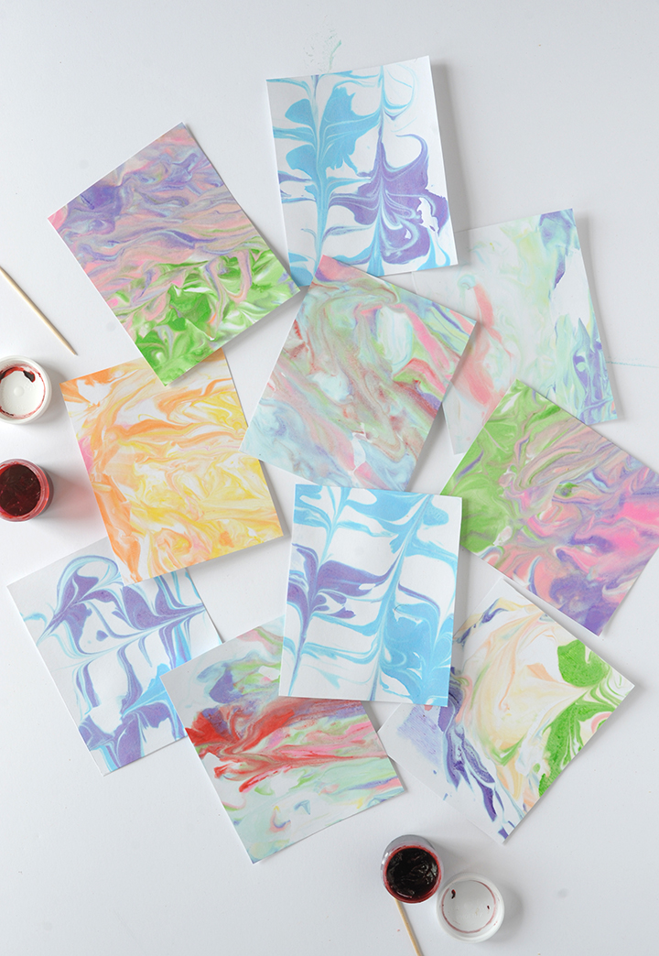
Art: Marbled paper
For this activity you will need…
- Shaving foam
- A shallow bowl
- Food colouring (the little dropper bottles work well)
- A stick
- Paper (heavy paper is best)
- Cardboard to scrape
Watch the clip Shaving Cream Marbling - YouTube and follow along with the instructions. When you have finished, you will have some beautiful, marbled paper that can be mounted onto black paper to make gorgeous artworks, used to write a letter to someone, make a card…the choice is yours! Plesae post your artwork onto Seesaw so we can see it!

Wednesday - Week 8, Term 3
Daily Task – Can you help load the washing machine, hang out the clothes and put them away once they are dry?
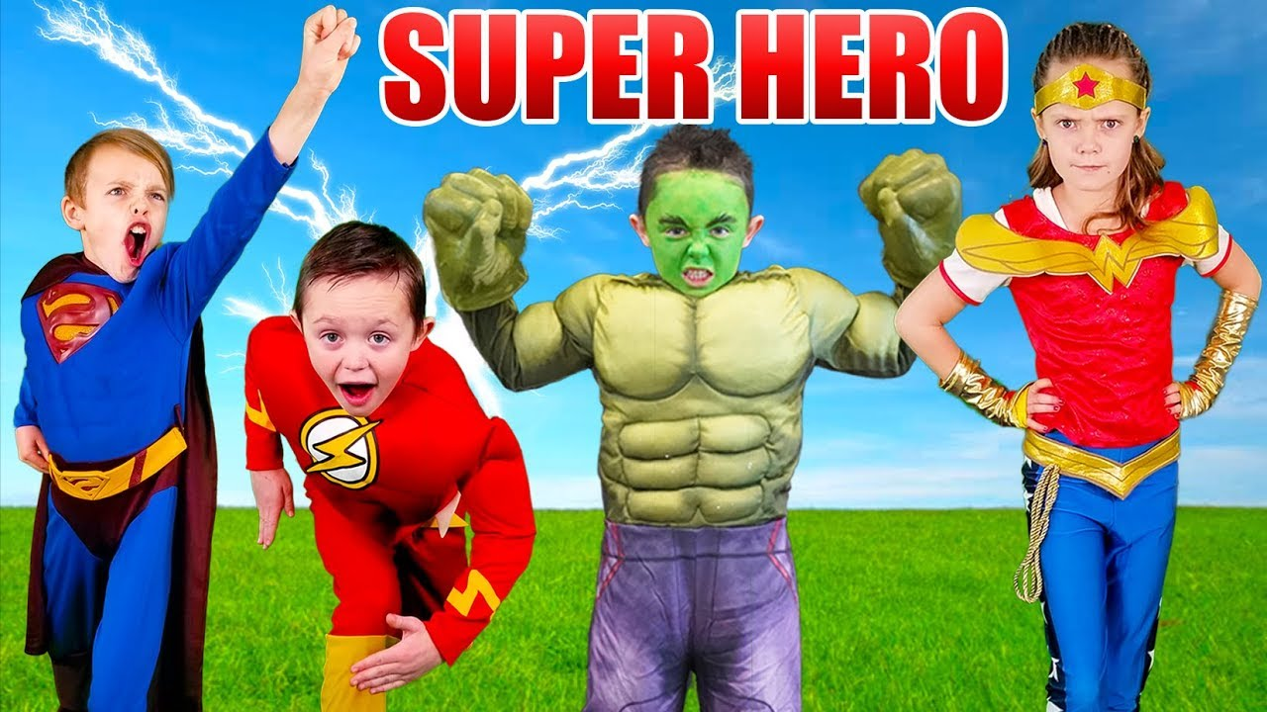
English: Today you will create your very own Superhero! You may have used a superhero in your comic strip yesterday so you can further develop that character today if you wish.
Brainstorm the characteristics of your superhero. Think about..
- What they wear
- What they look like
- What their powers are
- What their weaknesses are
- Where they live
- What items or special tools they use
- If they work as part of a team or individually
- If they have a pet
Make a poster, a PowerPoint, another comic strip, a story, a song, a rap or an artwork about your Superhero. If you are stuck for ideas, there is a Superhero identity sheet and Superhero templates to work from if you need them. Share this on Seesaw so we can learn about your amazing hero!
Make a superhero spelling list and write these words in a variety of ways; rainbow, in shaving foam, with pebbles, on your leg, in the air, in flour on the bench…
Take some time to work on Studyladder, reading eggs or ePM readers.
Break – Time to stop and refuel. Eat, play, have fun. Self-directed outside activities where possible.
Maths: Seasons
Create 4 posters or PowerPoint slides, one for each season: Autumn, Winter, Spring and Summer. https://www.youtube.com/watch?v=061ePX3k-hA
- Add images, drawings, cut out pictures from magazines etc to help you describe what happens in each season. Write (or have an adult scribe for you) some things that you know happen during the season like the kind of weather, special celebrations, clothing you may wear, things you may do etc
- Which is your favourite season and why? Ask your family which season they like and why? You could even ask to call your aunts and uncles or grandparents and ask them what season they like and why!
- Think about a holiday that you would like to go on and decide which season would be the best to go in. You may like to go skiing in winter or to the beach in summer. Act out what you are doing and see if someone from your family can guess what you are acting out and what season you are thinking about. Could they guess?
- Complete the Seasons Spin Wheel in your resource pack. If you don’t have split-pins you can use a pencil to hold the two pages together instead. Can you identify which season matches with the appropriate word?
- Complete the Superhero Eye Spy in your resource pack…
Log on to study ladder, maths seeds, ABCya or prodigy and play some games of your choice!

Break – Time to stop and refuel. Eat, play, have fun. Self-directed outside activities where possible.
Geography//PDHPE/CA
Today you are going to create an outdoor scavenger hunt for you family!
- Think of 10 (or more) things your family must find. You can make it as tricky or easy as you wish eg: one patterned leaf, a shiny stone, a pink flower, animal tracks, a Y shaped stick etc
- You will need to write the instructions and the list of items they need to find. If this is difficult, you could record yourself saying the instructions or draw pictures so your family can follow the instructions (you may need some help with this part).
- You can make the rules tricky or easy. For example, do they need to just see the item or search for and collect the items? These details are up to you!
- When you have everything ready you can start the race! The first person in your family to collect all the items you have told them to find is the winner! Woohoo!
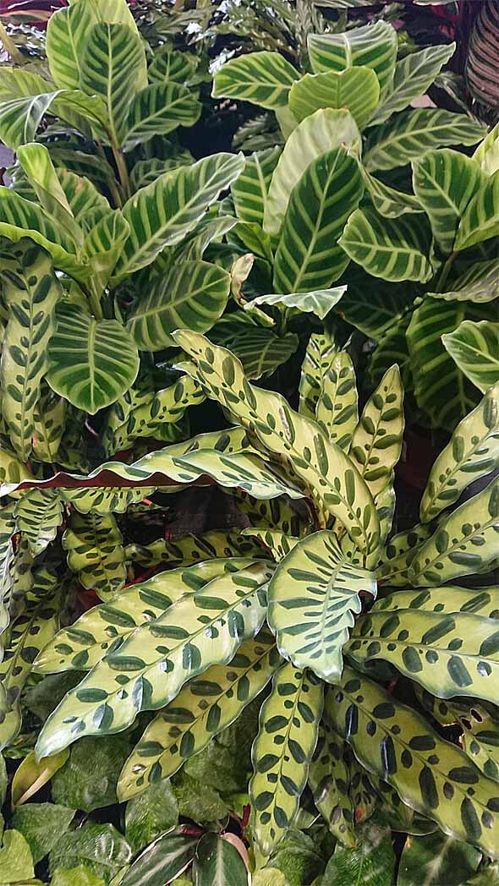
Think about the environment you were in when you held your scavenger hunt. Maybe you were in the backyard, or the beach or in a park. Watch this clip on how to sketch a landscape and have a try yourself. How to Draw a simple Landscape - Easy Pencil Drawing - YouTube Can you please post your landscape on Seesaw so we can imagine where you were?
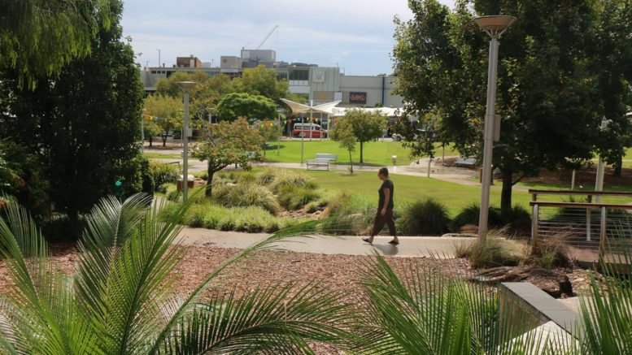
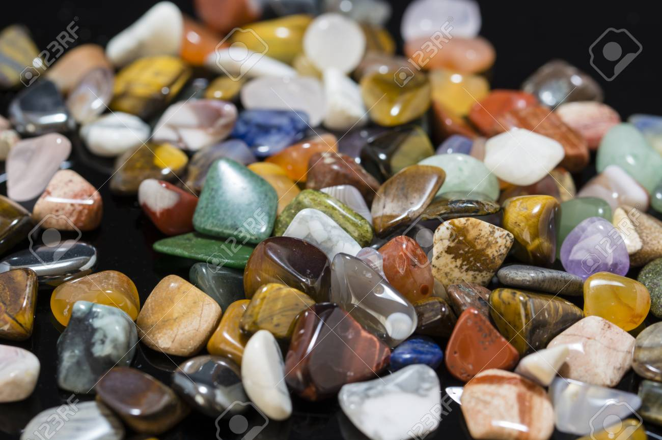
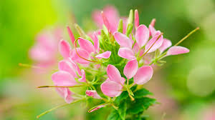

Thursday - Week 8, Term 3
Daily Task – Dry the dishes or unpack the dishwasher today.
English: Literacy
- Pretend you are hosting a big party!
- Think about and list all the things you will need…food, games, activities and party bags. Create an invitation to invite people to your virtual party. Make sure you include where, when, who, why and what!
- Make a shopping list of the food you will need. Look in an old catalogues or recipe books for ideas of the kinds of food you could eat.
- Look at the wonderful cakes on this website! Top 10 cakes from the Australian Women's Weekly Children's Birthday Cake book | Better Homes and Gardens (bhg.com.au) Which would you like and why? Can you think of a different cake you would want? Describe your favourite cake and draw a picture of it for us to see!
- Make a list of the activities and games you would play and do. What equipment would you need? Can you create a game for you and your family to play? Some ideas are…pass the parcel, pin the tail on the donkey or musical statues.
- Write a procedure about one of the party games or one of the food items you have chosen. You will need to list the materials/ingredients needed and write clear, sequential steps on how to make the items/play the game. You can use the Procedural Recount sheet in your resource pack if you would like to or you can create your own. If it is too difficult to write your lists you can use illustrations or photos instead.
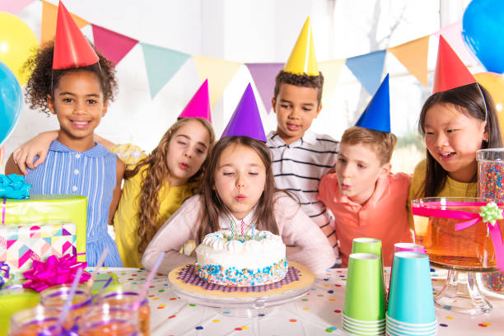
- Can you make a list of party decorations? Can you make some decorations and hang them in your room? Host your virtual party with your family members and some toys as guests. Take some photos and make a collage of them to share on Seesaw.
Visit the https://www.topmarks.co.uk/Interactive.aspx?cat=40 site…find something that suits you!
Log onto Reading Eggs or ePM collection and find some more books and activities to enjoy!

Break – Time to stop and refuel. Eat, play, have fun. Self-directed outside activities where possible.
Maths: 2D shape

- Go on a shape hunt around your house! Can you find three of each shape in a different location? You need to find 3 squares, 3 triangles, 3 circles, 3 hexagons and 3 rectangles. You can extend yourself by locating more shapes or adding some different shapes like pentagons, octagons and rhombuses.
- You can use the ‘2D shapes around the home’ sheets in your resource pack if you wish!
- Make shapes using toothpicks, paddle pop sticks, uncooked spaghetti pasta, drinking straws, sticks or string. Draw or take photos of the different shapes you found and made and upload them on Seesaw!
- Can you create a picture by tracing around some of the shapes you found? Use pencil first, then go over the outlines with a dark texta. Colour you picture in using pencils, textas or paint.

Visit the site https://www.foldnfly.com/#/1-1-1-1-1-1-1-1-2 to make a paper airplane. Measure how many steps the plane flies. Measure the distance it travels. Try a new design to see if you can beat that distance. Upload a video of your paper plane flying and share it on Seesaw and with your parent/carer and family.

Log on to Studyladder, Maths seeds or prodigy and have some fun!

Break – Time to stop and refuel. Eat, play, have fun. Self-directed outside activities where possible.
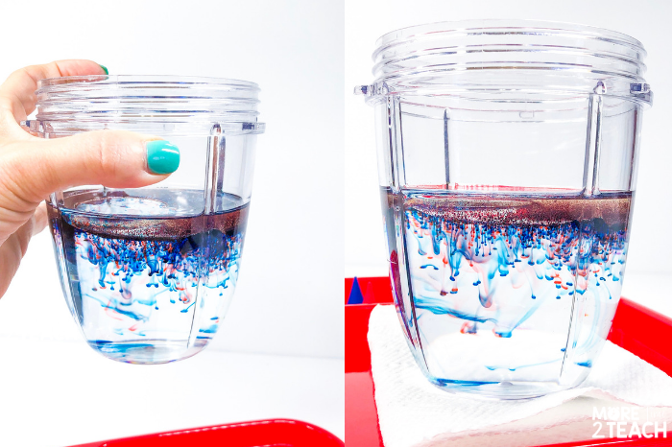
Science
Today you are going to do a very simple science experiment using some items that do not mix.
You will need
- A glass vase or large drinking glass
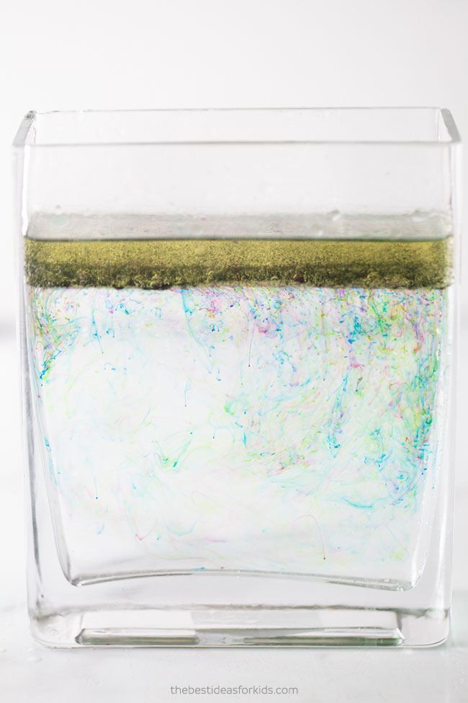
- Vegetable oil
- Food colouring
- A smaller glass
- Something to stir your mixture (a straw, wooden skewer or spoon would work)
Watch the Seesaw activity of Miss Scott doing the experiment… or watch this clip https://www.youtube.com/watch?v=9J_SCQhTmcM
What is happening to the oil, the water, and the food colouring? Why do you think this is? Has the same thing happened to your experiment? What happens if you put the oil and food colouring mixture into the glass first then add the water? Does the experiment still work? Why? Why not?
The theory behind this experiment is that oil is less dense than water and floats on top of the water. Food colouring is water-based so it mixes with the water. When you add the food colouring to the oil it will not mix. Once you add the oil to the water, the food-coloured droplets start to drop down since they are heavier than the oil. It makes a beautiful dropping rainbow of colours!

Friday - Week 8, Term 3
Daily Task – Ask if you can do some gardening today or over the weekend. You could pull out weeds or pick up sticks and leaves!
English: Watch this clip from Literacy Shed about Danny MacAskill, a famous mountain biker. The Sports Shed - THE LITERACY SHED
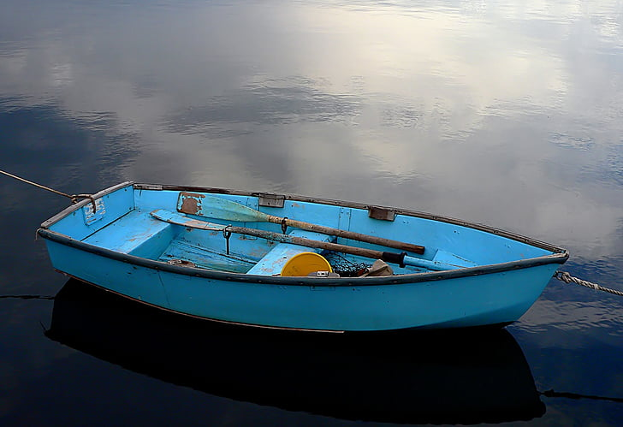
Using this wonderful visual literacy as a guide, complete the following tasks…
- Write or record yourself saying 10 nouns (names of items) and draw illustrations of them eg row boat, seal, mountain bike, boulders
- Write or record yourself saying 10 verbs (action words) eg riding, climbing, rowing, talking
- Write or record yourself saying 10 adjectives that describe your nouns eg small, blue row boat or sleek, slippery seal
- Using your nouns, verbs and adjectives write and illustrate some sentences eg The small, blue row boat bobbed in the deep, dark lake.
- Brainstorm how you think Danny MacAskill felt in different times of the clip, eg on the shore, rowing over the lake, riding over boulders and fallen trees, carrying his bike to the summit and riding down the ridge. Write your ideas, put them into a poem, write a rap or song about him or draw an artwork about his emotions and feelings.
- Imagine you are a famous athlete. You could be a gymnast, diver, skateboarder, surfer, badminton player, axe thrower…anything! Write a short passage (or record yourself talking or have an adult scribe for you) about how you feel when you are playing your sport and what you love about it. Draw a picture of yourself playing your sport, or search for images online or in magazines and make an artwork of you as a famous sports person!
Watch this clip about children who are already professional sports people. 8 Kids Who Play Professional Sports - YouTube Is there a sport in the video that you already play? Which sport would you like to do the most out of those shown? Why? Is there a sport you would be scared to do? Why? Why not?
Choose one sport and find out some facts about it eg what items do you need, where did it originate, what kind of uniform do you need to wear, can it be played professionally by boys and girls etc. Can you post your facts on Seesaw?
Go to Storyline online and find a story you like…grab some milk and biscuit and sit back and relax! Storyline Online - Home
Break – Time to stop and refuel. Eat, play, have fun. Self-directed outside activities where possible.
Maths: Number

Today you are going on Number Hunt: what numbers can you find in your house?

- Can you find the numbers from zero to twenty? Twenty to one hundred? Larger numbers?
- You might find numbers on a remote control or a clock. Can you find numbers on shoes, on food in the cupboard or in the fridge?
- Write 20 of the numbers on paper.
- Can you order them from smallest to largest?
- Can you add them using a calculator?
- Can you add or subtract 5, 50 or 500 from each number?
- Can you write your numbers in a place value chart?
- Can you write your numbers in expanded from eg 52=50+2 or 1872=1000+800+70+2
- Can you draw or take a photo of some of the activities you have done? Which did you like doing the most and why?

Complete the dot-to-dot worksheets in your resource pack.

Play a board game with a family member, for example Snakes and Ladders. If you don’t have games at home visit this site https://www.safekidgames.com/board-games/ Some of these games you can play by yourself against the computer! Good luck!

Break – Time to stop and refuel. Eat, play, have fun. Self-directed outside activities where possible.
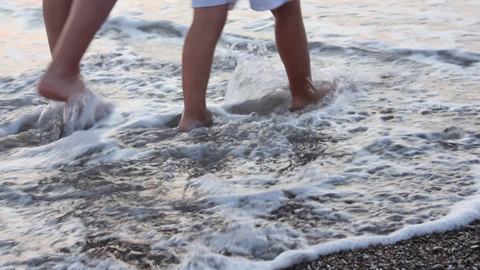
Happy FriYAy! Time to relax…

- Go to this link Balloon (Peace Out: Guided Meditation for Kids) | Cosmic Kids - YouTube
- Find a quiet spot and follow the meditation. Tell someone how you feel once completing the meditation.
- Choose a colouring sheet from your resource pack and enjoy some peace and quiet! Post an image of your work onto Seesaw!

Thank you for all the hard work you have done this week! Enjoy your weekend!
