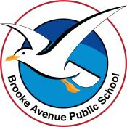
Learning from Home – Brooke Avenue Public School
Kindergarten – Week 8, Term 3
The following timetable can be used by students to support learning at home. All tasks have been linked to syllabus outcomes. If technology is available at home, please use the attached links to support learning.
Monday - Week 8, Term 3 - Kindergarten
Daily Task - Match socks and sort washing.
English
Phonics: You will need a piece of paper and a pencil. Access Seesaw. Watch the video by Mrs Rex and follow her instruction. If unable to access Seesaw, review all sounds on Jolly Phonics. Focus sound is w like wig. Ask your child to write the following words, web, white, wet, twin, win.
Reading: Read a book on https://app.pmecollection.com.au. Use the record tool to record yourself reading and listen to it back.
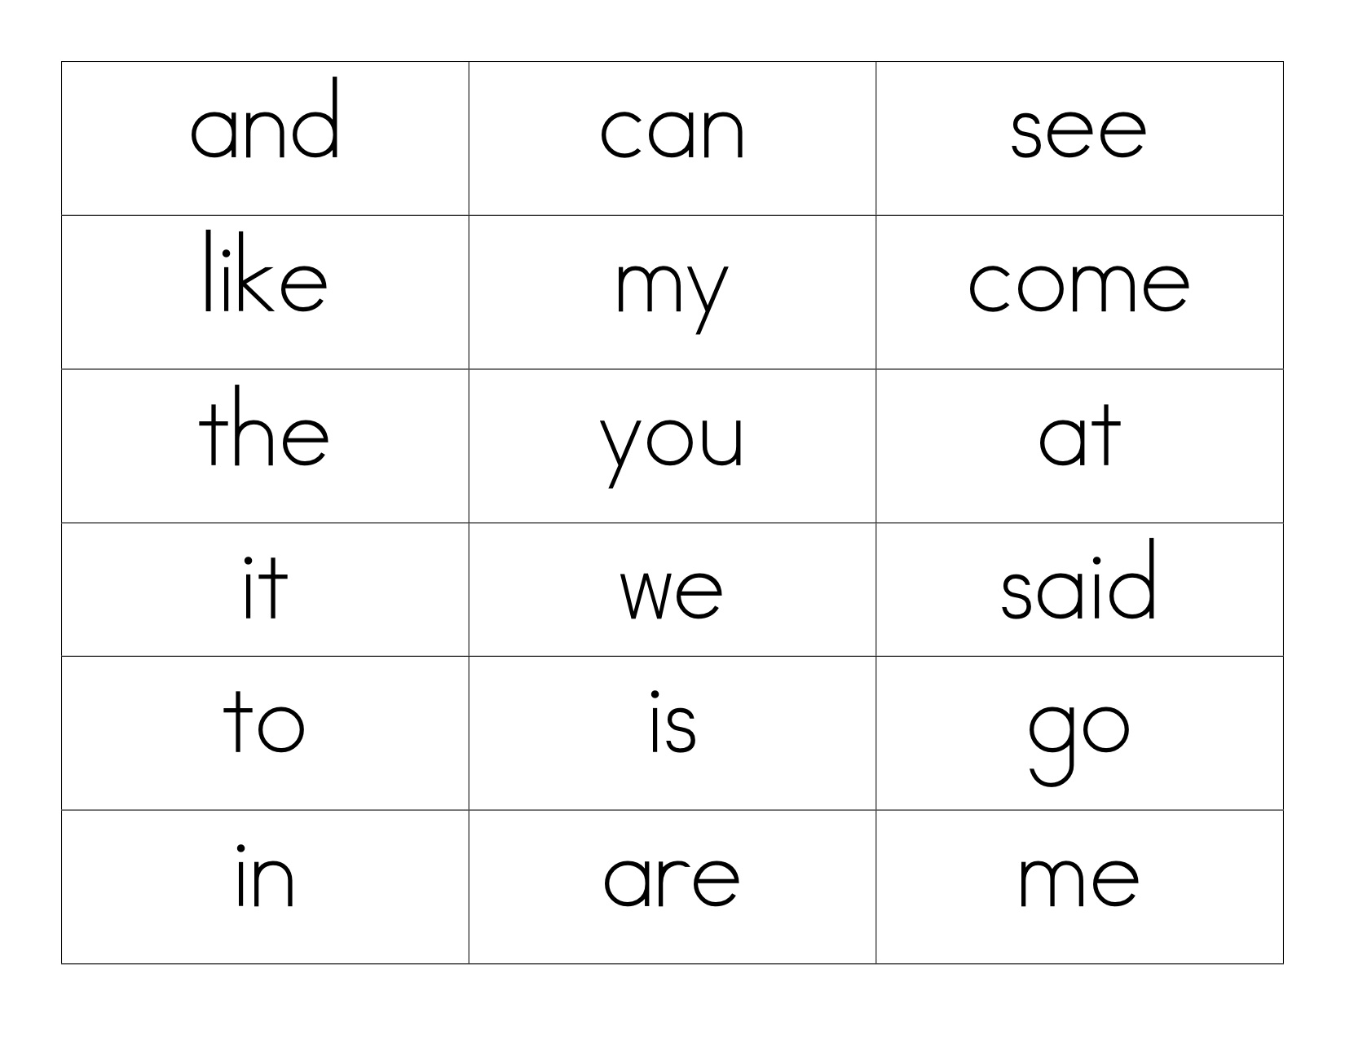
Writing: You will need a piece of paper and a pencil. Access Seesaw. Watch the video by Mrs B. Today we are learning to write a list. Pretend you were given some money and you could buy 5 different things. Make a list of what you would buy. Remember, lists are short and written from top to bottom. See the example of a list.
Sight words: Using flashcards with your sight words on them, play a game of Go Fish. Add some new words in that you have been learning over the past few weeks.
Extension: Write a sentence with 3-5 of your sight words.
Optional – complete 10 minutes of Reading Eggs activities.
Break – Time to stop and refuel. Eat, play, have fun. Self-directed outside activities where possible.
Maths
Warm up: Play a game of memory, matching the teddy cards to the corresponding number. You can play with card numbers 1-5, 6-10 or 1-10. Keep these cards to play this game again another day.
We are learning to: compare the volumes of two objects by observing the amount of space each occupies, eg a garbage truck takes up more space than a car.
Use the language: volume, space, has more, has less, takes up more space.
Watch the video with Miss Hetherington.
Collect a variety of objects from around the room that range (clearly) in volume. E.g a match, key, apple, orange, tissue box, pillow
Arrange the objects in order. Remember to use the language above when you reason and problem solve.
Complete the worksheet attached.

Break – Time to stop and refuel. Eat, play, have fun. Self-directed outside activities where possible.
WELLNESS WEEK AT B.A.P.S  Access the Wellness Week Seesaw activity for Monday  Social Wellbeing - When we care for and help others, we feel good about ourselves. Sometimes we can get unexpected rewards.  When we delivered the letters on our walking trip, we weren’t expecting anything back however we were so happy to receive a few letters from our neighbours.  Create some small postcards and write or draw a picture. Deliver to your neighbours when you are out and about with an adult.  “A friend is one of the nicest things you can have, and one of the best things you can be.”  Douglas Pagels  EARN POINTS FROM THE FAMILY WELLBEING CHALLENGE | Watch this cute clip about kindness  https://safeshare.tv/x/ss610d29847eeb2

Tuesday - Week 8, Term 3 - Kindergarten
Daily Task - Wash the dishes.
English
Phonics: You will need a piece of paper and a pencil. Access Seesaw. Watch the video by Mrs Rex and follow her instruction. If unable to access Seesaw, review all sounds on Jolly Phonics. Focus – after a w, the letter a usually makes an ‘o’ sound, like in the words water or was. Practice writing these words: wash, want, wasp, swan, warn, watch, wand.
Reading: Read a book on https://app.pmecollection.com.au. Draw or write what happened at the beginning, middle and end of your story. Take a picture and post to Seesaw.
Writing: You will need a piece of paper and a pencil. Access Seesaw. Watch the video by Mrs B. Edit the sentence ‘i am soooooo proud of Kindergarten because vey are trying so hard wiv their home learning’.
Sight words: Make 5 of your sight words with playdough. Take a picture and post to seesaw.
Extension: Find out what 3-5 of your sight words mean. You can use a dictionary or Google.
Optional – complete 10 minutes of Reading Eggs activities.
Break – Time to stop and refuel. Eat, play, have fun. Self-directed outside activities where possible.
Maths
Warm up: On the net of a cube resource, create dice patterns and ask a family member to help you cut it out and build some dice. Roll the dice and write down the friend of 10. E.g. If I rolled a 4, I would write down 4 + 6 = 10. If you are up for a challenge, see if you can make friends of 20. E.g. If I rolled 5, I would write down 5 + 15 = 20.
Part 1 - We are learning to: identify which three-dimensional objects stack and pack easily (Reasoning).
Watch the video with Miss Hetherington or get some lego (of the same size), cubes (of the same size) or counters (of the same size) and a container. Take it in turns to pack each unit into the container and have a discussion about which three-dimensional objects can be packed the best. Repeat for stacking.
Part 2 - We are learning to: compare the volumes of two objects made from connecting cubes directly by deconstructing one object and using its parts to construct a copy of the other object.
Students create two objects using blocks or connecting cubes. Use the language volume, space, has more, has less, takes up more space, to describe your findings.
Recreate the volumes on the worksheet and identify which volume has more and which one has less.
Break – Time to stop and refuel. Eat, play, have fun. Self-directed outside activities where possible.
WELLNESS WEEK AT B.A.P.S  Access the Wellness Week Seesaw activity for Tuesday.  Cognitive Wellbeing - is about trying new things, doing your best and working at something even if you don’t think you can do it. Cognitive wellbeing is about how we think and how we learn. Looking after our cognitive wellbeing helps us try our hardest and learn new things.  Practice a new skill - Check with an adult first. Practice doing cartwheels! See if you can do 3 in a row. If you are a great ‘cartwheeler’, see if you can start them using the other arm.  “ You never know what you can do until you try”. C.S.Lewis  EARN POINTS FROM THE FAMILY WELLBEING CHALLENGE | Watch this cute clip animation. Even when we think something might be impossible, with practice we can do it!  https://safeshare.tv/x/ss610d29ec82040  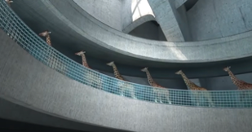
Wednesday - Week 8, Term 3 - Kindergarten
Daily Task – Make your bed.
English
Phonics: You will need a piece of paper and a pencil. Access Seesaw. Watch the video by Mrs Rex and follow her instruction. If unable to access Seesaw, review all sounds on Jolly Phonics. Focus sound today is v like vacuum. Ask your child to write the following words down, vest, van, vet, vote
Reading: Read a book on https://app.pmecollection.com.au. Use the record button and record yourself reading.
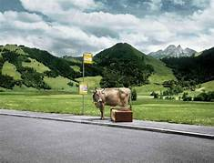
Writing: You will need a piece of paper and a pencil. Access Seesaw. Watch the video by Mrs B. Look at the picture and write one or more sentences describing what is happening in it. Where is the cow going? How will he get there?
Sight words: Write 5 of your sight words in rainbow colours.
Extension: Circle the digraphs (2 letters that make one sound) in each word.
Optional – complete 10 minutes of Reading Eggs activities.
Break – Time to stop and refuel. Eat, play, have fun. Self-directed outside activities where possible.
Maths
Warm up: Using your teddy cards, place them in a pile upside down. Turn over a card and write the number down, now write the number before and the number after that number. To challenge yourself, you might like to roll your dice twice to create a two-digit number and then write down the number before and the number after.
We are learning to: compare the volumes of two piles of material directly by filling two identical containers. Watch the video with Miss Hetherington.
eg 'This pile of rice has a larger volume as it takes up more space in the container'
Collect two identical containers from within your home. Add volumes to each container and students use the language volume, space, has more, has less, takes up more space, to describe their findings.
Extension: Use a range of solid materials, rice, pebbles, flour, teddies, cubes etc. Use a range of containers cubes, rectangular or round.
Break – Time to stop and refuel. Eat, play, have fun. Self-directed outside activities where possible.
WELLNESS WEEK AT B.A.P.S  Access the Wellness Week Seesaw activity for Wednesday  Emotional wellbeing - is about our feelings. We can look after our emotional wellbeing by thinking about how we feel and talking to people we trust to help us manage our emotions.  Trace around your hand and write 5 things (one on each finger) you can do to feel happy (cuddle, go outside, play with your pet, make a yummy snack, read, quiet time in your room, swing, swim, sing)  “Every day may not be good, but there is something good in every day”. Alice Morse Earle  EARN POINTS FROM THE FAMILY WELLBEING CHALLENGE | Inside Out Movie Clip - Our Emotions  https://safeshare.tv/x/ss610d2b6585468  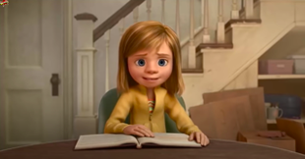
Thursday - Week 8, Term 3 - Kindergarten
Daily Task – Help an adult with an outside activity.
English
Phonics: You will need a piece of paper and a pencil. Access Seesaw. Watch the video by Mrs Rex and follow her instruction. If unable to access Seesaw, review all sounds on Jolly Phonics. Focus is the z sound, like in zebra. Have your child write the following words down, zoo, zoom, zebra, zero.
Reading: Read a book on https://app.pmecollection.com.au. Use the record tool and record yourself reading the book.
Writing: You will need a piece of paper and a pencil. Access Seesaw. Watch the video by Mrs B. Connect the following pairs of sentences using the word ‘so’.
Today it was sunny. I went outside to play.
I get scared in the dark. I put my night light on.
Sight words: Write 10 of your words on post it notes or small bits of paper. Stick these to your fence outside. Use something like a ball or nerf gun and throw it at a word. Read the word you hit.
Extension: Add points to each word. 1 point for every letter (EG: because would be worth 7 points). Hit and say your sight words and calculate how many points you got in total.

Optional – complete 10 minutes of Reading Eggs activities.
Break – Time to stop and refuel. Eat, play, have fun. Self-directed outside activities where possible.
Maths
Warm up: Using your teddy cards, ask a family member to quickly flash them to you. How fast can you say the numbers or the number of teddies on the cards?
We are learning to: Use comparative language to describe capacity, eg has more, has less, will hold more, will hold less. Watch the video with Miss Hetherington.
Collect a range of containers from around your home. Test the capacity by pouring liquid into each container from the one you are comparing it to. Students will presume that big/tall means that it holds a large capacity. Encourage reasoning and problem solving when this is not always the case.
Complete the worksheet – Compare Capacities

Break – Time to stop and refuel. Eat, play, have fun. Self-directed outside activities where possible.
WELLNESS WEEK AT B.A.P.S  Access the Wellness Week Seesaw activity for Thursday  Spiritual Wellbeing - is about the things that we believe in and are important to us. We can look after our spiritual wellbeing by taking the time to think about what we care about and what matters the most to us.  Grab a teddy bear or small toy that you love. Lay down or sit comfortably and listen to Teddy Bear Breathing on Smiling Minds. While you listen think about people in your life you care about.  Create a card and start with...I care about you because (always hug me, make me feel safe, make me yummy food, help me, make me smile, funny)  “Act as if what you do makes a difference. It does.” William James  EARN POINTS FROM THE FAMILY WELLBEING CHALLENGE | https://app.smilingmind.com.au/sessions/433/1184/2451/  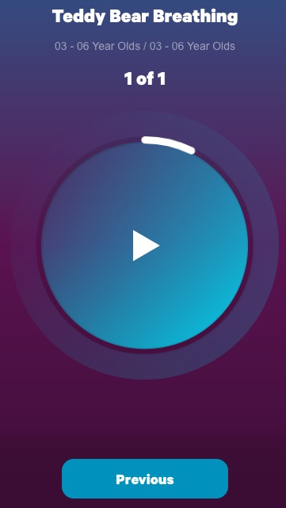
Friday - Week 8, Term 3 - Kindergarten
Daily Task – Clean up your room.
English
Phonics: You will need a piece of paper and a pencil. Access Seesaw. Watch the video by Mrs Rex and follow her instruction. If unable to access Seesaw, review all sounds on Jolly Phonics.
Reading: Pick your most favourite book in the house. Read it with a family member. Draw or write why it is your favourite book.
Writing: You will need a piece of paper and a pencil. Access Seesaw. Watch the FriYay Feedback video by Mrs B. Write Yes or No if you achieved your goal. If you wrote yes, think of a new goal to help improve your writing next week.
Sight words: Ask a family member to test you on the sight words you have been learning. Take a picture and post to your teacher on Seesaw.
Optional – complete 10 minutes of Reading Eggs activities.
Break – Time to stop and refuel. Eat, play, have fun. Self-directed outside activities where possible.
Maths
Warm up: Write your numbers 1-20 on a piece of paper or outside on your driveway in chalk.
We are learning to: record volume and capacity comparisons informally using drawings, numerals and words. Watch the video with Miss Hetherington.
Create a poster about ‘Volume.’ What have you learnt this week? What new vocabulary do you know? Draw pictures and write words supporting this. You could even write out the total of your volumes you create at home. Upload it to Seesaw.
Break – Time to stop and refuel. Eat, play, have fun. Self-directed outside activities where possible.
WELLNESS WEEK AT B.A.P.S  Access the Wellness Week Seesaw activity for Friday  Physical Wellbeing - is about feeling fit and healthy. This is more than doing exercise; it includes eating healthy food, getting enough sleep, being active and giving things a go even if you feel you can’t be bothered or you’re just starting out.  Draw a plate with healthy food and label it.  Go outside and enjoy! Take in big deep belly breaths and practice your cartwheels! HAPPY FRIYAY  “Take care of your body. It’s the only place you have to live”.Jim Rohn  EARN POINTS FROM THE FAMILY WELLBEING CHALLENGE | 