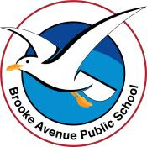
Learning from Home – Brooke Avenue Public School
Stage 1– Week 7, Term 3
The following timetable can be used by students to support learning at home. All tasks have been linked to syllabus outcomes. If technology is available at home, please use the attached links to support learning,
Please upload work marked with the camera icon to Seesaw.
Monday - Week 7, Term 3 – Stage 1
Daily Task - Match socks and sort washing.
English
Reading
Choose a book to read, find a story on Seesaw from your teacher or check the PM ecollection. Remember that the book shouldn’t be too easy or too hard. It should be a little challenging to read. Try to read for 15 or more minutes.
Before reading PREDICT what the story will be about. Use the book title, front and back covers to assist you.
During reading CLARIFY any words you don’t understand. Ask an adult if you are not sure.
After reading SUMMARISE what the happened in the book. This means retell the story! You can write this down OR record yourself speaking so that you can check how well you did.

Spelling
The letter/sound combinations for spelling this week are: ee and ea. Write your list into your book. You can choose List 1 or List 2 or do both.
Watch the YouTube song and sing along - https://video.link/w/Odp5c
Spelling List Week 7
List 1 ee/ea | List 2 ee/ea
see | free
bee | glee
tree | mean
tea | queen
bean | feast
cream | freedom
green | seagull
sheep | canteen
dream | breeze
jeans | gleefully
Extension: Can you think of extra ‘ee’ and ‘ea’ words to add to your weekly spelling list, e.g., team.
Writing
Using the image below, write a paragraph about what you see.
Remember to use adjectives to add detail and use a capital letter at the beginning of your sentence and a full stop at the end.
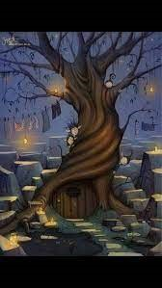
Speaking and Listening
Read your writing to a friend or an adult. Ask them what they liked about it.
Break – Time to stop and refuel. Eat, play, have fun. Self-directed outside activities where possible.
Maths
Warm Up
The number is 25.
Create as many number sentences as you can that equal 25. Try to think of some addition and some subtraction number sentences. Can you think of ten? Example: 10 + 15 = 25 OR 50 – 25 = 25.

Activity - 3D Shape Scavenger Hunt
Three Dimensional (3D) shapes (cube, cone, sphere, cylinder, pyramid, rectangular prism). Watch this video introducing 3D Shapes - https://video.link/w/cQy5c
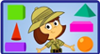
Complete the 3D Shape Colouring sheet. You will need a blue, red, pink, yellow, orange and green pencil, crayon or texta. You may like to watch the video again while you do the activity to help you identify the 3D shapes.
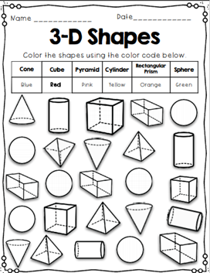
Creative Arts - Create your own bookmark
This week is book week! For your art activity today, design and create your own bookmark. You can use a strip of paper or cardboard. You might also like to cut an empty tissue box or cardboard box into a strip and glue paper to the front and back for a stronger bookmark.
You can decorate your bookmark however you like. Here are just a few ideas: recreate your favourite book cover, your name in bubble writing, your favourite book character. Remember to decorate both sides of your bookmark!
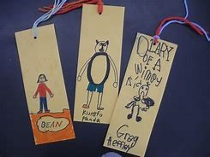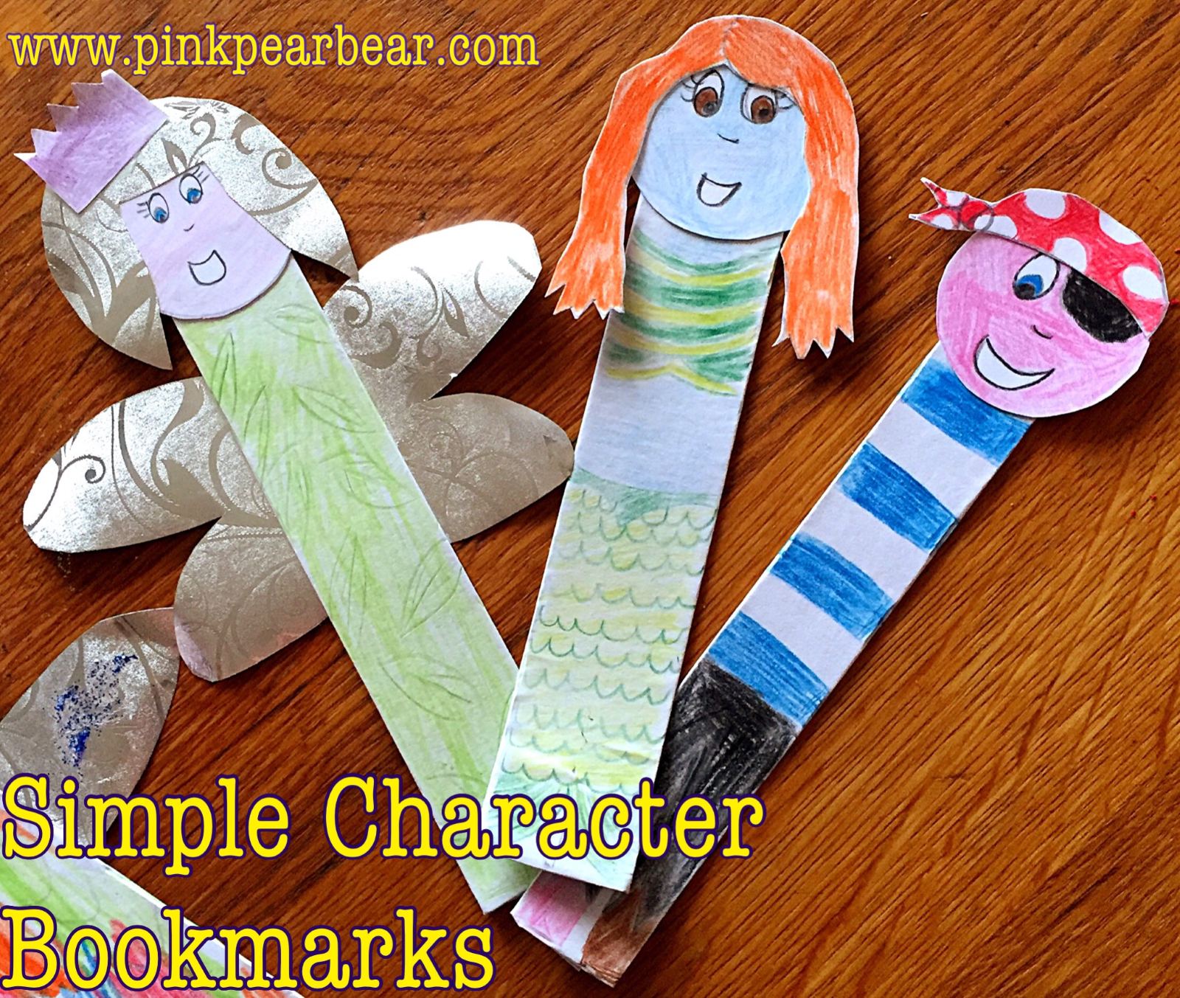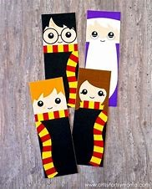

Break – Time to stop and refuel. Eat, play, have fun. Self-directed outside activities where possible.
Physical Activity
Complete thirty minutes a day of physical activity. Go for a walk, run or ride with an adult.
OR
Follow the link to a fun episode of Get Active with Sam and Victor – Episode 5 (Bouncing and Dribbling) GetActive@Home Kindergarten-Year 2 Episode 5 on Vimeo https://vimeo.com/418788433

Tuesday - Week 7, Term 3 – Stage 1
Daily Task – Wash the dishes.
English
Reading
Choose a book or a PM reader online to read. Remember that the book shouldn’t be too easy or too hard. It should be a little challenging to read. Try to read for 15 or more minutes.
After reading, answer the following questions.
- What are 3 things you enjoyed about this book?
- What do you think might happen to the characters after this story?
- Have you experienced anything that the characters have? Discuss.
Spelling
Watch the YouTube clip on the ‘ee’ and ‘ea’ sound. https://video.link/w/kXo5c English
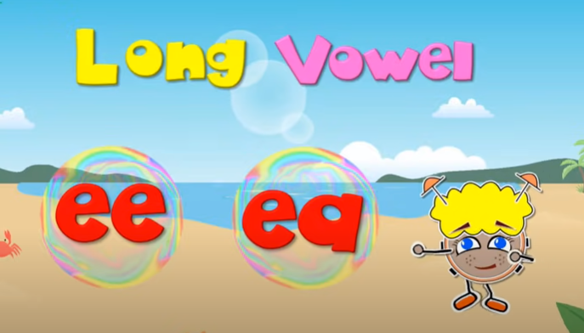
Read your spelling words out loud. Create 3-5 sentences that include some of your spelling words. Try to make your sentences interesting and longer by using joining words such as (and, but, so, because). For a challenge, try to have more than 1 spelling word in each sentence.
Then, complete Week 7 Find a word.
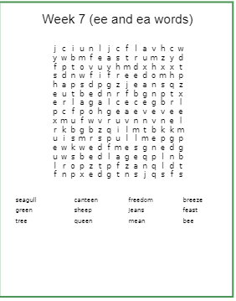

Writing
This week is book week, and the theme is Old Worlds, New Worlds, Other Words. One of the shortlisted books for 2021 is Norton and the Bear written by Gabriel Evans. Watch and listen to the story read by Frankie Jaiyeola. https://video.link/w/fWS5c
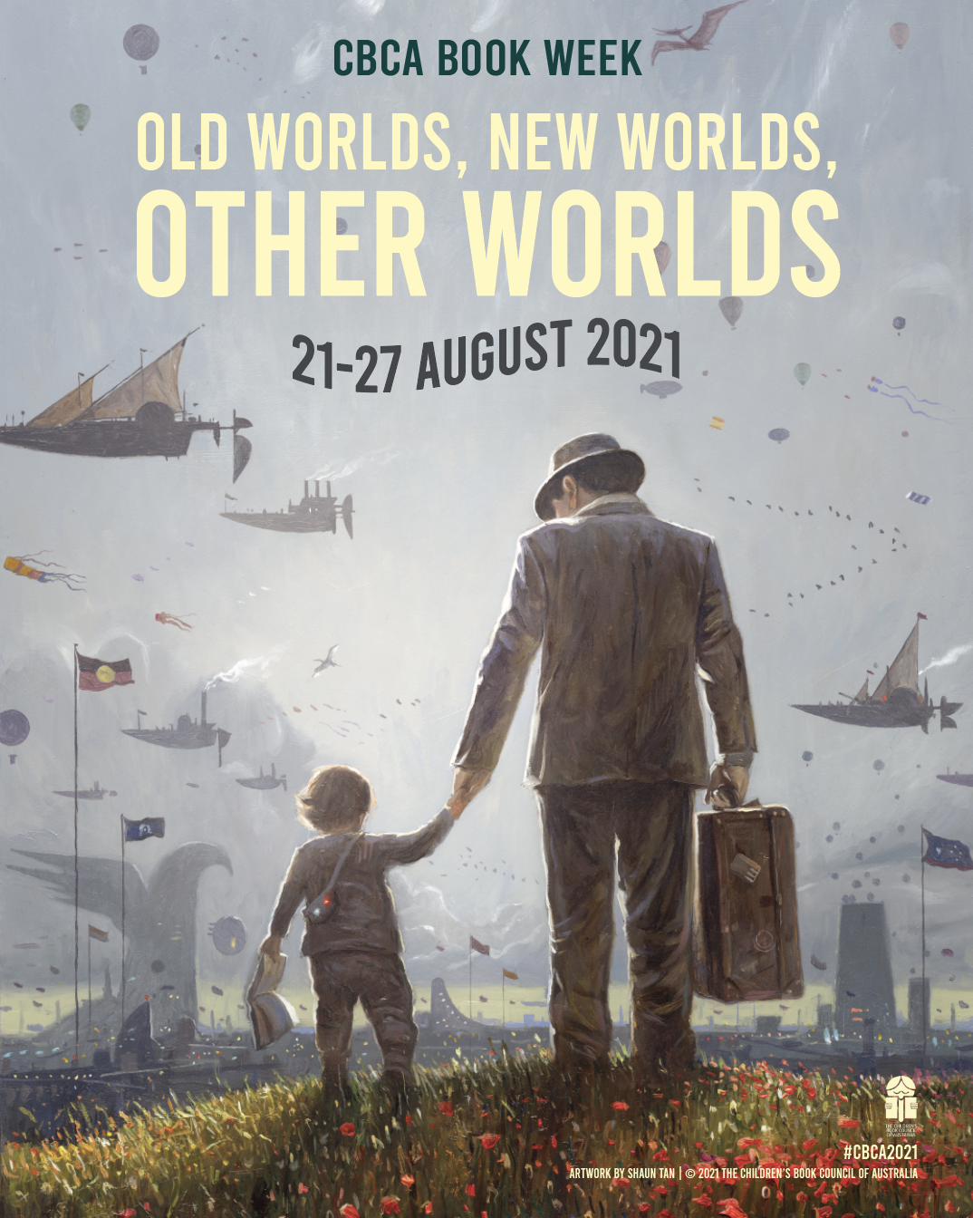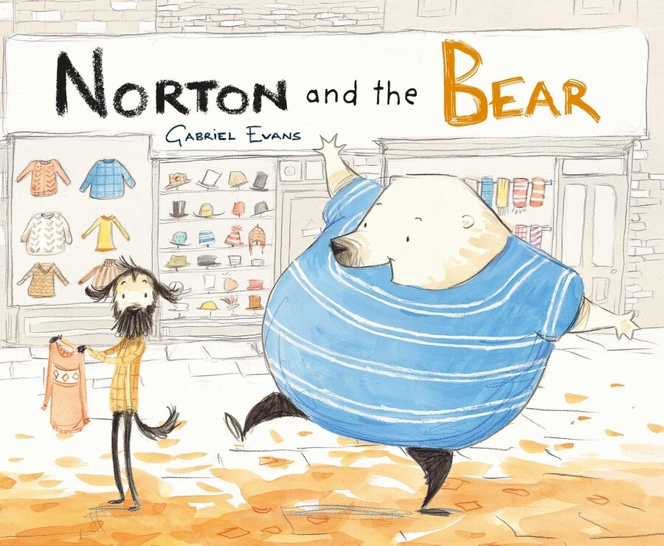
After you have watched the story, write 2 to 4 sentences as a response to the book. Think about the two main characters Norton and the Bear. You might talk about your favourite part, how you think Norton felt at the beginning or even why you think Bear liked to copy Norton. Write on a clean piece of paper and remember to go back and edit your writing.
Break – Time to stop and refuel. Eat, play, have fun. Self-directed outside activities where possible.
Maths
Warm Up
Set a timer for a minute. Start counting forwards by 1s from 36. What number did you reach?
Set a timer for 30 seconds. Start counting forwards by 3s from 15. What number did you reach?

Activity
Three Dimensional shapes (cube, cone, sphere, cylinder, pyramid, rectangular prism). Watch this video about everyday 3D shapes - https://video.link/w/QXo5c
Complete the activity by finding the 3D objects in and around your home. Draw a picture and label the object you found.
For example:
Rectangular Prism – Tissue Box
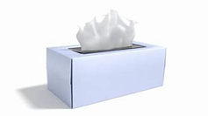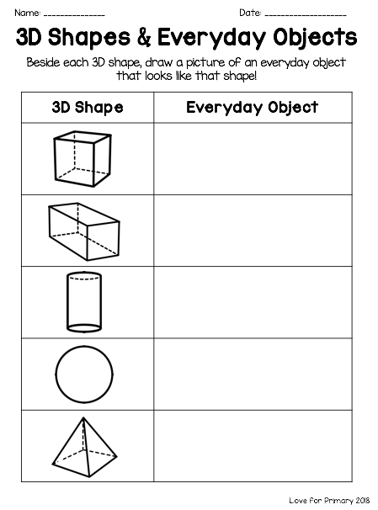

Creative Arts
Directed Drawing – How to Draw a Bear
Watch the YouTube video - https://video.link/w/0Zo5c
You will need a piece of paper, a lead pencil or black marker, brown, tan, and black crayon/pencil, or Texta to colour the bear. You may need to pause the video in between each step. You may even like to give your bear a name.
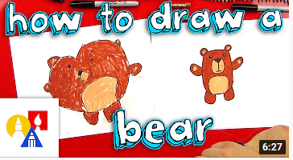

Break – Time to stop and refuel. Eat, play, have fun. Self-directed outside activities where possible.
Physical Activity
Complete thirty minutes a day of physical activity. Go for a walk, run or ride with an adult.
OR
Watch and follow along to the Minecraft Cosmic Yoga - https://video.link/w/jap5c

Wednesday - Week 7, Term 3 – Stage 1
Daily Task – Make your bed.
English
Reading
Choose a book to read, find a story on Seesaw from your teacher or check the PM Readers collection. Remember that the book shouldn’t be too easy or too hard. It should be a little challenging to read. Try to read for 15 or more minutes. While you are reading look for the following sight words (choose just one list) and record how many times you find it throughout the book.
List 1 – were, come, for
List 2 – said, get, with

Spelling
Read through your spelling words for this week. Write your spelling words in rainbow writing and underline the ee or ea sound.
For example: tree cream
Writing
Using the image below to write a story.
Remember to use adjectives to add detail and use a capital letter at the beginning of your sentence and a full stop at the end.
Think of a catchy title for your story. For example: The Animals Bought a Bus!
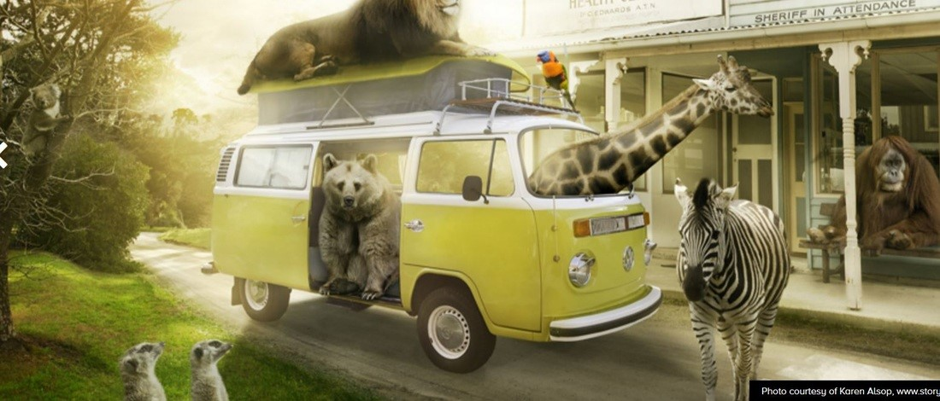
Speaking and Listening
Read your story to a family member (at home or call someone in your family to read your writing to!). If you are at school, read your writing to a friend.
Make sure your writing makes sense before you start reading it to someone else (read it to yourself first!).
Break – Time to stop and refuel. Eat, play, have fun. Self-directed outside activities where possible.
Maths
Warm Up
The problem is 23 – 15 = ?. Use a strategy of your choice to solve this number sentence (jump strategy, split strategy). Record your thinking on a piece of paper.
Can you think of another strategy you could use to solve the problem? Record your thinking.
Challenge: how many different strategies could you use to solve the problem? Record your thinking.
Activity - Three Dimensional (3D) Shapes and Their Properties
Watch this video on 3D shapes and their properties - https://video.link/w/W3F5c
Then, complete the activity by identifying each shape and its properties (faces, edges, vertices/corners). You might like to use some of the 3D objects you found on Tuesday to help you see and feel each shape’s properties.
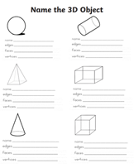
Physical Activity
Complete thirty minutes a day of physical activity. Go for a walk, run or ride with an adult.
OR
Use YouTube to search and choose a few ‘just dance’ dances to do at home – remember to ask your parents first!

Do each exercise for 20 seconds each, with a 10 second rest in between:
- Star jumps
- Mountain climbers
- Plank
- Running on the spot
Break – Time to stop and refuel. Eat, play, have fun. Self-directed outside activities where possible.
Science - What is Sound?
Before watching the video, talk to an adult or friends about ways in which different body parts help people to sense things e.g. our eyes allow us to see. What do our ears do?
Watch this video - https://video.link/w/TaL5c
“Sound is made from vibrations. The vibrations travel through the air or another medium (solid, liquid or gas) to the ear. The stronger the vibrations, the louder the sound. Sounds are fainter the further you get from the sound source. Sound changes depending on how fast or slow an object vibrates to make sound waves.”
Activity – Shake it Up
You will need:
- 3 different sized clear plastic containers with a lid
- Rice or other small object (sand, rocks, marbles) - only use one to make sure the experiment is reliable
Procedure:
- Place the same small objects (e.g. sand) into 3 different types of containers. Only fill around a quarter of the container.
- Investigate ways to make sounds with the containers (e.g. shaking, tipping, rolling, spinning).
- Observe what happens to the objects when they are making sound.
- Write down or draw some of your observations.
Keep Safe - Ensure that the containers are securely sealed before trying to make sounds with them.
Think:
What other senses help you know when a sound is happening? Discuss this with an adult or friend.

Thursday - Week 7, Term 3 – Stage 1
Daily Task – Help an adult with an outside activity.
English
Reading
Log in to your PM Readers account or read a book that you have at home. Select a book of your choice and record yourself reading. Remember that the book shouldn’t be too easy or too hard. It should be a little challenging to read. Try to read for 15 or more minutes. If you do not know a word add it to your word list.

Speaking and Listening
Discuss with a friend or an adult what the book you just read was about.

Writing
After reading your book, complete a book review by filling out the template.
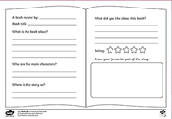
Spelling
Use a dictionary or research online the definitions of your spelling words. Choose 5 of your words and write your spelling words and the definitions of each word on a page.
Break – Time to stop and refuel. Eat, play, have fun. Self-directed outside activities where possible.
Maths
Warm Up
1 more, 1 less, 10 more, 10 less.
Complete the activity using the following numbers. If you need to, use a hundred chart to help.
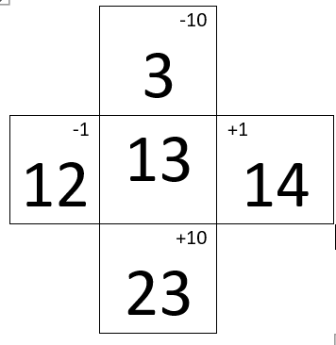 Your numbers - 12, 65, 32, 79, 26, 50, 88, 104
Activity - Make a 3D object
Make 3D objects (cone, cylinder, cube, sphere and prisms) from plasticine/BluTak and straws (or anything else you might have at home). Talk about the shapes that you have made with a friend or adult. You might like to record yourself telling your teacher about your 3D object to upload onto Seesaw.
Things to include in your discussion:
- What is the 3D shape?
- Does it have flat or curved surfaces?
- How many faces does it have?
- How many edges does it have?
- How many vertices/corners does it have?
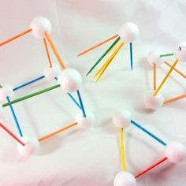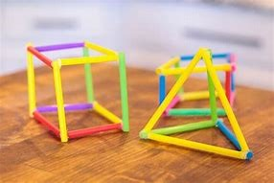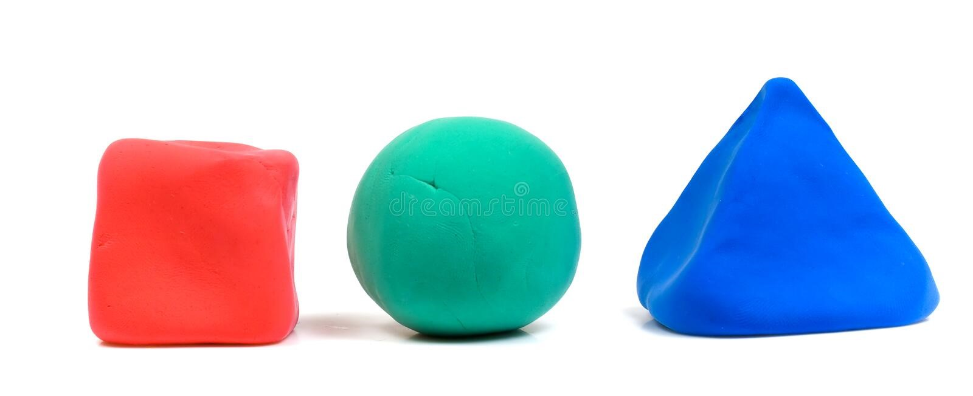
Creative Art
This week is Book Week. For your art activity today, you are to draw a page or scene from one of your favourite books. You might like to recreate a page from the book or create and draw a scene from a book that has no pictures (a chapter book). You may even like to recreate the cover of the book or your favourite character from a book.
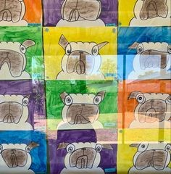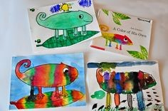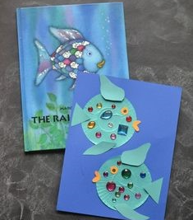

Break – Time to stop and refuel. Eat, play, have fun. Self-directed outside activities where possible.
Physical Activity
Complete thirty minutes a day of physical activity. Go for a walk, run or ride with an adult.
OR
Design your own Obstacle Course in your backyard/lounge room. Remember to include different movements e.g.
- Running
- Balancing
- Hopping
- Throwing
Use a timer to time how fast can you do it. Complete your obstacle course again. Can you beat your time?

Friday - Week 7, Term 3 – Stage 1
Daily Task – Clean your room.
English
Reading
Choose one of your favourite books to read with an adult, find a story on Seesaw from your teacher or check the pm ecollection. Remember that the book shouldn’t be too easy or too hard. It should be a little challenging to read. Try to read for 15 or more minutes.
Before reading: What do you think will happen in the book? What clues are there that make you think this?
After reading: Draw a picture of your favourite character from the book. Write a description of the character. Explain what you like about them.

Spelling
Write your spelling words. Draw a picture of each of the words to show you know what they mean.

Writing
This week is book week, and the theme is Old Worlds, New Worlds, Other Words. For your writing task today, you are going to think, draw and write about your ideal world. Close your eyes and think about your ideal world. What does it look like, sound like, feel like and smell like? You may like to write these down as your planning.
Then, draw an illustration of your ideal world inside the snow globe (see attached document). Include as much detail as you can.
After you have finished your drawing, describe your ideal world on the lines below the snow globe. Some possible sentence starters could be:
  - My ideal world is called…
  - If I could live anywhere, I would live…
  - I would like to live in a world that…
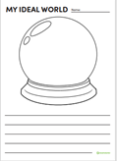
Speaking and Listening
Share your ideal world with a friend or adult. Read them the description of your world and talk about the picture you drew.
Break – Time to stop and refuel. Eat, play, have fun. Self-directed outside activities where possible.
Maths
Warm Up
Play ‘Hit the Button’ - https://www.topmarks.co.uk/maths-games/hit-the-button
Pick a maths topic and answer as many questions as you can before time is up!
Race someone in your house.
Activity - 3D Building
Use 3D objects you can find around the house to construct a building or other structure. You could use tissue boxes, canned food, toilet rolls, balls, books, funnels, building blocks or soda cans. Challenge: try to have at least one object from each group in your structure (cone, cylinder, cube, sphere, pyramid and rectangular prism). Take a photo of your creation to upload onto Seesaw.
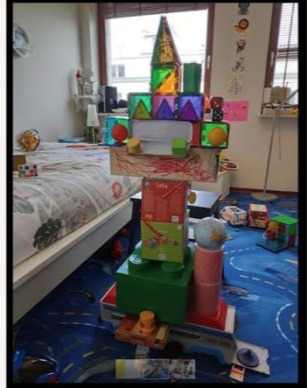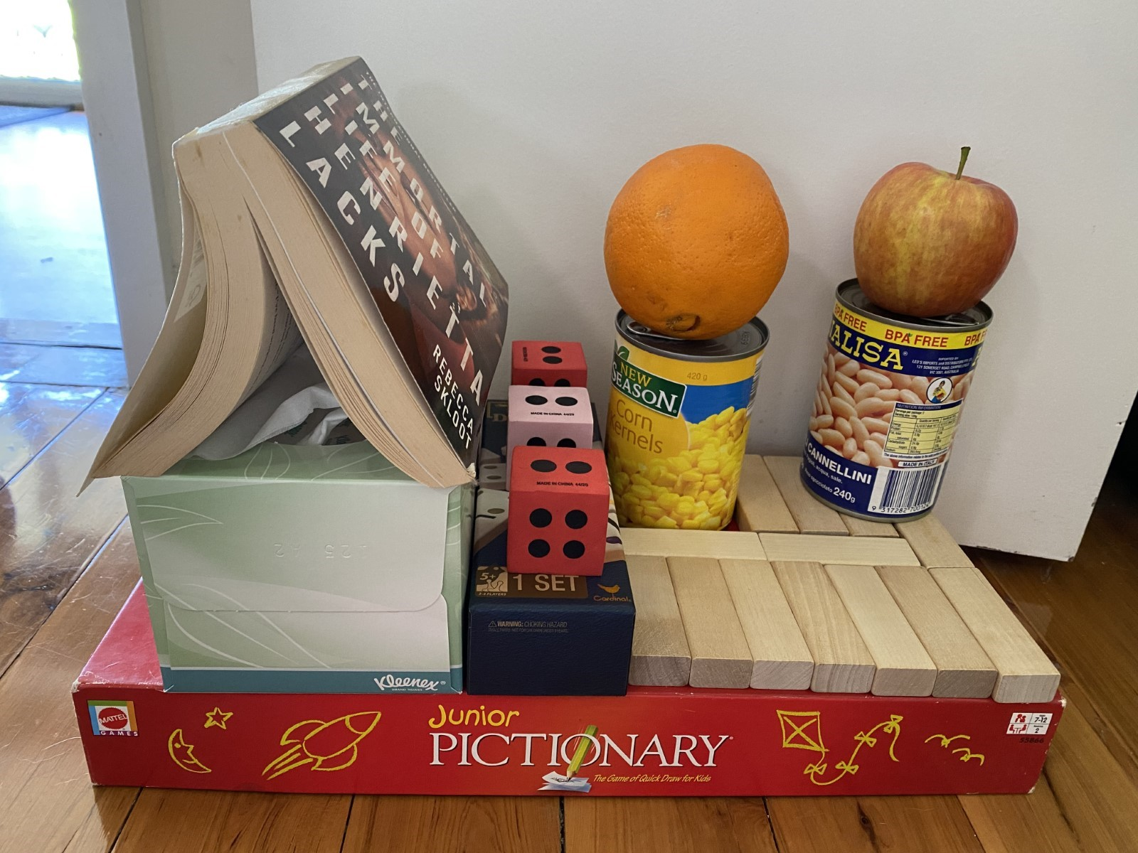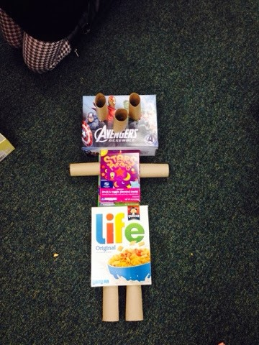

Physical Activity
Complete thirty minutes a day of physical activity. Go for a walk, run or ride with an adult.
OR
Play a game outside (tip, hide and seek, ship/shark/shore, hopscotch, skipping or make up a dance).
Have a go at completing the Level Up! 3 video - https://video.link/w/Usz5c
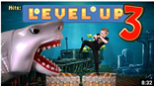

Break – Time to stop and refuel. Eat, play, have fun. Self-directed outside activities where possible.
FRI-YAY
Pick an activity that you enjoy and have some fun! This may be by yourself or with an adult.
Take some photos and send them to your Teacher on Seesaw to show you how to celebrate your Fri-Yay!
Enjoy an activity outside or even get creative at home.
Have a great weekend!

