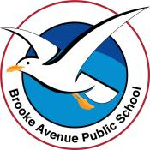
Learning from Home – Brooke Avenue Public School

K-6J, K-6M and K-6S – Week 7, Term 3
The following timetable can be used by students to support learning at home. All tasks have been linked to syllabus outcomes. If technology is available at home, please use the attached links to support learning.

ATTENTION PARENTS: please note that we have tried to vary the learning to give options for all students. Please choose whatever suggested learning activities suit your own child.
Monday - Week 7, Term 3
Daily Task - Match socks and sort washing.
English: This week, we’re looking at plurals. Plurals mean there is more than one of something. Watch this video to understand more.
https://www.youtube.com/watch?v=lD1OaD4FBqM.
Activity: See if you can name the plural of 10 random objects in your home (e.g. cup/cups, plate/plates).
Grammar: There are a list of nouns attached to this document. See if you can change each noun into its plural form.
Reading: Read your favourite story or log into PM Readers/Reading Eggs or read online. Identify the purpose of the text. Is it a narrative (written to entertain the audience)? Is it an informative text (written to provide factual information to the audience)? Is it a procedural text (written to provide instruction to an audience)? Why do you think the writer has made a connection with you through their text? What do you like best about it and why?
Technology: Here is a link to a “whack-a-mole" game that helps you learn more about plurals. ENJOY! https://wordwall.net/play/6315/200/210
Parents/Carers: This week, we have attached a range of FREE CHOICE activities that students may do. Just choose the one that suits your child. There is also a handwriting booklet available at the front of the school, on request.
Break – Time to stop and refuel. Eat, play, have fun. Self-directed outside activities where possible.
Maths: Week 7 – Focus – Mass - This week, we are working on Mass. What is mass? https://www.youtube.com/watch?v=BJJOZ5QQpmc
When we weigh try to find the weight of objects, we can use different methods. One way to estimate weight is to heft. Hefting is when we hold different objects in each hand and try to determine which is heavier/lighter.
Warm up: Watch this video to give you an idea of hefting. https://www.youtube.com/watch?v=iTFfLeMd0pY
Activity: Select 10 items from around the house that are easy to hold and manage. Heft the objects and try to sort them in order from lightest to heaviest. Are there any that are the same weight? Can you combine two or more objects to make the same weight as another object?
Variation: Can you estimate the weight of each object in grams/kilograms? Have a guess and then, if you have scales at home, see if you can weigh the objects to see how close you get to the actual weight. Then see if you can list the object and its metric weight (i.e. grams, kilograms).
Option: You may also log in to Math Seeds, Studyladder or Prodigy to complete activities set for you.
Break – Time to stop and refuel. Eat, play, have fun. Self-directed outside activities where possible.
PDHPE: How will you get active today? Look at the attached document, roll the dice and choose and activity that you would like to do today. Of course, check with your parents/carers first to make sure you can complete the activity. Post your pictures on Seesaw to share with your teachers and friends.

Tuesday – Week 7, Term 3
Daily Task - Wash the dishes.
English: - Grammar: Log in to Seesaw and complete the sorting activity for plurals.
Watch: Humpback Whales https://www.youtube.com/watch?v=joBvuEJyUd0
Discuss: What did I learn about the 🐳humpback whale? What do humpback whales eat? How do they move? What was something new I learned about the humpback whale?
Writing: Today, we are going to plan and create an informative text. There are different types of informative texts (e.g. to recount an experience, to write a procedure or to describe something). Today, we are going to create an information report that describes humpback whales and provides the audience with facts about them. The writing templates attached will help you plan and compose your text. You may use a drawing and labels to support your information text if you like.
Technology: Log in to Reading Eggs and complete an activity. Post some of your learning on Seesaw to share with teachers and friends.
Break – Time to stop and refuel. Eat, play, have fun. Self-directed outside activities where possible.
Maths: Week 2 focus – Mass
Warm up: Number Sense – Today, we’re going to have another go at number sense to warm up our brains (see attached). Remember that you can either use dice or cards to make a 2-, 3-, or 4-digit number, then use the template below to demonstrate different ways to show the number.
Activity: Select a group of pantry/fridge/bathroom objects and see if you can locate and read the weight on them. Then, see if you can locate the objects in a supermarket brochure. Cut and paste (or draw) the objects onto a page to create a poster/collage labelled with the weight of each of your chosen items.
Variation: This one is a real challenge! Use this link https://auspost.com.au/business/shipping/check-sending-guidelines/size-weight-guidelines to determine how much it would cost you to post your objects to someone in Australia. Then write that price next to your object.
Technology: (Stage 2+) Play Mostly Postie https://ictgames.com/mobilePage/mostlyPostie/index.html or complete a mass activity on Studyladder, or any other activity on Math Seeds or Prodigy.
Break – Time to stop and refuel. Eat, play, have fun. Self-directed outside activities where possible.
Artwork: Today we are going to create an abstract artwork using regular and irregular 2D shapes. You can choose to draw a pattern with a black texta then colour in the shapes between the lines in the patterns. Alternatively, you could use 2D shapes to make a face, an animal or a landscape. Look at these ideas for inspiration. Once you have created your artwork, see if you can discuss the regular and irregular shapes you have used.
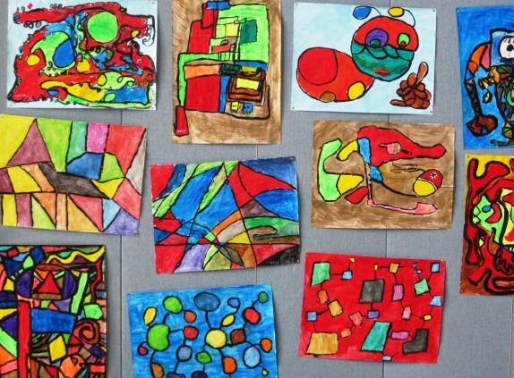

Wednesday - Week 7, Term 3
Daily Task – Make your bed.
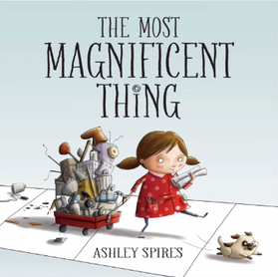
English & Grammar: complete one of the plural worksheets attached. There are a range to choose from, so you can select one that is appropriate for your child.
Story: Log in to Seesaw and listen to the story “The most magnificent thing!”
Response: Use your imagination to create and build your own magnificent thing! Look around your home to find materials to build with: Legos, Duplo, Play-Doh, blocks, boxes, wood, paper, blankets, sticks, string, etc.
1. Design and build with your materials. It can be anything!
2. Tap the add button to add this activity to your Seesaw journal.
3. Take a photo of your creation.
4. Tap the label tool and label your photo or tap the mic to tell about what you created. Use lots of descriptive words.
5. Tap the check to add to your journal.
Technology: Log in to Reading Eggs and complete an activity.
Break – Time to stop and refuel. Eat, play, have fun. Self-directed outside activities where possible.
Maths: - Mass – how to measure mass – Choose one of the suggested videos - K-2 video suggestion https://www.studyladder.com.au/games/activity/measuring-mass-using-informal-units-3408?backUrl=/games/mathematics/au-year-two/mathematics-mass-1727
Year 3-6 video suggestion: https://www.studyladder.com.au/games/activity/measuring-weight-using-a-kitchen-scale-4076?backUrl=/games/mathematics/au-year-four/mathematics-mass-1727
Activity: If you have scales at home, see if you can work with an adult to weigh some of the objects you found in the pantry yesterday. Are they the same as what the label says? Why is it different? Maybe someone has used some of the product already.
Suggestion for K-2 sort the objects into heavier/lighter. Then use a T-chart (attached) to classify the objects into heavier/lighter.
Suggestion for 3-6: Complete the attached worksheet.
Technology: Log in to Studyladder, Math Seeds or Prodigy and complete an activity on Mass.
Break – Time to stop and refuel. Eat, play, have fun. Self-directed outside activities where possible.
HSIE: Past and Present –How have schools changed over time? Watch the short film clip. Then identify things that are different in schools from the past to now. https://www.youtube.com/watch?v=-Q3uUckUaQc Have a chat to an adult and discuss the sorts of things that have changed since they were at school. Talk about things that have stayed the same. What do you think will stay the same in the future?
The future: Draw a plan of what you think schools will look like in 20 years’ time. Be creative use lots of colour and label your drawing. Share it on Seesaw. We’d love to see your ideas!

Thursday - Week 7, Term 3
Daily Task – Help an adult with an outside activity.
English – The Literacy Shed – Teeth – watch this clip https://www.literacyshed.com/teeth.html.
Discuss: When do you think this story is set, in the past, the present or the future? How can you tell?
How do you think the first man felt when his teeth disappeared? Did his friend feel the same? How do you know? Have you ever lost something that you needed or wanted? How did you feel?
Writing: Tell us about a time that you lost something that you needed or wanted. Tell us how you lost it, how you felt and how you overcame your feelings. Also, tell us about how you would have liked the incident to be different.
Technology: Log in to Reading Eggs and complete an activity.
Break – Time to stop and refuel. Eat, play, have fun. Self-directed outside activities where possible.
Maths: Mass – go through this PowerPoint presentation and see if you can work the answers out as you go.
Activities: Choose 1 (or more) of the worksheets attached for Mass. Parents/carers – we have included the answer sheets to make it easier for you. Students only need to complete one but may choose more if they like.
Technology: Try this link for some new activities https://www.bbc.co.uk/bitesize/primary
Break – Time to stop and refuel. Eat, play, have fun. Self-directed outside activities where possible.
PDHPE: A few weeks ago, we worked on our bouncing and dribbling skills. Today, we are going to work on our catching and throwing skills. Follow this link and choose one of the four episodes that suit your skills. https://app.education.nsw.gov.au/sport/throwing-and-catching#_g_4788422

Friday - Week 7, Term 3
Daily Task – Clean up your room.
English: Today, you will need to log in to PM Readers, read a familiar read and a new text. Then name and describe the characters in your story.
Grammar: Log into Seesaw/Reading eggs and complete an activity on plurals.
Writing: Write a letter to our Principal, Mr Dalkeith telling him about some things you would like to see in the new classrooms in the school. Tell him why you think they are a good idea. Perhaps you could draw and label your ideas so that he understands exactly what they will look like.
Break – Time to stop and refuel. Eat, play, have fun. Self-directed outside activities where possible.
Maths: Today, we are going to do some revision in the way of skip counting and playing Math games.
Select one of the attached games, or one of your own and play with someone from your home. There is a skip counting game and a battleship game too! Have fun.
Break – Time to stop and refuel. Eat, play, have fun. Self-directed outside activities where possible.
Creative Arts: It’s FRIYAY! Choose an activity that you love to do and do it! Perhaps you like building with Lego, or maybe you really want to practice throwing and catching a ball. Maybe you want to chill-out with some popcorn and watch your favourite movie! You have worked hard and deserve to celebrate your achievements so far.

Remember to always check with an adult before you make your choice.

Have fun!

T-chart for Mass

Lighter | 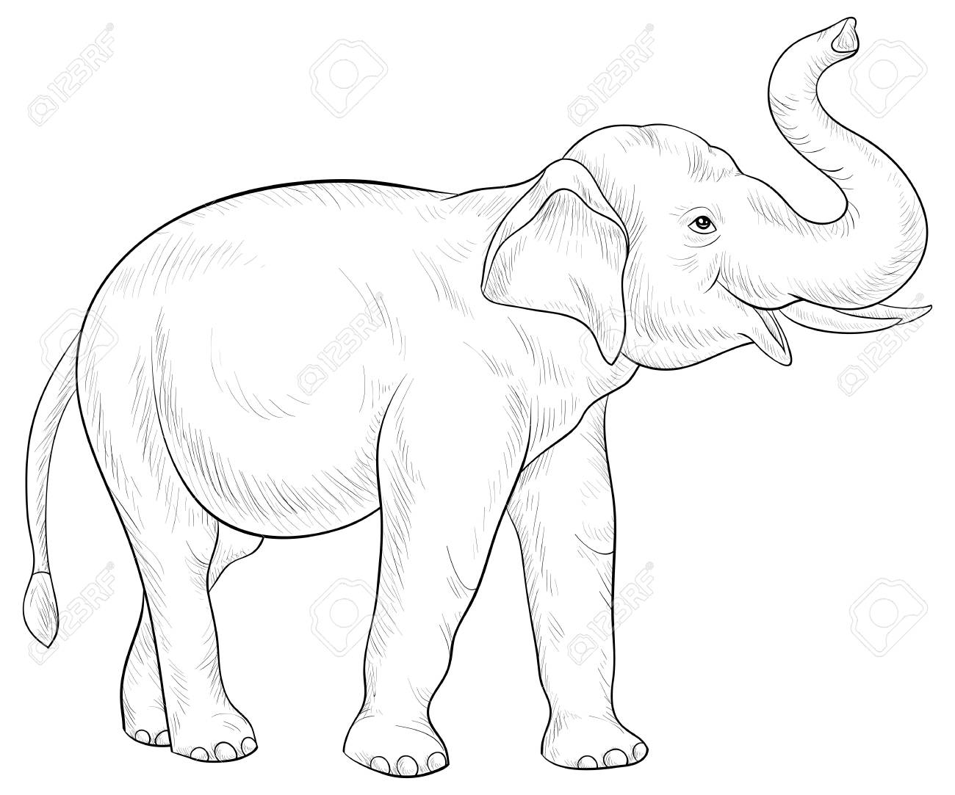  Heavier

Number Sense
Number of the day

