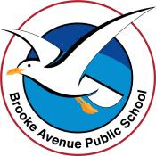
Learning from Home – Brooke Avenue Public School
Kindergarten – Week 7, Term 3
The following timetable can be used by students to support learning at home. All tasks have been linked to syllabus outcomes. If technology is available at home, please use the attached links to support learning.
Monday - Week 7, Term 3 - Kindergarten
Daily Task - Match socks and sort washing.
English
Phonics: You will need a piece of paper and a pencil. Access Seesaw. Watch the video by Mrs Rex and follow her instruction. If unable to access Seesaw, review all sounds on Jolly Phonics. Learn the sound ‘ear’ as in ‘fear’. Write 5 ‘ear’ words (tear, near, dear, fear, sear) and underline the sound.
Reading: Read a book on https://app.pmecollection.com.au. Use the record tool to record yourself reading and listen to it back.
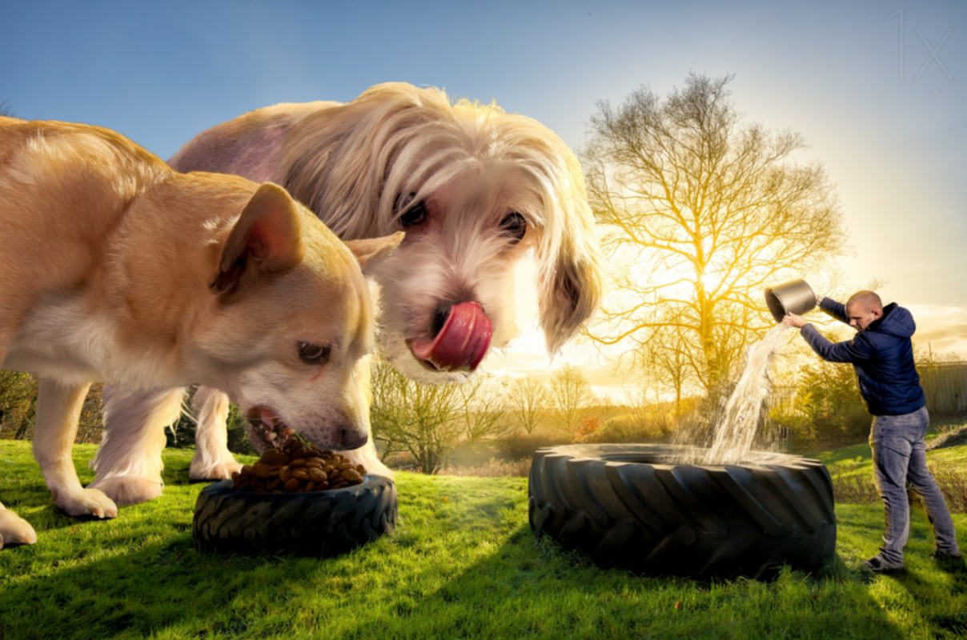
Writing: You will need a piece of paper and a pencil. Access Seesaw. Watch the video by Mrs B. Look at the picture and on your piece of paper, write one or more sentences that describe what is in it. Make sure you use some describing words.
Sight words: Using flashcards with your sight words on them, play a game of Go Fish. Add some new words in that you have been learning over the past few weeks.
Extension: Write a sentence with 3-5 of your sight words.
Optional – complete 10 minutes of Reading Eggs activities.

Break – Time to stop and refuel. Eat, play, have fun. Self-directed outside activities where possible.
Maths
Warm up: Use some playing cards with numbers 1-10 or 1-20 or 10-30. Turn three cards over and put them in order from smallest to largest. Repeat this 3 times.
We are learning to: Use visual representations of numbers to assist with addition and subtraction. Watch the video of Miss Hetherington.
Activity: Use the ten frame provided and put 5 items on the top row. You know there are 5 items here. You don’t need to count from one, today we will count on from 5. Now put 3 items on the bottom row. Encourage your child to say, “5- 6, 7. 8” Leave the 5 items in the top row and change the number of items on the bottom row.
Extension: You could use the 15 frame and start with 8 items. Encourage your child to count on from the 8. “8 and 5 more is 8- 9, 10, 11, 12, 13. There are 13 items now.”
Optional: Complete some Mathseeds activities for 10 minutes.
Break – Time to stop and refuel. Eat, play, have fun. Self-directed outside activities where possible.
PDHPE: Select a yoga lesson from cosmic kids https://www.youtube.com/user/cosmickidsyoga  or complete 3 rounds of ‘garden yoga for kids’ holding each pose foe 1 minute.  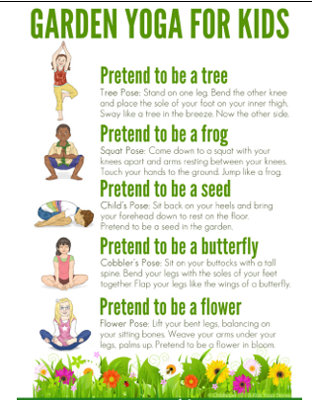 | Creative Arts: Make a Pet  Make a pet out of playdough, lego, sticks, or you might like to draw or paint a pet.  When creating the pet, also add in  - where they will live  - what they will eat  - where they will sleep  Examples:  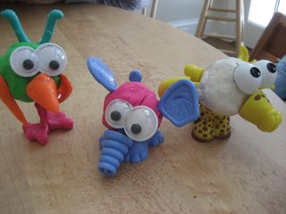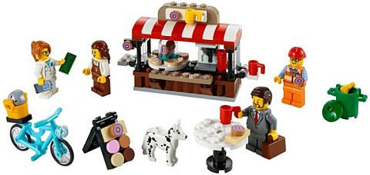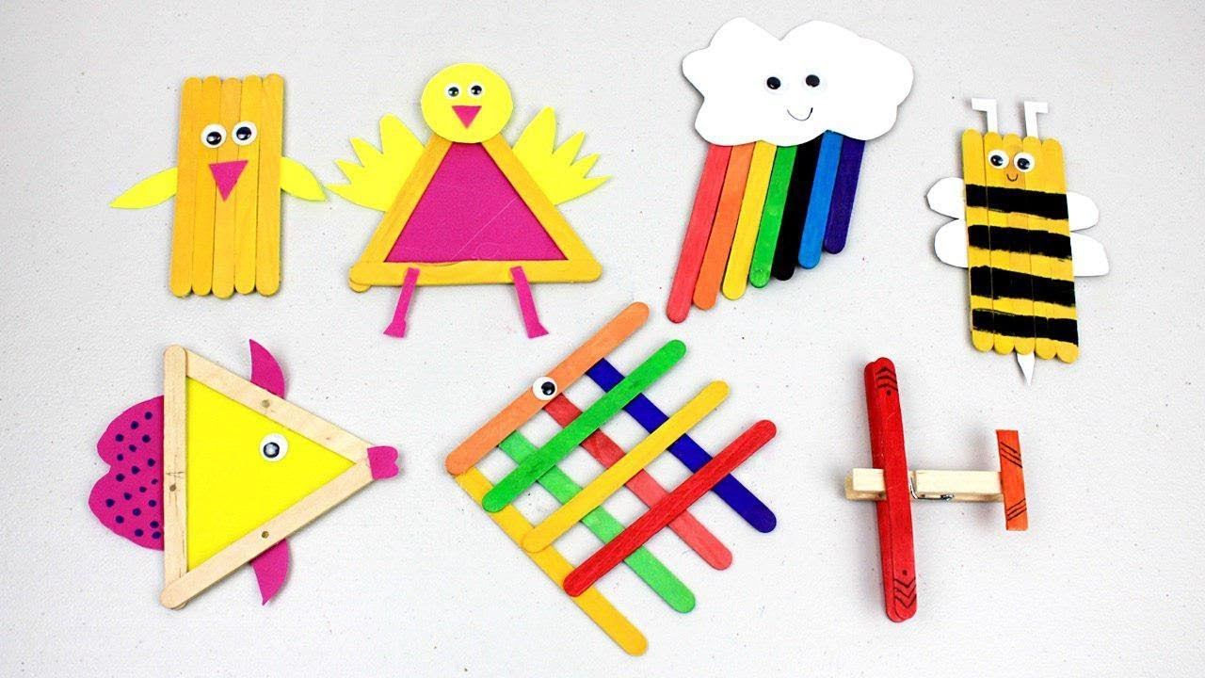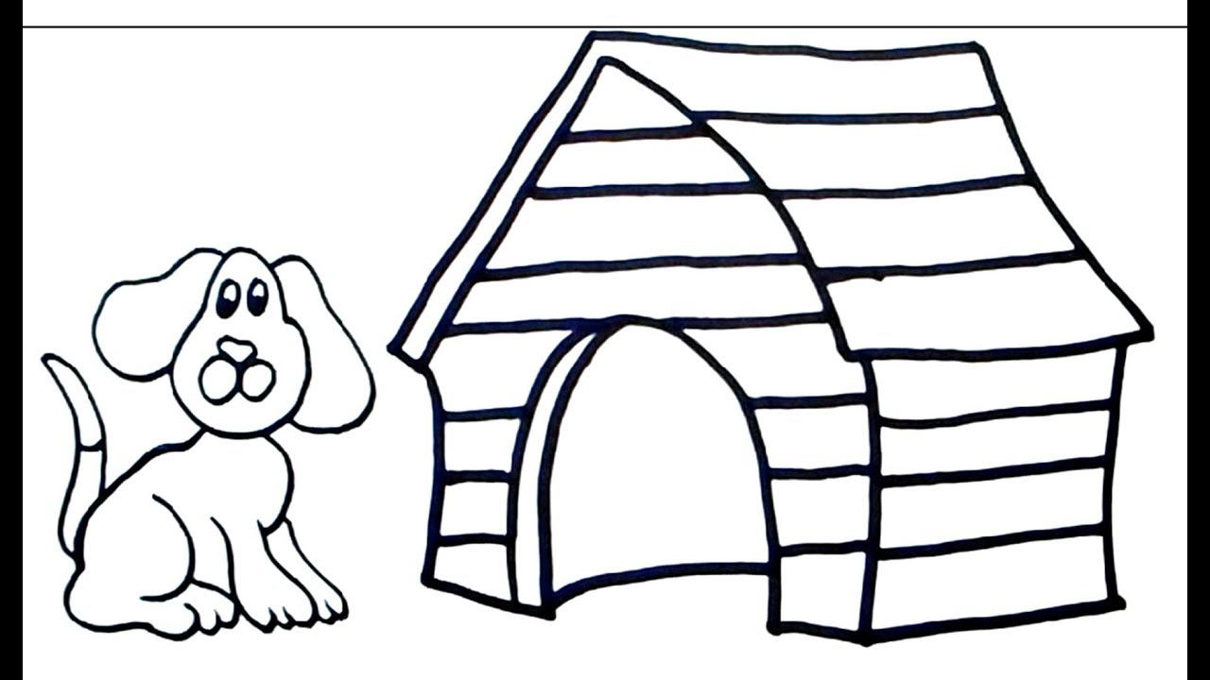

Tuesday - Week 7, Term 3 - Kindergarten
Daily Task - Wash the dishes.
English
Phonics: You will need a piece of paper and a pencil. Access Seesaw. Watch the video by Mrs Rex and follow her instruction. If unable to access Seesaw, review all sounds on Jolly Phonics. Learn the sound ‘air’ as in ‘fair’. Write 5 ‘air’ words (fair, fairy, fairly, dairy, stair) and underline the sound.
Reading: Read a book on https://app.pmecollection.com.au. Draw or write what happened at the beginning, middle and end of your story. Take a picture and post to Seesaw.
Writing: You will need a piece of paper and a pencil. Access Seesaw. Watch the video by Mrs B. Edit the sentence ‘if I was u bird I would beee a parrot’ See if you can make this sentence more detailed by adding a describing word about the parrot.
Sight words: Make 5 of your sight words with playdough. Take a picture and post to seesaw.
Extension: Find out what 3-5 of your sight words mean. You can use a dictionary or Google.
Optional – complete 10 minutes of Reading Eggs activities.
Break – Time to stop and refuel. Eat, play, have fun. Self-directed outside activities where possible.
Maths
Warm up: Roll a dice and do the following:
Roll 1 – number of star jumps,
Roll 2 – number of push-ups
Roll 3 – number of hops
Roll 4 - number of jumps
We are learning to: create and recognise combinations for numbers to at least 10. See the video with Miss Hetherington.
Activity: You will need a collection of 10 objects (lego bricks, counters, marbles, sticks) Write down the number 4. Show your child how to make different combinations to make 4. For example, 3 sticks and 1 stick = 4 sticks, 2 sticks and 2 sticks = 4 sticks, 4 sticks and zero sticks = 4 sticks,
Repeat this for numbers up to 10.
The aim of this activity is to show students that there are different number combinations to make the total number. After the activity or throughout the day, say to your child, “Can you remind me of two numbers that make 5?” “Tell me two numbers that make 6.”
Using the sheet provided – write some of the combinations you have just practiced. For example – write the number 5 in the top circle and then write 2 numbers that add up to make 5, eg 4 and 1, or 2 and 3.
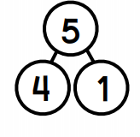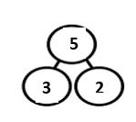
Extension: This activity can be extended by using larger numbers.
Optional: Complete some Mathseeds activities for 10 minutes.
Break – Time to stop and refuel. Eat, play, have fun. Self-directed outside activities where possible.
PDHPE:  Watch https://vimeo.com/417383335 OR play a game of soccer  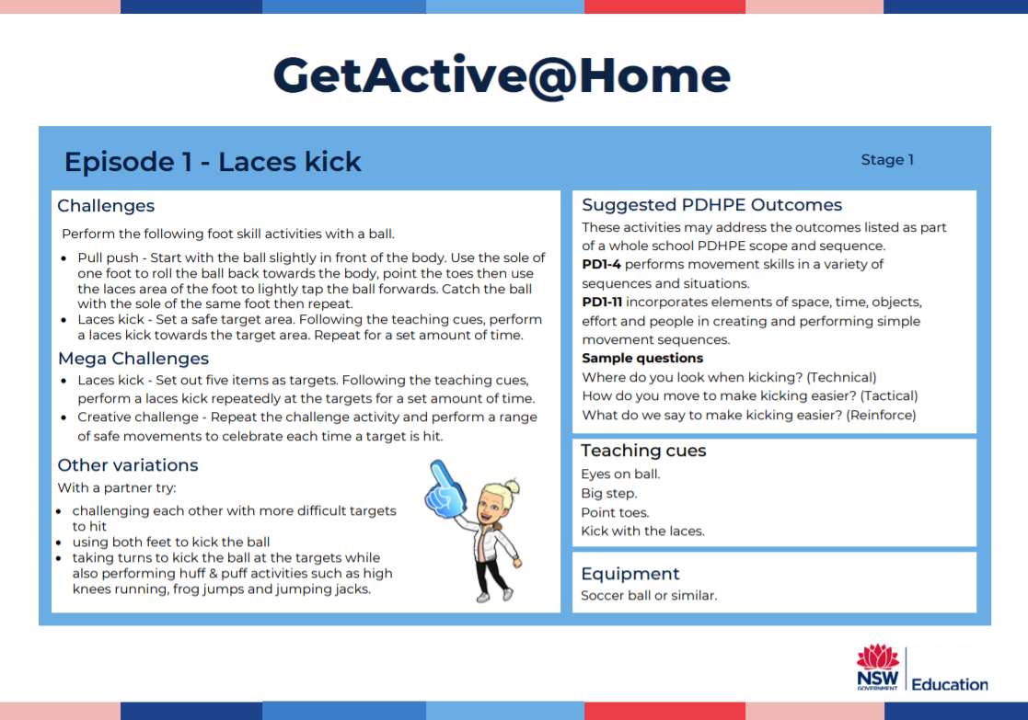 | Science: Needs and Wants  What do we do in our day to meet our needs? (eg food - have breakfast, lunch and dinner, go shopping; air - to breathe; water - to drink; shelter - go into our homes at night, rest in our beds, keep warm/safe during very cold or dangerous weather.)  - Determine needs / want  - Discuss types of needs - food is a need, but a lolly is a want  - Cut and Paste ‘Needs and Wants’ Worksheet
Wednesday - Week 7, Term 3 - Kindergarten
Daily Task – Make your bed.
English
Phonics: You will need a piece of paper and a pencil. Access Seesaw. Watch the video by Mrs Rex and follow her instruction. If unable to access Seesaw, review all sounds on Jolly Phonics. Learn the sound ‘ure’ as in ‘sure’. Write 5 ‘ure’ words (sure, cure, pure, lure, dure) and underline the sound.
Reading: Read a book on https://app.pmecollection.com.au. Use the record button and record yourself reading.
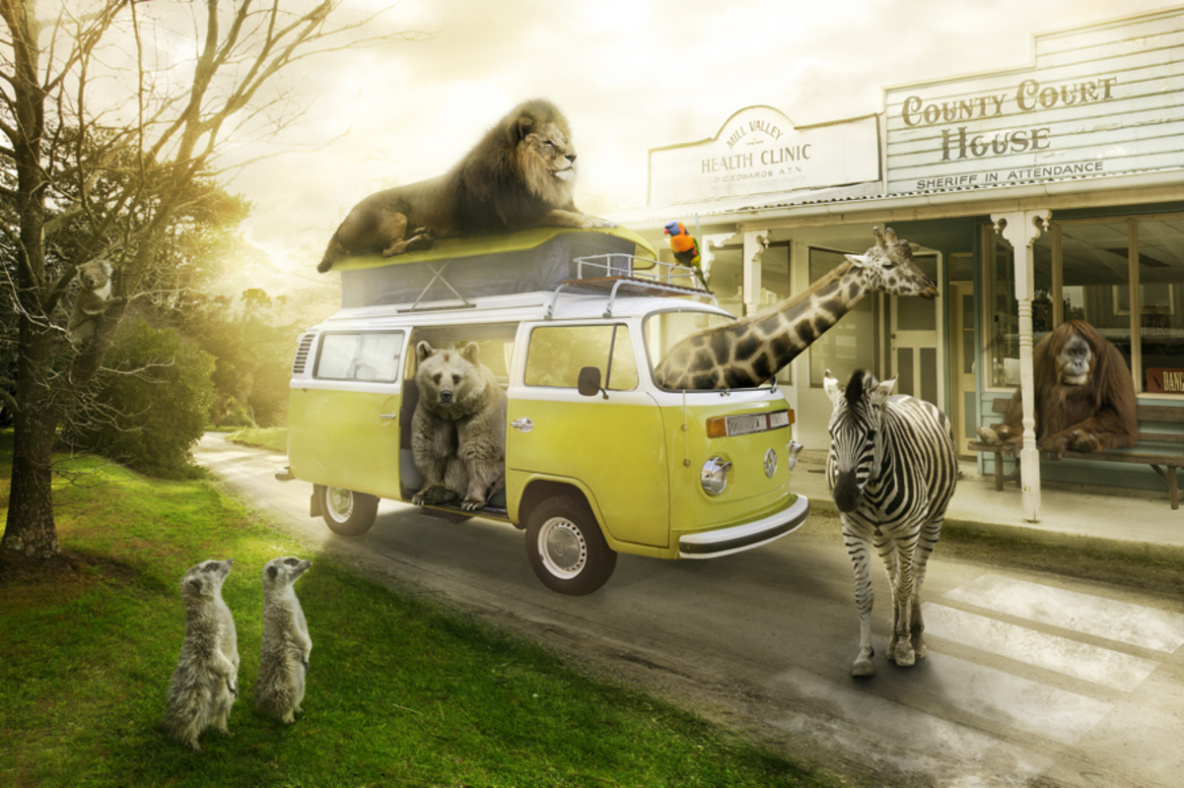
Writing: You will need a piece of paper and a pencil. Access Seesaw. Watch the video by Mrs B. Look at the picture and write one or more sentences describing what is happening in it.
Sight words: Write 5 of your sight words in rainbow colours.
Extension: Circle the digraphs (2 letters that make one sound) in each word.
Optional – complete 10 minutes of Reading Eggs activities.
Break – Time to stop and refuel. Eat, play, have fun. Self-directed outside activities where possible.
Maths
Warm up: Count forwards to 30, count backwards from 20. Have a helper say some numbers to you. Then tell them the number before and after that number. Repeat five times.
We are learning to: Create and recognise combinations for numbers to at least 10. Watch the video with Miss Hetherington.
Activity: You will need 2 dice for this activity and the sheet provided. Roll 2 dice and say the larger number. Then count on from the larger number to find the total. Write the total down in the top circle and the 2 dice numbers on the other circles. Repeat this activity.
Extension: This activity can be done with 3 dice.
Optional: Complete some Mathseeds activities for 10 minutes.
Break – Time to stop and refuel. Eat, play, have fun. Self-directed outside activities where possible.
Creative Arts and Science: Food Packaging
Gather an assortment of food packaging: plastic bottles, noodle packet or container, milk carton, cereal box, chip bag, candy wrapper.
Discuss – What are good characteristics of food packaging?
E.g. Keep food fresh for longer, easy to store, easy to carry, won’t break is dropped.
Design – A food wrap or package for your favourite food.
This could be a new way to package cereal, design a new shape milk bottle, a new chip packet.
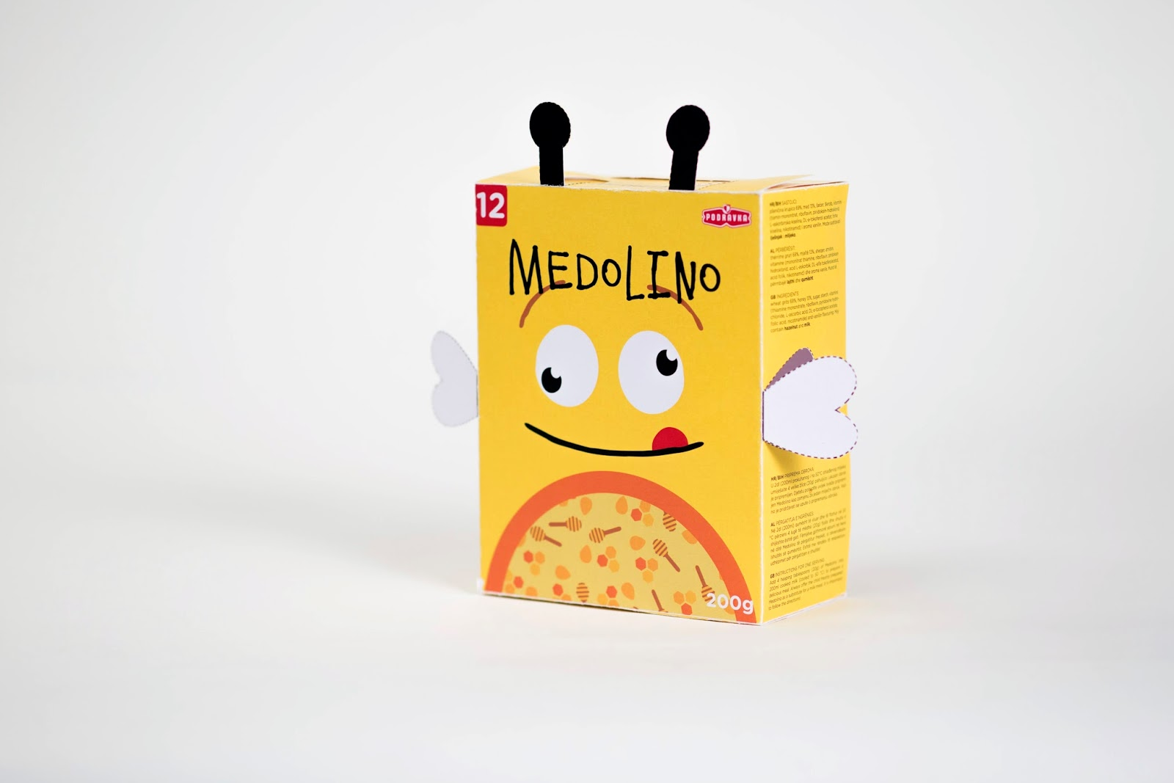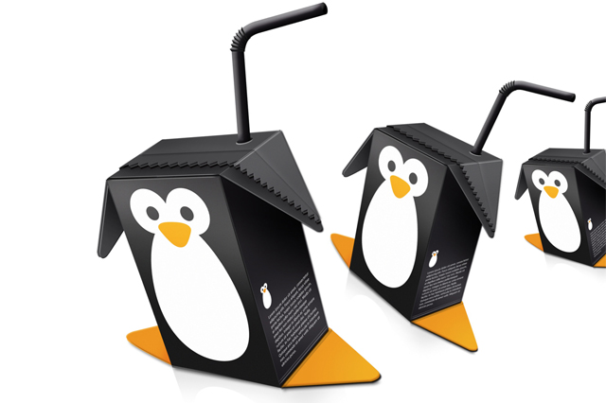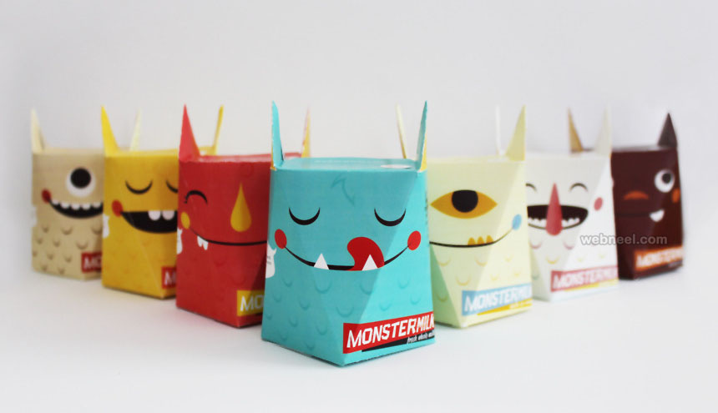

Thursday - Week 7, Term 3 - Kindergarten
Daily Task – Help an adult with an outside activity.
English
Phonics: You will need a piece of paper and a pencil. Access Seesaw. Watch the video by Mrs Rex and follow her instruction. If unable to access Seesaw, review all sounds on Jolly Phonics. Learn the sound ‘ck’ as in ‘clock’. When we hear ‘ck’ at the end it is usually shown by using both c and k together. Write 5 ‘ck’ words (clock, peck, sack, track, stuck) and underline the sound.
Reading: Read a book on https://app.pmecollection.com.au. Make a video or write about what happened in the story. Post to your teacher on Seesaw.
Writing: You will need a piece of paper and a pencil. Access Seesaw. Watch the video by Mrs B. Connect the following two sentences using the word ‘because’.
I love to play soccer. It is a fun game.
Sight words: Write 10 of your words on post it notes or small bits of paper. Stick these to your fence outside. Use something like a ball or nerf gun and throw it at a word. Read the word you hit.
Extension: Add points to each word. 1 point for every letter (EG: because would be worth 7 points). Hit and say your sight words and calculate how many points you got in total.
Optional – complete 10 minutes of Reading Eggs activities.
Break – Time to stop and refuel. Eat, play, have fun. Self-directed outside activities where possible.
Maths
Warm up: On a piece of paper or on a white board write the number 20. Write everything you know about the number twenty. How can you write it, how many ways can you make it, how many combinations make twenty?
We are learning to: Use visual representations of numbers to assist with subtraction and describe the action of separating, using everyday language.
Activity: Have a collection of 10-15 items (eg lego pieces, counters, marbles, rocks, flowers, lollies, etc). Put a pile of 9 items down. Say, Here are 9 marbles, I am going to take away 4 marbles, how many marbles will be left?” Encourage your child to put the larger number (9) in their head and count back by ones, “9, 8, 7, 6, 5. There are 5 marbles left.” Children can then use the items to check their answer. Repeat with 10 take away 6, 11 take away 5, 8 take away 4, 12 take away 8.
Extension: This can be done with larger numbers, eg 20 take away 6 marbles.
Optional: Complete some Mathseeds activities for 10 minutes.
Break – Time to stop and refuel. Eat, play, have fun. Self-directed outside activities where possible.
PDHPE: Complete the Animal Theme HIIT Workout. Can you do each activity for 30 seconds on 30 seconds off. Try to get through 3 rounds.
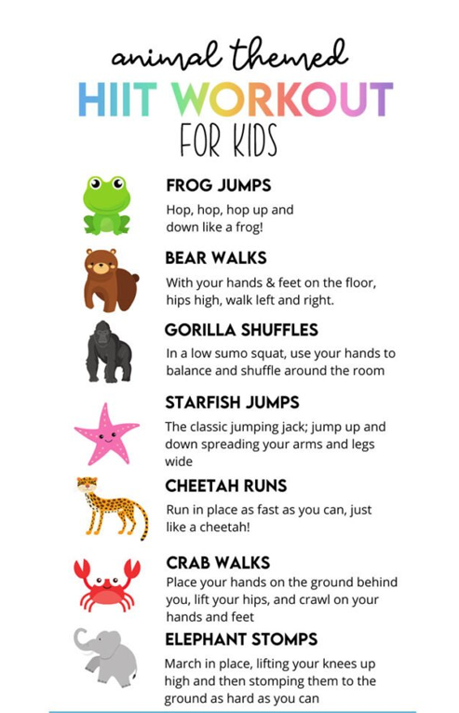

Friday - Week 7, Term 3 - Kindergarten
Daily Task – Clean up your room.
English
Phonics: You will need a piece of paper and a pencil. Access Seesaw. Watch the video by Mrs Rex and follow her instruction. If unable to access Seesaw, review all sounds on Jolly Phonics. Review all the sounds you have learned this week. Ask a family member to test you on 10 words you have learned this week.
Reading: Pick your most favourite book in the house. Read it with a family member. Draw or write why it is your favourite book.
Writing: You will need a piece of paper and a pencil. Access Seesaw. Watch the FriYay Feedback video by Mrs B. Write Yes or No if you achieved your goal. If you wrote yes, think of a new goal to help improve your writing next week.
Sight words: Make your sight words with playdough or lego. Ask a family member to call some out and make it without looking at the words.
Optional – complete 10 minutes of Reading Eggs activities.
Break – Time to stop and refuel. Eat, play, have fun. Self-directed outside activities where possible.
Maths
Warm up: Write your numbers 1-20 on a piece of paper or outside on your driveway in chalk.
We are learning to: use visual representations of numbers to assist with addition and create number combinations for numbers to 10. Watch the video with Miss Hetherington.
Activity: You will need a clothes hanger and ten pegs. Attach the pegs to the clothes hanger as shown in the photos. Then move the pegs so there are two distinct groups on either end. For example, “4 pegs and 6 pegs makes 10 pegs.” This can be done with 9 pegs, 11 pegs, 12 pegs. Have your child write some of the combinations down.
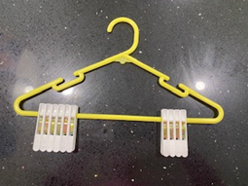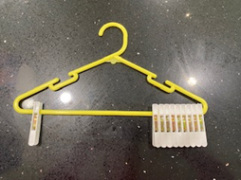
If students are confident with the + symbol, they could write some sums on a piece of paper.
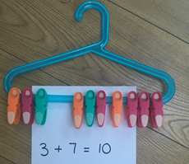Optional: Complete some Mathseeds activities for 10 minutes.
Break – Time to stop and refuel. Eat, play, have fun. Self-directed outside activities where possible.
FriYAY fun activities. Thanks for working hard this week. Post a photo of your FriYAY activity on SeeSaw.

