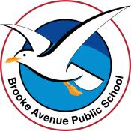
Learning from Home – Brooke Avenue Public School
Stage 2 (Years 3 and 4) – Week 6, Term 3
The following timetable can be used by students to support learning at home. All tasks have been linked to syllabus outcomes. If technology is available at home, please use the attached links to support learning.
Monday 16th August
Daily Task - Match socks and sort washing.
Morning - Zoom Meeting 9:45am
English:
Reading
Read about writing a letter to a Paralympian. Go to the website below or use the attached information.

ttps://education.paralympic.org.au/wp-content/uploads/sites/3/2020/05/8257-Paralympics-Australia-Education-Resources_Students_Paralympic-Pen-Pals_FA.pdf

Writing
Choose a Paralympian who you would like to write to. Create a plan using words or pictures of what you will include in your letter to the Paralympian.
Spelling
Write your list of spelling words as neatly as you can.

Break – Time to stop and refuel. Eat, play, have fun. Self-directed outside activities where possible.
Maths – Addition and Subtraction
Complete timed addition grid and record your score.

Complete “Linking Addition and Subtraction” worksheet.

Break – Time to stop and refuel. Eat, play, have fun. Self-directed outside activities where possible.
Science
Over the past 5 weeks, we have learned all about the sun, the moon and earth. You have found planets that you researched yourself.
This week we are looking at those strange facts that are just plain weird.
Facts about space
1) One million Earths could fit inside the sun – and the sun is considered an average-size star.
2) Comets are leftovers from the creation of our solar system about 4.5 billion years ago – they consist of sand, ice and carbon dioxide.
3) You wouldn’t be able to walk on Jupiter, Saturn, Uranus or Neptune because they have no solid surface!
4) If you could fly a plane to Pluto, the trip would take more than 800 years!
5) Space junk is any human-made object orbiting Earth that no longer serves a useful purpose. Scientists estimate there are about 500,000 pieces of space junk today, including fragments from rockets and satellites, and everyday items like spanners dropped during construction of the International Space Station!
6) An asteroid about the size of a car enters Earth’s atmosphere roughly once a year – but it burns up before it reaches us. Phew!
7) There are more stars in the universe than grains of sand on all the beaches on Earth. That’s at least a billion trillion!
9) The sunset on Mars appears blue.
10) THERE IS A PLANET MADE OF DIAMONDS
There’s a planet made of diamonds twice the size of earth The "super earth," aka 55 Cancri e, is most likely covered in graphite and diamond.
11) Spaghettification! It’s a real thing look it up!
Send a message to your teacher about the weird and wonderful fact at number 11 and one more mind blowing space fact that you find.

Creative Arts
Ba designer-
Design your own space inspired bed cover. For example, the images below show covers you can buy from a shop.
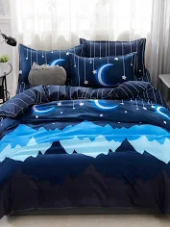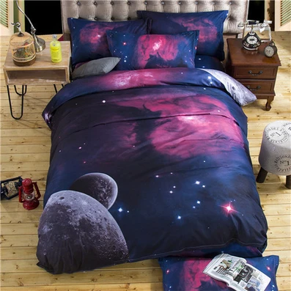

Tuesday 17th August
Daily Task - Match socks and sort washing.
Morning
English:
Reading
Choose a book / magazine / newspaper of your own to read. Read some of it aloud to a family member.
Writing-
Using your plan from Monday, write a letter to a Paralympian.
Grammar
Complete the attached worksheet on Compound Words.
Spelling
Create a ‘Find A Word’ using your spelling words and words from your research on the Paralympics. Ask someone to see if they can solve it.

Break – Time to stop and refuel. Eat, play, have fun. Self-directed outside activities where possible.
Maths
Complete timed addition grid and record your score.
Work through “Addition Strategies” worksheet. Now create some of your own questions to answer with either of the strategies. You may like to roll a dice to create your questions.
PDHPE
Choose a physical activity you would like to do for half an hour. It may be going for a jog, jumping on a trampoline, riding a scooter or dancing. Do what you enjoy and improve your fitness level. You may like to tell your teacher what you chose to do on Seesaw.
Break – Time to stop and refuel. Eat, play, have fun. Self-directed outside activities where possible.
PDHPE
Write 5 questions that could be asked in a Kids Trivia Quiz on Zoom about the Tokyo Olympics.

Wednesday 18th August
Daily Task - Wash the dishes.
Morning
English:
Reading
Read over your letter to the Paralympian from the day before and edit it. Look at suggestions from your teacher on Seesaw to assist you with this.
Writing
Now, publish your letter on this site and send it to the Paralympian.
https://education.paralympic.org.au/for-students/paralympic-pen-pal/
(Scroll down to see where you add your details and write your letter.)
Grammar: Complete Antonyms/Synonyms Worksheet Attached.
Spelling: Write out your list of words. Circle any small words you see inside your spelling words.

Break – Time to stop and refuel. Eat, play, have fun. Self-directed outside activities where possible.
Maths
Complete timed addition grid and record your score. Hopefully you can improve your time from the last two days!
Complete “Subtraction Strategies” worksheet.

Break – Time to stop and refuel. Eat, play, have fun. Self-directed outside activities where possible.
Science
Watch this link- Do Black Holes Suck In Planets?
https://www.abc.net.au/btn/classroom/do-black-holes-suck-in-planets/13485706
Creative Arts
Listen to music of your choice. You may like to practise your singing or dancing.

Thursday 19th August
Daily Task – Make your bed.
Morning
Reading
Read “What is Minecraft’.
Writing:
Answer the comprehension questions on “What is Minecraft?” in sentence answers.
Grammar
Edit the ‘Deep-sea Diving’ paragraphs. (attached)
Spelling
Write out your list of words as neatly as you can. Use a dictionary to find the meaning of your words, then write the words in sentences.

Break – Time to stop and refuel. Eat, play, have fun. Self-directed outside activities where possible.
Maths

Complete timed subtraction grid and record your score.
Complete “Linking Addition and Subtraction Strategies” worksheet.
PDHPE
Complete the attached worksheets on the 5 major food groups.

Break – Time to stop and refuel. Eat, play, have fun. Self-directed outside activities where possible.
Creative Arts
Draw a fruit or vegetable of your choice by looking at it.
Friday 20th August
Daily Task – Help an adult with an outside activity.
Morning
English:
Reading
Read a book/comic/magazine/newspaper of your choice for at least 20 minutes. Have a discussion with someone in your house about what you have read.
Grammar

Revision of noun, verb and adjective. Colour the worksheet attached according to the instructions.

Writing
Write about some of the activities you will do over the weekend. You may like to draw a picture before you start the writing to help you with this.
Spelling
Do ‘Look, Cover, Write, Check’ to see which words you need to practise more.
Break – Time to stop and refuel. Eat, play, have fun. Self-directed outside activities where possible.
Maths
Complete timed subtraction grid and record your score. Hopefully you can improve your time from yesterday!
Play a board game that involves some addition or subtraction. Monopoly or Snakes and Ladders are both great games to practise Maths Skills. ABCya Number has many online games that focus on addition and subtraction. For example, ‘Clear it’.

Break – Time to stop and refuel. Eat, play, have fun. Self-directed outside activities where possible.
Friyay

Master Chef
Cook a recipe of your choice or find a recipe of something you would like to cook. Don’t forget to upload your photo to Seesaw.

