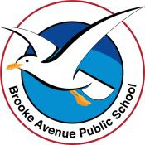
Learning from Home – Brooke Avenue Public School
K-6J, K-6M and K-6S – Week 6, Term 3
The following timetable can be used by students to support learning at home. All tasks have been linked to syllabus outcomes. If technology is available at home, please use the attached links to support learning.

ATTENTION PARENTS: please note that we have tried to vary the learning to give options for all students. There are writing templates for K-2 and others for 3-6 student, which they may choose to use, if they are comfortable doing so without teacher support. There is also another blank wordsearch and some maths worksheets that you may choose to do as alternatives.
Please note that you may choose whatever suggested learning activities suit your own child.
Monday - Week 6, Term 3
Daily Task - Match socks and sort washing.
English: Watch the book The Colour Monster https://www.youtube.com/watch?v=W6wIEp-M4tg What feelings do you think each of the colours represent?
Reading: Read by yourself, to someone or have someone read to you. What is your favourite story? Why do you like it? There are stories available on Reading Eggs that you can access or log on to PM readers with your login details provided on Seesaw.
Activity: Verbs can be any action you can do. They can be describing how someone speaks, how they think and what someone is doing.
Doing words and describe what someone is doing. For example: Mrs Scott jumped onto the table. Miss Johnson napped on the grass. Ms McBride danced under the COLA.
Watch this video: https://www.youtube.com/watch?v=DzmmSbLwOGo or https://www.youtube.com/watch?v=j3EYciNco58 to see what a verb is and get some ideas.
Complete the verb find a word or the word hunt.
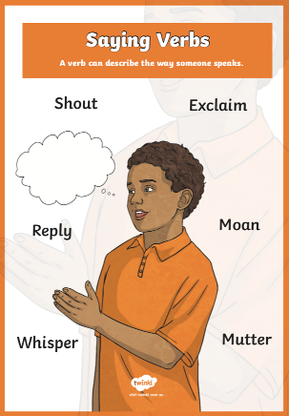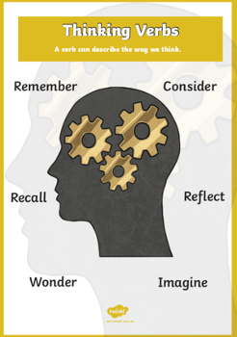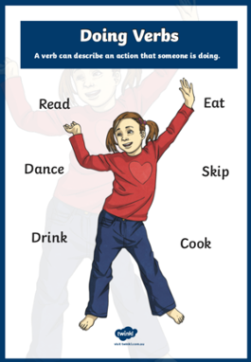

Spelling: If you are not sure what spelling words or sight words you would like, follow this link to work through a list that suits you and find some inspiration for new words you do not know. There are also suggested Sight word games on this website too: https://sightwords.com/sight-words/flash-cards/creator-4up/
Speaking and Listening + Writing – Narrative (story) Write your own story about the Colour Monster and choose any colour you like. Make sure you use interesting verbs in your story... Especially when your characters are speaking! Think of more exciting words you can use rather than said. Read your story to a family member, or record it for a teacher on Seesaw.
Technology: Log in to Reading Eggs, Studyladder or Seesaw and complete an activity.
Break – Time to stop and refuel. Eat, play, have fun. Self-directed outside activities where possible.
Maths: Week 6 focus – Fractions.
- Early stage 1 is introduced to using the language of half,
- Stage 1 is introduced to using fraction notations such as: ½ ¼ and 1/8
- Stage 2 investigates equivalent fractions and can represent fractions on a number line.

This week, we are working on fractions. There are a series of worksheets below, as well as a range of activities on MathSeeds, Studyladder or Prodigy. Miss Johnson has also recorded a few lessons to be watched on Seesaw.
Warm up: We know we can cut cakes and pizzas into slices/smaller parts, these parts are called fractions because each slice is one part of a whole (whole cake, or whole pizza, YUM!) Watch https://www.youtube.com/watch?v=362JVVvgYPE or https://www.youtube.com/watch?v=FSTlQjxznUg

Activity:
- Grab a piece of paper or a ribbon. With scissors, cut it into half. Make sure it is two equal parts and that both parts are the same. With another, cut it into two parts, but make sure they are not the same (demonstrating a non-example). These parts are not equal halves as they are not the same and it wouldn’t be fair to share them as they are not equal.
-If you already know what a half is, you can do this with quarters by cutting something into four equal parts, if quarters is mastered, try learning eighths.
-You may also like to draw simple drawings like smiley faces, houses etc. Cut them out and try fold in half. Are both sides the same?
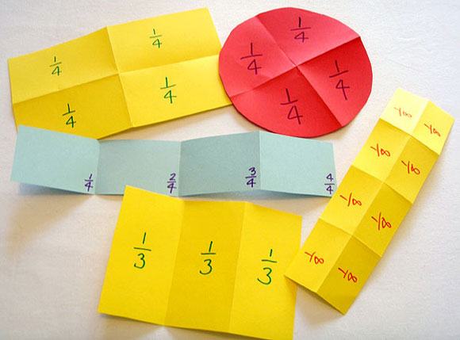

Worksheet – Sorting fractions and quarters. You will need scissors and glue.
Colouring one half.

Use the language: whole, part, equal parts, half, halves, about a half, more than a half, less than a half. One-half, one-quarter, one-eighth

Option: You may also log in to Math Seeds, Studyladder or Prodigy to complete activities set for you.
Break – Time to stop and refuel. Eat, play, have fun. Self-directed outside activities where possible.
Cooking: Go into the kitchen ready to bake something. Make sure you get to measure the liquids with your measuring cups and see if you can spot the fractions on the measuring cups and see if you can learn how to read it!
While your tasty treat is cooking, get outside and be active in the sunshine any way you know how to. Dance to some music, play tag, climb on your play equipment etc.
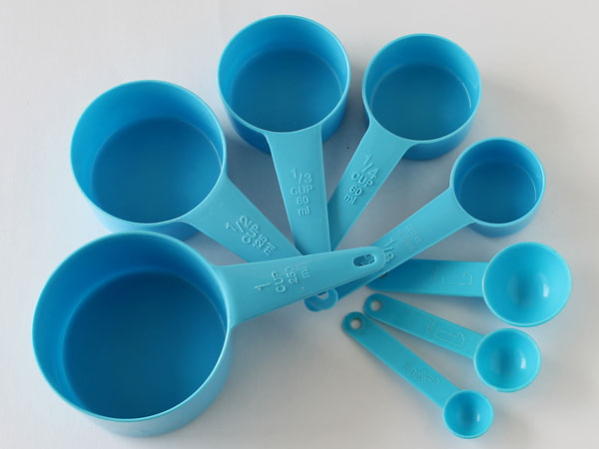

Tuesday - Week 6, Term 3
Daily Task - Wash the dishes.
English: Warm up: Rhyming. Watch: https://www.youtube.com/watch?v=B5-y__faQrY or https://www.youtube.com/watch?v=RVophT8naUM for each of the following words, think of 1-3 different rhyming words that match: Cat, dog, pen, man, bed, bun, bell, hair, snake, meet, hook.
Reading: Have a family member read an unfamiliar book to you today. Can you retell the story after you heard it? What was interesting about the book? What was the complication? Did you think the ending was interesting enough, or could you change the ending of it and think of a new version?
Activity: Complete any left-over verb work from yesterday.
Reread your story about the Colour Monster. Are there any words you think may need fixing? Are there more interesting words you could replace? A great writer always comes back to their own work to check that it is as interesting as possible! Illustrate some pictures for your story.

Cut out and play the rhyming match up card game included within the resource pack.
Choose any words from your rhyming word cards to make into a sentence, maybe you’d like to use them to make a story instead?
Spelling: Choose 3 words you do not know how to spell, try to practise spelling them.

Technology: Explore Interland and learn about digital safety or learn touch typing with Typing Club.
https://beinternetawesome.withgoogle.com/en_us/interland
https://www.typingclub.com/
Break – Time to stop and refuel. Eat, play, have fun. Self-directed outside activities where possible.
Maths: Play “I’m thinking of a number” with someone. Describe your number to your best ability without saying what the number is.
Activity: When making your sandwich today ask for quarters and see what they look like. Then maybe ask for it to be cut into eighths!
Using the pizza resource, take an order from two different family members and make your pizza half/half so they each have one half of the pizza the way they like it.
Challenge yourself and see how many people you could share your pizza with!
Complete fractions house worksheet to show different fractions on the house.
Stage 2 students watch fractions on a number line video here: https://www.youtube.com/watch?v=rxkbIw3VlGE or https://www.youtube.com/watch?v=SZaXtOHNh6s Complete fractions on number line worksheet.
Technology: Find a fractions activity/ maths game on Toy Theater: https://toytheater.com/category/teacher-tools/
Or explore the fraction games on this website: https://www.education.com/games/fractions/
Have some free time playing any math game online.

Break – Time to stop and refuel. Eat, play, have fun. Self-directed outside activities where possible.
Head to smiling minds and calm down for the day. Maybe you’d like to do a meditation before bedtime instead. Log in to the website and choose and appropriate task, sit back, listen and enjoy. https://www.smilingmind.com.au/

Wednesday - Week 6, Term 3
Daily Task – Make your bed.
English: Watch the story Penguin in Peril https://www.youtube.com/watch?v=nbwYy6LZgTk Talk about the penguin. Why was he escaping? Was it scary? Did you like the cats or the penguin better as a main character? Why? Look at the last page where it says ‘Cat Gang Foiled.’
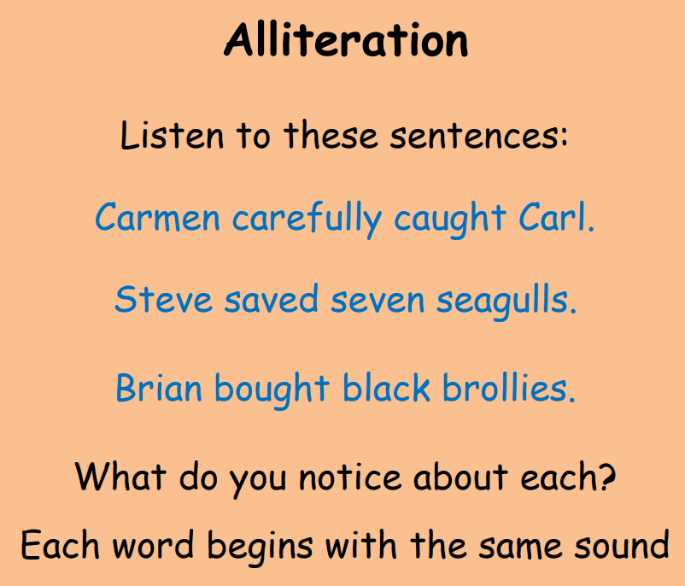
Make your own Newspaper article about the story and what happened to the cats and the penguin.
- Watch this video about alliteration: https://www.youtube.com/watch?v=y-koivS_aho
Can you think of a catchy phrase to grab a reader’s attention using alliteration? Make sure you illustrate your article as well! We can’t wait to see them.

Reading: Search for your favourite song lyrics online. Play the song while reading along to the lyrics. Alternatively, find a popular nursery rhyme and read the words to that. It will become easier the more times you practise reading it! 😊

Speling: Choose a favourite spelling activity and complete it again.
Technology: Log in to Reading Eggs and complete an activity or log into PM readers.

Break – Time to stop and refuel. Eat, play, have fun. Self-directed outside activities where possible.
Maths: Watch Mrs Wellfare play Greedy Pig: https://video.link/w/uWk5c If you think you can play this game, have a try and let us know how you go.
Activity: Complete the half of a collection puzzle matching cards.
- Too easy? Move onto the matching fraction cards and match them up. Use these cards as a discussion point, you could also move towards playing snap with them too.
- Roll a dice and double the number. Roll it again. Play with someone else and see if you can beat them by saying the double. Too easy? Use two or three dice and see if you can add the total, then double it! Alternatively, you could also roll a dice and beat another person in saying what half of that number is.
- Practise your correct number formation with chalk, paint, drawing, writing in coloured rice etc…

Break – Time to stop and refuel. Eat, play, have fun. Self-directed outside activities where possible.
BTN: Watch this clip of BTN, the elephants have finally arrived home!
- https://www.abc.net.au/btn/newsbreak/btn-newsbreak-20210811/13493084
- Retell a news story from this show to a family member in your own words.
- Why do you think it was important to share?
- You can also practise your note taking skills while you are listening.
Thursday - Week 6, Term 3
Daily Task – Help an adult with an outside activity.
English Writing: What does it mean to be kind? Write this down or tell someone your definition.
Watch the story Be Kind: https://www.youtube.com/watch?v=kAo4-2UzgPo After you have watched this story, has your idea of what kind is changed? Discuss this with a parent/carer. Write a letter to someone you know that has once been kind to you, thank them for being kind and tell them how it made you feel. Sometimes it is nice to be acknowledged when you have done the right thing. If it is to another class member, post it on Seesaw and your teacher will pass it on. It will make their day!
Speaking & Listening: Record yourself saying something kind to three different people, why is it kind, how does it make you feel? Or tell people in your household if they have been kind to you and why. Don’t forget to thank them and return the kindness!
Reading: Read your favourite story or log on to Reading Eggs or PM home readers. See if you can yourself reading this book and then listen along to yourself reading the book while looking at it again. Did you make any mistakes? Did you fix them the next time you read it? Did you read it smoother?
Technology: Log in to Reading Eggs.
Break – Time to stop and refuel. Eat, play, have fun. Self-directed outside activities where possible.
Maths:
- Practise reading and writing your teen numbers. If you have mastered this, practise reading and writing 3 or 4-digit numbers remembering to make a table that has thousands, hundreds, tens, units in each column.
- Choose a number of the day, refer to Mrs McBride’s video on number of the day how she can represent her numbers in many different ways.
-ten more, ten less, tally marks, groups, it can be split in half, it can be doubled, it can be drawn or shown as a collection of objects, it can be written in word form etc…
- Consolidate your doubles and halves number facts. It may be helpful to draw a ten-frame to assist.
Technology: Try this link for some new maths activities https://pbskids.org/games/math or https://au.mathgames.com/
Break – Time to stop and refuel. Eat, play, have fun. Self-directed outside activities where possible.
STEAM
Design a Boat to Float 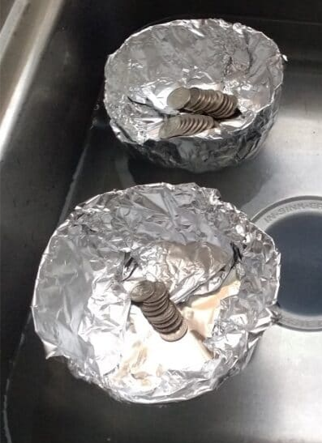 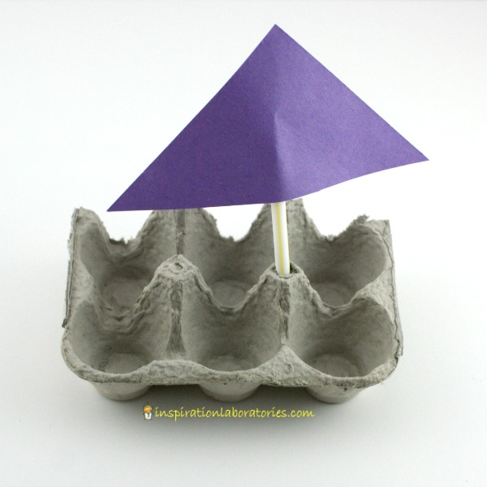 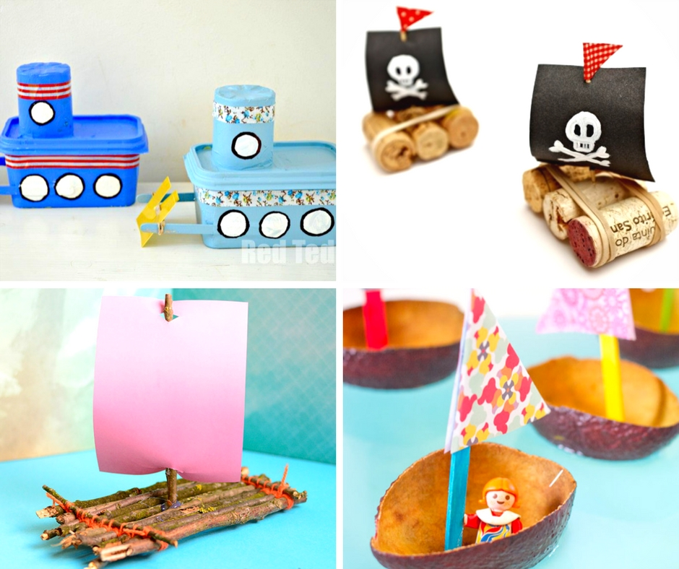 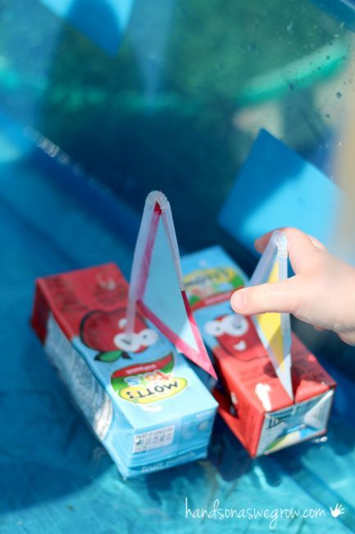
PLAN:
- Sketch and label your design ideas on a piece of paper.
- What materials will you use? (Suggested Materials: aluminium foil, paddle pop sticks, coins or other small, weighted objects, a container or a sink filled with water)
- Label your sketch with the materials that you will need.
DESIGN:
- Build your first boat.
- Test your design. - Does it float? - Make improvements if needed.
PLAY:
- Try adding one coin or object at a time to your boat.
- Can you think of a way to improve your design so that it might hold more weight?
Additional Challenge Idea: try creating a boat using different types of materials (cardboard, styrofoam, etc). What design features work best?

Friday - Week 6, Term 3
Daily Task – Clean up your room.
English: https://www.pobble365.com/ find a picture that catches your interest on Pobble 365.
Writing: Use as many describing words you can to describe this picture to someone else without them seeing the picture.
After you have described the picture, show the other person your writing. After they read the writing, show them the picture. Ask them if your writing helped them create a mental picture. Instead of writing, you can use this as a speaking and listening activity instead. Describing it to your best ability.
Write a story about what is happening. Remember to use your adjectives to describe what is happening.
Spelling: Choose an activity suggested from: https://sightwords.com/sight-words/games/ Lots of different games to engage with.
Technology: Search ABCya for a fun literacy or numeracy activity to engage with.
Break – Time to stop and refuel. Eat, play, have fun. Self-directed outside activities where possible.
Maths:
- https://www.youtube.com/watch?v=G5tG_VjLT_U Watch this video and use your fraction cards from during the week (Sort out and use pictures only, if you want a challenge, use them all!) Pick two fraction cards up see if you can choose which fraction is larger. A parent/carer may need to help you with this. It is easier to compare fractions with the same denominator such as ¼ is smaller than ¾.
- Want an alternative? Make fractions of a group, get a number of counters/ Lego pieces etc and split the group into half. Talk about if the fraction is fair or not because it is sharing between two. Complete this with quarters (four people to share between) etc.
- Choose any maths activity or game from the week to consolidate. What was your favourite activity? Why?

Congratulations on all of your hard work this week! Take some time to relax, maybe watch BTN or another educational show.

Break – Time to stop and refuel. Eat, play, have fun. Self-directed outside activities where possible.
Creative Arts: Next week is book week. Think of your favourite character from a book. Design, draw, label, colour or talk about a possible costume that you could dress up in for Book Week next week.
