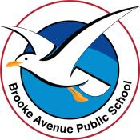
Learning from Home – Brooke Avenue Public School
Stage 1– Week 5, Term 3
The following timetable can be used by students to support learning at home. All tasks have been linked to syllabus outcomes. If technology is available at home, please use the attached links to support learning.
Monday - Week 5, Term 3 – Stage 1
Daily Task - Match socks and sort washing.
English:
Reading:
Choose a book or a PM reader online to read. Remember that the book shouldn’t be too easy or too hard. It should be a little challenging to read. Try to read for 10 or more minutes.

Spelling:
The letter/sound combinations for spelling this week are: ing, ong, ang, ung. There are also two high frequency (commonly used) words to learn: ‘after and ‘again’. Write your list/s into your book. You can choose either list or do both.
List 1 | List 2
king | everything
sling | something
sting | during
wrong | belong
strong | boomerang
hang | overhang
slang | young
lung | youngster
High Frequency Words
after | again

Extension: Think of extra ‘ing, ong, ang, ung’ words to add to your weekly spelling list, e.g. string.

Writing:
This week we are going to focus on persuasive writing. Persuasive writing is convincing people to agree with your opinion. Your opinion is what you think, feel or believe. Watch this video (optional) in the link for some extra information: https://video.link/w/FFM4c
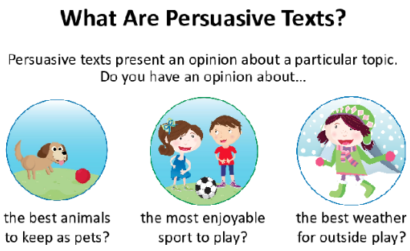

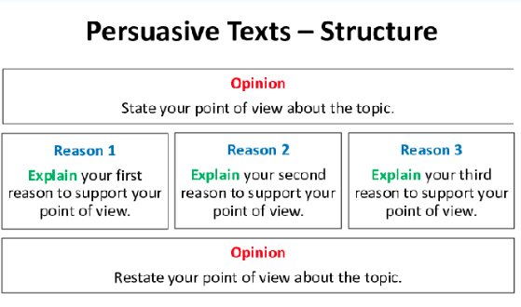

The persuasive writing topic for this week is ‘Learning from Home is Better than School’ or ‘School is Better than Learning from Home’. Choose one of those topics to write about. Your task is to persuade the audience to agree with your opinion.
Persuasive texts are written in a certain way. See the image.

Today for Day 1 of persuasive writing, you will write your title (either ‘Learning from Home is Better than School’ or ‘School is Better than Learning from Home) on a page and then write your opinion/introduction in a full sentence.

Title

Opinion

You don’t need to write your reasons for your opinion choice today. We will work through the rest of the persuasive writing through the week.

Speaking and Listening:
Discuss with someone in your house your opinion on the persuasive text topic. Tell them why you chose that opinion and then listen to their response.

Break – Time to stop and refuel. Eat, play, have fun. Self-directed outside activities where possible.
Maths: Whole Number

Whole Number Warmup:
Set a timer for a minute. Start counting forwards by 1s from 42. What number did you reach?
Set a timer for 30 seconds. Start counting forwards by 2s from 12. What number did you reach?

Whole Number Activity:
Write these numbers in increasing (going forwards) order: Complete each set separately.
Set 1: 22, 11, 68, 123, 103, 1001, 333.
Set 2: 202, 22, 56, 3, 11, 20.
Set 3: 10, 7, 66, 135, 28, 78.

Extension Set: 1099, 1009, 1199, 999, 10099, 9099.

Write these numbers in decreasing (going backwards) order: Complete each set separately.
Set 1: 49, 52, 203, 6, 66, 97.
Set 2: 66, 77, 99, 88, 11, 2.
Set 3: 100, 99, 101, 108, 96, 90.

Extension Set: 2022, 202, 20, 22, 222, 2122.

Physical Activity:

Complete thirty minutes a day of physical activity. Go for a walk, run or ride with an adult.
Play a game outside (tip, hide and seek, ship/shark/shore, hopscotch, skipping or make up a dance).
Use YouTube to search and choose a ‘just dance’ to do at home.

OR

Watch Miss Finch’s Olympic Challenge video 1 in your Seesaw activities – ‘Volleyball’.
Attempt the challenge using things from around your house.

Break – Time to stop and refuel. Eat, play, have fun. Self-directed outside activities where possible.
Creative Arts:
Piet Mondrian Art
Dutch modern painter Piet Mondrian is best known for his 1920’s works of art that feature only horizontal and vertical lines along with black, white and primary colours (red, yellow and blue).
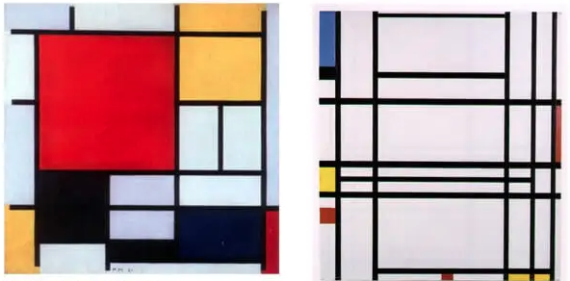
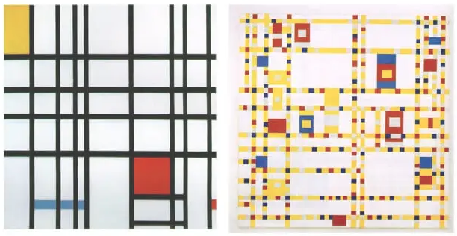
Use bold and straight outlines, high contrast, and bright colours to create your Mondrian inspired artwork.
Use paper or canvas, paint or coloured pencils or oil pastels, pencil or paintbrush, ruler or electrical tape (to create straight lines) and a rubber (for mistakes) to create your artwork!

Tuesday - Week 5, Term 3 – Stage 1
Daily Task – Wash the dishes.
English:

Reading: Choose a book or a PM reader online to read. Remember that the book shouldn’t be too easy or too hard. It should be a little challenging to read. Try to read for 15 or more minutes.

Spelling: Write all your ‘ing, ong, ang, ung’ and high frequency spelling words in the shape of a snake! Every spelling word must be a different colour. Don’t forget to draw the head and tail of the snake. See example below.
Writing:
Day 2 of persuasive writing. Open your page from persuasive writing yesterday. Leave a line underneath where you’ve written the title and opinion/introduction from yesterday. Leaving a line starts a new paragraph. Now it’s time to write your first reason! Why did you choose your opinion? ‘Learning from Home is Better than School’ or ‘School is Better than Learning from Home’

Start your sentence with ‘Firstly,…'.

For example: ‘Firstly, I think School is better than Learning from Home because we can learn and play with our friends at school. It’s important to socialise with your friends because it improves your problem-solving skills and we can have fun together!’

Title

Opinion

Reason 1

Speaking and Listening: Read your persuasive writing to an adult in your house. Remember to read with a clear and confident voice. Ask the adult if they agree or disagree with you and why.

Break – Time to stop and refuel. Eat, play, have fun. Self-directed outside activities where possible.
Maths: Place Value

Using a table, represent each of the following numbers by showing the place value of each digit e.g. 321
Hundreds (H) | Tens (T) | Ones (O)
3 | 2 | 1
Represent the place value of each digit by drawing the correct number of flats (hundreds), sticks (tens) and unit cubes (ones) e.g. 321
Hundreds (H) | Tens (T) | Ones (O)
3 | 2 | 1

2-digit numbers: 13, 67, 90, 44 [tens and ones]

3-digit numbers: 152, 397, 748, 401 [hundreds, tens and ones]

Extension
**4-digit numbers: 2155, 3569, 6915, 5096 [thousands, hundreds, tens and ones]

**4-digit numbers are ‘thousand’ numbers – 1234 = one thousand, two hundred and thirty four.
When representing these numbers say them slowly to understand the larger place value. You can represent them in picture with a ‘cube’ shape.
e.g. 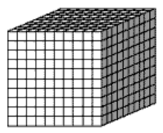 Thousands (Th)

Physical Activity:
Complete thirty minutes a day of physical activity. Go for a walk, run or ride with an adult.
Play a game with a ball using different skills and movements – passing, kicking, throwing, shooting, etc.
Do you think it would be easier or harder to play your game or practise your skills with a larger or smaller ball?
- Try your game or your skills with different sized balls.

OR

Watch Miss Finch’s Olympic Challenge video 2 in your Seesaw activities – ‘Underarm Throw’
Attempt the challenge using things from around your house.

Break – Time to stop and refuel. Eat, play, have fun. Self-directed outside activities where possible.
Drama:
With your family at home (or ask an adult to video call a different family member or a friend), take turns completing the drama challenges. Remember that drama tells a story using your body, your face and also sound.
- Animal Kingdom – think of an animal that you can represent using your body. DON’T tell the other person. Use your body to become the animal while the other person guesses until they get it right. Take turns.
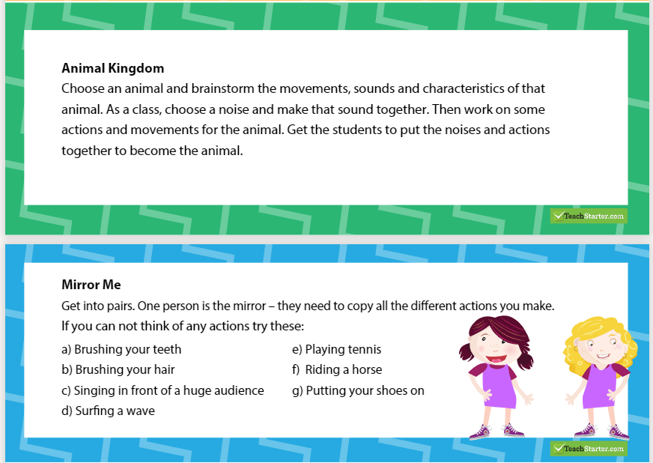
Wednesday - Week 5, Term 3 – Stage 1
Daily Task – Make your bed.
English:
Reading: Choose a book or a PM reader online to read. Remember that the book shouldn’t be too easy or too hard. It should be a little challenging to read. Try to read for 20 or more minutes. Record about 2-3 minutes of yourself reading and send it to your teacher via Seesaw. Your teacher would love to hear you read.

Spelling: Use a dictionary or research online the definitions of your spelling words. Write your spelling words and the definitions of each word on a page.
Writing:
Day 3 of persuasive writing. You will need to write more than one reason to persuade someone to agree with your opinion. Now it’s time to write your second reason! ‘Learning from Home is Better than School’ or ‘School is Better than Learning from Home’.

Open your page from persuasive writing yesterday. Leave a line underneath your first reason. Now write your second reason in two or three sentences. Start your next reason with ‘Secondly...’. Remember you are writing to persuade the reader.

Title

Opinion/Introduction

Reason 1

Reason 2

Speaking and Listening:
Speak to someone in your house or call someone and ask their opinion on ‘Learning from Home is Better than School’ or ‘School is Better than Learning from Home’. Don’t tell them your opinion before you ask. Listen to their response, think about what they said and then comment.

Break – Time to stop and refuel. Eat, play, have fun. Self-directed outside activities where possible.
Maths:

Roll it, Make it, Expand it --> 2 and 3-digit numbers.

Complete the activity by creating your own 2-digit or 3-digit numbers.
You will need to write the numbers that you roll, draw the numbers using MAB bocks and expand the numbers to show the hundreds, tens and ones.
See the following worksheet on 2-digit numbers for a structure to complete this task.

Challenge yourself to ‘Roll it, Make it, Expand it’ with 3-digit numbers also.
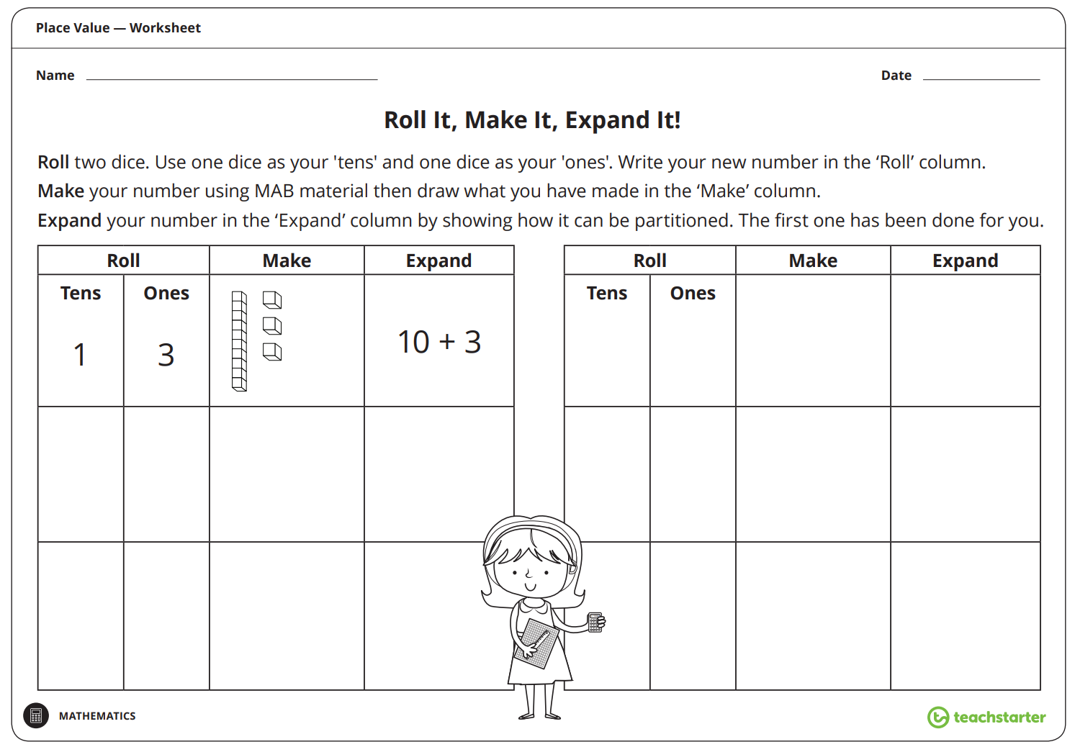
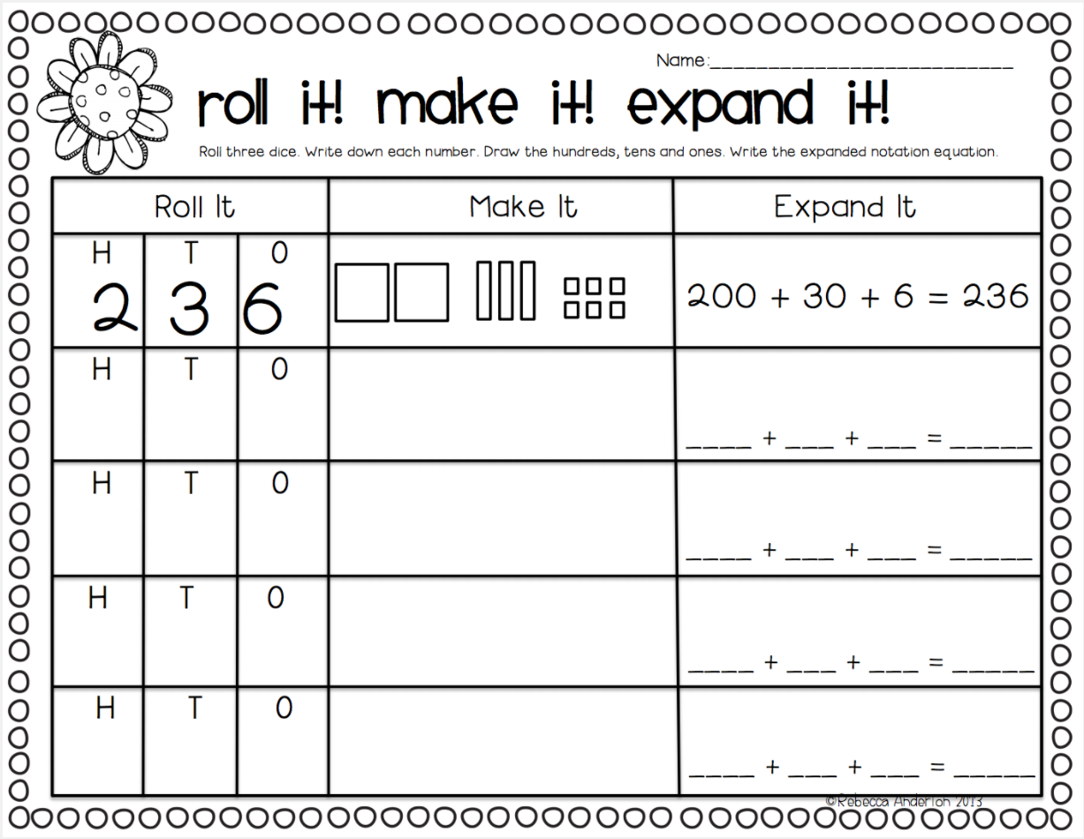

Extension: 4-digit numbers
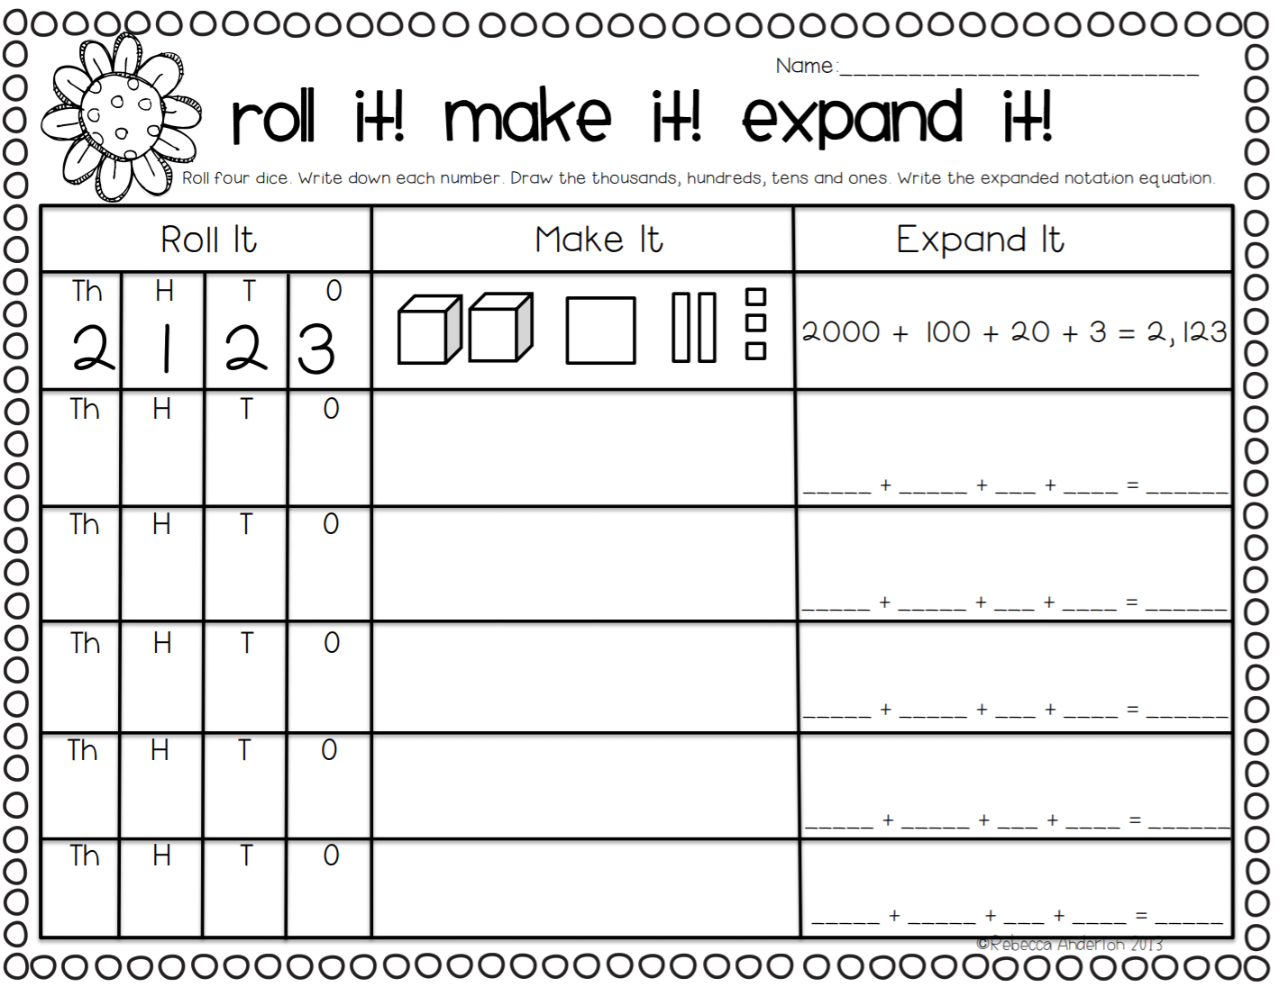

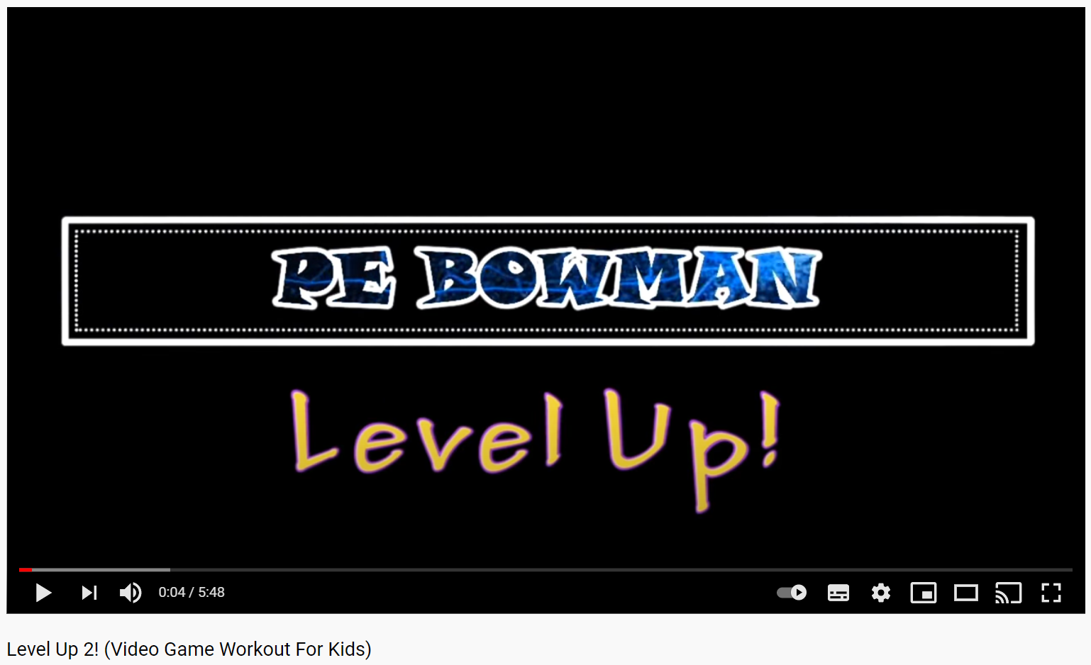

Physical Activity:
Complete thirty minutes a day of physical activity. Go for a walk, run or ride with an adult.
Have a go at completing the Level Up! 2 youtube clip - https://video.link/w/KcN4c

OR

Watch Miss Finch’s Olympic Challenge video 3 in your SeeSaw activities – ‘Long Jump’
Attempt the challenge using things from around your house.

Break – Time to stop and refuel. Eat, play, have fun. Self-directed outside activities where possible.
Science: - Exploring Sound
“Sound is created when something vibrates and sends waves of energy (vibration) into our ears. The vibrations travel through the air or another medium (solid, liquid or gas) to the ear. The stronger the vibrations, the louder the sound. Sounds are fainter the further you get from the sound source.
Sound changes depending on how fast or slow an object vibrates to make sound waves”.

Create your own musical instruments (or use ones you have at home) to explore the difference in sound.
- Maracas (using a finished toilet roll, block one end and add rice. Block the other end and shake!)
- Clapping sticks (find 2 strong sticks (thick) and clap them together).
- Drum (use a metal pot or bowl and turn it upside down. Use a metal spoon to hit the bottom).

What did you learn about the sounds?
- Were the sounds the same or different? Why?
- How did you make the sound come from each instrument? (Think about verbs - action words)
- Can we change the sound we made in any way?

Thursday - Week 5, Term 3 – Stage 1
Daily Task – Help an adult with an outside activity.
English:

Reading: Today, you have a reading challenge! Ask your parent/carer if you are allowed to make a reading den. If you can’t make a den, imagine you are reading in a den or a cave. If yes, make sure they supervise you. Make a den to share a book in! Read a book to someone else in your den.
Spelling: Using your spelling words, write a sentence for each word. Try to make your sentences interesting and longer by using joining words such as (and, but, so, because). You also know the definitions of your spelling words from yesterday’s work. You could use those definitions to make and add even more detail to your spelling sentences.
Writing: Day 4 of persuasive writing. It’s time to write your third and final reason of your persuasive text. If it is your third reason, start your sentence with ‘Thirdly’ or ‘Finally’.
Write in full sentences and remember to use capital letters and full stops!

Title

Opinion/Introduction

Reason 1

Reason 2
Reason 3

Extension: Write more than three reasons in your persuasive writing. You can write as many reasons as you like! Make sure it flows and makes sense.

Speaking and Listening:
Group Discussion. When your family and people you live with are all together (maybe at mealtimes), ask this question to everyone, ‘What do you think is your best skill and why?’ Listen to everyone’s responses then discuss what you are super good at.

Break – Time to stop and refuel. Eat, play, have fun. Self-directed outside activities where possible.
Maths:
Warm Up: 1 more, 1 less, 10 more, 10 less.
Complete the activity using the following numbers. If you need to use a hundred chart to help.
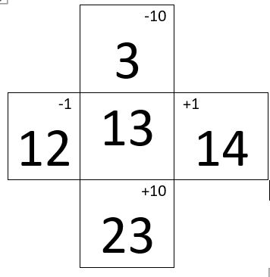

Your numbers - 27, 39, 46, 50, 63, 71, 88, 94, 107

Australian Money:
Collect Australian coins from your money boxes – or ask a parent.
Order the coins from the coin worth the least amount of money, to the coin worth the most amount of money.
- Write the amount that each coin is worth (hint: silver coins are ‘cents’ or ‘c’ and gold coins are ‘dollars or ‘$’).

In each dollar there are 100c. (You can draw coins for this activity if you don’t have enough)
- 5c: How many times do you need to count by ‘5’ until you get to ‘100c’ or ‘$1”? (Use 5c coins to help you count!
- 10c: How many times do you need to count by ‘10’ until you get to ‘100c’? (Use 10c coins to help you count!)
- 20c: How many times do you need to count by ‘20’ until you get to ‘100c’? (Use 20c coins to help you count!)
- 50c: How many times do you need to count by ‘50’ until you get to ‘100c’? (Use 50c coins to help you count!)

We can add our silver coins together to make different amounts of money.

Extension:
Can you add some silver coins together in different ways to equal $1?
Show your teacher as many different ways as you can!

Physical Activity:
Complete thirty minutes a day of physical activity. Go for a walk, run or ride with an adult.
Work on a gross motor skill that you need to practice – ball skills (kicking, throwing, shooting), balance (riding a bike/scooter, walking in a straight line, balancing on a low ledge), etc.
Can an adult help you to get better at these skills? Will practising just one time help you get better?

OR

Watch Miss Finch’s Olympic Challenge video 4 in your SeeSaw activities – ‘Bowling’
Attempt the challenge using things from around your house.

Break – Time to stop and refuel. Eat, play, have fun. Self-directed outside activities where possible.
Creative Arts:
Patience is a very important skill we all learn. Have a go at recreating this colourful artwork. Find different sized circles in your house to trace around, and then colour each section a different colour. If you have coloured paper at home, you may want to cut different coloured/sized circles and glue them with the largest on the bottom to the smallest on the top.
Your goal is to not have the same colour touching!
When you are tracing make sure you take your time. Don’t rush and use a rubber to help fix up any lines that you need to.
Are there any other shapes this would work with? If you would like a challenge, show your teacher this artwork with different shapes e.g. squares.

Friday - Week 5, Term 3 – Stage 1
Daily Task – Clean your room.
English:
Reading: Choose a book to read from home or on your PM E-reader. Remember to stretch out any words that you don’t know. Write down any words you had trouble with to keep practising.
Spelling: Write your spelling words in rainbow colours and use a different colour for each sound [e.g. sp/e/ll/ing = spelling]
Writing: Day 5 of persuasive writing. This is the final day of your persuasive writing. Now let’s a write final opinion/conclusion. Restate your opinion with different wording to your opening opinion/introduction.
For example: ‘If you read all my reasons in my writing, you will agree that School is much, much better than Learning from Home!’
Edit your work. Reread all your writing. Check and then fix spelling errors, punctuation (full stops, capital letters, question marks and exclamation marks), paragraphs and check all your sentences make sense?
Title

Opinion/Introduction

Reason 1

Reason 2

Reason 3

Restate Opinion/Conclusion
Speaking and Listening: Read your writing to a family member (at home or call someone in your family to read your writing to!). If you are at school, read your writing to a friend.
Make sure your writing makes sense before you start reading it to someone else (read it to yourself first!).
Break – Time to stop and refuel. Eat, play, have fun. Self-directed outside activities where possible.
Maths:

Warm Up: Draw a picture by listening to the instructions given to you by an adult (at home, as a video call or over the phone). The picture may be of an outdoor scene (sun in the top right corner, tall tree on the left-hand side).
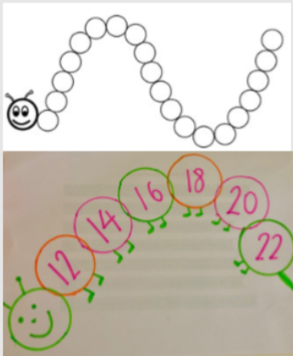
Discuss the different language and vocabulary involved before starting - horizontal, vertical, left, right, top, bottom.
As the adult gives the instructions, they also draw their own picture. Show each other at the end.
- Are they the same?
- Are they different? Why?
- Is it hard to listen to the instructions?
- Did the person do a good job at explaining their instructions?

Swap - now the student gives the directions to draw the picture.
- Is it hard to give the instructions?
- Did the other person do a good job at listening?

Skip Counting:
Create a sequencing caterpillar --> make one for skip counting by 2’s, 5’s and 10’s.
DON’T start at 0 – find a different number to start with and keep counting from there.
Practise counting both forwards and backwards.

Try this activity with both 2-digit and 3-digit numbers e.g. counting by 10: 377, 387, 397, 407, 417

Physical Activity:
Complete thirty minutes a day of physical activity. Go for a walk, run or ride with an adult.
Talk to an adult at home – what sports did they play when they were your age?
Use equipment found at home to learn about the sports they played and to give them a go!

OR

Watch Miss Finch’s Olympic Challenge video 5 in your SeeSaw activities – ‘Javelin: Overarm Throw’
Attempt the challenge using things from around your house.

Break – Time to stop and refuel. Eat, play, have fun. Self-directed outside activities where possible.
FriYay Fun Time:

Take some photos and send them to your Teacher on Seesaw to show you how to celebrate your Fri-Yay!
Enjoy an activity outside or even get creative at home.
Have a great weekend!

