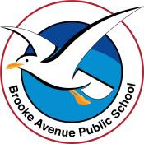
Learning from Home – Brooke Avenue Public School
K-6J, K-6M and K-6S – Week 5, Term 3
The following timetable can be used by students to support learning at home. All tasks have been linked to syllabus outcomes. If technology is available at home, please use the attached links to support learning.
Monday - Week 5, Term 3
Daily Task – Make the beds and tidy the living room.
English:
Watch this short film about Jimmy and his move to the city. https://www.literacyshed.com/embarked.html Answer some of the questions attached to the film.

Would you prefer to live in the city or the country? Why? Can you draw a picture of your ideal house and garden? What would you include in your house and garden and why? Maybe you would have a slide instead of steps, or an elevator, or secret rooms, or a fairy garden, or a pool and spa? Post your work onto Seesaw so we can see your beautiful house and garden!

Nouns are naming words. Write (or have an adult help you to write) some of the names of things you saw in the film eg, treehouse, hardhat, overalls, slide, swing, clouds, tyre, hand basin. Can you present these words in different ways? You could write them in sand or dirt, type them, use rainbow colours, spray shaving foam and trace them in the foam or even collect small stones from the garden and make your words using the stones! Be creative and show someone your finished list!

Logon to your reading eggs account and enjoy some down time! https://readingeggs.com.au/

Break – Time to stop and refuel. Eat, play, have fun. Self-directed outside activities where possible.
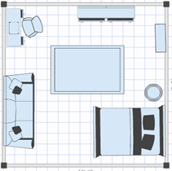
Maths:
Today you are going to draw a ‘bird’s eye view’ of a room in your house. You need to imagine that you are flying over the room and looking down on it. What can you see? Can you imagine the shape of your furniture from above? The example includes a bed, couch, desk and chair, two dressing tables, a side table and a rug. Is your drawing similar to this or did you choose a different room in the house? You may choose to label your furniture. You can use the attached worksheets about Jimmy’s Room or create your own template!

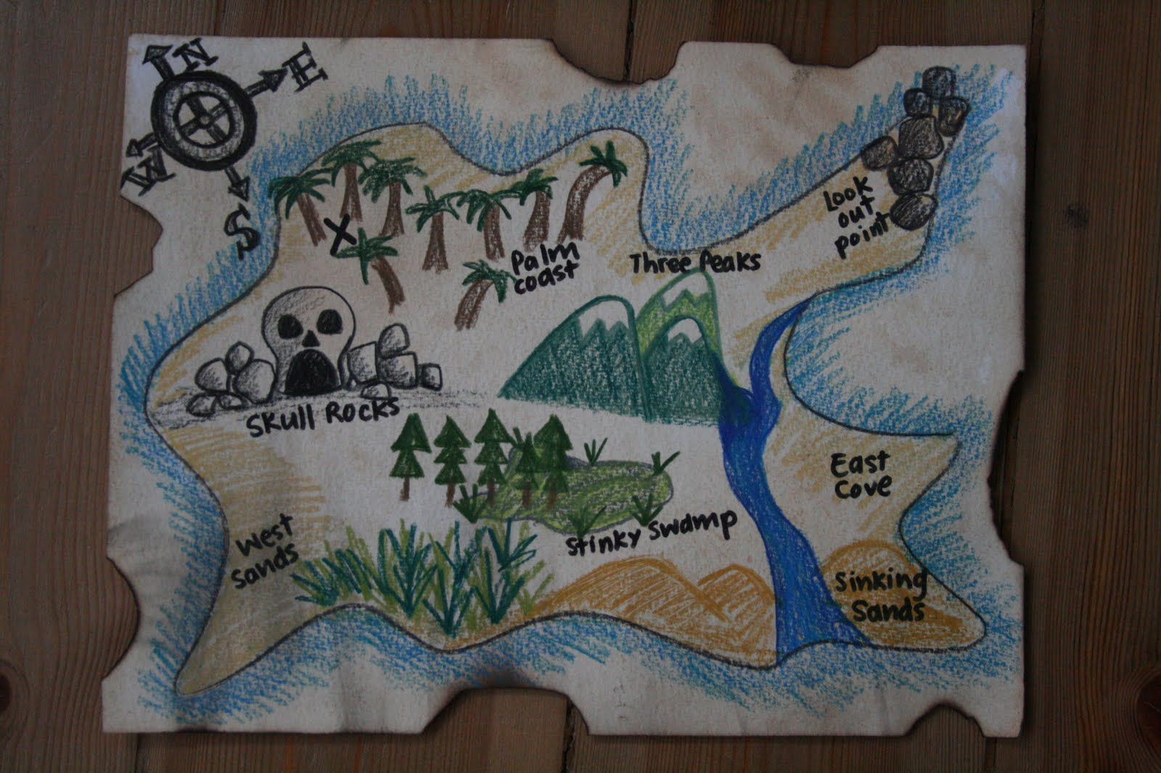
Can you create a pirate treasure map using ‘bird’s eye view’? What will you include on your map? Maybe you will have some quicksand, or mountains, or a wobbly bridge, or cave full of wild animals? Once you have drawn your map, trace over any pencil with a texta and ask if you can stain the paper using an old, wet teabag. You can also tear the sides of your map. This will give your map an ‘old’ look.

Please post one of your maps onto Seesaw so we can see your work!

Break – Time to stop and refuel. Eat, play, have fun. Self-directed outside activities where possible.
Art/Science: Making playdough!
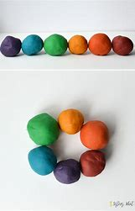
Follow the procedure on this short video or follow your own recipe to make playdough. This is a no cook recipe: Playdough recipe - BBC Good Food and this one requires heating on an element Cream of Tartar Playdough Recipe – Playdough Recipe.
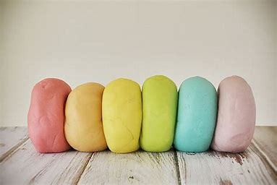
Make sure you have all your ingredients and equipment ready.
Put on an apron as this may get a little messy!
Follow the instructions and carefully measure each ingredient.
You may need the help of an adult as the mixing part can get a little difficult!
Once your playdough is ready, knead it with a little flour and then you’re ready to start playing!
Make sure you store your playdough in an airtight bag as it will last longer this way and will not dry out!

Please post some photos of the amazing things you have made with your playdough onto Seesaw so we can see your creations! Woohoo!

Tuesday - Week 5, Term 3
Daily Task – Clean out the plastic container cupboard and match the containers and lids!
English:
Watch the Rainbow fish https://www.youtube.com/watch?v=Z3cmddZh6t8
This story is about being a good friend and helping others.
Write (or have an adult help you write) some ways that you can be a good friend to others and how you could help someone else. For example, you could ask someone to join your game, help prepare dinner, share your toys or give someone a compliment. When you have a few ideas, create a poster, a song, a poem, a PowerPoint or a list of your ideas and illustrate each idea. Post your display onto Seesaw so we can see the wonderful ways you can be kind and caring towards other people!
Choose some of the words from the above task and write them in an interesting way…rainbow writing, put them into another sentence, make a word find or a crossword using your words, type them in different fonts and change the size and colour of your words or say them using funny voices.
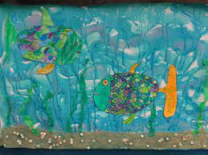
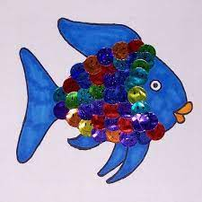
Create an artwork about the rainbow fish…these images will give you some ideas…
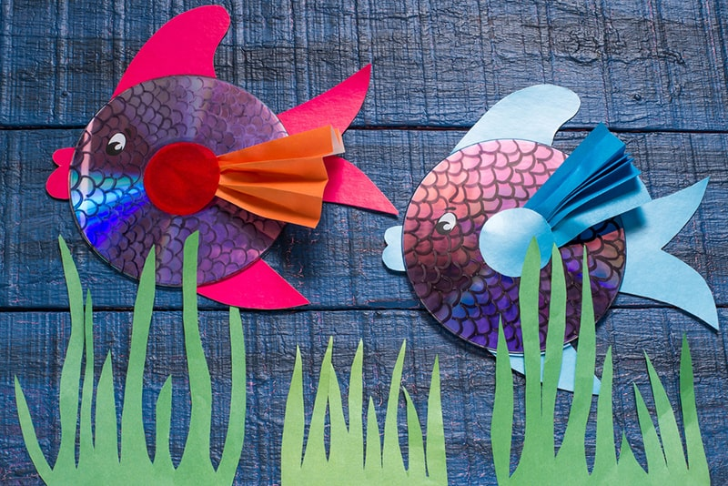
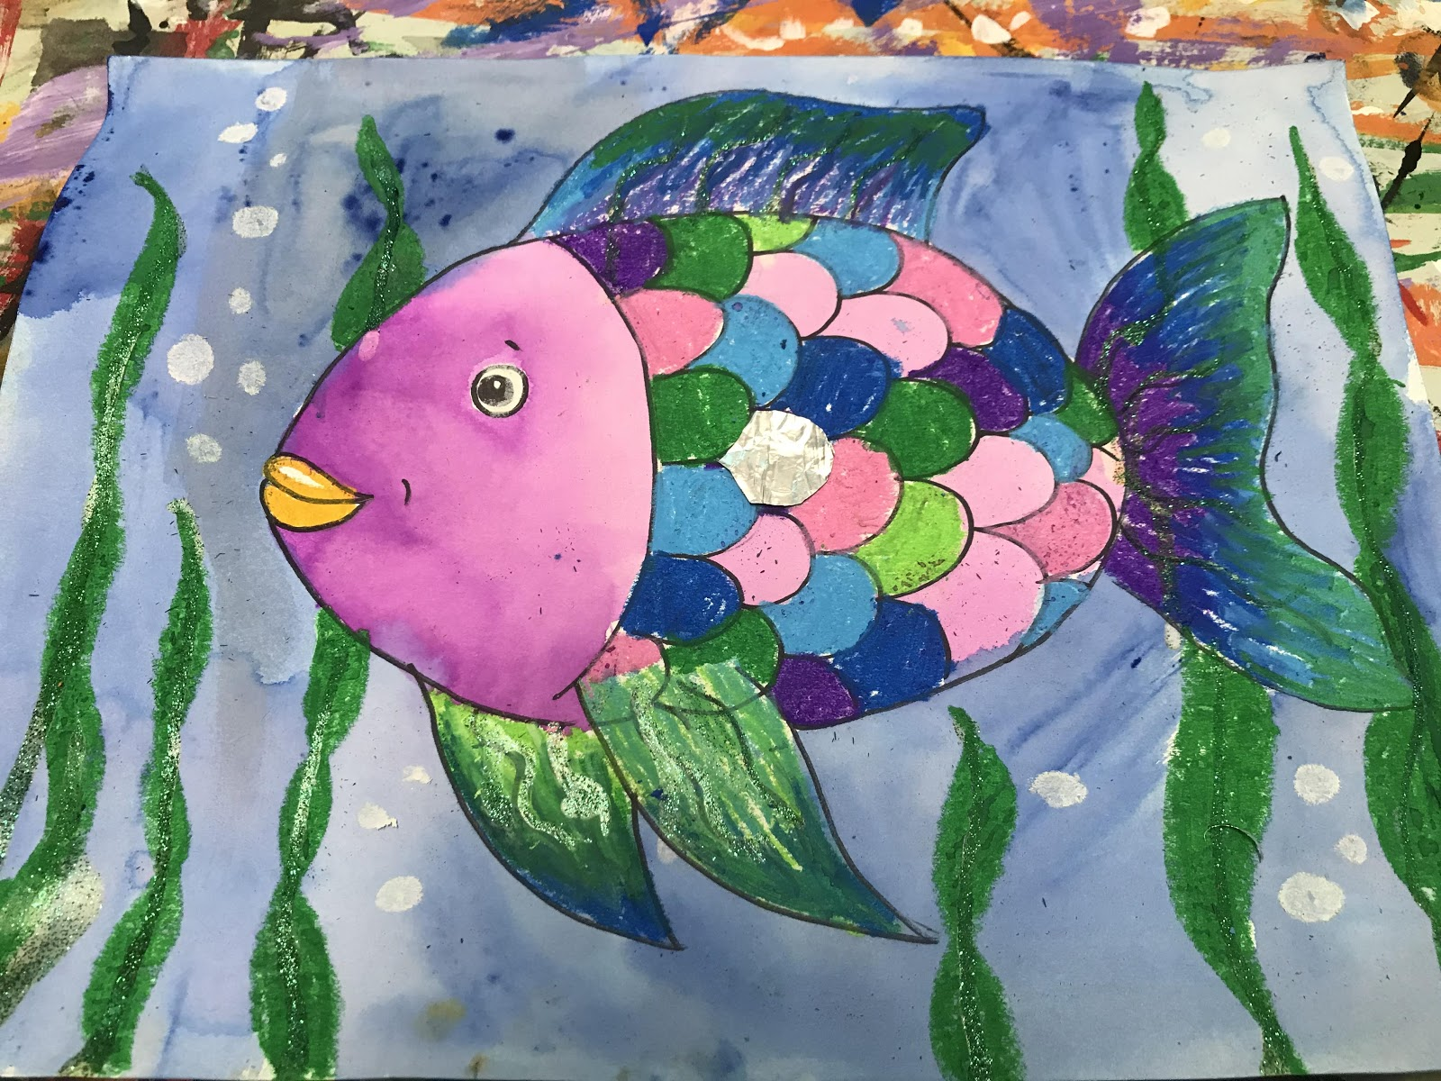

Practise your letter formation by interacting with this game Sky Writer - mobile friendly (ictgames.com) and copying what the jet does. You can do this any way you like…on paper, in sand, in the air with your finger, on someone’s back, on your own leg, in shaving foam, in uncooked rice…whatever suits you! (Note to parents/carers-please don’t select the cursive option!). Have fun!

Break – Time to stop and refuel. Eat, play, have fun. Self-directed outside activities where possible.
Maths:
Today we are going to work on positional language; under, next to, on top of, over, behind, inside…this short clip will explain this Position Words - YouTube To extend students, words like left, right, north, east, south and west can be used too. You can use the resources provided and then make up a position game of your own.
Cut out the Humpty Dumpty positional cards and lie them face down on the table or the floor. Choose a toy each. Take a card, read the position to yourself and go and hide your toy without the other player/s seeing. Each person playing takes a turn to do this. Once everyone has hidden their toy each player gives directional clues as to where their toy is hidden…eg ‘Walk through the kitchen door and turn left, you will find the toy under something brown that is beside the sofa.’ The person to find the toy first is the winner.
You could make two copies of the cards and create a memory game. Turn the cards over on the table or floor face down. Taking turns, select two cards and turn them face up. If they match you get to keep the two cards, if they don’t match the cards are turned back over in place and the next person has a turn. The player at the end with the most pairs is the winner.
Try these fun maths activities…
Ordering and sequencing numbers Caterpillar Ordering - An Ordering and Sequencing Game (topmarks.co.uk)
Finding numbers and counting on and back Blast Off - Mental Maths for 5 to 8 Year Olds (topmarks.co.uk)
Addition to 10 Addition To 10 (topmarks.co.uk)
Log onto your maths seeds or study ladder accounts and do some activities…

Break – Time to stop and refuel. Eat, play, have fun. Self-directed outside activities where possible.
Personal Development and Health
Eating a wide range of foods is very important for your health and general wellbeing. Look at the ‘Eat the Rainbow’ poster and try to think of a fruit or vegetable you know that match the colours in the rainbow. Create your own rainbow or healthy food poster by drawing pictures of fruits and vegetables, cutting images out of magazines or finding and printing online images.
Choose one of the fruits or veges and make an acrostic poem about it…
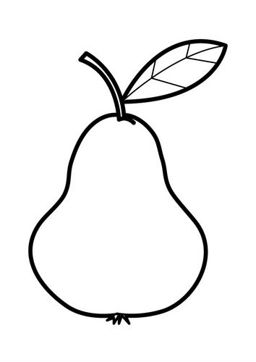
Perfectly plump
Easy to eat
Always available
Ready to take to school
Sweet and delicious!
Publish your poem on a piece of paper cut in the shape of your fruit or vege…
More information about healthy eating can be found on the Sanitarium Website ’12 before 12’ program 12 before 12 - healthy eating and cooking for kids | Sanitarium Health Food Company
Wednesday - Week 5, Term 3
Daily Task – Sort through your old toys-make a keep, donate and throw away pile.
English: Watch “Go Home, Cheeky Animals’ Go Home, Cheeky Animals! read by Jack Charles | Play School Story Time | ABC Kids - YouTube
Can you write a list of the animals in the story and what they did? Illustrate your list.
Using your imagination create another ‘page’ in this book. Maybe you will have some Cheeky Chickens who come into the camp and start eating the vegetables growing in the garden? Or a Cheeky Dingo that takes the dogs balls and sticks, and buries them in the dirt? Perhaps a Cheeky Echidna will visit the camp and poke everyone with its spines? You will need to think of the text and type or write it (you may need an adult to help with this part) and also illustrate your page. Please post your work onto Seesaw to we can see what you have done!
Cut out the ‘nature themed alphabet’ in your resource pack. Randomly choose a letter and think of an animal that starts with that letter. For example G-goat, P-pink flamingo etc. Can you find an animal for every letter?
Can you make an alphabet like this one? Work on this of the rest of the week because it will take you a while to make each letter. Post images of your letters onto Seesaw so we can see your work! Have fun!
Take some time to work on your studyladder, reading eggs or ePM readers.
Break – Time to stop and refuel. Eat, play, have fun. Self-directed outside activities where possible.
Maths: Data
Today we are going to look at collections of items and how you can display them in a graph to make it easier to see what was the most common item, or the least common and to find out any items that were the same. To get into the mood and to give you an idea of what to do, complete the sheet attached called ‘Australian Animals Count and Graph’. You may need an adult to help you to complete this or perhaps you can do it by yourself?
Now it is your turn to choose an item, count and graph your results. Use the blank templates attached or make your own using graph paper or a ruler to draw even sized boxes. Some ideas of what you could graph are: counters, M&M’s, coloured cars that drive past your house, lego blocks, beads, the colour of clothes that hang in your wardrobe, the colour of your toys, different shapes around your house, different foods you have in the pantry…use your imagination-you can graph the results of almost any collection of items!
Once you have completed your graph think of some questions that you could ask someone about your graph. For example, if you graphed shapes around your house you could ask…‘Which shape is the most popular? Which shape has the least items? How many more squares are there than circles? What shapes recorded the same amount? How many shapes are there altogether on the graph? Did the person get all the questions correct? Take a photo of your graph and post it on Seesaw. Can we answer your questions?
Complete some of these data games…
Fishing Pictograph Game | 2nd Grade Math Games | Toy Theater
Fruit Fall Pictograph Game | 2nd Grade Math Games | Toy Theater
Curious George . Hat Grab | PBS KIDS
Log on to study ladder, maths seeds, ABCya or prodigy and play some games of your choice!

Break – Time to stop and refuel. Eat, play, have fun. Self-directed outside activities where possible.
Art
Get a piece of paper, a black texta, some coloured textas and something round that you can trace around (maybe a large glass or saucer). Go to this art hub link about drawing an emoji monster. How To Draw An Emoji Monster - Folding Surprise - YouTube
Follow the steps and soon you will have your very own emoji monster! Please take some photos of it and post it onto seesaw so we can see your amazing work!
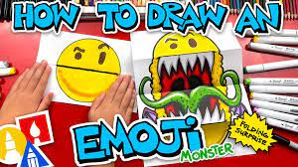
There are so many cool drawings that you can do by following these instructions! Or you can use your imagination and draw something of your own!
You could make a folding shark with huge teeth, a cute cat with a huge smile or a dog with a big, slobbery tongue! We can’t wait to see your artwork!
Have fun!

Thursday - Week 5, Term 3
Daily Task – Help with breakfast, lunch and dinner today!
English: Watch this clip about Anna and her dad going shopping so they can make a yummy eggplant cake! Anna Goes To The Supermarket - Educational Stories for Kids - YouTube
Look at the recipe for Breakfast Berry Trifle…it looks delicious doesn’t it! See if you can find a recipe for a lunch and a dinner so you have a whole meal plan organised. You can look through cookbooks you may have at home, go onto Goggle and search for recipes or visit this link that has a lot of easy kids meals to make. Kids' cooking recipes - BBC Good Food .
- Make a shopping list of all the items you will need in order to make your meal plan (if this is too difficult then just choose one recipe or have an adult help you).
- Are there any tricky words in your list that you can add to your spelling list?
- Can you read all of the words?
- Can you write the words of the items you will need and draw a picture of them?
- Can you draw a picture of your meals and label each item in them?
- Can you make recipe cards that have each step on them to make your recipe easier for you to follow?
- Look through the cupboards and draws at home to see if you have all the materials and equipment you will need to make your meals, like…knife, bowls, plates, frying pans etc. If you do not have all of your equipment, write what you need on your shopping list.
- Ask your family members which recipe they like the most and why. Which do you like and why?
Watch this book called ‘Pete the Cat and the Perfect Pizza Party!’ Pete the Cat and the Perfect Pizza Party - Read With Me Book - YouTube. Maybe pizza is on your menu? If you were making a pizza what would it have on it? Pretzels, pickles and popcorn? Or do you prefer something more traditional like ham, cheese and pineapple? Ask your family members what their favourite pizza is!
Play the spooky sounds game. Choose the sounds you would like to practise and drag them into the cauldron…can you find these sounds in your recipes? Spooky Sounds (ictgames.com)
Log onto Reading Eggs or ePM collection and find some more books and activities to enjoy!
Break – Time to stop and refuel. Eat, play, have fun. Self-directed outside activities where possible.
Maths: For maths today, you are going to search for the items you need for your meal plan using these online catalogues. Coles | Recipes & Meal Inspiration - Weekly Deals Catalogue, Woolworths Supermarket - Buy Groceries Online, IGA Online Shop: Home Delivery Service | IGA Supermarkets. If you don’t have access to the internet, use old shopping catalogues that you have at home.

- Look at the shopping list you have written earlier today.
- Type in the item you need and write the cost of it next to the item name.
- To make this task easier, just add the dollar amount but if you want a challenge, write the total amount using dollars and cents.
- Once you have found and written all the amounts down, estimate how much this grocery shop is going to cost.
- Write your estimate down.
- Now, using a calculator, add the amounts together and write the grand total down. Kid's Calculator (kidssearch.com) (don’t forget to use the decimal point!)
- How close to the total cost was your estimate?
- To challenge yourself, do this task again but using a different supermarkets online shopping list. Was it cheaper or more expensive? Which supermarket do you think is a better one to shop at? Why?

Can you order money from the smallest value to the largest? Look for the money sheet in the resource section and see if you can complete it!
Log on to studyladder, Maths seeds or prodigy and have some fun!

Break – Time to stop and refuel. Eat, play, have fun. Self-directed outside activities where possible.
Science:
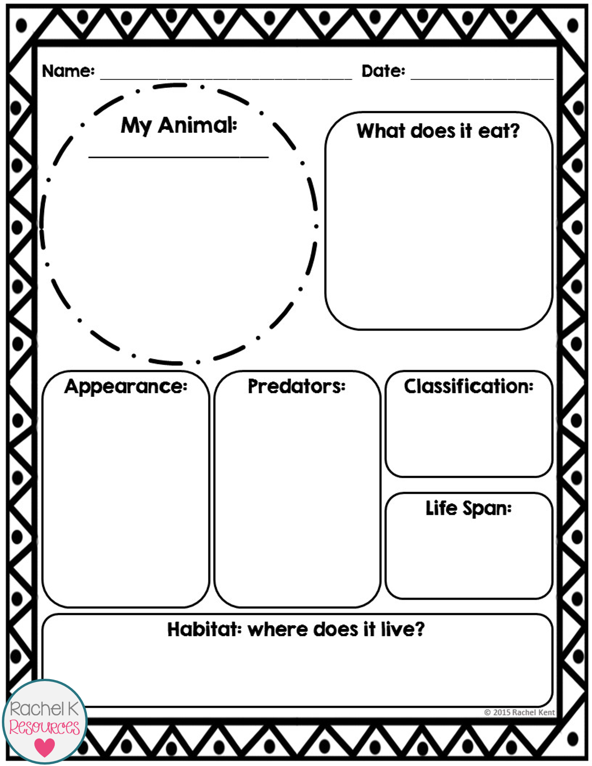
Choose an episode to watch about an animal that you like https://iview.abc.net.au/show/72-cutest-animals (these episodes are quite long so you may need a break in the middle!)
Can you create a report on the animal? You will need to listen carefully to where your animal lives, what it eats, how it moves, what colour it is, how long it lives, how many babies it has, and you may also find out some interesting information about it. You can present your information any way you like. You could create a PowerPoint, or a poster, a speech, or use a template from below to give you some ideas. If you would like to use the templates provided about Australian native animals they can be found in the resource section of this document.
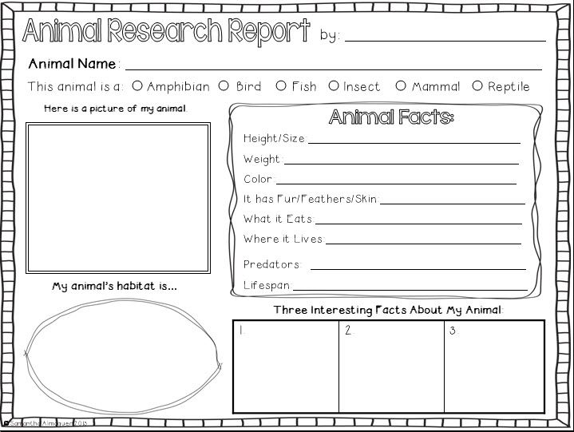
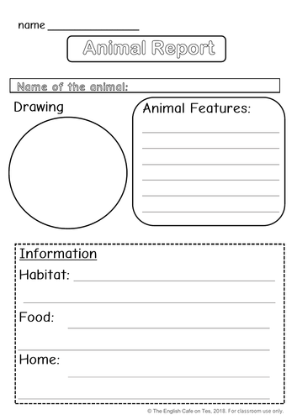
Please post your work onto Seesaw so we can see it!

Friday - Week 5, Term 3
Daily Task – Ask if you can vacuum the floors and clean the mirrors! The house will look fantastic!
English: Indoor Scavenger Hunt!
Your task is to go on a hunt around your house for the following items! If you find the list too long, you can adjust the list to suit you!
- something with wheels
- a book with the first letter of your name in the title
- a matching pair of socks
- four things that are green
- something very soft
- a toy smaller than your hand
- something round
- an item you can see yourself in
- something that makes you feel warm
- your favourite toy
- something you can eat
- three things made from plastic
- something that doesn’t belong to you
- an item that is older than you
- something that is alive
- an item that cannot roll
- one item of your choice

Gather all your items in the same place (if you can) and order them from the thing you like the best to the item you like the least. Tell an adult your reasoning behind why you ordered your items like this. Ask an adult or someone else at home to order the items in the order that they like them. Did they order things the same way as you? Why do you think this is?

Choose 5 of the items and use them as props in a play, rap, song, a story or in an artwork. For example, you may have a banana, a mirror, a plastic solider, a toy car and a blanket. How could you use your items? Could you create a story about them? Could you make an artwork about your items? A song or poem? We are very excited to see how imaginative you can be!

When you have finished with the items from the Scavenger Hunt, make sure you return everything to its place!

Enjoy FriYay by watching a show of your choice from ABC kids! ABC Kids

Break – Time to stop and refuel. Eat, play, have fun. Self-directed outside activities where possible.
Maths: FriYay maths is FunYay maths!

Use the templates for the Chatter Box and the Paper Flower Pot to create your own special origami. You will need scissors and glue, and possibly an adult or older sibling to help you with some of the steps. Have fun and please post these onto Seesaw so we can see the finished product!

- Play with this online geoboard Geoboard by The Math Learning Center
- Enjoy making beautiful patterns with these online 2D shapes Pattern Shapes by The Math Learning Center
- Try this patterning game Shape Patterns (topmarks.co.uk)
- Go to ABCya and choose some fun games to play ABCya! • Learning Games and Apps for Kids

If you don’t have internet access go through the resources from this weeks Working from Home document. Is there anything that you need to complete? What did you enjoy doing and why? Go onto Seesaw and watch the stories and videos we have posted throughout the week/s.

Break – Time to stop and refuel. Eat, play, have fun. Self-directed outside activities where possible.
Happy FriYAy!
You have worked very hard this week so now is the time for you to do something that YOU would like to do!
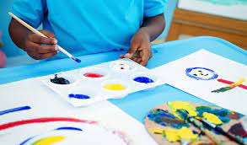
You could…
- Paint a picture
- Play with your playdough
- Ask an adult if you could go for a walk on the beach
- Play a video game
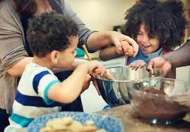
- Facetime a friend
- Watch a movie
- Do some baking
- Read your favourite book
- RELAX!

Plesae send us a photo of you having fun on FriYay! Have a great weekend!

