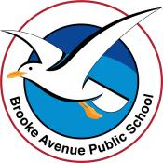
Learning from Home – Brooke Avenue Public School
Kindergarten – Week 5, Term 3
The following timetable can be used by students to support learning at home. All tasks have been linked to syllabus outcomes. If technology is available at home, please use the attached links to support learning.
Monday - Week 5, Term 3 - Kindergarten
Daily Task - Match socks and sort washing.
English:
Phonics
Today we are learning the oa sound as in boat. We see the oa in the middle of a word or at the start of a word – oats or toad.
- Write the oa sound and say it as you write it.
- Write the word t-oa-d then change to make r-oa-d then change to make l-oa-d
Rhyming Words:
Say or create a list of rhyming words with the oat sound.
Coat/goat/oat/gloat/float/boat/throat
Extension: Write a sentence with as many oa words in it as you can.
Reading
- With a family member or by yourself, read the story ‘Sam and Mac’ and answer questions.
- Read a story on the PM eReaders app (https://app.pmecollection.com.au/login)
Writing
- Draw or write about which sport you have liked watching on the tv of the Olympics. You could keep it simple and write, “I like …...” and write about the sport you have liked watching. You could extend your sentence by writing, “I like the...because...” Take a photo of you with your writing and show your teacher on Seesaw.
Sight Words
- Write your sight words somewhere outside – use chalk on your driveway or path.
Extension: Write 3-5 sentences using your sight words.
Optional - Complete Reading Eggs Activities for 10 minutes.
Break – Time to stop and refuel. Eat, play, have fun. Self-directed outside activities where possible.
Maths:
This week we are learning about time. Children will learn to tell the time to the hour.
- Ask your child: Why is knowing the time important? Discuss analog and digital clocks and what they look like.
Use the link to explain today’s activity https://youtu.be/Z-YpJA56bOM
- Go on a ‘time tour’ around your house and draw all the clocks you find on a piece of paper.
- Complete the Clock Activity Worksheet for Monday. Label the numbers on the analog clock. Label the short and long hand.
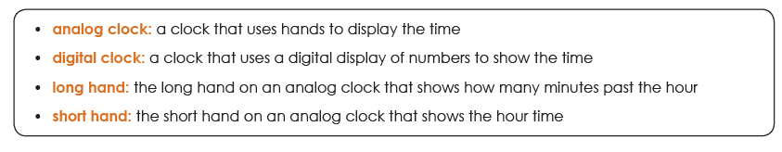
Extension: View the ABCKids TV guide https://www.abc.net.au/tv/guide/abc2-7day-guide.htm write down the time of three of your favourite shows. Have a go at drawing your favourite character from each show.
Play with a friend https://youtu.be/Qh44oRex-Hw
Optional - Ask a family member to write out any 10 numbers between 1-30 on a piece of paper. Write the numbers that come before and after the numbers written down.

Break – Time to stop and refuel. Eat, play, have fun. Self-directed outside activities where possible.
PDHPE: Dancing

Click the link below and participate in the dance lesson.
GetActive@Home – Episode
Creative Arts: Visual Arts
These surreal works are by Salvador Dali. Surreal means that it isn’t real. Draw your own surreal clock on a piece of paper. You may colour it in or paint it.
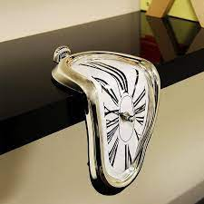
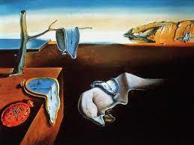

Tuesday - Week 5, Term 3 - Kindergarten
Daily Task - Wash the dishes.
English:
Phonics
Today we are learning the ow sound as in grow. We see the ow sound at the end of a word.
- Write the ow sound and say it as you write it.
- Write the word b-ow, then change it to l-ow, then change it to m-ow
Rhyming Words:
Say or create a list of rhyming words with the ow sound.
bow, row, tow, mow, snow, show, slow, grow, throw
Extension: Write a sentence with as many ow words in it as you can.
Reading
- With a family member or by yourself, read the story ‘Deb the Vet’ and answer questions.
- Read a story on the PM eReaders app (https://app.pmecollection.com.au/login)
Writing
- Draw or write something you know about Tokyo. With the Olympics being on, you will be seeing and hearing a lot about Tokyo. Can you write something about Tokyo? Take a photo of you with your writing and show your teacher on Seesaw.
Sight Words
- Write your sight words in rainbow colours.
Extension: Write 3-5 sentences using your sight words.
Optional - Complete Reading Eggs Activities for 10 minutes.
Break – Time to stop and refuel. Eat, play, have fun. Self-directed outside activities where possible.
Maths:
Today we are making an analog clock to practise showing the time. The word analog means a clock that uses hands to display the time. Watch https://video.link/w/qo14c
- Find an anolog clock and point to the clock face, this is the flat part of the clock. The hands and numbers on the clock face help us tell the time. One can be viewed at -https://toytheater.com/clock/ Tip: Turn the digital clock option OFF.
Use the link to explain today’s activity https://youtu.be/92t2iM_06_c
- Starting at 1, revise the numbers on the clock. These numbers are used to read what hour time it is.
- Point to the hands on the clock face. Explain that these are called hands. Ask your child to tell you the difference between them; one is long and one is short.
- The hands move around the clock face pointing to different numbers. Point to the short hand. The short hand shows us the number of the hour.
- When we read the o’clock time or the hour time, the long hand is always pointing to the 12 and the short hand tells us the number of the o’clock.
- Cut out clock on the Making a Clock Worksheet and practise making times.
Extension: Fold a piece of paper into quarters. Write down the time, go outside and draw what the weather looks like. Repeat x3 more times.
Play with a friend https://youtu.be/XitsXOEF_TY
Optional - Complete Maths Seeds Activities for 10 minutes.

Break – Time to stop and refuel. Eat, play, have fun. Self-directed outside activities where possible.
PDHPE:
Dancing: Complete some of the activities on the dance challenge card.

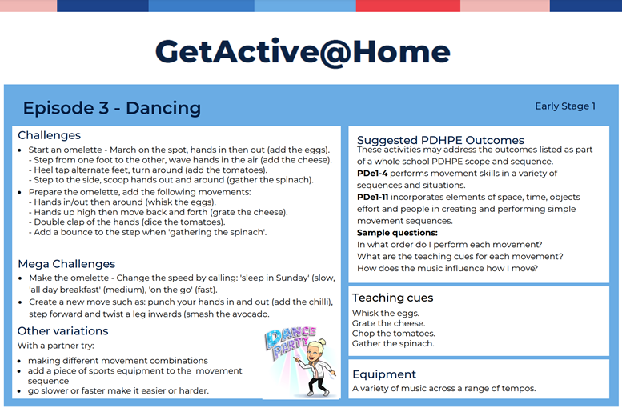
Creative Arts: Drama
Think about your favourite animal.
- How does it move?
- What noises does it make?
Pretend to be your favourite animal.
Ask a family member to film you being your favourite animal and post to your teacher on Seesaw.
Wednesday - Week 5, Term 3 - Kindergarten
Daily Task – Make your bed.
English:
Phonics
Today we are learning the or sound as in horn. We see the or in the middle or end of a word.
- Write the or sound and say it as you write it.
- Write the word c-or-k then change to make f-or-k then change to make f-or-m
Rhyming Words:
Say or create a list of rhyming words with the or sound.
orn - corn / born / horn / torn / worn,
ort – fort / port / sort / sport
Extension: Write a sentence with as many or words in it as you can.
Reading
- With a family member or by yourself, read the story ‘Stick bugs’ and answer questions.
- Read a story on the PM eReaders app (https://app.pmecollection.com.au/login)
Writing
- Draw or write about a different sport you have seen or heard about from the Olympics. Take a photo of you with your writing and show your teacher on Seesaw.
Sight Words
- Write a simple table on a piece of paper and sort your words into how many letters they have
1 letter | 2 letters | 3 letters | 4 letters
I | my | the | went
Extension: Write 3-5 sentences using your sight words.
Optional - Complete Reading Eggs Activities for 10 minutes.
Break – Time to stop and refuel. Eat, play, have fun. Self-directed outside activities where possible.
Maths:
Today we are playing, Make that Time.
Use the link attached to explain today’s activities https://youtu.be/lxQxZYYJLiM
- Using the clock you made yesterday, ask a family member to call out times to the hour and make them on your clock.
- Draw or write about what you normally do at these times: 9:00am, 11:00am, 3:00pm, 7:00pm
Extension: Create times to half past an hour. Before making these times, ask someone to show you how the long hand moves when making half hour times.
Play with a friend https://youtu.be/1obSDmmkaKM
Optional - Write out ‘friends of 10’ example: 9+1, 8+2 and ‘friends of 20’ example: 15+5, 10+10

Break – Time to stop and refuel. Eat, play, have fun. Self-directed outside activities where possible.
Creative Arts and Science:
Draw a picture of any living thing.
Ask a family member to video you showing your picture and tell us what makes it a living thing.
Thursday - Week 5, Term 3 - Kindergarten
Daily Task – Help an adult with an outside activity.
English:
Phonics
Today we are learning the oy / oi sound as in soy. We see the oy sound at the end of a word and the oi sound in the middle of a word.
- Write the oi sound and the oy sound and say it as you write it.
- Write the word b-oy, then change it to c-oy, then change it to s-oy
- Write the word s-oi-l then change it to b-oi-l, then change it to c-oi-l
Rhyming Words:
Say or create a list of rhyming words with the oy sound.
boy, soy, coy, joy, toy, ploy, enjoy,
Say or create a list of rhyming words with the oil sound
oil, boil, soil, coil, foil, toil, spoil,
Reading
- Read the story, ‘Jake has a pet snake’ and answer the questions.
- Read a story on the PM eReaders app (https://app.pmecollection.com.au/login)
Writing
- Draw or write a simple review of the Tokyo Olympics Opening Ceremony. You may like to find a highlights video online and watch it and then write about what you liked.
Sight Words
- Make 3 sight words out of lego bricks or outside using sticks or leaves.
Extension: Write 3-5 sentences using your sight words.
Optional - Complete Reading Eggs Activities for 10 minutes.
Break – Time to stop and refuel. Eat, play, have fun. Self-directed outside activities where possible.
Maths:
Today, we are learning how to read digital clocks to the hour, using the term o’clock.
Use the link attached to explain today’s activities https://youtu.be/Aa3dUGNc1Kc
- A digital clock is a clock that uses a digital display of numbers to show the time. Were any of the clocks found in your ‘time tour’ from Monday digital clocks?
- Watch https://video.link/w/9n14c
- Complete the Clock Activity Worksheet for Thursday. Read out the times to your teachers via Seesaw
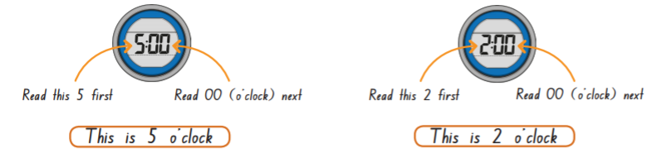
Extension: Ask your child to read the time from a digital clock throughout the day. Your child may like to write these times down and draw a picture of what they were doing at those times. Send it to their teacher via Seesaw.
Play with a friend https://youtu.be/L1L8F5qaH4E
Optional - Complete Maths Seeds Activities for 10 minutes.
Break – Time to stop and refuel. Eat, play, have fun. Self-directed outside activities where possible.
Read a story with Mrs Sullivan https://video.link/w/6dQ4c and write a sentence about why you are happy to be you! (See unicorn attachment)
Science: Living Things
Click the link below and learn what living things need.
https://www.youtube.com/watch?v=7oYTNFNvqO0&t=139s&ab_channel=makemegenius
On a piece of paper, draw the things that living things need. Take a photo and post to your teacher on Seesaw.
Friday - Week 5, Term 3 - Kindergarten
Daily Task – Clean up your room.
English:
Phonics
Sound Review
- Ask a family member to read out the sounds from this week and you write them – oa as in boat, ow as in show, or as in for, oy as in soy and oi as in foil.
CCVC activity worksheet.
There are 2 options for this activity:
Option 1 – do not fold the paper. Simply read the words and draw a line connecting the word to the picture. You could attempt to copy the words to match.
Option 2 – Fold the paper so you cannot see the words. Attempt to sound out each ccvc word and write it down. To check, unfold the paper and check your spelling.
Extension: Write sentences using the words from the CCVC sheet
Reading and Writing
- Listen to a story online from https://storylineonline.net/ and draw or write about the beginning, middle and ending of the story. Take a picture and post it on SeeSaw to your teacher.
Optional - Complete Reading Eggs Activities for 10 minutes.
Break – Time to stop and refuel. Eat, play, have fun. Self-directed outside activities where possible.
Maths:
Today, we are reading analog times to the hour and writing the times digitally.
- Revise features of a clock and how to tell time to the hour.
- Complete Clock Activity Worksheet for Friday https://youtu.be/9m3h2tRNaCM
Extension: Design a watch you would like to wear. Will it be a digital or analog clock face? What will the watch band look like? Does it have other features other than showing the time? Watch https://video.link/w/nz14c for an example.
Play with a friend https://youtu.be/OdVh-kKwj8k
Optional - Write out your numbers 1-30, select 3 numbers and write 4 different way to represent those numbers. Example: 5 - *****, 4+1=5, 10-5=5, 😊 😊 😊 😊 😊

Break – Time to stop and refuel. Eat, play, have fun. Self-directed outside activities where possible.
Mrs Sullivan’s Olympic Challenge
https://video.link/w/jeQ4c (See attachment)

Creative Arts:
Make a sculpture of a living thing. You could use clay or playdoh or even out of dirt/sand. Take a photo and post to your teacher on Seesaw.
HAPPY FRIYAY!
Pick a fun activity to do with a family member to celebrate Fri Yay! You could:
- Cook a tasty treat.
- Play a board game.
- Conduct a fun science experiment (EG: you could see what happens when you put a mentos into a Diet Coke).

