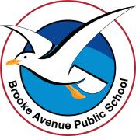
Learning from Home – Brooke Avenue Public School
Stage 1– Week 4, Term 3
The following timetable can be used by students to support learning at home. All tasks have been linked to syllabus outcomes. If technology is available at home, please use the attached links to support learning.
Monday - Week 4, Term 3 – Stage 1
Daily Task - Match socks and sort washing.
English:
Reading
-Choose a book to read. Watch and listen carefully to the video of the shared reading - Nobody Owns the Moon. https://vimeo.com/413152379
-Retell the story to someone else.
Spelling
Brainstorm/think of as many words as you can that have the letter/sound combinations – bl, br, nd, ng, nk, nt. Write them down. Choose 8 you would like to learn. These words will be your spelling words for the week.
Writing
Choose an animal that interests you and research it to write an information report.

Speaking and Listening:
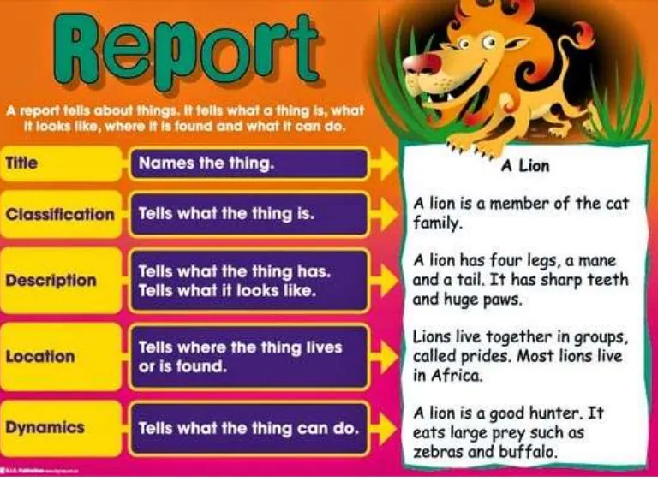
Share your information report with someone.
Break – Time to stop and refuel. Eat, play, have fun. Self-directed outside activities where possible.
Maths:
Clock fractions – Make or draw a clock. Use colours to show how the clock can be divided into halves and quarters. For example: Colour half the clock bule. On the remaining half, use 2 different colours to show quarters. Label the segments you have created as half ½ or a quarter ¼ . Draw the hands on the clock to show either half past 4 (year 1) or a quarter past 4 (year2).
Creative Activities 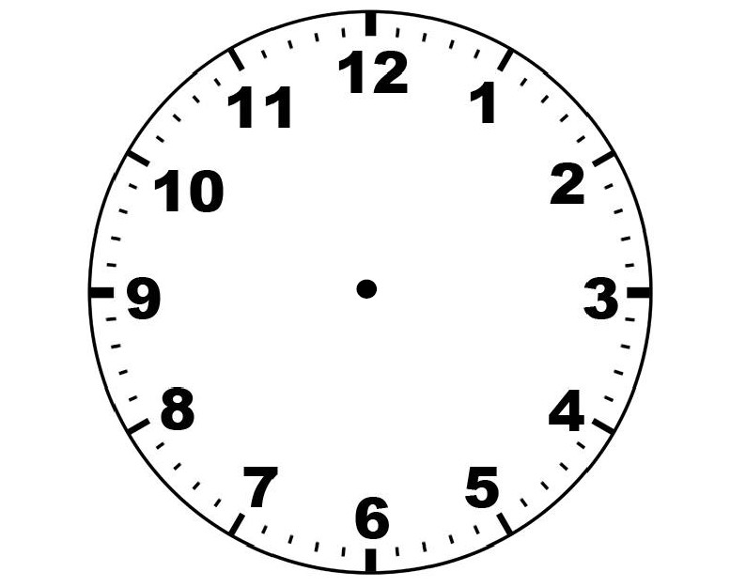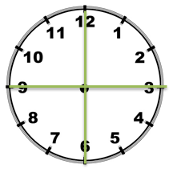
Draw an abstract self-portrait and upload a photo to Seesaw.
Abstract art is a form of modern art which does not represent images of our everyday world. It has colour, lines and shapes, but they are not intended to represent objects or living things. Take a look at the two examples below and create one of your own!
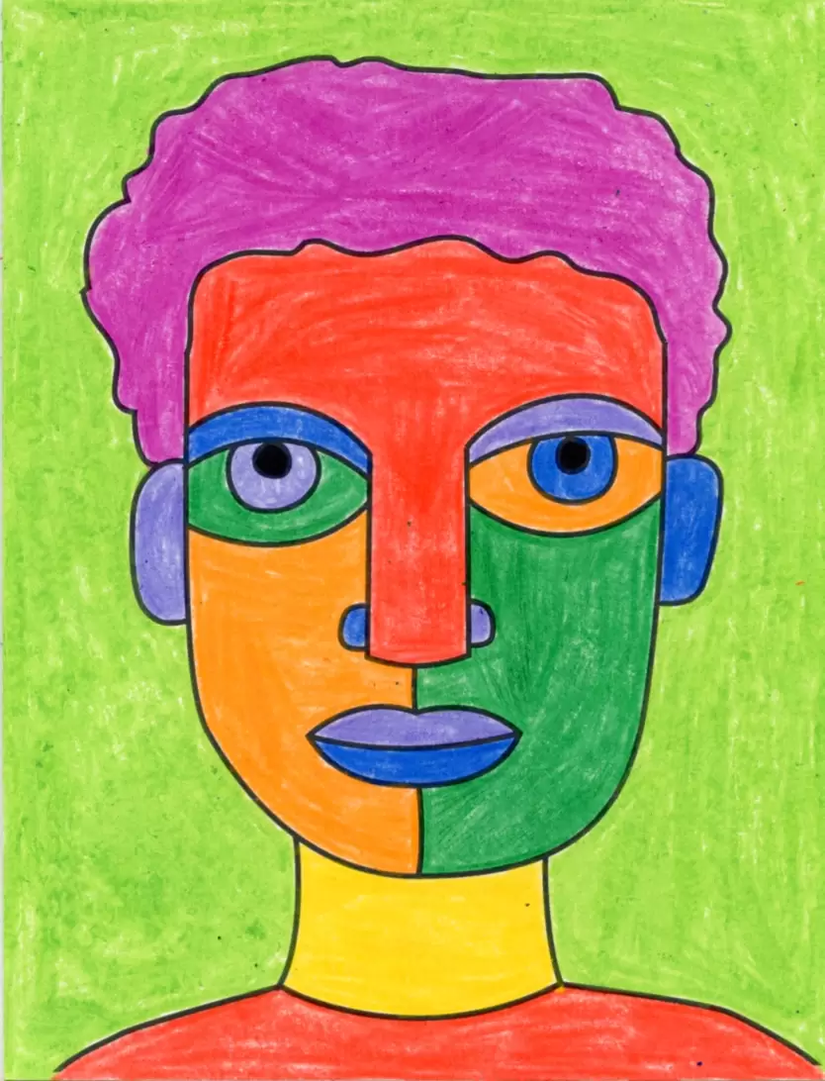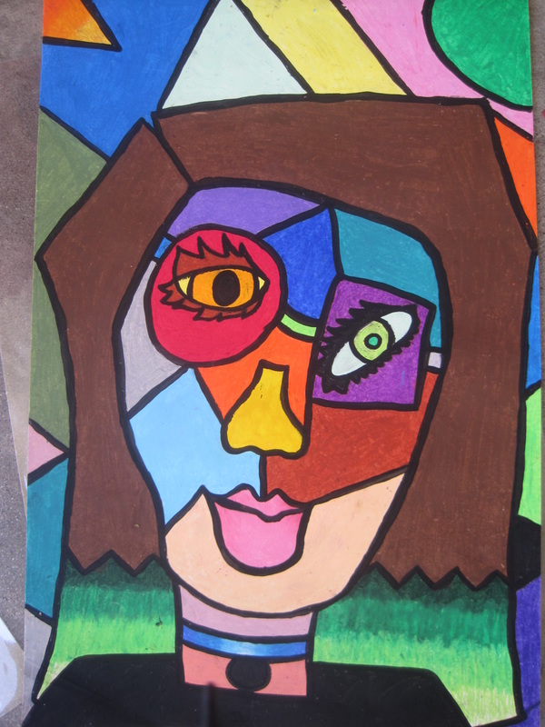

Break – Time to stop and refuel. Eat, play, have fun. Self-directed outside activities where possible.
PDHPE
Complete thirty minutes a day of physical activity. Go for a walk, run or ride with an adult.
OR
Play a game outside (tip, hide and seek, ship/shark/shore, hopscotch, skipping or make up a dance).

Tuesday - Week 4, Term 3 – Stage 1
Daily Task - Wash the dishes.
English:

Reading
Choose a book to read.

Watch and listen carefully to the shared reading of Alexander’s Outing. https://vimeo.com/414649709
Retell the story to someone else.

Spelling
Write your spelling words on flashcards or on post-it notes. Either hold them up and read them or place them around the house for you to read, whenever you see them.

Writing:

Underwater Olympics
Write a story about the Olympics being held under water.
Things to think about while you are writing
Would there still be the same sports?
How is the race in the picture different to a normal race?
What is your favourite Olympics event to watch?

Speaking and Listening:
Ask a family member or your family member if they went to watch the Olympics when they were last in Australia? If so, what was their favourite part?

Break – Time to stop and refuel. Eat, play, have fun. Self-directed outside activities where possible.
Maths:
Watch the Give me half! video on YouTube. https://video.link/w/DyA4c
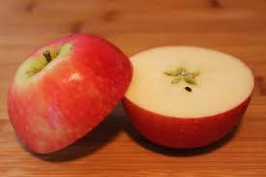
- What are some of the everyday items that the brother and sister shared?
- Do you think the pizza can be divided into more equal parts?
Activity:
Choose a variety of objects to demonstrate one-half. Year 2 - you may like to try showing quarters or even eigths!
Some ideas are: apple, bread roll, piece of paper, ribbon, string, tape, etc.
- When you put the two pieces together, does it still make a whole circle?
- What happens if you take pieces away? How much of the object is left?
PDHPE
Complete thirty minutes a day of physical activity. Go for a walk, run or ride with an adult.
Play a game of tip or skip with a skipping rope
OR
Complete the Avengers Challenge https://watch.lesmillsondemand.com/born-to-move-free/season:1/videos/born-to-move-marvel-let-s-go
Break – Time to stop and refuel. Eat, play, have fun. Self-directed outside activities where possible.
Creative Arts:
Create your own Olympic rings.
You can and draw or colour them in on the template provided if you do not have access to the resources that some of the examples show.
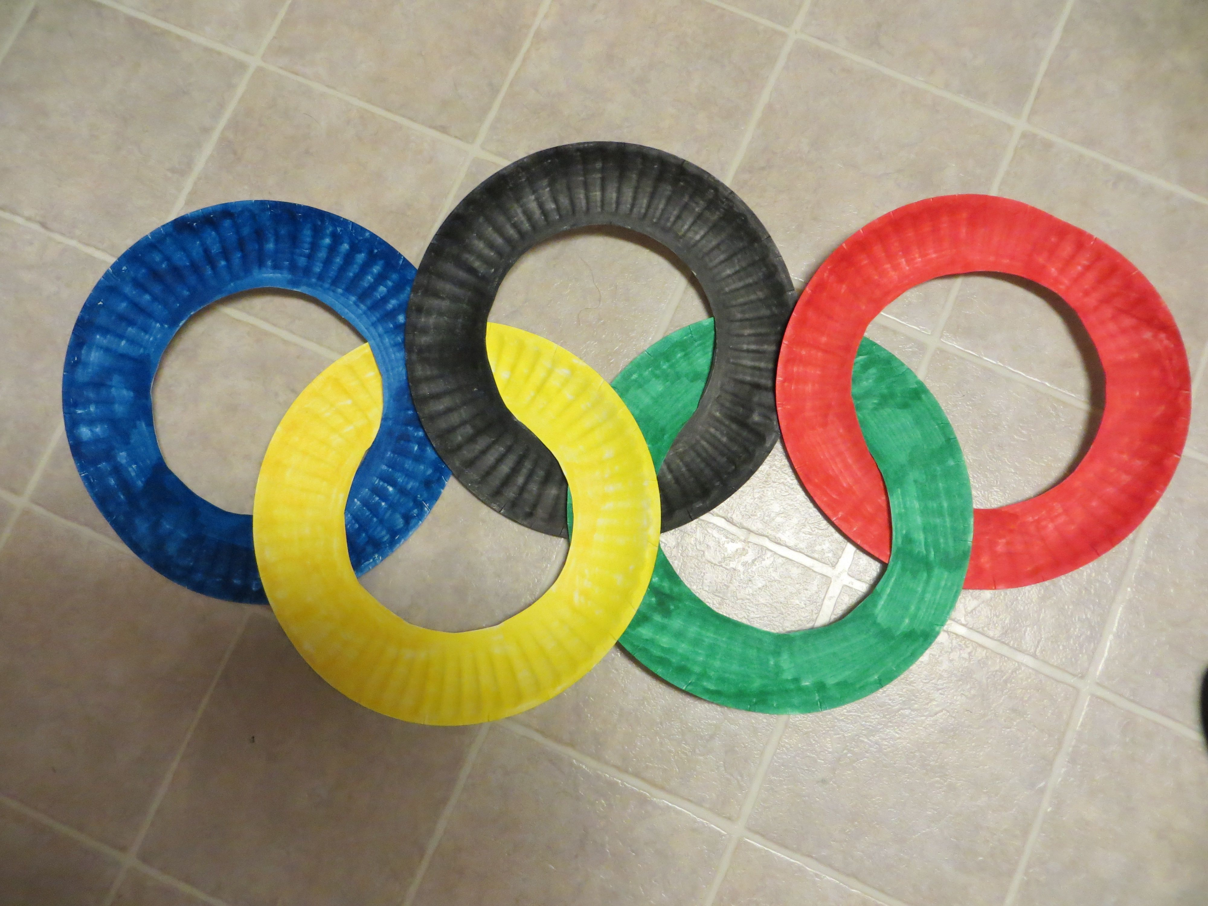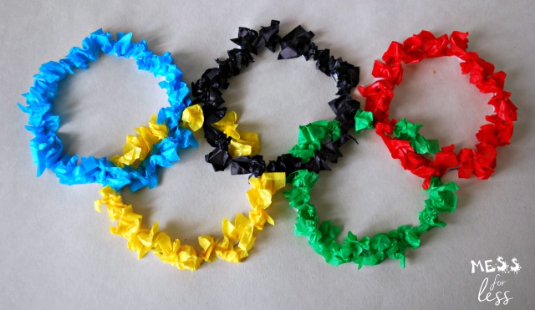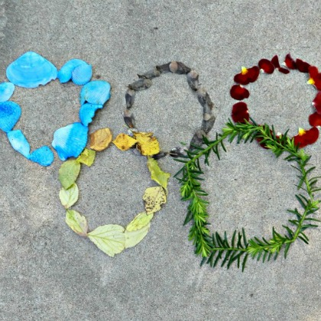

Wednesday - Week 4, Term 3 – Stage 1
Daily Task – Make your bed.
English:
Reading:
Choose a book to read or listen to one of your teachers read a story on Seesaw.
Spelling:
Using your spelling words, write a sentence for each word. Try to make your sentences interesting and longer by using joining words such as (and, but, so)
For example: The tall blonde-haired girl sat quietly at her desk working on her homework but her cat kept bothering her.
Complete the worksheet on Adjectives.
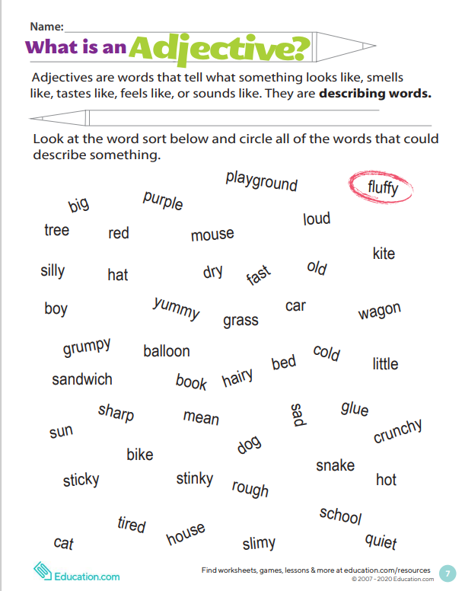

Writing:
Write a procedure on how to brush your teeth.
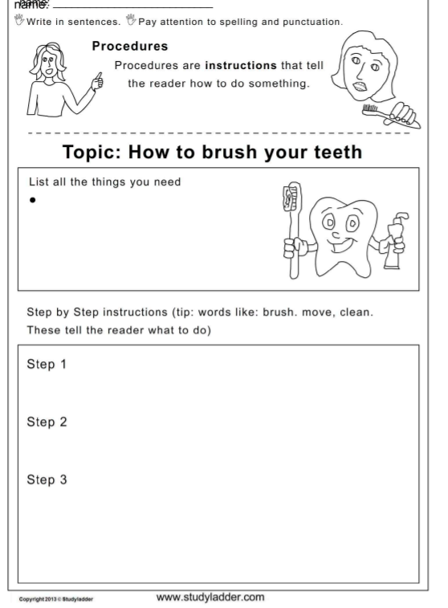
Procedures are instructions that tell the reader how to do something.
Speaking and Listening:
Share your procedure with someone else.
Would they add anything?
Break – Time to stop and refuel. Eat, play, have fun. Self-directed outside activities where possible.
Maths:
Watch the Whole, Halves and Quarters video on YouTube. https://youtu.be/ZLxbPQRIyjw
- What is it called when we cut a shape or object into two equal parts?
- What is it called when we cut a shape or object into four equal parts?
- What is it called when we join all of these parts together?
Create your own artwork representing either, halves, quarters or a whole.
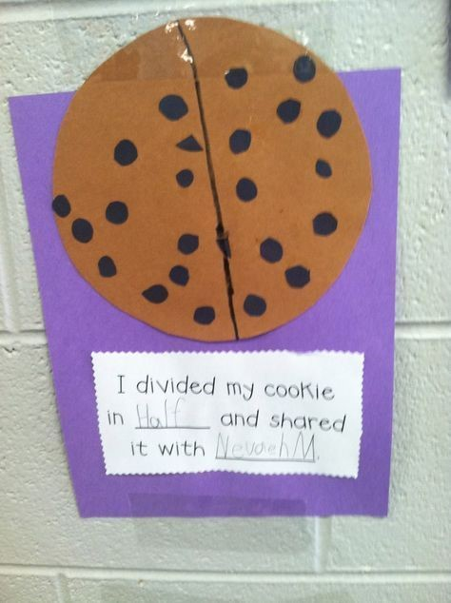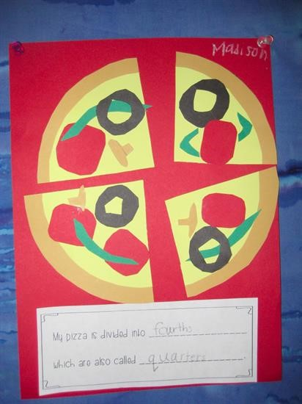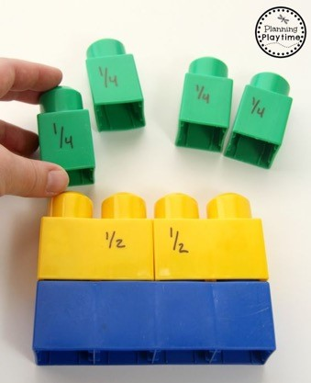
PDHPE:
Complete thirty minutes a day of physical activity. Go for a walk, run or ride with an adult.
Try and make an obstacle course outside with everyday items from home. Eg. - Balance on the hose - Run to the fence - Run around/to the clothesline twice Complete the obstacle course and time yourself. Try again and see if you can get a quicker time.

Break – Time to stop and refuel. Eat, play, have fun. Self-directed outside activities where possible.
Creative Arts:
Leaf Rubbing- Go outside and collect some leaves and place them under your paper. Lightly colour over the leaves to create a pattern onto the paper.
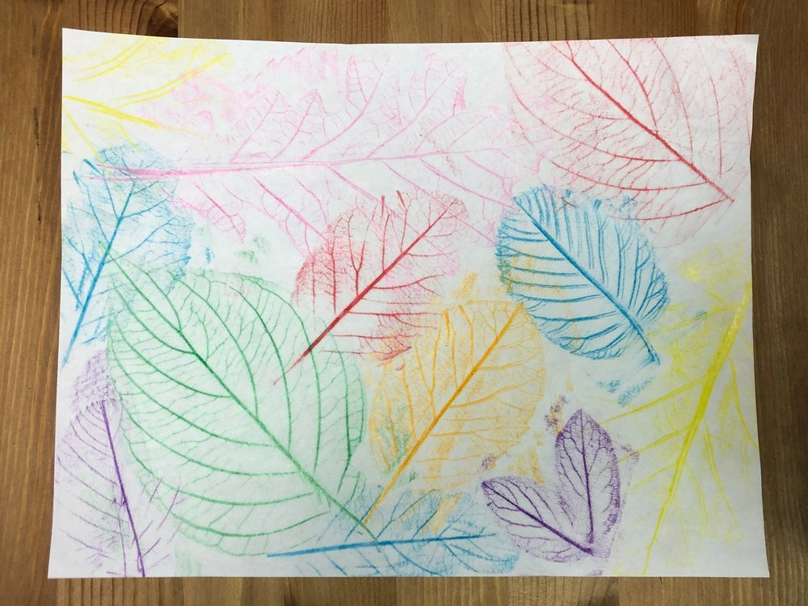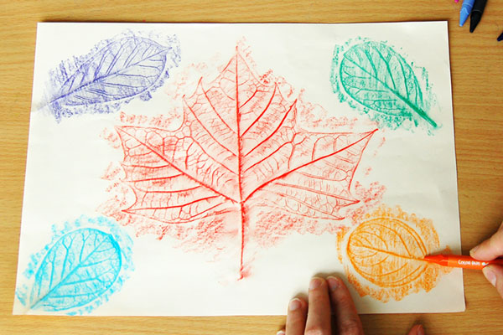
Thursday - Week 4, Term 3 – Stage 1
Daily Task – Help an adult with an outside activity.
English:
Reading:
Listen to the story Ten Thank-you Letters.
https://www.youtube.com/watch?v=SURkdR-AefM
Writing:
Write a compliment for a family member or a loved one using the template provided.
A compliment is a polite expression of praise or admiration.
For example: You are a wonderful Mum because you always make sure I have a healthy breakfast each morning.
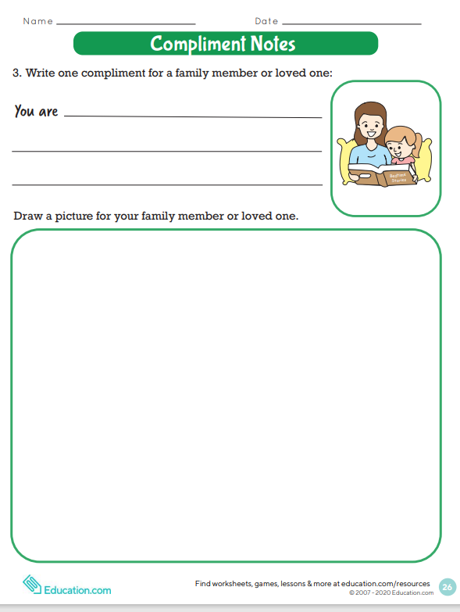

Spelling:
Write your spelling words and write the vowels in a different colour to the rest of the word. For example: blank, blue, bright
Speaking and Listening:
Share your writing with either the person that you wrote it for or someone else.
Break – Time to stop and refuel. Eat, play, have fun. Self-directed outside activities where possible.
Maths:
Making Two- or Three-Digit Numbers
Roll two dice or turn over two numeral cards and make a two-digit number.
What number comes after your number?
What number comes before your number?
How many more numbers to get to the closest ten?
Challenge:
Make a three-digit number.

What number comes before your number?
What number comes after your number?
How many more numbers to get to the nearest hundred?

Break – Time to stop and refuel. Eat, play, have fun. Self-directed outside activities where possible.
Creative Arts:
On a piece of paper, write the initial letter of your name (the beginning letter) in bubble writing. Design your letter however you wish to.
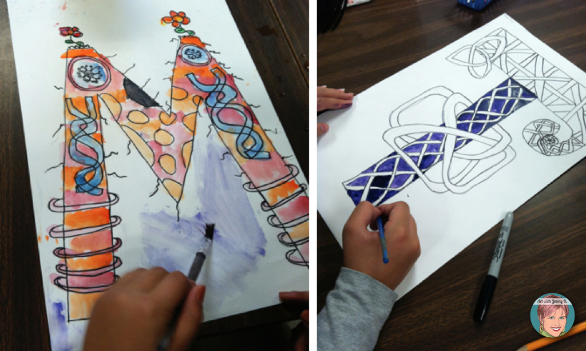
Friday - Week 4, Term 3 – Stage 1
Daily Task – Clean up your room.
English:

Reading:
Choose a book to read.

Before you read your story:
What do you think the book is about?
Is this an informative book or is it a book that tells a story?

Writing:
* Tablets and iPads should replace paper and pencils in the classroom *

Write a letter to your teacher explaining why you either agree or disagree with this statement.

Remember: you can only choose one side, you either agree or disagree.

Spelling:
How many syllables are in each of your spelling words? Write down the number of syllabus next to your spelling words.

Speaking and Listening:
Can you think of any rhyming words for your spelling words? With a family member, take turns in saying one of your spelling words out loud and the other person must think of a word that rhymes with your spelling word.
Hint: they need to be real words...

Break – Time to stop and refuel. Eat, play, have fun. Self-directed outside activities where possible.
Maths:
Year 1:
Fun Fact Dice Game:
If there is no dice, use the following numbers: 5 and 8, 9 and 2, 4 and 3, 5 and 6, complete the fact fun worksheet.
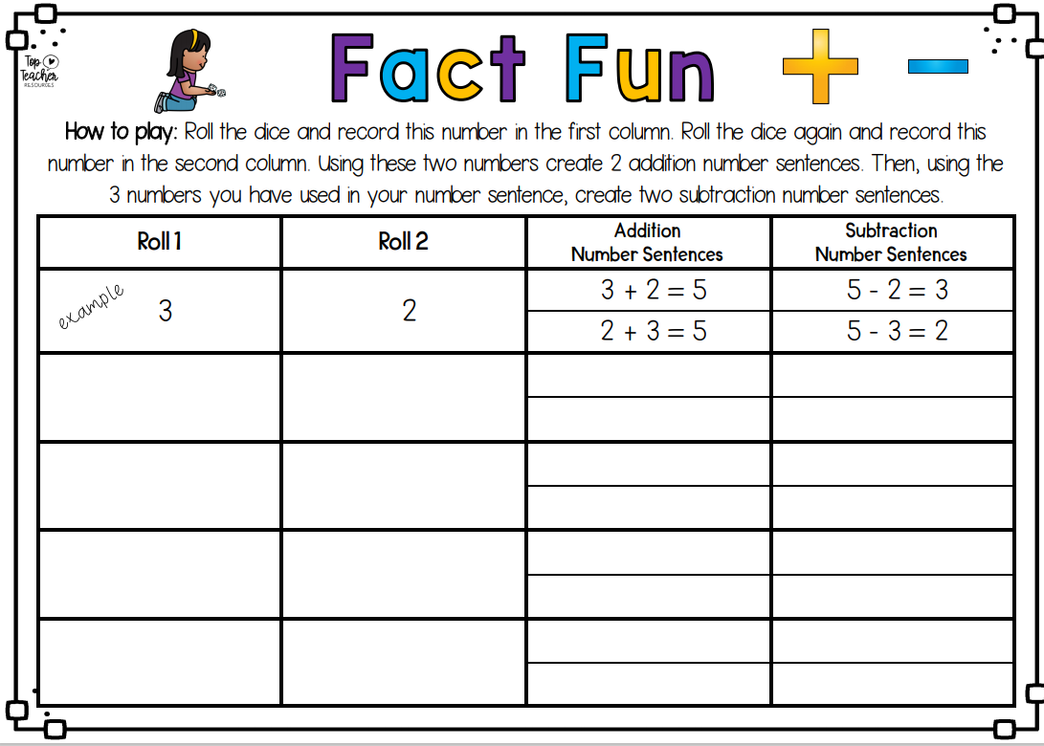
Year 2:
Work out addition word problems using the split strategy.

- Sophia and Tyler held a lemonade stall over the weekend. They sold 25 cups on Saturday and 18 cups on Sunday. How many cups did they sell altogether?
- Lily practised playing the trumpet for 48 minutes before school and 34 minutes after school. How many minutes did she practise altogether?
Create your own addition word problems and share them with your teacher.

Work out subtraction word problems using the split strategy.

- Riley had 35 lollies. He gave some to his friends. He has 16 left. How many lollies did he give to his friends?
- There were 65 cups in a shop. 37 cups fell off when a shelf broke. How many cups were left unbroken?
Create your own subtraction word problems and share them with your teacher

PDHPE:
Complete thirty minutes a day of physical activity. Go for a walk, run or ride with an adult.
Or
Cosmic Kids Yoga: https://www.youtube.com/watch?v=u8sEfRXRuAw

Break – Time to stop and refuel. Eat, play, have fun. Self-directed outside activities where possible.
Take some photos and send them through to your Teacher on Seesaw to show you how to celebrate your Fri-Yay!

RESOURCES:

