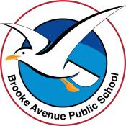
Learning from Home – Brooke Avenue Public School
Stage 2 (Years 3 and 4) – Week 10, Term 3
The following timetable can be used by students to support learning at home. All tasks have been linked to syllabus outcomes. If technology is available at home, please use the attached links to support learning.
The camera symbol shows the work sample we would like to see on Seesaw.
Monday 13th September
Daily Task – Make your bed
Morning -
English:

Reading

Read ‘The History of Pizza’. Answer the attached questions.

Writing
Spelling Revision - Using your spelling words from over the term, create a Find A Word for a friend or family member to solve.
Grammar:
Complete the attached page on ‘Providing Opinions’.

Break – Time to stop and refuel. Eat, play, have fun. Self-directed outside activities where possible.
Maths
Complete Number Sense warm up
In partners (parents/siblings) roll 2 dice and draw the array on dot paper.
First die – number is the row
Second die – number of rows.
What is the total? How can you write this as a multiplication?
EG. First rolled a 4, then rolled a 3. Can be written as 3 x 4 = 12
****
****
****
A strategy to complete multiplication is add groups of numbers together. For example, 3 x 5 = 5 + 5 + 5 = 15
Complete the attached sheet, ‘Adding up to Multiplication’.

Break – Time to stop and refuel. Eat, play, have fun. Self-directed outside activities where possible.
PDHPE
Complete ‘Stay Safe around Electricity’ task.

Creative Arts

Listen to the story at this link

https://players.brightcove.net/6110393209001/tW0Wj5ZPo_default/index.html?videoId=6156045121001

and then have fun creating your own incredible freedom machine.

Tuesday 14th September
Daily Task - Match socks and sort washing.
Morning
English:

Reading
Complete half an hour on Reading Eggs or read a book / magazine of your choice.
Writing:
Narrative – Look at the stimulus ‘Message in a Bottle’. Use the questions from the stimulus to help create a plan for
a narrative (story) on the topic. You may like to create the message that was in the bottle and take a photo of your note
and the bottle it would be found in.

Spelling

Write your spelling words out in ‘rainbow’ writing. Choose 4 words from your spelling list to find the dictionary meaning of.

Write the meanings and then put each of the words into an interesting sentence.

Break – Time to stop and refuel. Eat, play, have fun. Self-directed outside activities where possible.
Maths
Complete warm up activity.
Fill in the multiplication grid below.
HINT: Fill in the easy facts first. Then fill in the facts that you know. After that fill in the gaps if you can.
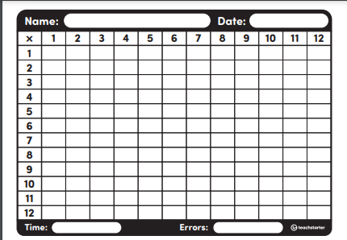
Complete multiply by multiples of 10 sheet.
EG: 3 x 2 = 6
30 x 2 = 60
3 x 20 = 60
PDHPE
Fitness Link attached or your choice of fitness.
https://vimeo.com/413442823
Break – Time to stop and refuel. Eat, play, have fun. Self-directed outside activities where possible.
PDHPE
Complete the Crossword on ‘Stay Safe Around Electricity’.

Wednesday 15th September – Wellbeing Wednesday- Technology Free Day
Daily Task - Wash the dishes.
Morning
English:
Reading
Read a book / magazine of your choice.
Writing
Use the plan you created on ‘Message in a Bottle’ to write your narrative.

Create a drawing or painting to illustrate part of your story.

Read your story to a family member and ask the person what they like about your story.

Break – Time to stop and refuel. Eat, play, have fun. Self-directed outside activities where possible.
Maths
Complete warm up activity – Dandy Dash Division Game. Play with a family member at home.

Complete division by multiples of 10 worksheet.

Just as we did in the previous lesson in multiplying by multiples of 10, we can also divide.
Division is the OPPOSITE to multiplication

Start with the answer
12 divided by 2 = 6
Therefore
120 divided by 2 = 60

Break – Time to stop and refuel. Eat, play, have fun. Self-directed outside activities where possible.
Wednesday Wellbeing Time
Choose an activity that will put a smile on your mind.
PDHPE –
Complete the ‘Stay Safe around Electricity’ Word Search.

Thursday 16th September
Daily Task – Make your bed.
Morning
Reading
Read the text ‘How to Play’.
Writing
Write instructions for how to play a game of your choice. (See the Procedure Text Writing Scaffold attached).
Spelling
Write your words in alphabetical order.
Break – Time to stop and refuel. Eat, play, have fun. Self-directed outside activities where possible.

Maths
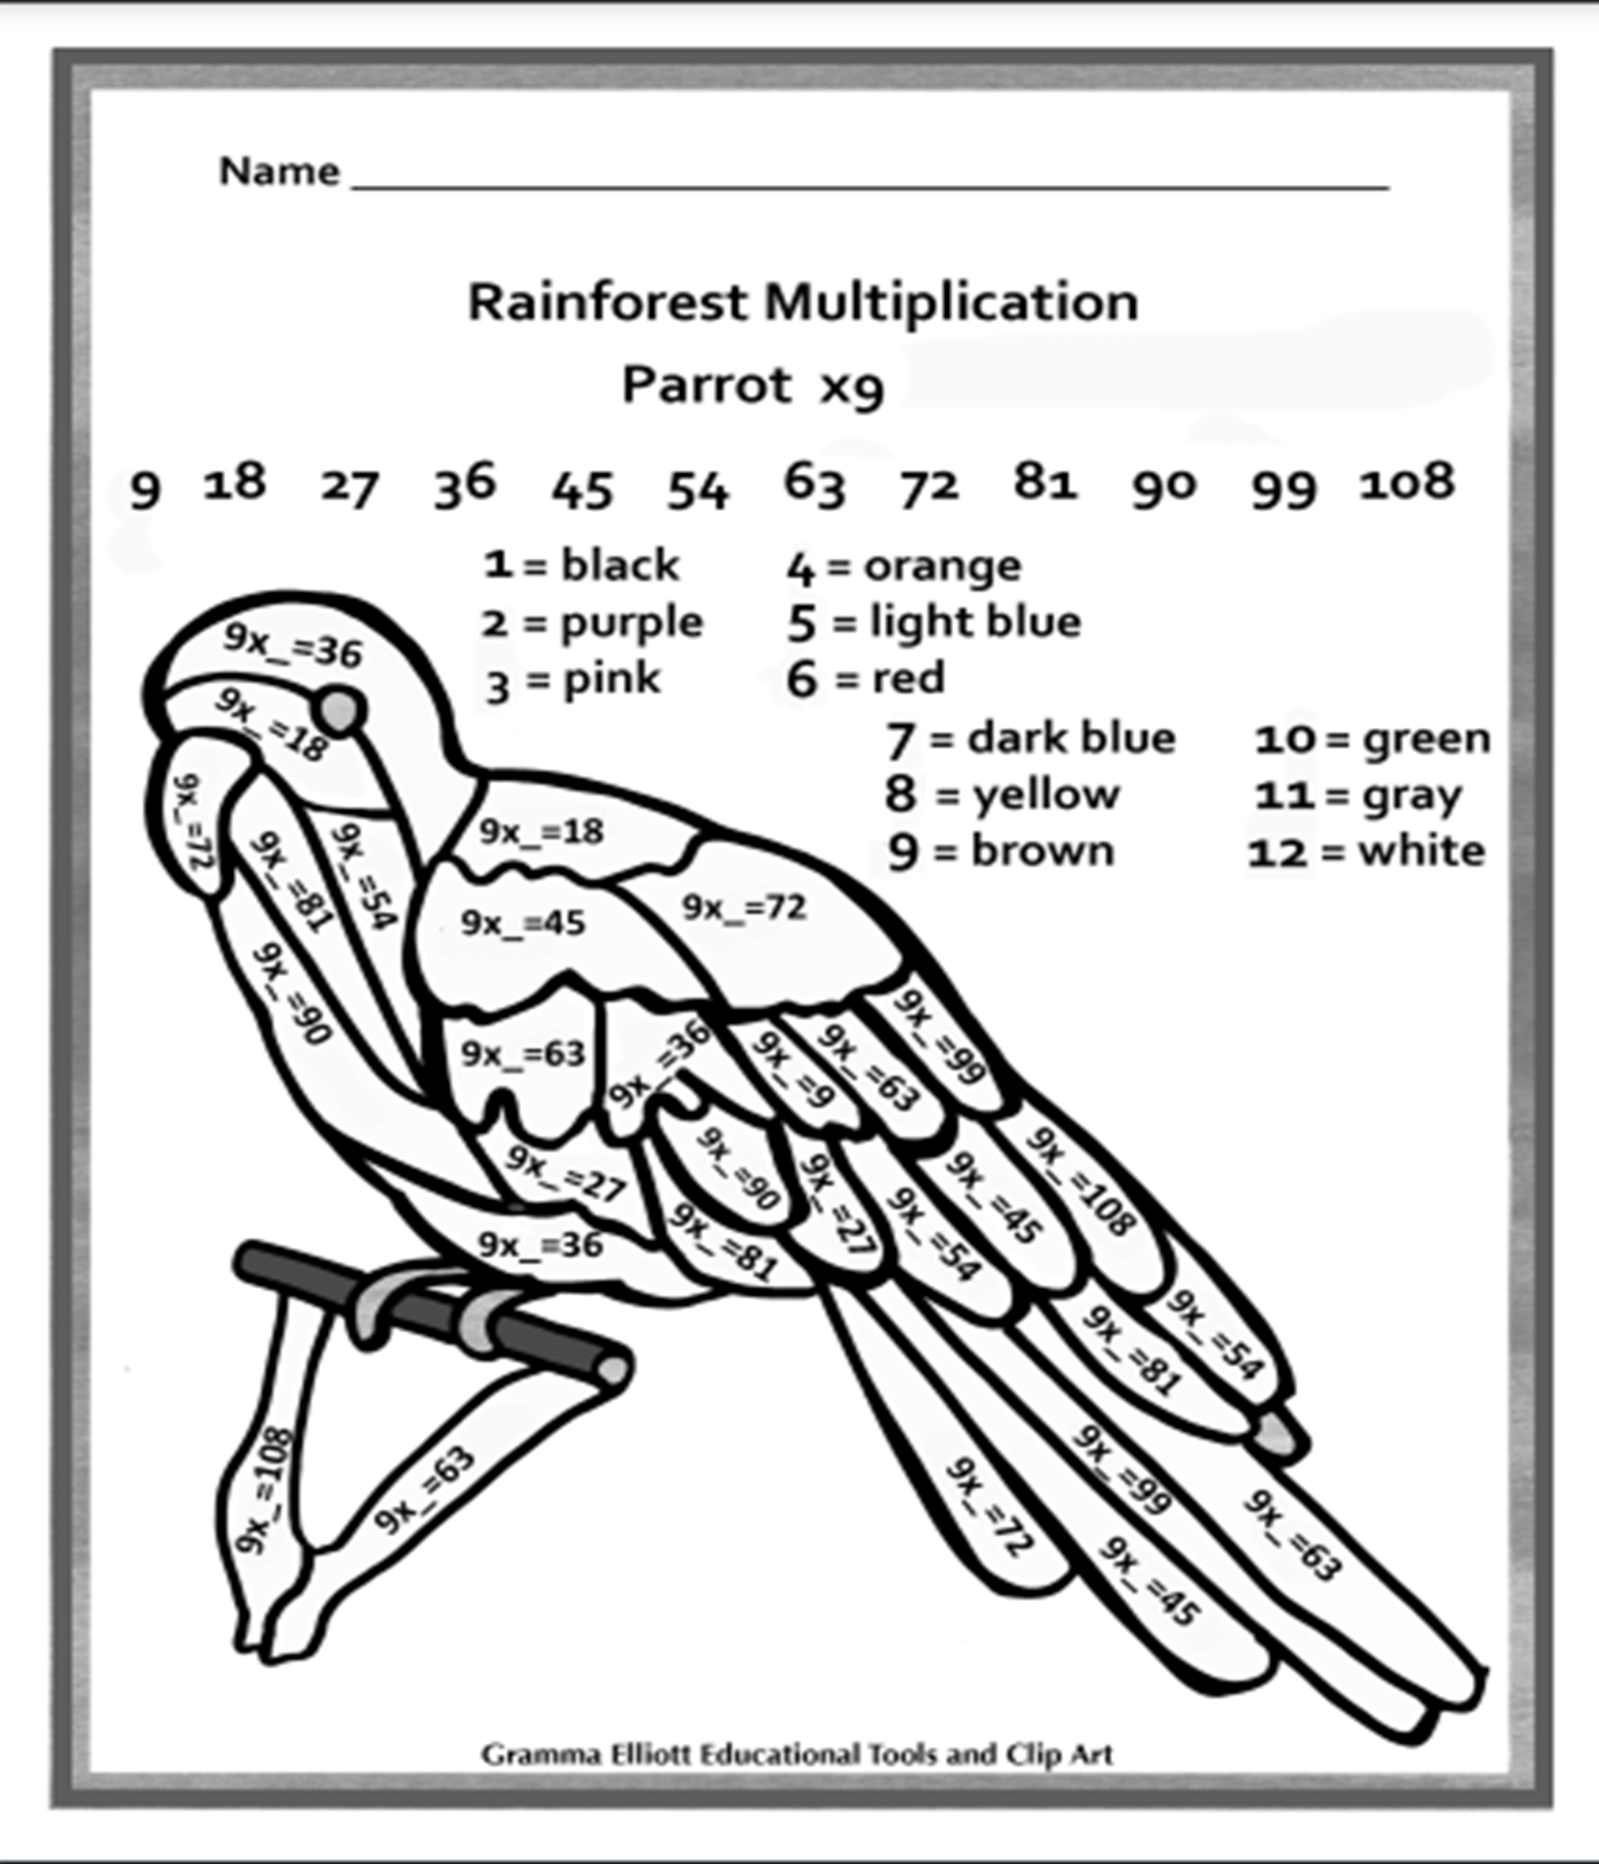

Break – Time to stop and refuel. Eat, play, have fun. Self-directed outside activities where possible.
Creative Arts - See the attached Dance Link
https://youtu.be/LaB9c3kQkfU
Friday 17th September
Daily Task – Help an adult with an outside activity.
Morning
PBL Reward Day / Stage 2 Kahoot Morning
Stage 2 Kahoot – Trivia Quiz – 9:15am
10am Fruit Break
Stage 2 Kahoot – Trivia Quiz – 10:15am
Break – Time to stop and refuel. Eat, play, have fun. Self-directed outside activities where possible.
Maths
Board Games
ABCYA Maths Games or Maths Seeds
Break – Time to stop and refuel. Eat, play, have fun. Self-directed outside activities where possible.
PDHPE- See the attached Lesson activities on Balancing using Household Items.

https://drive.google.com/file/d/1_KLTMUTz2gUZydd5uKV64F8ZW2RJLT4l/view

Friyay
Friday Afternoon Free time – Your choice.
From all the Stage 2 Teachers -We hope you have a lovely holiday and we look forward to seeing you in Term 4.

