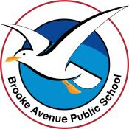
Learning from Home – Brooke Avenue Public School
Stage 1– Week 10, Term 3
The following timetable can be used by students to support learning at home. All tasks have been linked to syllabus outcomes. If technology is available at home, please use the attached links to support learning.
Please upload work marked with the camera icon to Seesaw
Monday - Week 10, Term 3 – Stage 1
Daily Task - Match socks and sort washing.
Magical Monday
English:
Reading:
Choose a book or a PM online reader to read. The book/reader should be a little challenging to read and you should always attempt to read unknown words before asking for help. Try to read for 20 or more minutes!
After you have read your book, discuss the main character with the adult you are working with today OR record yourself talking on Seesaw and send it to your teacher.
Spelling:
The letter/sound combinations for spelling this week are: or, aw, au. Watch this video before writing your list: https://video.link/w/SZJ7c
Write the spelling list/s into your book. You can choose either list or both of them. Please choose the list that has words you don’t already know.
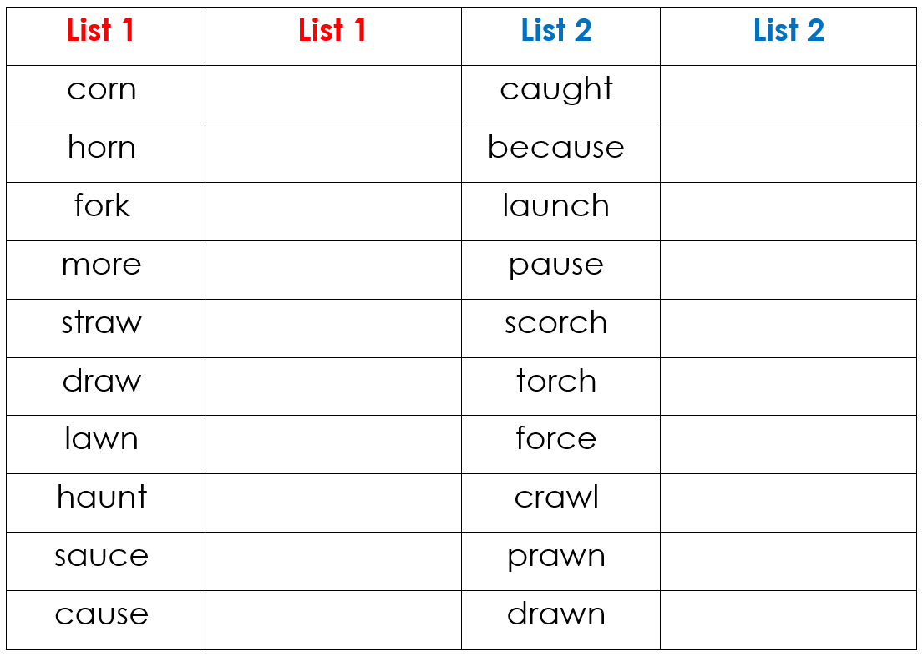

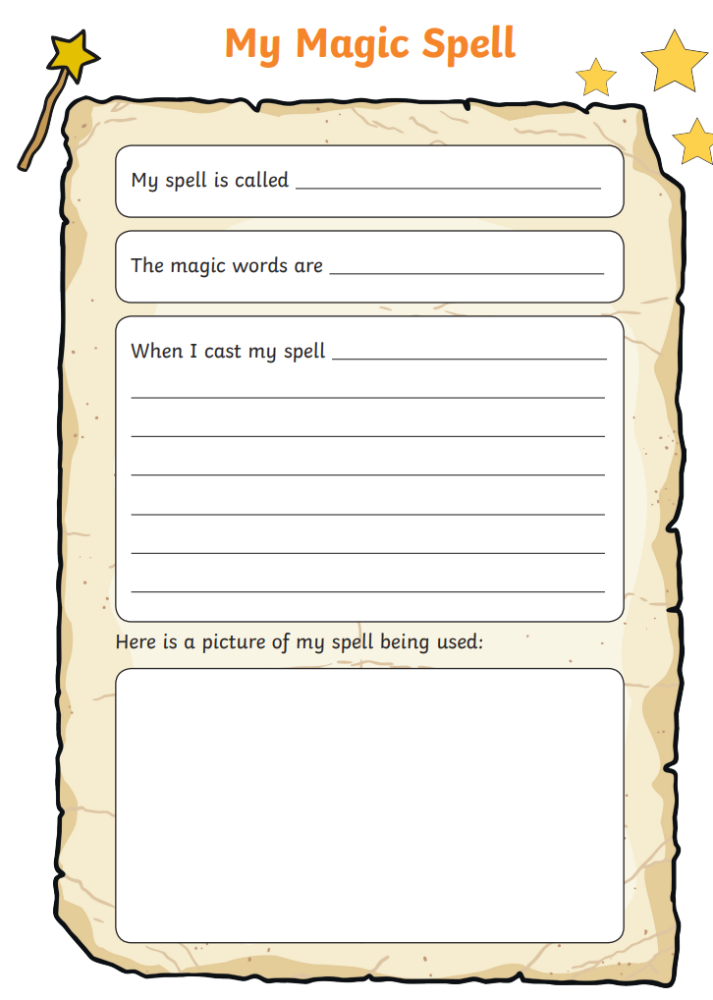
Writing: Choose one of the books below and listen to the story read by one of your teachers:
Listen to ’Room on the Broom’ read to you by Miss Finch (see SeeSaw activities).
Using the worksheet provided, create your own ‘Magic Spell’. This is a creative task, and we are excited to see what silly things might happen when you cast your spell!

Break – Time to stop and refuel. Eat, play, have fun. Self-directed outside activities where possible.
Maths:
Warm Up:

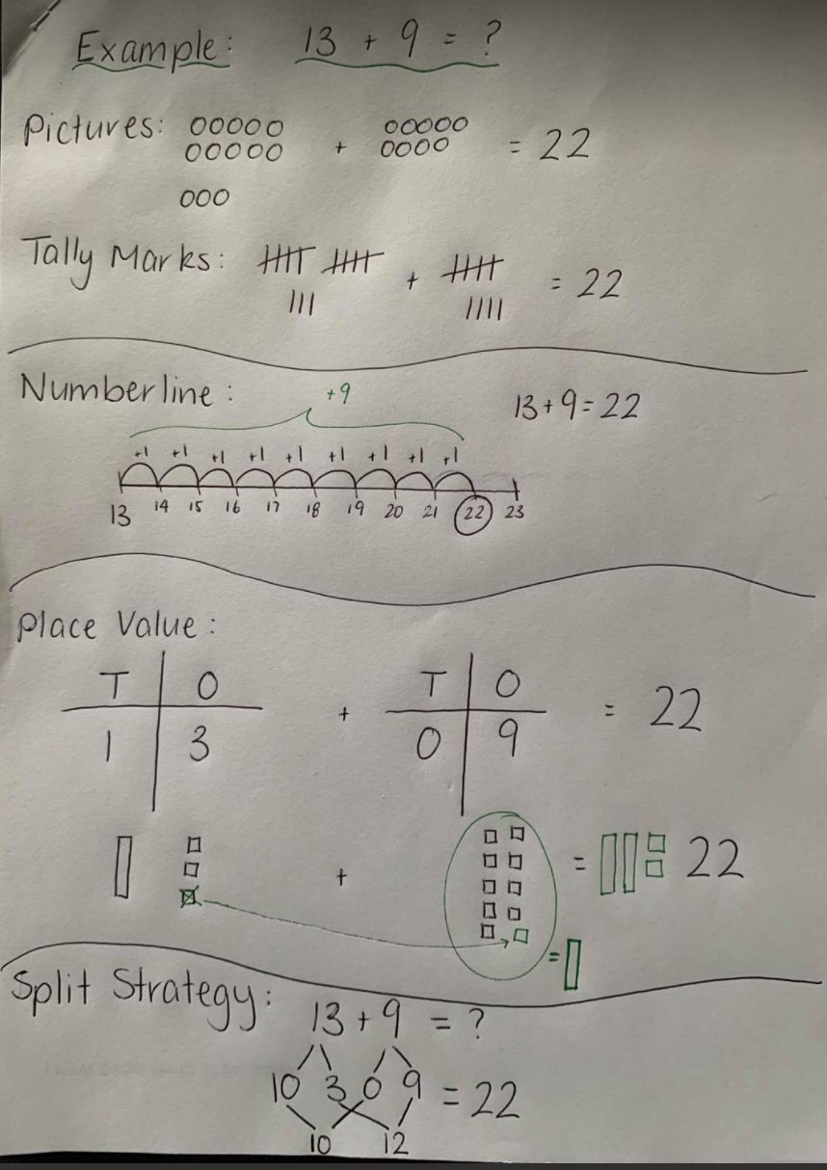
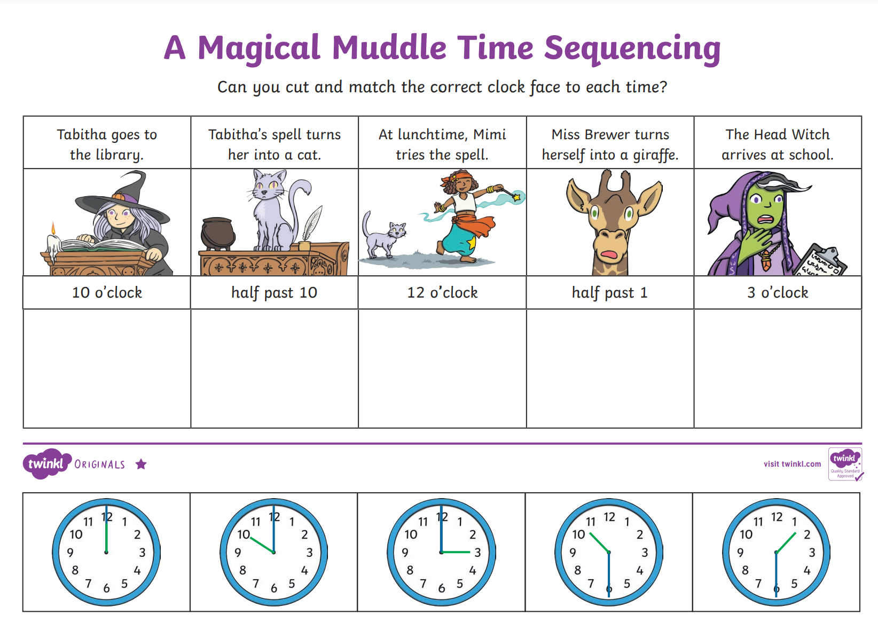

Lesson:
Model the following strategies to answer the questions AND SHOW ALL WORKING.
- Pictures OR Use Materials OR Tally Marks
- Number Line
- Split Strategy
- Place Value (Draw the Blocks)

17 + 15 = | 29 – 13 = | 37 + 21 = | 43 – 25 = | 52 + 39 = |

Extension: Answer the word problems. Show how you solved each of the problems.

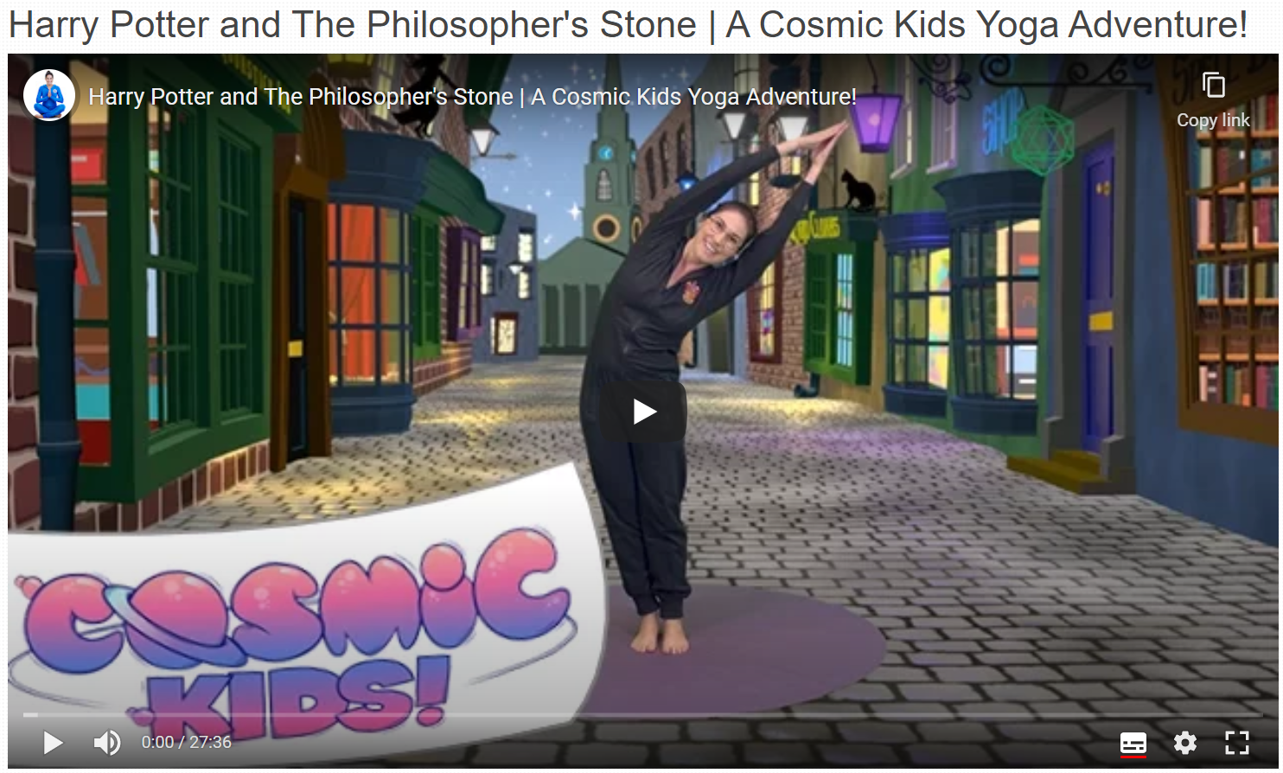
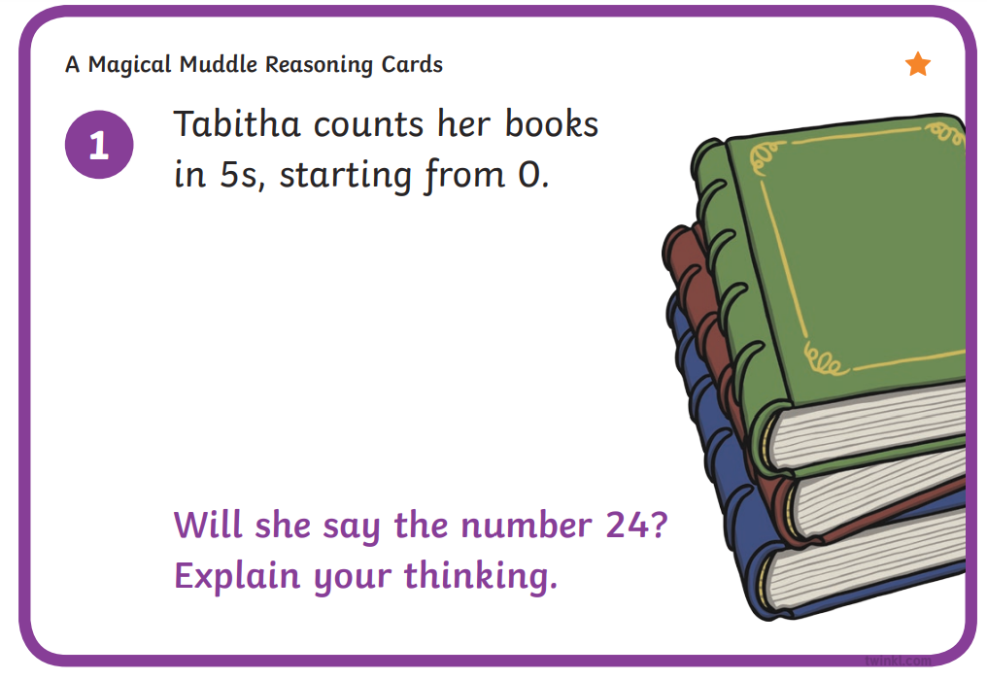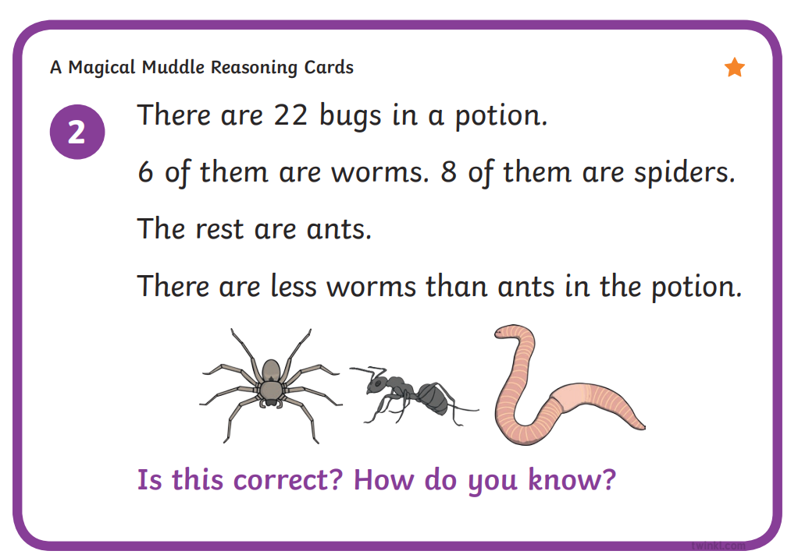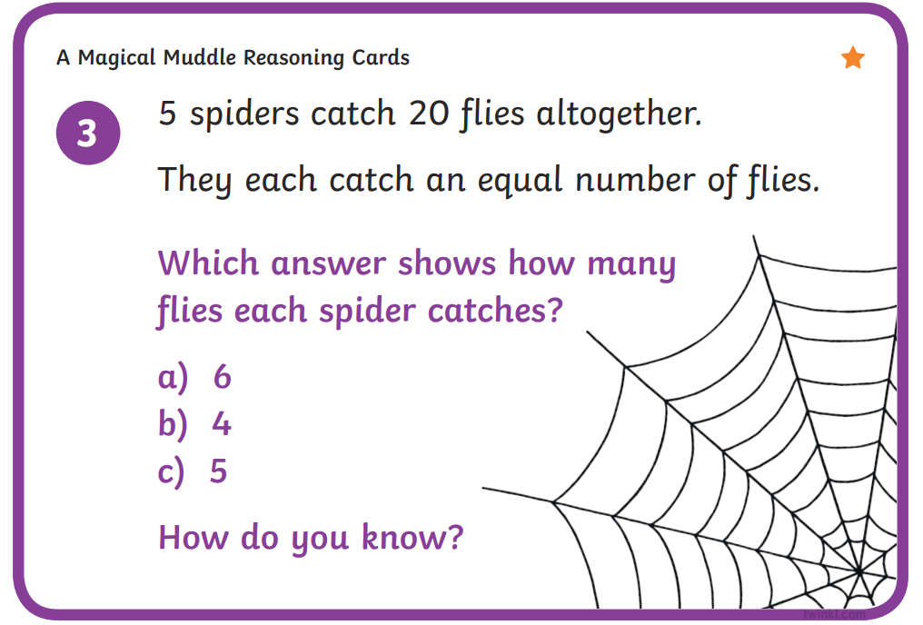

Physical Activity:
Complete thirty minutes a day of physical activity. Go for a walk, run or ride with an adult.
Click on the following link for a guided ‘Harry Potter Yoga’ lesson - https://video.link/w/AuK7c

Break – Time to stop and refuel. Eat, play, have fun. Self-directed outside activities where possible.
Creative Arts:
Choose one of the guided drawing videos to follow for ‘Magical Monday’
- How to Draw ‘Hagrid from Harry Potter’ - https://video.link/w/CBK7c
- How to Draw ‘A Cartoon Witch’ - https://video.link/w/MDK7c
- How to Draw a Castle Step by Step - https://video.link/w/0DK7c
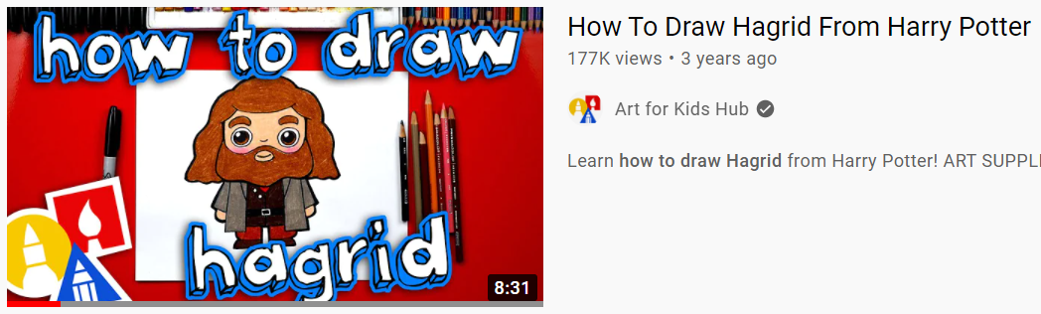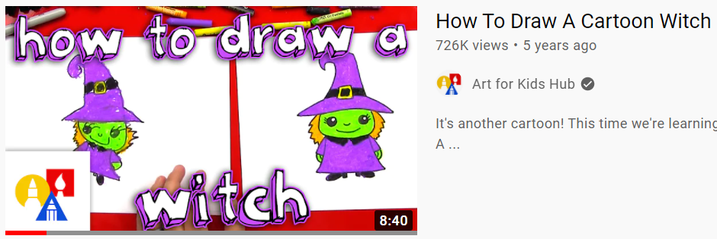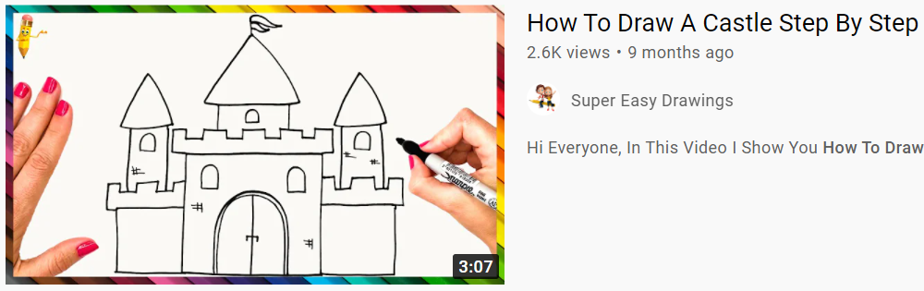

Tuesday - Week 10, Term 3 – Stage 1
Daily Task – Wash the dishes.
Extra - Terrestrial Tuesday
English:
Reading:
Choose a book or a PM online reader to read. The book/reader should be a little challenging to read and you should always attempt to read unknown words before asking for help. Try to read for 20 or more minutes!
After you have read your book, discuss the setting of the story with the adult you are working with today OR record yourself talking on Seesaw and send it to your teacher. The setting is where the story is happening – it might stay in the one place OR move to different places.
Spelling:
Unjumble your words! Unjumble these words from your spelling list and write them correctly beside. Write them in pencil and make sure you use ALL of the letters in each word! The words are NOT in the same order as the list on Monday.
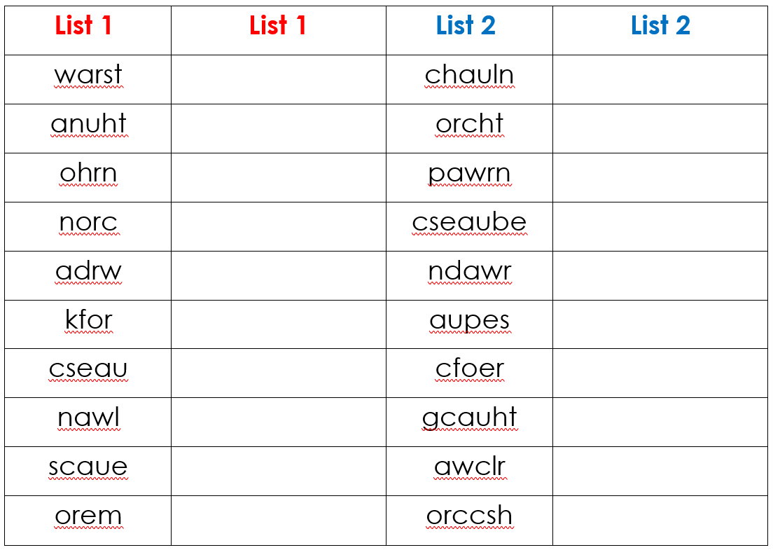

Writing: Choose one of the books below and listen to the story read by one of your teachers:
Listen to ’Thelma the Unicorn’ read to you by Mrs Wellfare
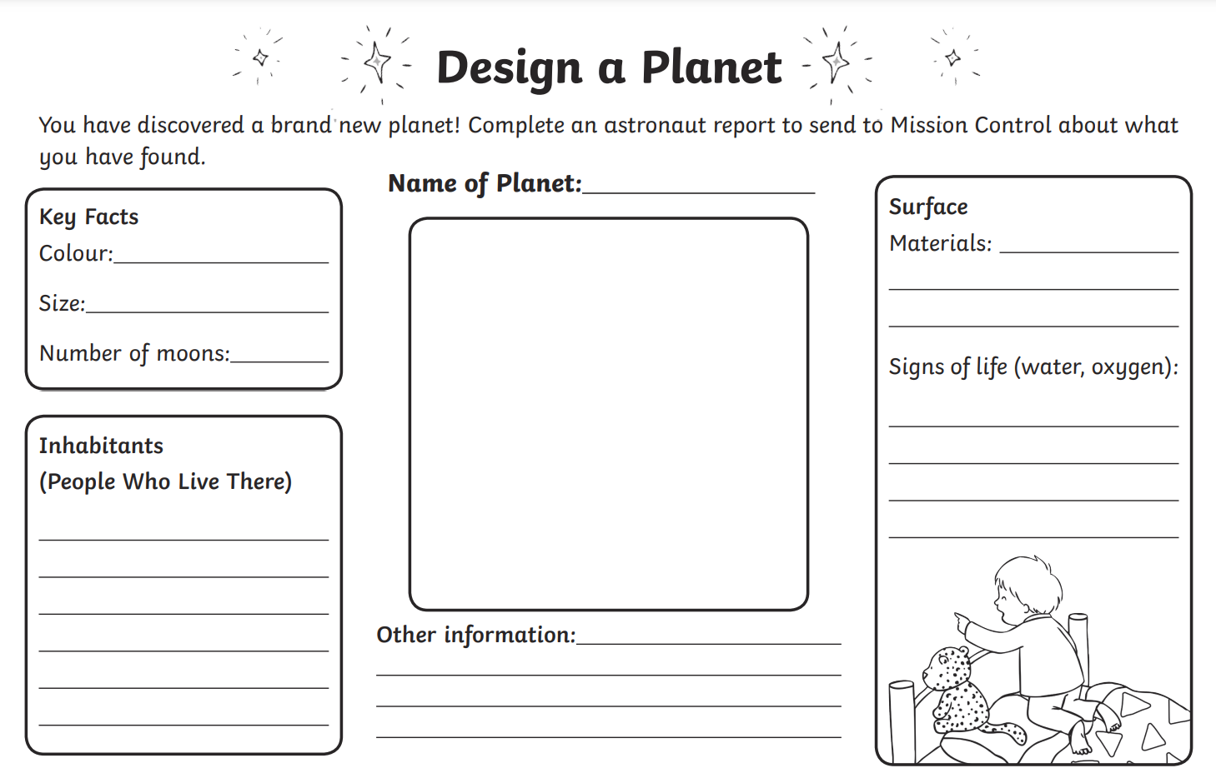
Using the worksheet provided, design your own planet! Don’t forget to use adjectives to describe! Maybe the Unicorns live on your planet?

Break – Time to stop and refuel. Eat, play, have fun. Self-directed outside activities where possible.
Maths:
Warm Up:
Complete the Solar System Code Breaker – Crack the codes by completing the addition and subtraction problems
-

Lesson:
Calculating area - area is amount of space/surface covered in a shape.

Play the ‘Dots and Boxes’ game – a fun game to compare area with a family member. This sheet has 4 playing grids. Read the instructions and use a different coloured pencil/texta/pen to take turns drawing your lines. At the end of each game count how many boxes have your first initial inside them. If you have THE MOST then you have covered the most area and are the winner.

Physical Activity:
Complete thirty minutes a day of physical activity. Go for a walk, run or ride with an adult.
Click on the following link for a guided ‘Unicorn Yoga’ lesson - https://video.link/w/ZKK7c
OR

Enjoy some relaxation and complete a guided mediation space journey - https://video.link/w/8LK7c
Break – Time to stop and refuel. Eat, play, have fun. Self-directed outside activities where possible.
Creative Arts:
Choose to create a spaceship from recycled materials around your house OR one of the guided drawing videos to follow for ‘Extra-Terrestrial Tuesday’.
- Create a spaceship from recycled materials
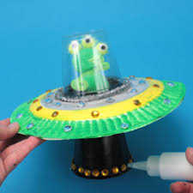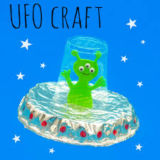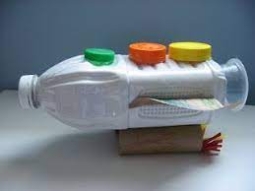
- How to draw ‘Toy Story Alien’ - https://video.link/w/s8K7c
- How to draw ‘A Cute Unicorn’ - https://video.link/w/l8K7c
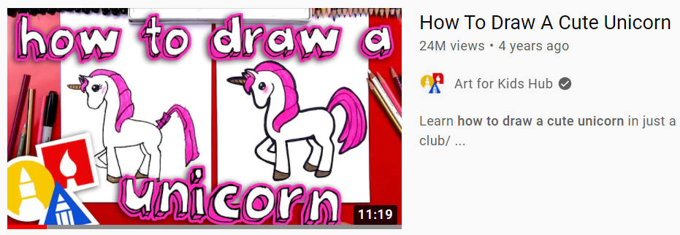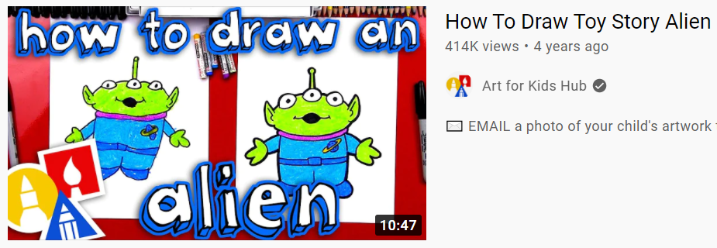

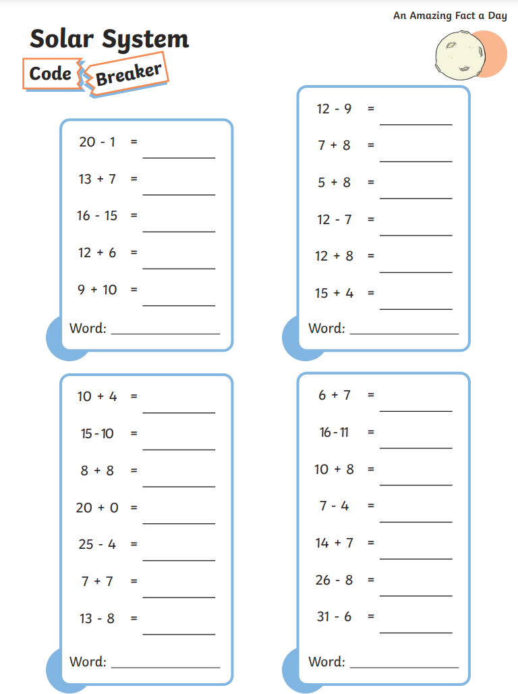
Wednesday - Week10, Term 3 – Stage 1
Daily Task – Make your bed.
Walk the Plank Wednesday
English:
Reading:
Choose a book or a PM online reader to read. The book/reader should be a little challenging to read and you should always attempt to read unknown words before asking for help. Try to read for 20 or more minutes!
Listen to Mrs Barnett read ‘Pirate Pups’ https://video.link/w/sBg8c
After you have listened to the book, discuss the ending of the story. Can you think of a different ending? Talk to the adult you are working with OR record yourself talking on Seesaw and send it to your teacher.
Spelling: Corner Words: Use your spelling words to create a “corner”. This means writing your words across the page and then down the page starting with the first letter.
Writing Arrr me hearties! Click on the link to write a message to translate into pirate talk. Below is an example. https://pirate.monkeyness.com/translate
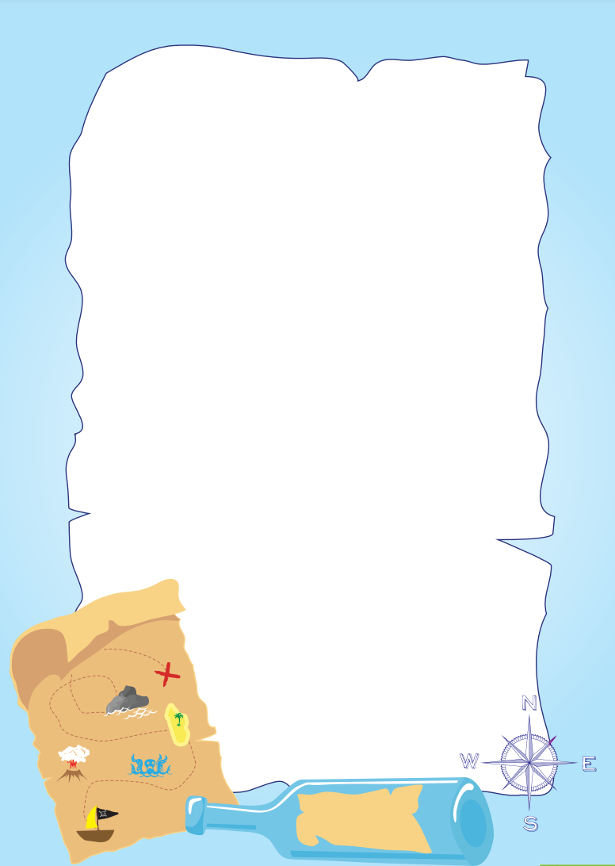
You may like to copy it onto the blank page and put your message inside a bottle to share with a family member. You could turn it into a game and send them on an adventure to find something hidden in your house!
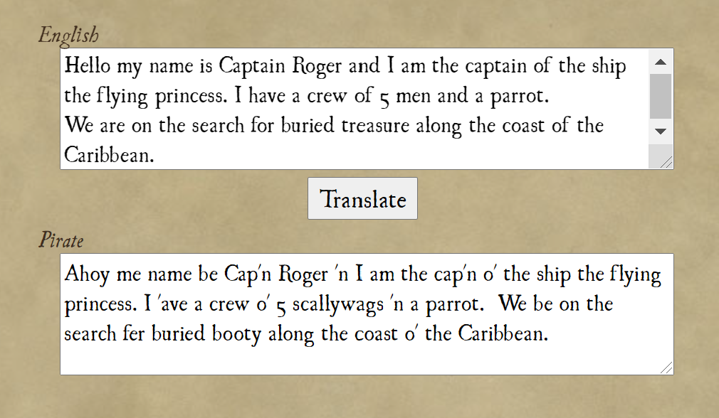

Break – Time to stop and refuel. Eat, play, have fun. Self-directed outside activities where possible.
Maths:
Warm Up:
1 more, 1 less, 10 more, 10 less.
Complete the activity using the following numbers. If you need to use a hundred chart to help.
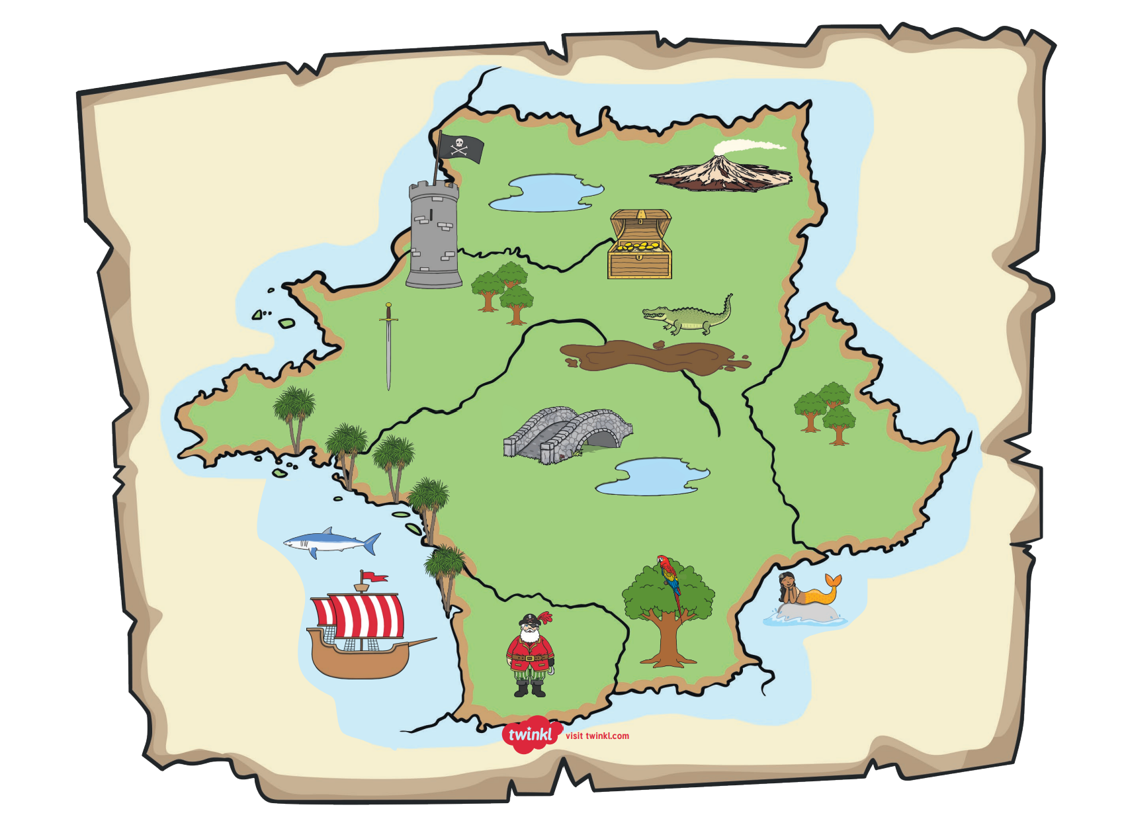
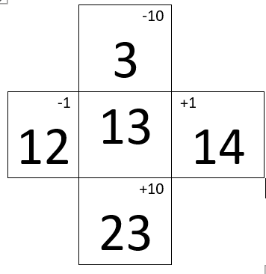 Your numbers - 100, 89, 108, 76, 120, 91

Lesson:
Looking at the pirate map. Using positional language, explain where the flag, treasure chest, sword and bridge is.
Extension – Can you help the pirate find the treasure; you need to direct him from where he is standing on the map.

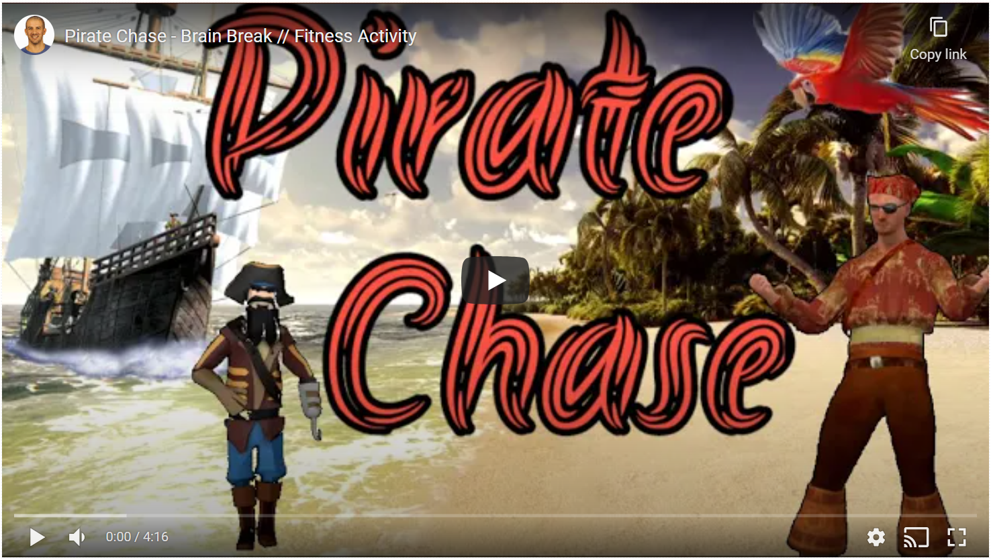
Physical Activity:
Complete thirty minutes a day of physical activity. Go for a walk, run or ride with an adult.
Click on the following link to have a turn at the ‘Pirate Chase’ - https://video.link/w/JsK7c

Break – Time to stop and refuel. Eat, play, have fun. Self-directed outside activities where possible.
Creative Arts:
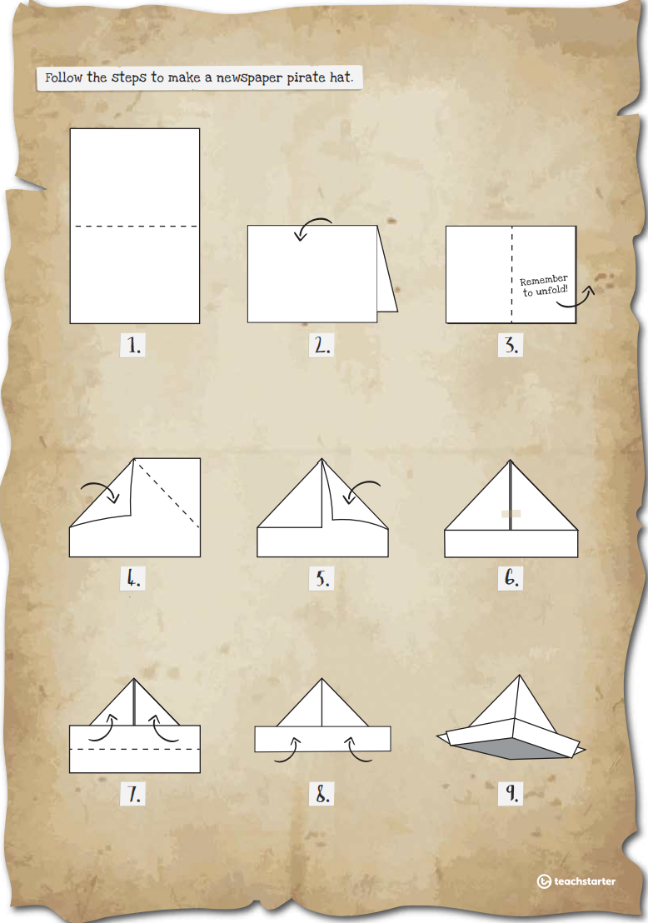
Follow the instructions to create your own pirate hat. Don’t forget to decorate it to show me hearties who the cap’n is!
This link also shows instructions step by step - https://video.link/w/gFK7c
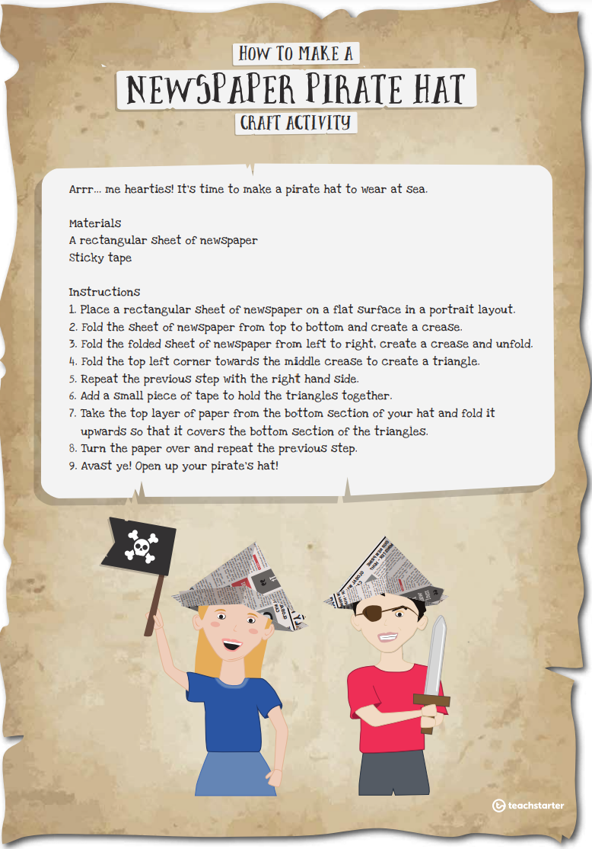

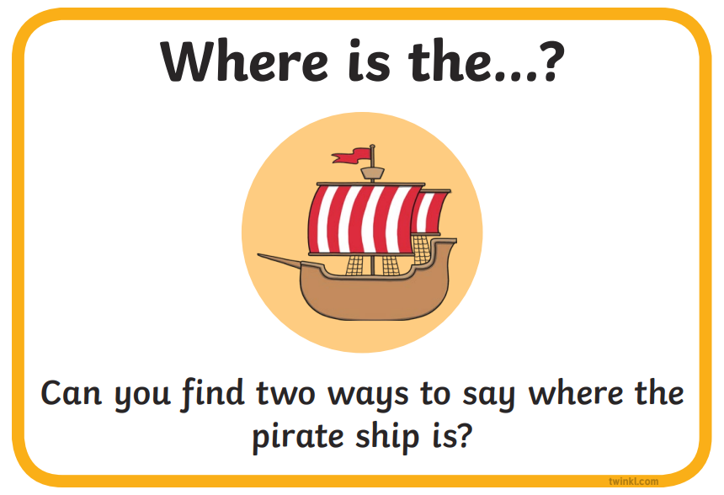
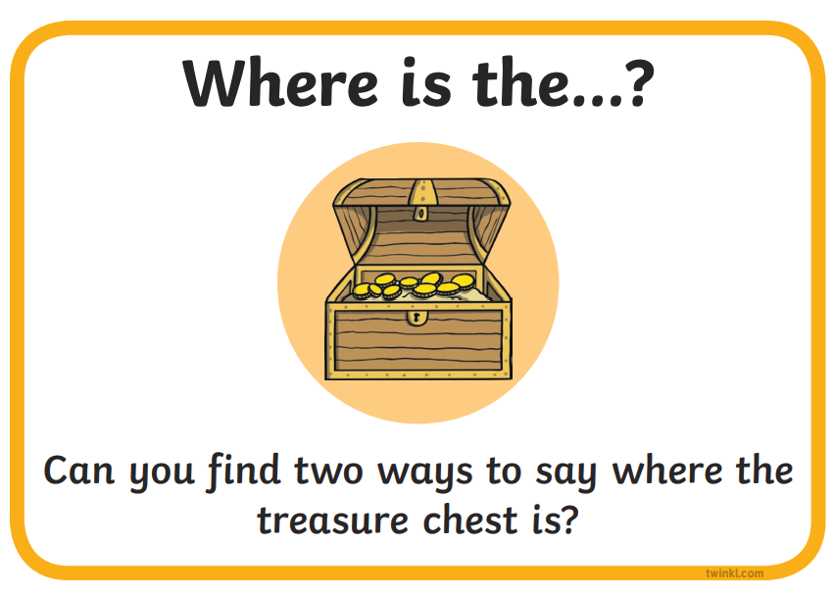 |  | 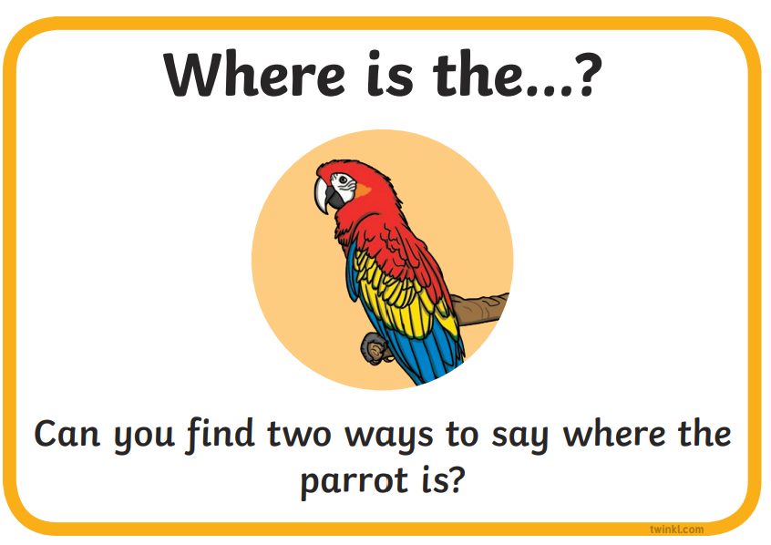
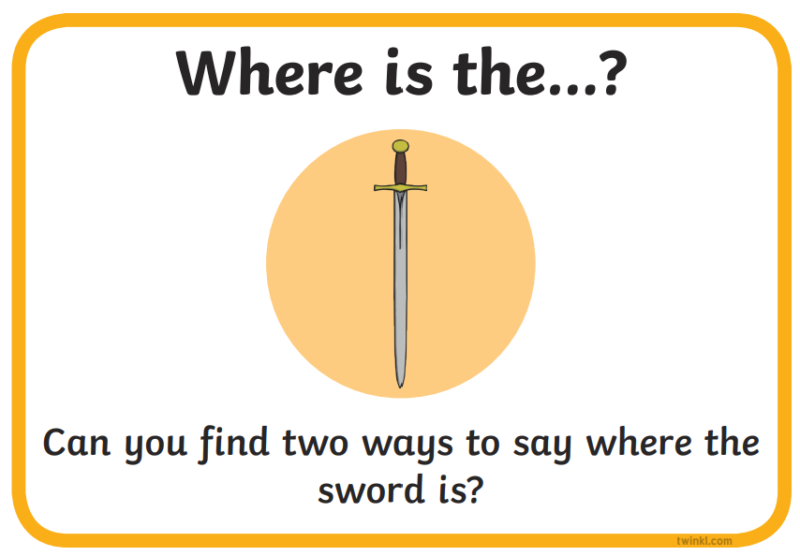 |  | 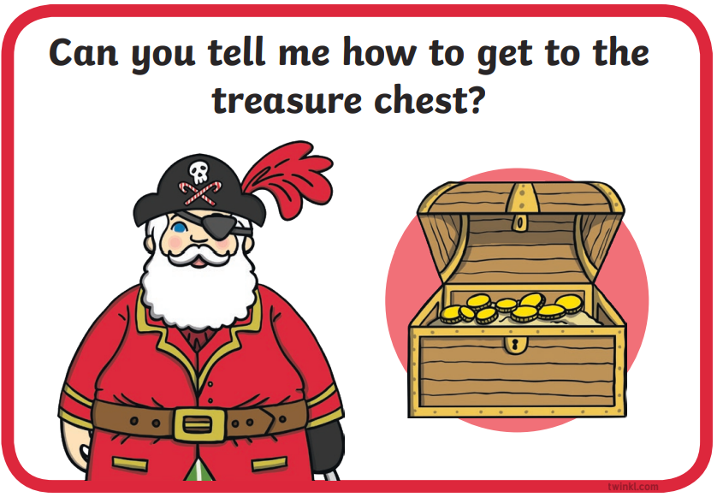
Thursday - Week 10, Term 3 – Stage 1
Daily Task – Help an adult with an outside activity.
Treacherous Thursday
English:
Reading:
Choose a book or a PM online reader to read. The book/reader should be a little challenging to read and you should always attempt to read unknown words before asking for help. Try to read for 20 or more minutes!
After you have read your book, turn back to your favourite double page. Record yourself reading this page showing your good reader skills. Why was this page your favourite? Send your video to your teacher on SeeSaw.
Spelling:
Rhyming words. Can you write a word that rhymes with the spelling words beside them? You might only need to change the first letter of each word to do this. Pick 10 words from either spelling list and write a word that rhymes beside.
Writing:
Listen to ’Where the Forest Meets the Sea’ read to you by Miss Finch (see Seesaw activities).
Have a look at the images of some of the strangest animals on earth (or view the 61 animals on the website) - https://www.boredpanda.com/strange-unusual-animals/?utm_source=google&utm_medium=organic&utm_campaign=organic)
Select one of the animals to write about. Things to think about when writing:
- Name of the animal
- Describe the animal (what it looks like)
- Where do you think the animal lives?
- What does it do?
- What do you think about the animal?
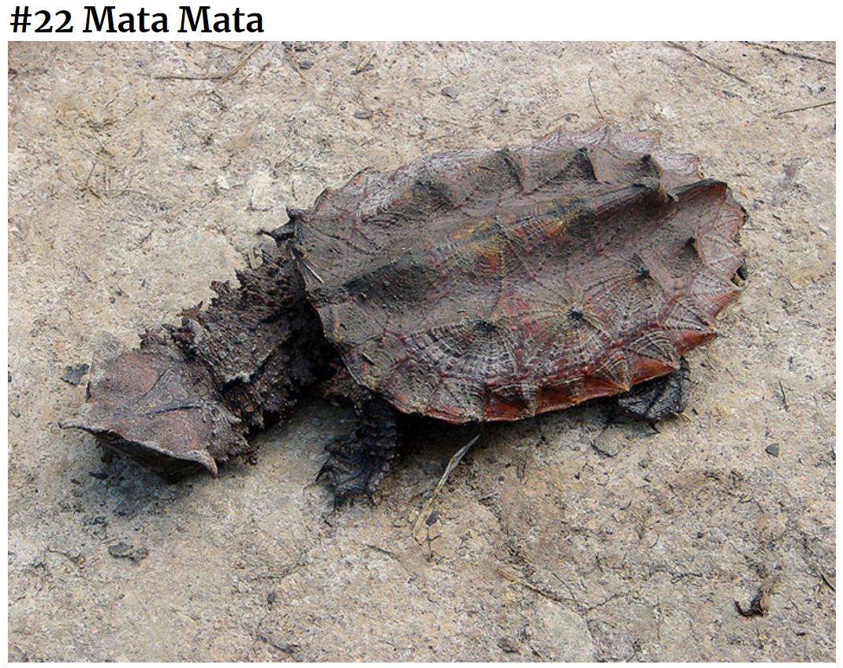
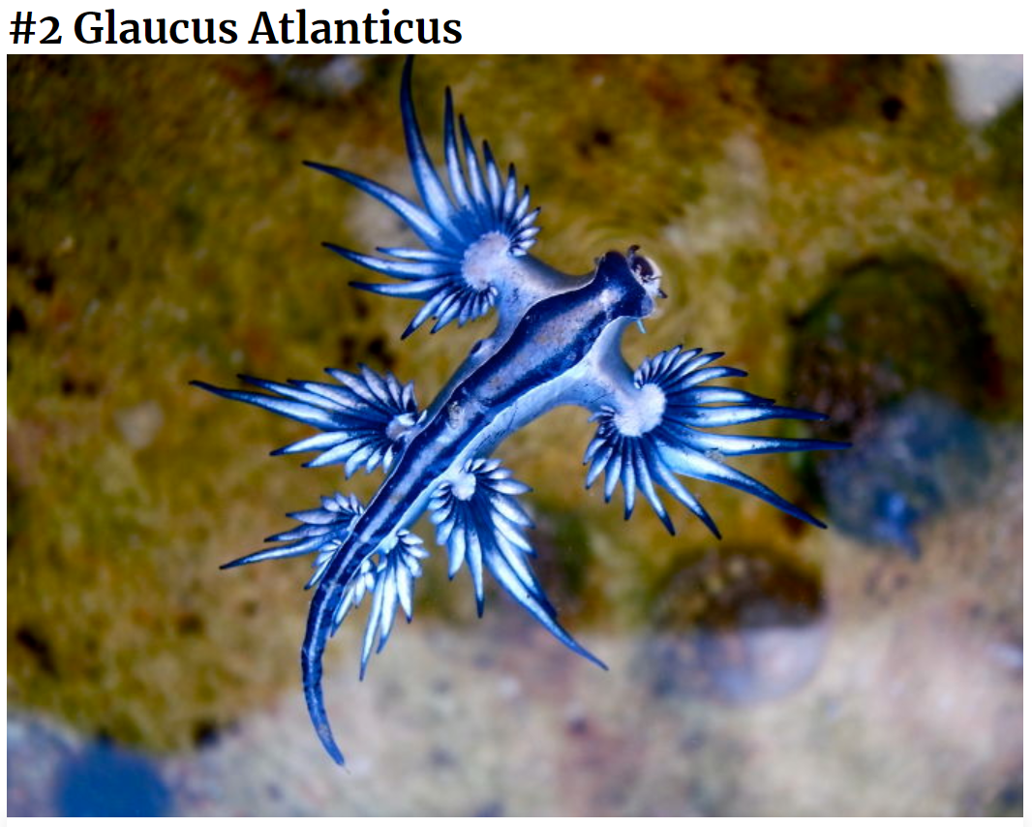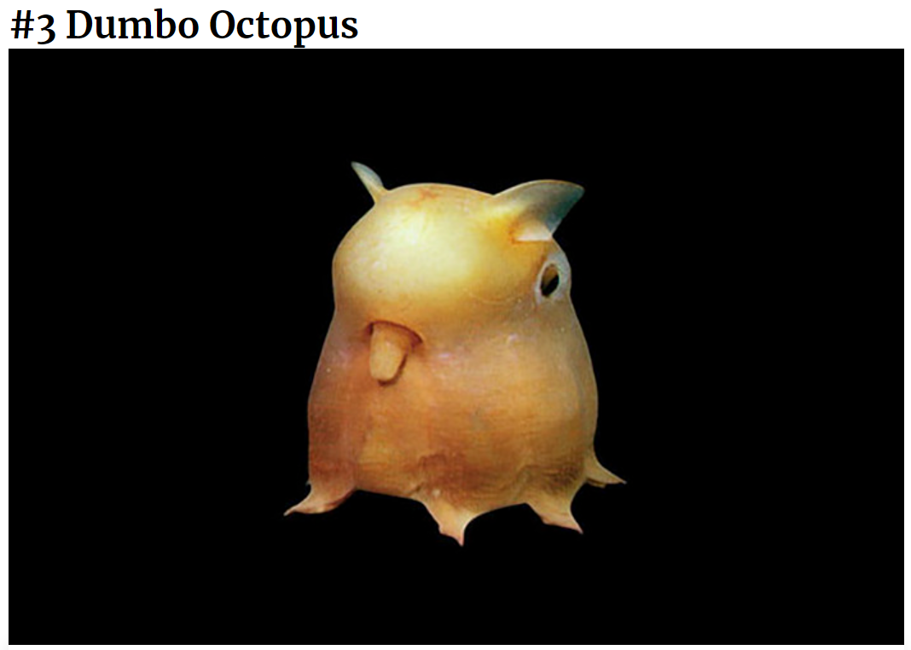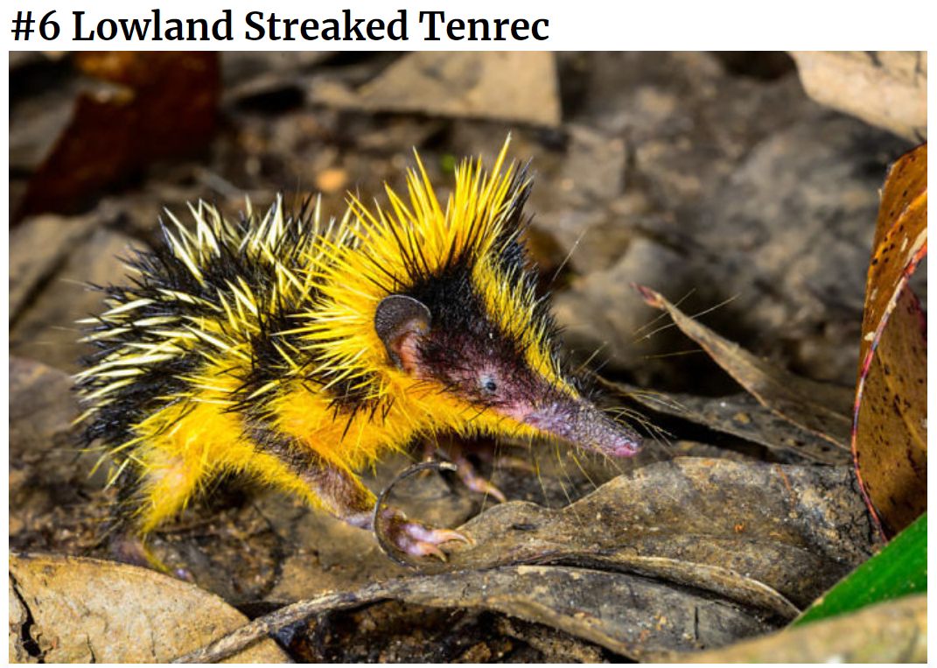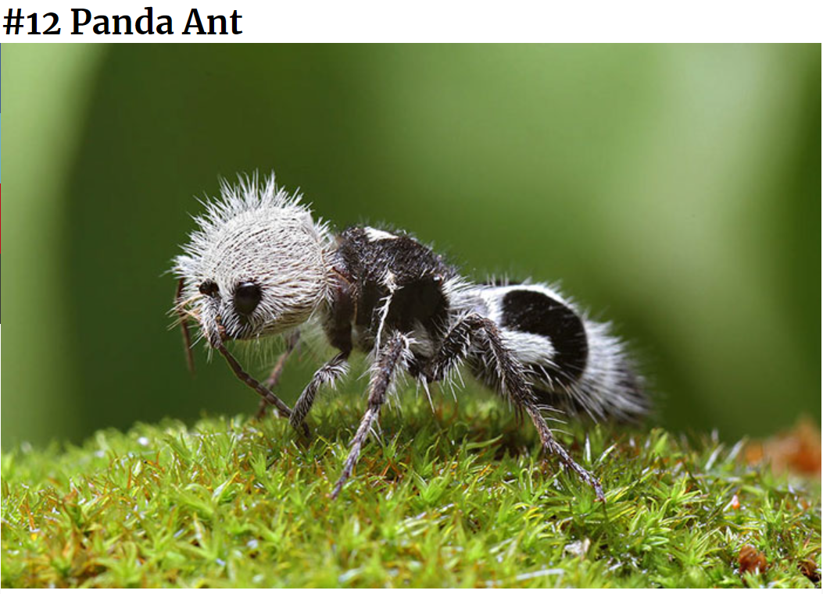
Break – Time to stop and refuel. Eat, play, have fun. Self-directed outside activities where possible.
Maths:
Number of the Day:
Play ‘Hit the Button’ - https://www.topmarks.co.uk/maths-games/hit-the-button
Pick a maths topic and answer as many questions as you can before time is up! You might like to race someone in your house.
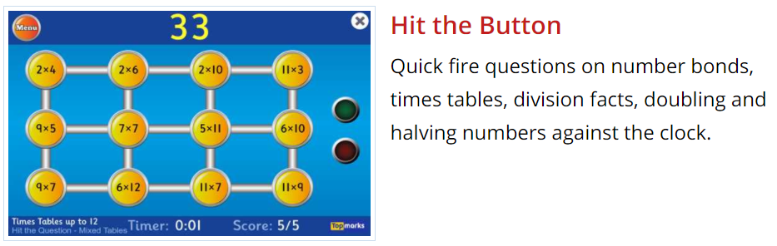

Lesson:
Complete four or more of the outdoor maths challenge cards:

Extension:
Complete the ‘Reasoning in Addition’ puzzle worksheet. Find the value of the shapes so that the given answers are correct. Remember that the value you give each shape needs to work for the questions for each puzzle.
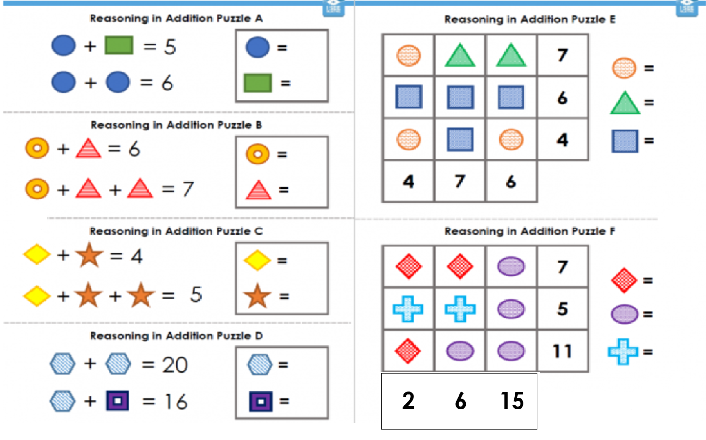

Physical Activity:
Complete thirty minutes a day of physical activity. Go for a walk, run or ride with an adult.
Click on the following link to have a turn at the ‘Jungle Chase’ - https://video.link/w/WNP7c
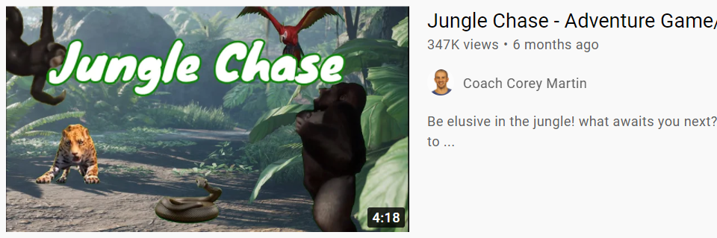

Break – Time to stop and refuel. Eat, play, have fun. Self-directed outside activities where possible.
Creative Arts:
Design a ‘hotel’ for an animal – could be your own pet, an animal that you like, or even the strange animal you wrote about this morning.
You can draw your design or even create it using recycled materials, Lego, blocks, or other things found around your house (ask your parents before using anything that you find). Some things to think about:
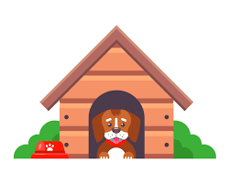
- Why would your animal live there?
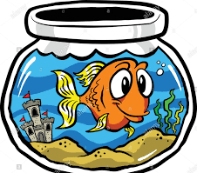
- Does it need anything to survive? (Water, shelter, etc.)
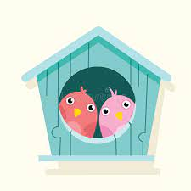
- Does it need something soft?
- Where would your animal go to the bathroom?
,

Friday - Week 10, Term 3 – Stage 1
Daily Task – Clean your room.
Fun Fri-YAY!
English:
Reading:
Choose a book or a PM online reader to read. The book/reader should be a little challenging to read and you should always attempt to read unknown words before asking for help. Try to read for 20 or more minutes!
Listen to Mr Riley read ‘How the birds got their colours’ https://video.link/w/v9g8c . After you have listened to the book, talk to the adult you are working with or record yourself talking to your teacher. Share your favourite part, and don’t forget to tell us WHY it is your favourite part!
Spelling: Read your spelling words to yourself or an adult out loud. Ask someone to read your spelling words to you. After they say each word have a go at writing it – trying your hardest to spell it correctly. A practie spelling test!
Writing: Using similes write a poem on the colours of rainbow. Think about what things you know that are red, orange, yellow, green, blue and purple. Try to put in some descriptive words (adjectives) eg- A rainbow is as purple as a plump and juicy plum.

Break – Time to stop and refuel. Eat, play, have fun. Self-directed outside activities where possible.
Maths:
Play a board or card game with someone at home. If you don’t have any games, you could always play greedy pig or race to 100.

Lesson:
Design a board game
You are going to decide a board, think of all the board games you know and how they work. Below there are two links to 2 types of games, you can do something similar.
https://video.link/w/uYg8c
https://video.link/w/qZg8c

Be creative and challenge a person at home to a game when you are finished!

Break – Time to stop and refuel. Eat, play, have fun. Self-directed outside activities where possible.
FriYAY:

WELCOME TO THE SCHOOL HOLIDAYS!
Before you find a fun celebration activity to do, your job is to clean up and pack away your home school area. This means make the area nice and tidy because you won’t be needing to work there for the next few weeks! (And hopefully not again!)
Have a wonderful break and enjoy yourselves – you deserve it. Well done for completing Term 3, we are super proud of you all and your commitment to your learning. We miss you all, but we are sure you are going to have lots of fun! - From your Stage 1 Teachers.
