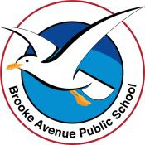
Learning from Home – Brooke Avenue Public School
K-6J, K-6M and K-6S – Week 10, Term 3
The following timetable can be used by students to support learning at home. All tasks have been linked to syllabus outcomes. If technology is available at home, please use the attached links to support learning.
Monday - Week 10, Term 3
Daily Task – Ask if you can vacuum the floors in the house
English:

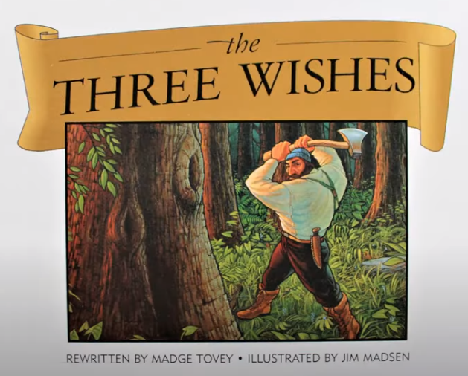
Watch this story called ‘The Three Wishes’ The Three Wishes - Fairy Tale Kids Book Read Aloud - Bedtime Stories for Kids - Storytime for Kids - YouTube

Complete the following activities about this story.
- Create a new character for the book that you think would grant wishes. Would it be a little man dressed in green like in the story? Or a fairy? Or a gene in a bottle? Or a pixie? Or something totally different? Tell us about your character and draw a picture of it.
- If you could have 3 wishes, what would they be? Think carefully about your wishes because you don’t want to waste them like the characters in the story did! Write your wishes down and tell us why you chose these wishes. Use the star templates from your resource pack to display your work.
- Choose 10 nouns (names of things) from the story and make a spelling list from them. Can you write your spelling words in rainbow writing? Can you make a word pyramid from them? Can you write them in a sentence? Can you draw an illustration of them? For example, you could use; axe, tree, boots, sausage…
- Tell somebody what your favourite part of the story was and why.

Logon to your reading eggs https://readingeggs.com.au/ or your ePM reader account PM eCollection | Guided Reading Re-Imagined | Nelson Cengage Learning Australia and enjoy some down time!

Break – Time to stop and refuel. Eat, play, have fun. Self-directed outside activities where possible.
Maths: Time

Today we are going to look at how long things take you to do. Follow the suggested activities…
- Think of 10 things you do throughout the day and write them down. For example, tie your shoes laces, eat dinner, make your bed, watch TV etc. List the activities in order of duration from shortest to longest time taken.
- Ask someone who is at home with you today about the time it takes them to the activities you have listed. Are they the same as yours or does it take them more or less time? Why do you think this is? I know that I can tie my shops laces quicker than you can! The reason for this is that I am very old and have had a lot more practise tying laces than you have!
- Complete the duration worksheets in your resource pack. One of the activities asks you to estimate how many times you can do something in 10 seconds and then to do the activity and count how many times you can do it! Was your estimation correct? Why? Why not?
- Ask an adult if you can use a timer or stopwatch (or use this online version https://www.online-stopwatch.com/ so you can record how long it takes you to do some of the things on your list. Before you start timing, estimate how long your activities will take you to complete. Were you correct? Why? Why not?

Log on to maths seeds Home - Mathseeds or ABCya ABCya! • Learning Games and Apps for Kids and play some maths games!

Break – Time to stop and refuel. Eat, play, have fun. Self-directed outside activities where possible.
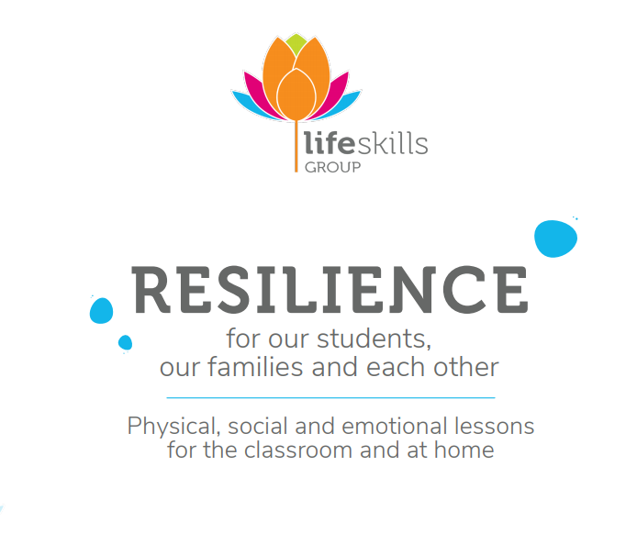
PDHPE: Resilience
Today you are going to be working on a healthy mind and body!
Using the ‘Life Skills Resilience’ document in your resource pack, choose 2 or 3 activities to do. You may need an adult to help you read the instructions. Set up a nice, quiet place to relax in, select peaceful background music and begin your activities. Take note of how you feel before you begin and then compare this to how you feel after completing the activities. Do you feel calmer and stronger afterwards? Why? Why not?
If you feel like you have a lot of energy afterwards, you can visit this link for some fun aerobics! https://www.youtube.com/watch?v=5if4cjO5nxo
If you feel relaxed try this yoga clip! https://www.youtube.com/watch?v=Rzw-Oir8UPw

Tuesday - Week 10, Term 3
Daily Task – Can you vacuum the inside of the car?
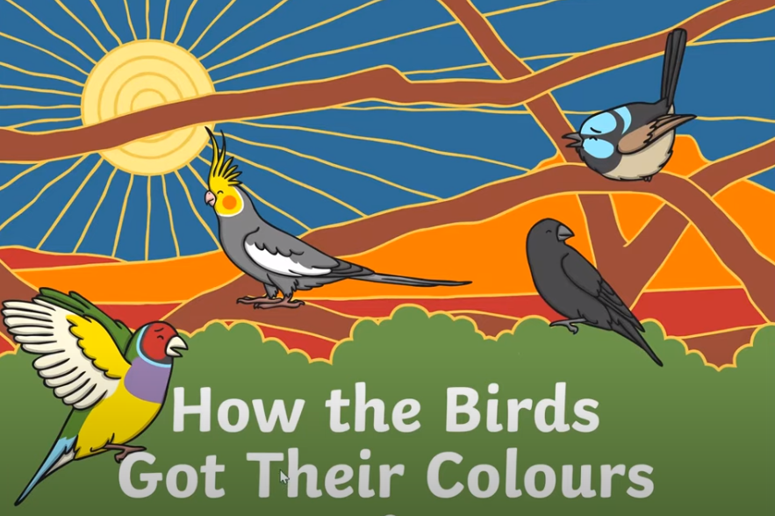
English:
Listen to this child read ‘How The Birds Got Their Colours’ how the birds got their colours - YouTube
Complete the following activities about this story…
- Tell someone what your favourite part of the book was and why.
- Complete the task sheet in your resource pack.
- Why did the crow remain black? Do you think that crows are happy being black when so many native Australian birds have beautiful, coloured feathers? What colour would you like to be if you were a bird? Draw, paint or use a computer paint program to make a picture of your ideal bird and post it on Seesaw!
- Cut out the masks in your resource pack and create your own retelling of the story using the masks. You can tie them around your head with string or could glue them to a skewer or paddle pop stick and hold them up to your face. You may need to have some other family members take on a character role as well as yourself.
- Create a new scene in the story. Maybe the birds all give Crow a coloured feather? Maybe they decide that colour doesn’t matter and live together in harmony?
Practise choosing the correct spelling of words in this interactive game Poop Deck Pirates - mobile friendly (ictgames.com)
Logon to your reading eggs https://readingeggs.com.au/ or study ladder and complete some of your own tasks.
Break – Time to stop and refuel. Eat, play, have fun. Self-directed outside activities where possible.
Maths:

‘What Are The Chances?’ game

What you'll need
Two coins, paper, and pencil to keep score

What to do
Flip one coin. Every time it comes up heads, you get 1 point. Every time it comes up tails, your partner gets 1 point. Flip it 50 times. Tally by 5's to make it easier to keep track of scores. The person with the most points wins. If one person has 10 points more than the other person does, score an extra 10 points. Does this happen very often? Why not? Try again with two coins.

Number walk-exploring your backyard or going for a walk with your parent/caregiver, look for numbers in the environment, e.g. on car registrations, house numbers, road signs, petals on a flower, shop windows. What was the largest number that you saw? The smallest? What was the most interesting number? Why? If you can, take some photos of the numbers you have found on your walk or draw a picture of your favourite number!

Go to Math Seeds, Studyladder or Prodigy to work on your maths skills!

Break – Time to stop and refuel. Eat, play, have fun. Self-directed outside activities where possible.
Science: Walking Water experiment
This experiment shows how paper can absorb water and transfer it from one place to another. It also shows how different colours combine to make new colours!
You will need…
- Plain paper towels
- 7 clear plastic cups
- Food colouring (red, yellow and blue)
- A safe space to leave your cups for a few hours…
Watch the following clip before beginning WALKING WATER Easy Kids Science Experiments - YouTube
You may need to pause the video so you can keep up with the steps. Remember that food colouring does stain things so take care not to get any on your clothes! You may need an adult to assist you with some of the steps! Have fun and please post an image of your experiment on Seesaw!

Wednesday - Week 10, Term 3
Daily Task – Ask if you can clean out the pantry or a cupboard in the kitchen. Arrange everything neatly!
English: Literacy
Visit these sites and learn about the beautiful Chameleon! What an amazing animal! https://kids.nationalgeographic.com/animals/reptiles/facts/chameleon and https://www.youtube.com/watch?v=KJtaIqahi3I
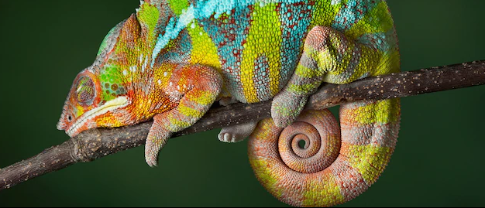
Answer the following questions about chameleons…
- Why do they change colours?
- What different colours can they change into to?
- What is special about their eyes?
- How fast can the flick their tongues?
- How large can they grow?
- What is the size of the smallest chameleon?
- How many different species of chameleon are there?
- Name three areas of the world that they can be found.
Watch Eric Carle’s ‘The mixed-up Chameleon https://www.youtube.com/watch?v=02i3akeNLnc
- What was your favourite part of this story?
- Why do you think the Chameleon was feeling mixed-up?
- If you could change colours to blend into an environment, what would you change into and why?
Colour the chameleon colouring page in resource pack and cut it out. On another page, draw the environment that you think the chameleon lives in. When you have finished that background drawing, paste your chameleon into place! Post an image of your picture onto Seesaw so we can see your work!
Match the safari animal patterns to the correct animal. You will find this activity in your resource pack. Once you have cut each item out and matched them, you could play memory or snap using your safari animal cards.
Take some time to work on Studyladder, reading eggs or ePM readers.
Break – Time to stop and refuel. Eat, play, have fun. Self-directed outside activities where possible.
Maths: Number
Today we are looking at before and after numbers. Here are some activities you can do…
- Roll a dice, write the number and then write the number before and after.
- Choose a playing card (take out the picture cards first) and say the number before and after.
- Ask someone at home to say 10 numbers (you can make them as tricky or simple as you wish) then figure out the numbers before and after.
- Look for numbers around the house (eg on the clock, in your shoes, on food packets), write the number down and write the number before and after.
- Complete the before and after numbers, and missing number activities in your resource pack.
- Cut out the word problem cards from your resource pack and randomly choose 4 to solve. Try to estimate your answer, solve the problem, then check your answer with an adult or using a calculator. You may need some help with this. For a challenge, see if you can create some of your own word problems, post them on Seesaw and we will try to solve them!
Play this online version of snakes and ladders! You can play against the computer if you wish! Have fun! https://toytheater.com/snakes-and-ladders/
Log on to study ladder, maths seeds, ABCya or prodigy and play some games of your choice!

Break – Time to stop and refuel. Eat, play, have fun. Self-directed outside activities where possible.
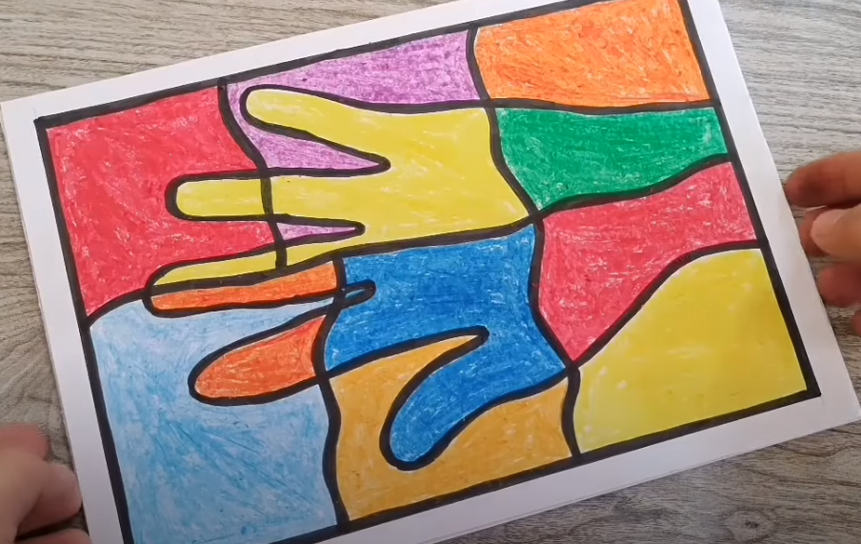
Art:
Today you are going to create an amazing artwork using an outline of your own hand!
You will need…
- Your hand!
- A piece of paper
- A black texta or permanent marker
- Crayons, coloured pencils or textas
Watch this clip and follow the steps. You may need to pause the video so you can keep up with the instructions. Very Easy Art For Kids | Easy Drawing Ideas | School Project | Arts & Crafts - YouTube Please post an image of your hand art onto Seesaw so we can see it! Have fun!

Thursday - Week 10, Term 3
Daily Task – Can you clean the mirrors in the house? What about the windows in your room?
English: Poetry
Watch this clip of the story about Tiddalick the Frog Dreamtime Stories - Tiddalick The Frog - YouTube
Using the Diamante Poem template in your resource pack and the ideas given, see if you can create your own poem about Tiddalick. You will need to think of nouns (naming words), adjectives (describing words) and verbs (doing words) to describe what kind of creature he is.
Choose your own character from a story you like and create a Diamante Poem about that character. You could use any character you wish or even base your poem on a real person (mum, dad, grandparent, sibling, tecaher etc). Please post your poem on Seesaw! You could display your poem with an illustration, drawing or painting of the character or person you have chosen.
In your resource pack, there is another poem for you to complete about a rainbow. You need to think of something that corresponds with the colours in the rainbow to describe the rainbow. For example; As red as…a fresh strawberry; as blue as…a shimmering swimming pool.
Visit the https://www.topmarks.co.uk/Interactive.aspx?cat=40 site…find something that suits you!
Log onto Reading Eggs or ePM collection and find some more books and activities to enjoy!
Break – Time to stop and refuel. Eat, play, have fun. Self-directed outside activities where possible.
Maths: 3D Shape
- Watch this 3D shape song https://www.youtube.com/watch?v=2cg-Uc556-Q
- Go on a shape hunt around your house! Can you find examples of each shape in a different location? You need to find 5 cubes, 3 cylinders, 6 spheres, 1 pyramid and 2 cones
- Can you sketch each item, write its name and what it is used for and post your work onto Seesaw so we can see it?
- Can you use some of the items you found to build a creation? Maybe you could make a city? A mini skate park? An amusement park? Use your imagination!
- This website has printable nets for shapes. Ask someone at home if you could print one and make the shape! https://www.math-salamanders.com/3d-geometric-shapes.html
- Complete the 3D shape sheets in your resource pack.
Go to https://www.coolmathgames.com/ and play a game that you like!

Break – Time to stop and refuel. Eat, play, have fun. Self-directed outside activities where possible.
PDHPE: Resilience
Today you are going to be working on a healthy mind and body!
Using the ‘Life Skills Resilience’ document in your resource pack, choose 2 or 3 activities to do that you did not choose on Monday. You may need an adult to help you read the instructions. Set up a nice, quiet place to relax in, select peaceful background music and begin your activities. Take note of how you feel before you begin and then compare this to how you feel after completing the activities. Do you feel calmer and stronger afterwards? Why? Why not? Were the exercises easier or more difficult than the activities that you chose on Monday? Why? Why not?
If you feel like you have a lot of energy afterwards, you can visit this link for a zumba class! Zumba Dance Party - YouTube
If you feel relaxed, try this meditation clip! Guided Meditation for Children | CRYSTAL HEALING CAVE | Kids Meditation for Happiness - YouTube
Friday - Week 10, Term 3
Daily Task – Make the house look beautiful ready for the holiday break! Find 10 things that have been left out and put them away!
English: Literacy
Imagine you could go on a holiday anywhere you like! Some ideas about where you could travel can be found in these videos. This clip shows some amazing places that you can visit without having to leave Australia https://www.youtube.com/watch?v=Uu4z4t1CXUk and this clip shows some destinations around the world https://www.youtube.com/watch?v=hxeITyt_XfU . You could always pretend you are going on holiday to a place you have already been to, or you could ask an adult where they have been and would like to take you.
Complete the following tasks…
- Decide where you would like to travel to and begin to research your destination. Consider how you will get there. Is it a flight? A long drive? Can you walk? Why have you chosen your destination? What time of year would you travel? Are there some interesting activities to do there? Who would you go with? How much would it cost to get there? Would you stay at a resort, a motel or would you hire a camper van? This is an open-ended task so the options for your research are endless!
- Decide how you will display the information you have gathered. You could create a PowerPoint presentation, make a poster, make a brainstorm mind-map, draw images, find images online or in magazines etc. Choose some interesting information to tell us about your choice.
- In your resource pack you will find an activity about what you may like to pack in your suitcase. Ensure you consider the time of year you will be travelling to make sure you pack the correct clothing.
- Create your own passport using the template in your resource pack.
- Complete the ‘My holiday snapshots’ activity in your resource pack. On the first page draw a picture in the blank box and on the next page, write what is happening in the picture.
Post some of your work on Seesaw so we can share in your holiday dreams!
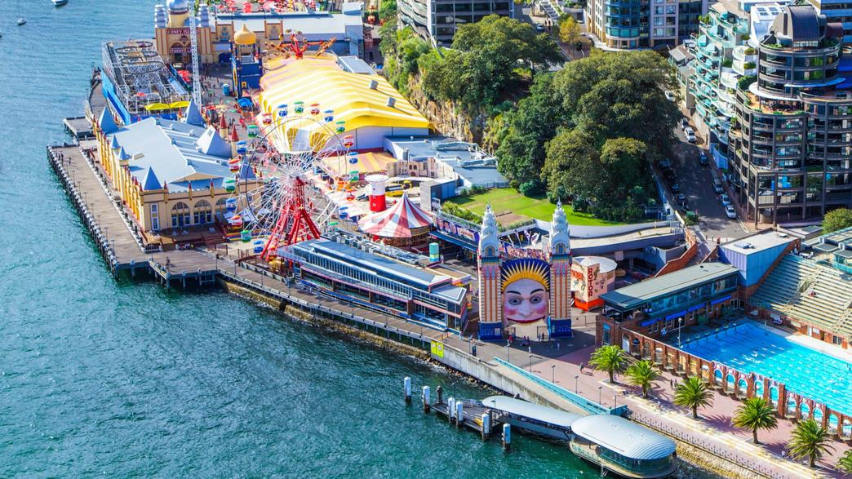
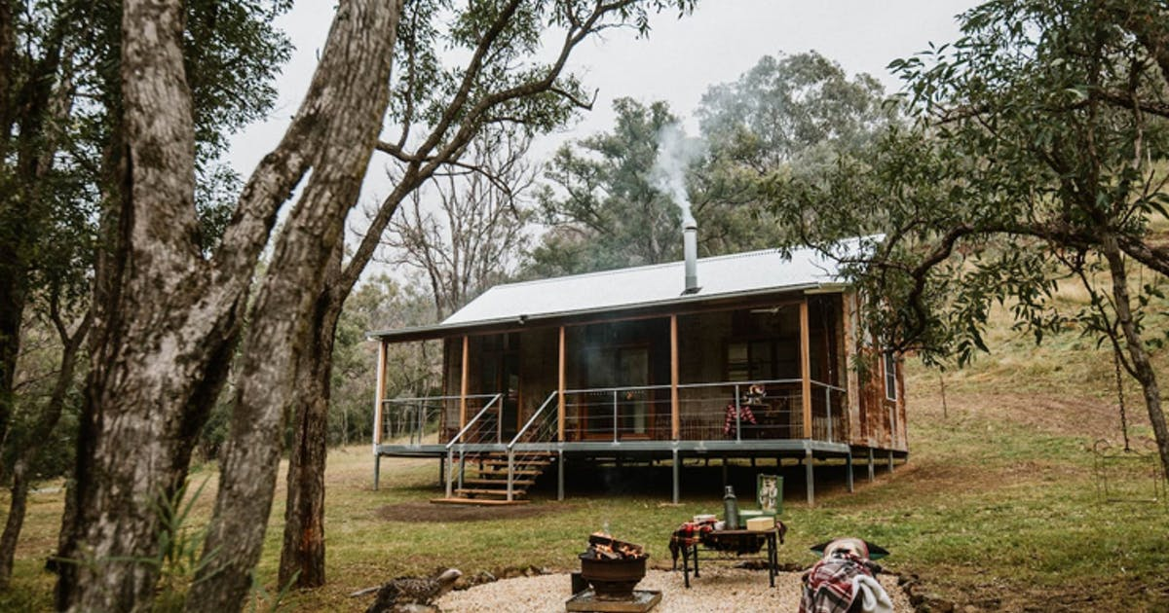
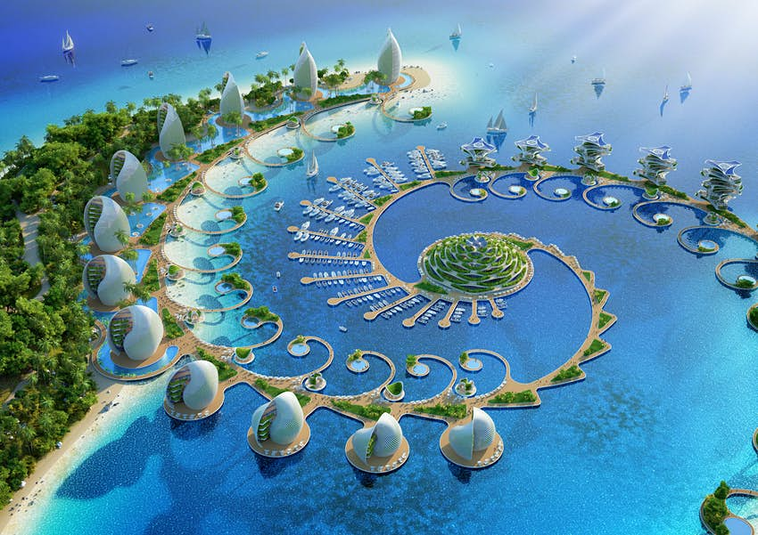

Break – Time to stop and refuel. Eat, play, have fun. Self-directed outside activities where possible.
Maths: Fun Maths! Have fun today playing games or completing items from your Resource Packs that you may not have finished!

Play a board game with a family member, for example Checkers. If you don’t have games at home visit this site https://www.safekidgames.com/board-games/ Some of these games you can play against the computer! Good luck!

Play a card game like Snap, Go Fish or UNO. This site has lots of different card games you can play! https://www.kidspot.com.au/parenting/things-to-do/snap-12-classic-card-games-to-teach-the-kids/news-story/1d153893aee53908749c1377c588928c

Go to ABCya https://www.abcya.com/ or Get Smart https://getsmarts.weebly.com/ or Cool Maths Games https://www.coolmathgames.com/ and play some educational games!
Break – Time to stop and refuel. Eat, play, have fun. Self-directed outside activities where possible.
Happy FriYAy and Happy Holiday!

You are an AMAZING person and we adore you! Complete the ‘I am an amazing person’ sheet in your Resource Pack and create an artwork that defines you! Post it on Seesaw then…

ENJOY YOUR HOLIDAY!

We miss you! Have a wonderful break, stay well and safe, and we really look forward to seeing you in Term 4!

Much love from all your teachers!

