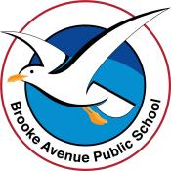
Learning from Home – Brooke Avenue Public School
Kindergarten – Week 10, Term 3
The following timetable can be used by students to support learning at home. All tasks have been linked to syllabus outcomes. If technology is available at home, please use the attached links to support learning.
Monday - Week 10, Term 3 - Kindergarten
Daily Task - Match socks and sort washing.
English

Phonics: You will need a piece of paper and a pencil. Access Seesaw. Watch the video by Mrs Rex and follow her instruction. If unable to access Seesaw, review all sounds on Jolly Phonics. Focus this week is short vowel sounds. Ask your child to write 5 words that have an “a” sound in them, eg – hat, cap, dad, cab, ham, trap. Have your child underline the vowel sound.
Reading: With a family member or by yourself, read a book on https://app.pmecollection.com.au. Use the record tool to record yourself reading and listen to it back.
Writing: You will need a piece of paper and a pencil. Access Seesaw and watch the video by Mrs B. Think of something that you might like to see at our school. Would you like more play equipment? A slide? Would you like to have more mufti days? Write a letter to Mr Dalkeith explaining what you would like to see at school and why it is a good idea. Remember to finish it by writing who it is from.
Sight words: Practise reading your sight words.

Break – Time to stop and refuel. Eat, play, have fun. Self-directed outside activities where possible.
Maths

Warm up: Play a few games of scissors, paper, rock with a family member and keep track of who wins by using tally marks.
We are learning to: 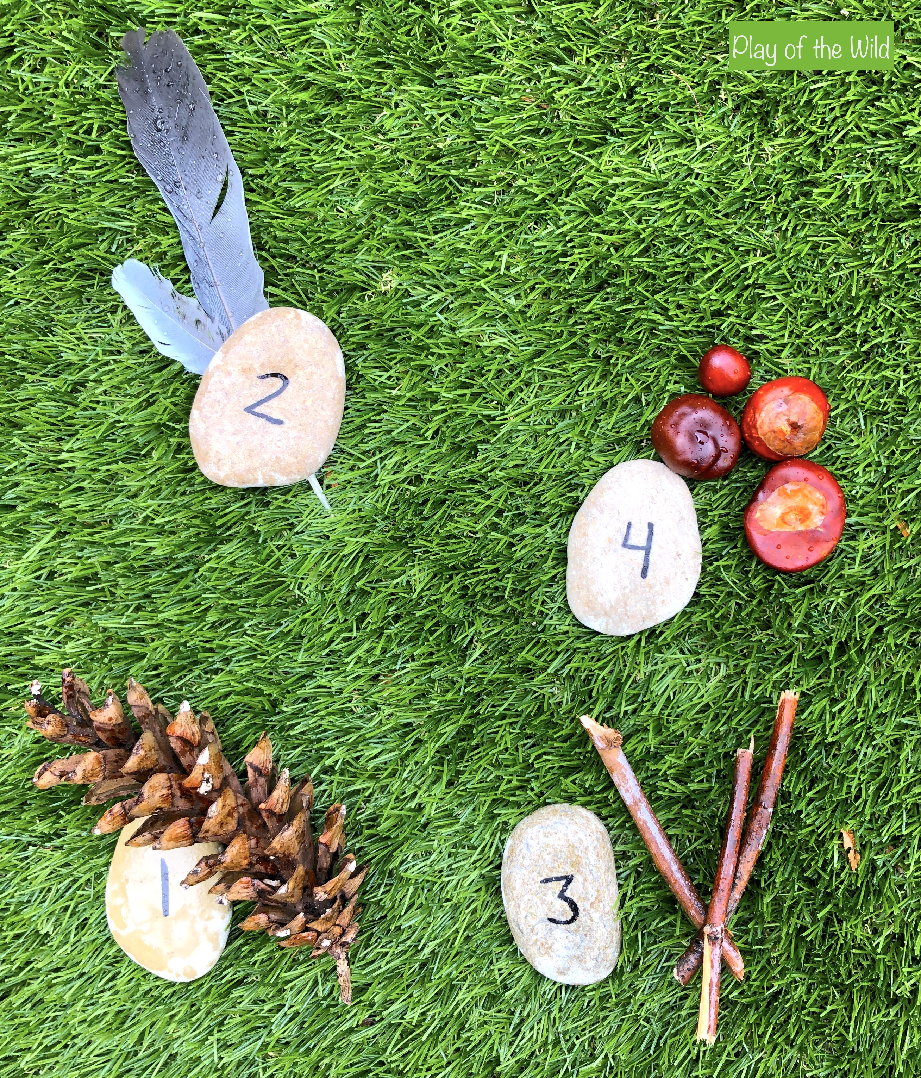 represent numbers using concrete materials.
Using numeral cards 1-20, rocks with numbers or numeral flashcards, represent each number using concrete materials.
Extension: Use 2- or 3-digit numeral cards to form combinations. See Miss Hetherington’s video.

Break – Time to stop and refuel. Eat, play, have fun. Self-directed outside activities where possible.
PDHPE:
Practise catching the egg with this video for today's lesson. Have a pair of socks ready to go! https://www.yout-ube.com/watch?v=7Ypx7PiH6Qs&t=183s

Tuesday - Week 10, Term 3 - Kindergarten
Daily Task - Wash the dishes.
English

Phonics: You will need a piece of paper and a pencil. Access Seesaw. Watch the video by Mrs Rex and follow her instruction. If unable to access Seesaw, review all sounds on Jolly Phonics. Focus this week is short vowel sounds. Ask your child to write 5 words that have an “e” sound in them, eg – step, yes, hen, pet, red. Have your child underline the vowel sound.
Reading: Read the story ‘The Ocean’ and then answer the questions by writing on the lines. Read a book on https://app.pmecollection.com.au. Use the record tool to record yourself reading and listen to it back.
Writing: Access Seesaw. Watch the editing video by Mrs B. Edit the following sentence. ‘vis term we have ben learning from home and have worked very hard?’ There are 2 spelling mistakes. Also does it need a question mark? Is it asking something? Rewrite the sentence correctly. Take a photo and post to your teacher on Seesaw.
Sight words: Practise reading your sight words.
Break – Time to stop and refuel. Eat, play, have fun. Self-directed outside activities where possible.
Maths

Warm up: Cut out the dominoes cards (resources) and play a game of dominoes. You can play by yourself and match the dots of each tile, or you might like to ask a family member to play a game with you.
We are learning to: Count on.
Using one set of playing cards and one set of numeral cards. Students turn 1 card from each pile. Start with numeral card pile and count on using the symbols from the playing cards.
Extension: Use a deck of cards with numbers 5-10. Students take two cards and ask partner to add together without showing them the numbers.

Break – Time to stop and refuel. Eat, play, have fun. Self-directed outside activities where possible.
Science and Creative Arts
To start, watch the short video on bees. Next you will be completing a directed drawing of a bee https://www.yout-ube.com/watch?v=Ho4aUHY6fss Once finished, upload a photo of your bee with a voice over telling your teacher one interesting fact that you learnt about bees.
Wednesday - Week 10, Term 3 - Kindergarten
Daily Task – Make your bed.
English

Phonics: You will need a piece of paper and a pencil. Access Seesaw. Watch the video by Mrs Rex and follow her instruction. If unable to access Seesaw, review all sounds on Jolly Phonics. Focus this week is short vowel sounds. Ask your child to write 5 words that have an “i” sound in them, eg – wig, twin, swim, kid, tip. Have your child underline the vowel sound.
Reading: Read the story ‘Playground’ and then answer the questions by writing on the lines below. Read a book on https://app.pmecollection.com.au. Use the record tool to record yourself reading and listen to it back.
Writing: Access Seesaw. Watch the writing video by Mrs B. Today we are writing a list for what we would have needed for our excursion tomorrow. What would we need to take? Remember a list starts at the top and goes down the page.
Sight words: Practise reading your sight words.
Break – Time to stop and refuel. Eat, play, have fun. Self-directed outside activities where possible.
Maths

Warm up: Using the dominoes cards (resources) count the dots on a tile and match them to another tile with the same number of dots. E.g.
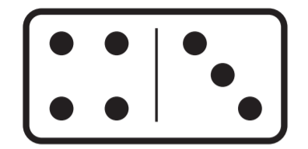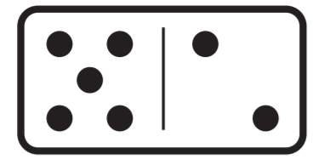 Both these tiles show the number 7.
We are learning to: compare lengths indirectly by copying a length, eg using the same squares to compare lengths. Complete worksheet.
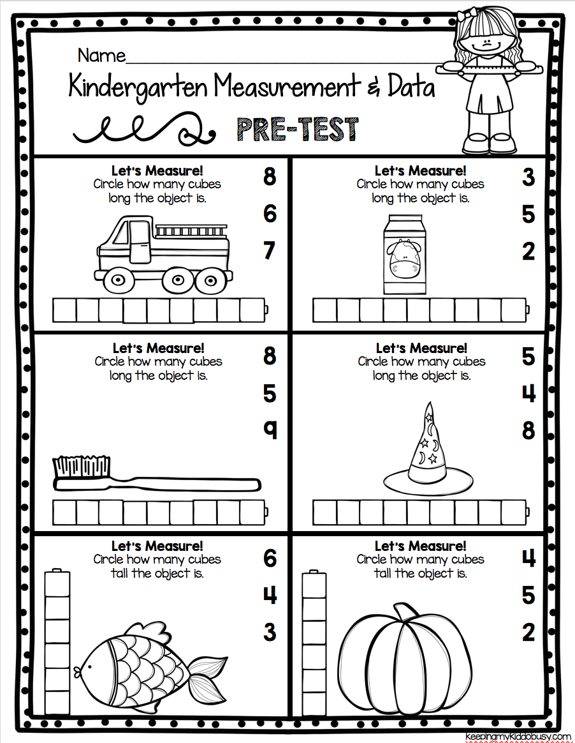Collect a variety of objects from around the house. Order them from longest to shortest, try use the language longer, higher, taller than, shortest, lower than, longest, the same as 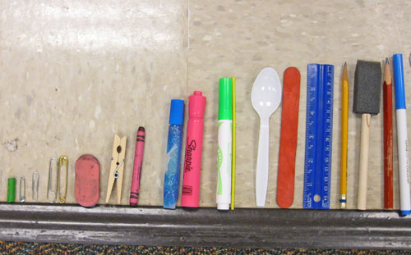

Break – Time to stop and refuel. Eat, play, have fun. Self-directed outside activities where possible.
Science
Start Today’s lesson by watching the following video on bees https://www.yout-ube.com/watch?v=ta154f5Rp5Y which explains how bees pollinate flowers and fruits/ vegetables. Bees sure are important insects! After you have watched the video, click on the next picture to look at a book called Bee and Me by Alison Jay. This is a special book that has no words, only pictures and shows a beautiful friendship between a girl and a bee. Like all good friends, the girl and the bee help each other and by helping each other something magical happens to their city. Once grey and flowerless, the girls and bee work together to make the city come to life with the colours and smells of hundreds of beautiful flowers! Your task today is to fold a piece of paper down the middle. On the left half, you will draw a picture of the city at the start of the book. It looked dull and boring! On the right-hand side, draw a picture of the city at the end of the story after the bee had pollinated all of the plants and hundreds of flowers had bloomed! Upload a photo of your drawing to Seesaw!
Science
First, complete the Seesaw slide by labelling the picture of the bee by dragging the words to the collect part of the bee. On the next slide, there is a link to a Cosmic Yoga Session with Enzo the Bee https://www.yout-ube.com/watch?v=uyj5LooYWyg

Thursday - Week 10, Term 3 - Kindergarten
Daily Task – Help an adult with an outside activity.
Excursion Day!
This term Kindergarten would have been excited to attend a stage excursion. Spend the morning visiting some interest based ‘virtual’ excursions and websites. (Links attached below)

Break – Time to stop and refuel. Eat, play, have fun. Self-directed outside activities where possible.
Excursion Day!
Spend the afternoon visiting a local landmark or National Park focusing on our natural environment.

Break – Time to stop and refuel. Eat, play, have fun. Self-directed outside activities where possible.
Excursion Day!

Friday - Week 10, Term 3 - Kindergarten
Daily Task – Clean up your room.
English

Phonics: You will need a piece of paper and a pencil. Access Seesaw. Watch the video by Mrs Rex and follow her instruction. If unable to access Seesaw, review all sounds on Jolly Phonics. Focus this week is short vowel sounds. Ask your child to write 5 words that have an “o” sound in them, eg – hot, mop, drop, shop, spot. Have your child underline the vowel sound.
Reading: Read your favourite book at home to a family member. After reading tell your family member what happened at the beginning, middle and end of the story. You might also like to draw a picture as well.
Writing: PBL Rewards Day! Write one or more sentences about what you plan to do for the PBL Rewards Day.
Sight words:

Break – Time to stop and refuel. Eat, play, have fun. Self-directed outside activities where possible.
Maths
Warm UP Using the dominoes cards, play a game of dominoes parking lot (resources). Put the dominoes in the corresponding parking lot.

PBL Reward - See the resources available on our website to celebrate a term of positive behaviour.
Go to Seesaw for details for the Chippy Disco.
Break – Time to stop and refuel. Eat, play, have fun. Self-directed outside activities where possible.
STEM
For this week’s STEM challenge, you are asked to make a bee from recycled materials from around your house. Just like last week, you will need to have a think about the body parts of a bee! If you don’t have the materials or the time to make the bee from recycled materials, there is a bee template in the working from home pack (see attached), that you can colour and use for the activity. After you have made/coloured and assembled your bee, you are to take your bee for a fly around your garden or local park to have a look for a few things that bees like. Can you find any flowers for your bee to collect pollen? Can you find any trees, branches or rocks where your bee could build its hive? Take a photo of your bee near one of these things and upload to Seesaw. If you would like to include more information, record your voice and tell your teacher an interesting fact that you have learnt about bees!

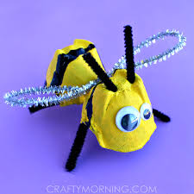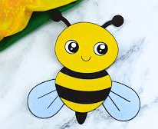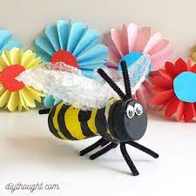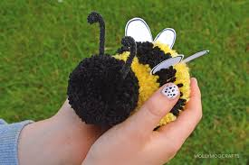

Virtual Excursion Links
Robert Irwin - Zoo | https://video.link/w/M0G5c
Robert Irwin – Dinosaurs | https://video.link/w/o1G5c
Melbourne Zoo | https://video.link/w/51G5c
Reptile Park – Monotremes | https://video.link/w/s3G5c
Reptile Park – Eric Feed | https://video.link/w/h3G5c
Reptile Park – Koala | https://video.link/w/73G5c
Roller Coaster Ride | https://video.link/w/s4G5c
Walking on Country - Shoalhaven | https://video.link/w/z5G5c
Great Barrier Reef | https://video.link/w/J6G5c
Indigenous Literacy Day | https://dartlearning.org.au/excursion/indigenous-literacy-day-2021/?fbclid=IwAR18dPtXMLZabOsck0t_cjrTkoK2G4KygvWHFpVtH_eU4koF2-2COVCeUdQ

