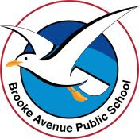
Learning from Home – Brooke Avenue Public School
Stage 1– Week 2, Term 4
The following timetable can be used by students to support learning at home. All tasks have been linked to syllabus outcomes. If technology is available at home, please use the attached links to support learning.
Please upload work marked with the camera icon to Seesaw
Monday - Week 2, Term 4 – Stage 1
Daily Task - Match socks and sort washing.
English:

Reading Read a book out loud and record yourself reading the first page. This may include a book you have at home or log in to your PM Readers account. After you have read the first page, listen to the recording and see how your reading sounds.
Does it sound like talking? Is it smooth or did it sound like a robot reading. Think about what you could do to make your reading sound interesting. When reading aloud, fluent readers read in phrases and add intonation appropriately. Their reading is smooth and has expression.
Spelling This week in spelling the focus is plurals. For some words this means adding an s to the word, an es or even dropping the y and adding ies. List 1 will focus on adding s and es and List 2 will include some more challenging words. Watch the Seven Plural Rules in a Rap song as a warmup for this week's spelling rule. Choose from List 1 or List 2 and write these words down.
Plurals s, es, ies
Click this link to learn about plurals Spelling List Term 4 – Week 2
List 1 | List 2
girls | trucks
dogs | friends
ships | cars
cooks | classes
buses | kisses
ladies | wishes
matches | taxes
dishes | berries
gases | wives
lives | lunchboxes
Writing Recount
Write a recount of what you did in the September school holidays. Remember the structure to use. Today you are going to write the title and do the orientation to your recount. Start planning the events by writing down ideas on a separate piece of paper. The rest will be completed tomorrow. Edit your writing for spelling errors and check it makes sense. You may like to read your writing to an adult. Take a photo of your recount so far and send to your teacher.
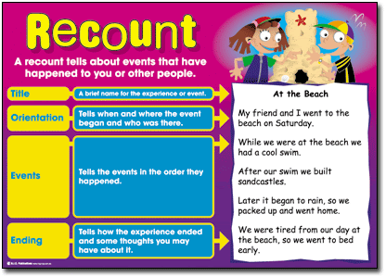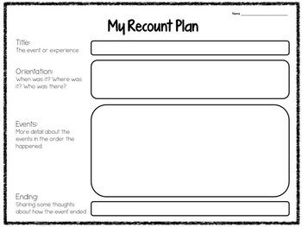
Speaking and Listening Record yourself or tell an adult/sibling about your holidays. Think about the structure you have just used with your recount writing. Remember the key questions – Who, What, When, Where, Why and How?

Maths:

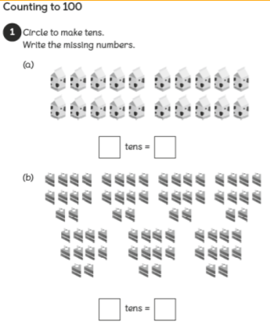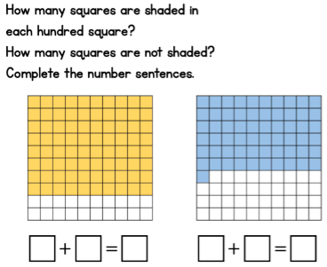

Volume and Capacity: Watch this video to learn about capacity. Flynn and Dodley Capacity

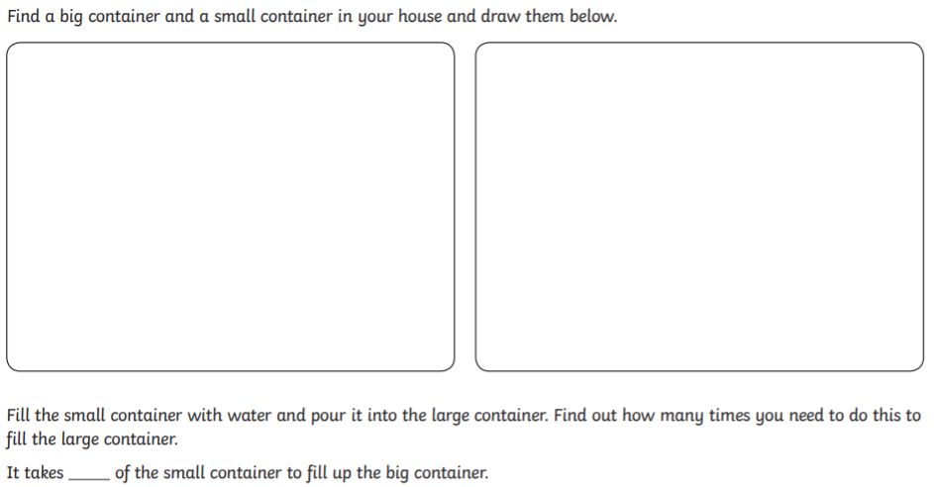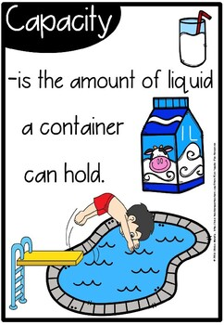
P.E Move and Freeze Get your boogie on with this dance video. You will be singing the song and doing the moves in no time. If you don’t feel like dancing, feel free to do any other physical activity of your choice. Get active and move!
Click this link for a fun PE activity
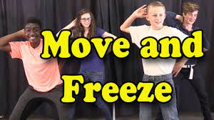

Break – Time to stop and refuel. Eat, play, have fun. Self-directed outside activities where possible.
Geography: Environments can be used in different ways by different people.
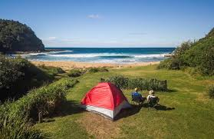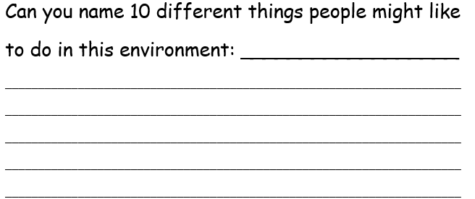

Tuesday - Week 2, Term 4 – Stage 1
Daily Task - Wash the dishes.
English:
Reading Choose a reading passage. Read one of the 3 reading passages - At the Park, Pam’s Vacation or Rabbits. Record yourself reading and send your best read through to your teacher. Remember to use expression and to pause at the punctuation.
Or you can read a book from home, Seesaw or on the PM readers online.
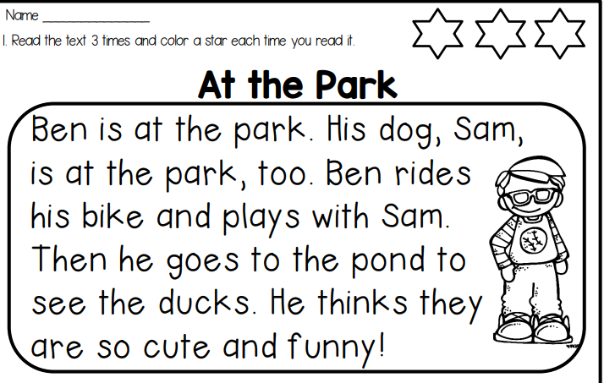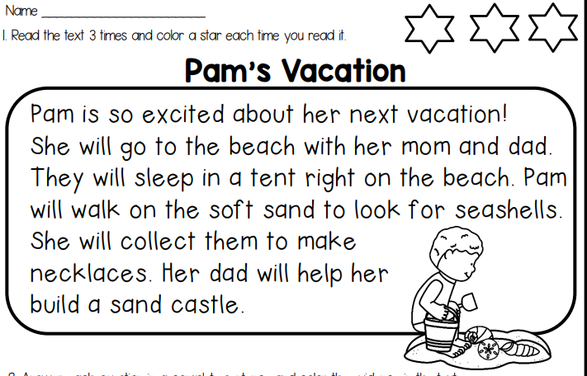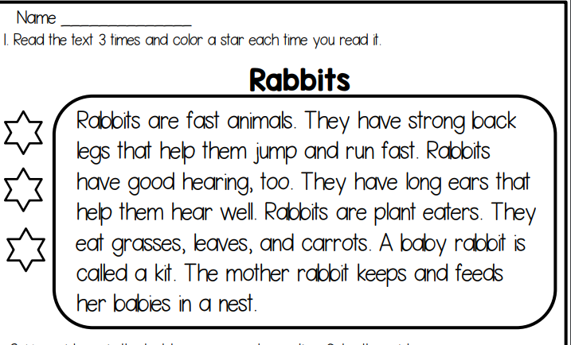
Spelling Plurals – Complete the find a word attached with words from both lists. Try and use a different colour for each word you find.
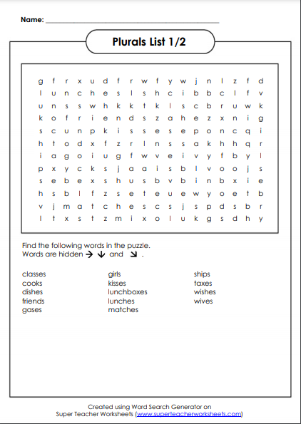
Writing Recount
Today you are going to write the events and the ending to your recount. Yesterday you wrote down some ideas of what you did in the holidays. You can use the sentence beginnings such as First, Then, Next, After that. The ending summarises the events in your recount and finishes with a positive comment/statement. Show/read your writing to an adult. Take a photo of your finished recount and send to your teacher. This poster and template are attached below.
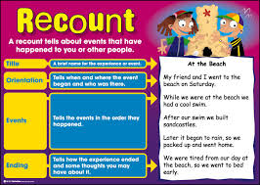
Break – Time to stop and refuel. Eat, play, have fun. Self-directed outside activities where possible.
Maths:
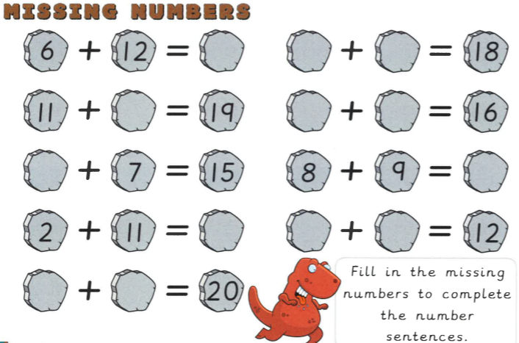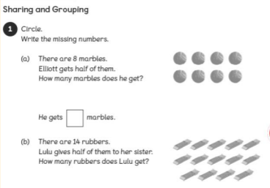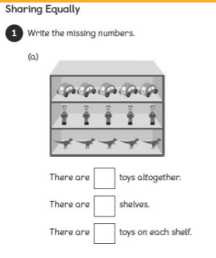

Volume and Capacity

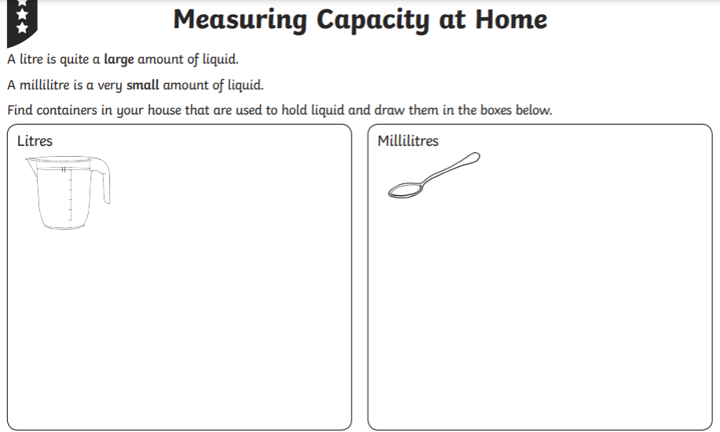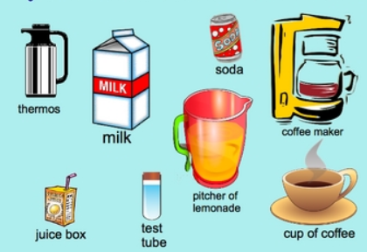

P.E This or That Choose what picture you think is the funniest and move to that side of the room. Then complete the exercise for 30 seconds. There are 10 different slides. Or go for a bike ride or a walk with a family member. Try to aim for 30 minutes exercise.

Click this link for a fun PE activity

Break – Time to stop and refuel. Eat, play, have fun. Self-directed outside activities where possible.
Science and Geography - Listen to this story to learn about natural and man-made things.
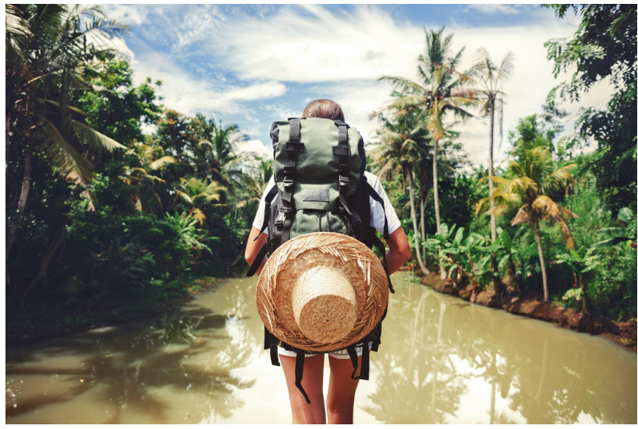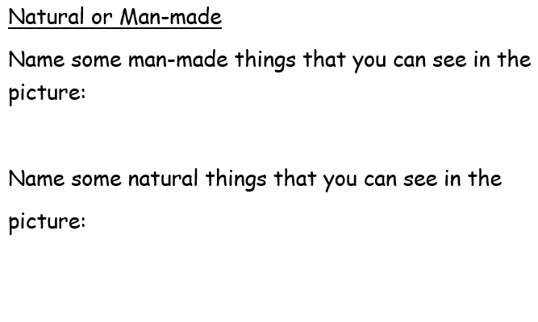
Wednesday - Week 2, Term 4 – Stage 1
Daily Task – Make your bed.
English:
Reading Today’s reading task involves you reading only 1 page from a Pig the Pug book. But there is a twist! We are focusing on reading with expression and intonation. Firstly, you need to read the passage in your normal voice. Then you need to read the same page again using one of the emotion cards. Try reading with all 6 (happy, sad, angry, surprised, scared and like a mouse) and record your favourite one. Send this to your teacher on Seesaw.
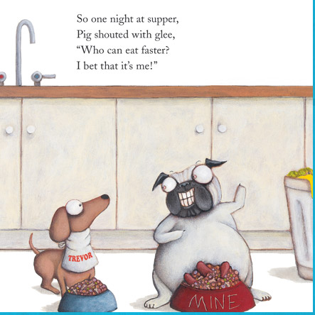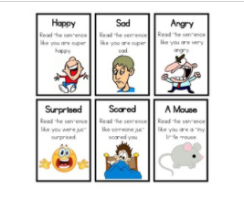
Spelling Plurals – s, es, ies Unjumble the words and write the correct spelling next to the jumbled word. They are not in the order of the spelling list.
List 1 - jumbled | List 1 - Unjumbled | List 2 - jumbled | List 2 - Unjumbled
sligr |  | dsferni
ssega |  | rsca
thcmase |  | xeboncuhls
sgod |  | xtesa
sidale |  | veswi
sseub |  | rrsiebe
vesli |  | hswise
hspis |  | sselcas
hsdies |  | ksrtuc
ockos |  | sseski
Writing Watch the trailer for the new animated movie Turning Red. Click this link
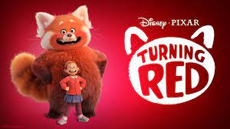
Using the same recount structure as Monday you will write a recount of the trailer Turning Red. Today you need to write the Title and the Orientation and on Thursday you will complete the Events and Ending sections. You may need to re-watch the trailer a few times in order to plan the sequence of events. Template is attached below.
Speaking and Listening Give an oral recount of the trailer Turning Red. You may like to record yourself giving the recount or tell it to a sibling/friend or parent. You may like to start with... The new trailer coming out in 2022, Turning Red is about …
Break – Time to stop and refuel. Eat, play, have fun. Self-directed outside activities where possible.
Maths:
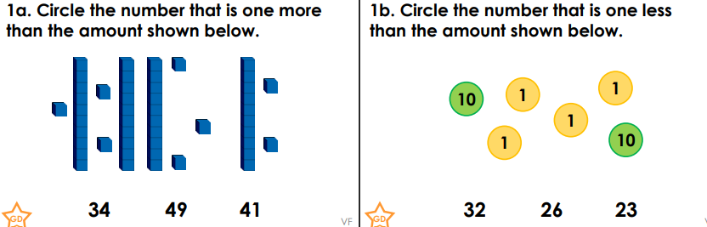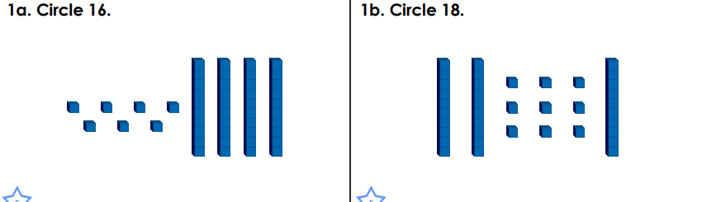
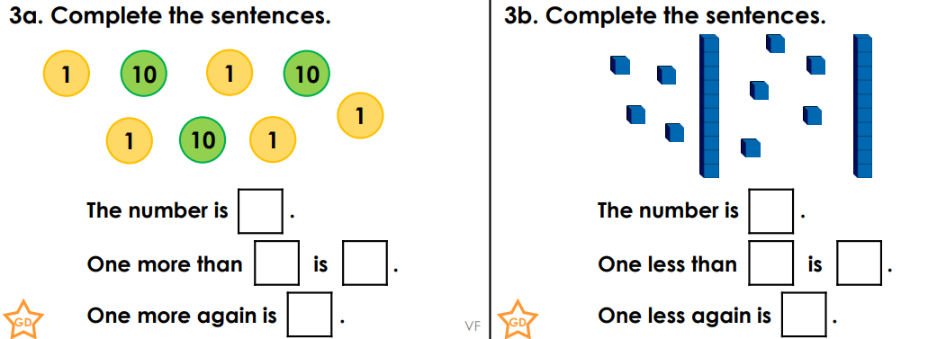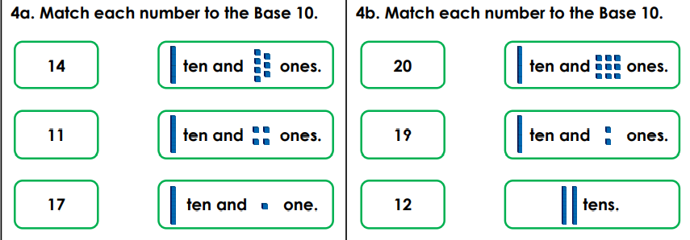

Volume and Capacity
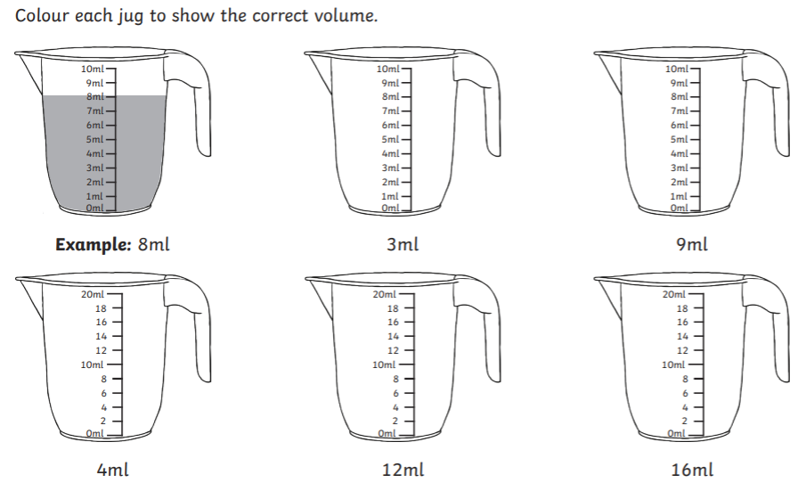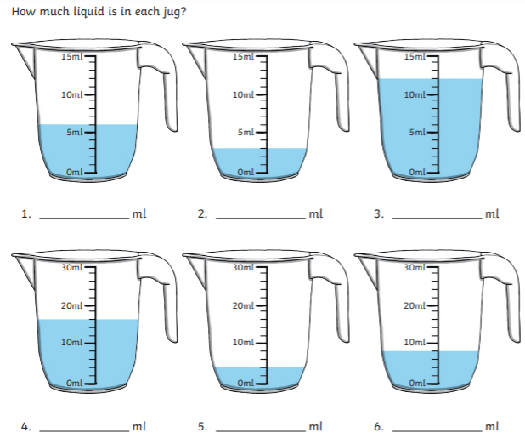
Extension: Watch this video to learn more about litres and millilitres You might like to create your own fruit juice recipe like the children in the video.

P.E Can you guess what the animal is? Look at the silhouette of the animal. Guess what you think it is and do that animal’s exercise. The instructions are at the start of the video. See how many points you can get. Have fun!
Click this link for a fun PE activity

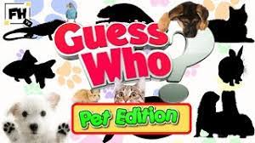

Break – Time to stop and refuel. Eat, play, have fun. Self-directed outside activities where possible.
Science and Geography: Go on a scavenger hunt in your yard, local park or school. Tick off the natural features that you are able to find. Remember not to touch or disturb any insects, berries, flowers or plants. Some insects and plants can be poisonous.
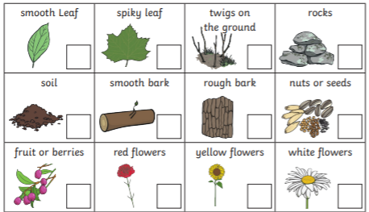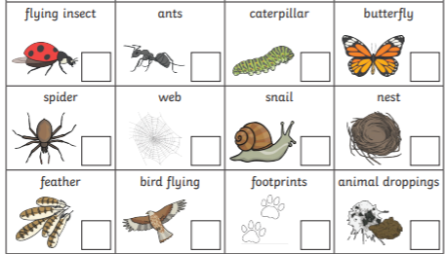
Thursday - Week 2, Term 4 – Stage 1
Daily Task – Help an adult with an outside activity.
English:
Reading Choose a reading passage. Read one of the 3 reading passages Picking Apples, Baseball Game or School Carnival. Record yourself reading and send your best read through to your teacher. Remember to use expression and to pause at the punctuation.
Or you can read a book from home, Seesaw or on the PM readers online.
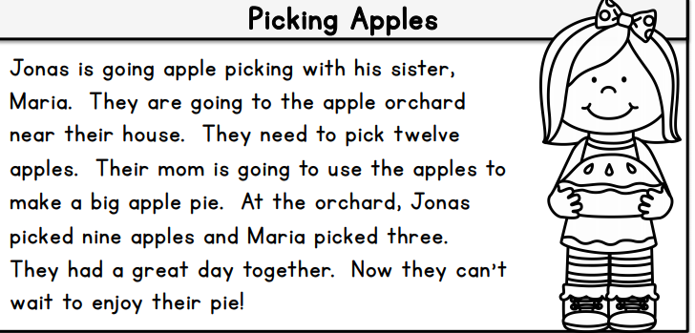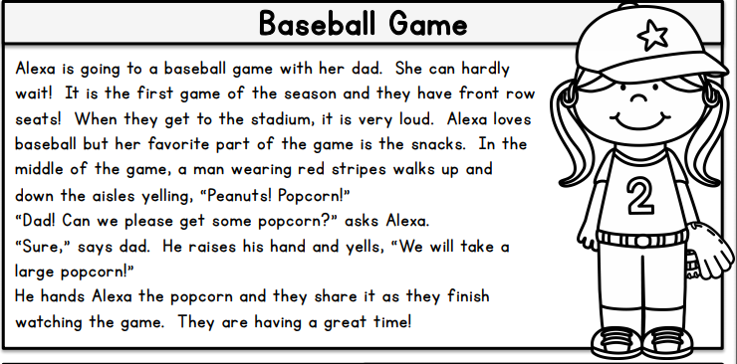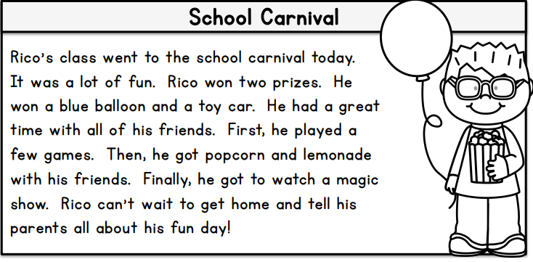
Spelling Read your spelling words out loud. Create 3-5 sentences that include some of your spelling words. Try to make your sentences interesting and longer by using joining words such as (and, but, so, because). For a challenge, try to have more than 1 spelling word in each sentence.
E.g. All the trucks, cars and buses were saving lives during the fire.

Writing Continuing on from yesterday’s writing lesson, re-watch the trailer for the new animated movie Turning Red. Using the same recount structure as yesterday, you will continue writing a recount of the trailer Turning Red. Today you need to write the Events in the order they occurred and then the Ending of your recount. Write down what happened – the girl was at school in class, her mum was hiding behind a tree, the girl got really embarrassed, then she turned red and into a giant red panda. Once you have completed your recount, send a photo of it to your teacher.
Click this link
Break – Time to stop and refuel. Eat, play, have fun. Self-directed outside activities where possible.
Maths:
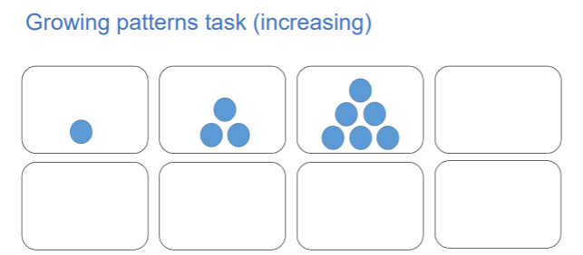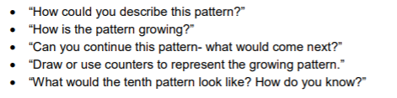
Draw the 10th pattern

Volume and Capacity:
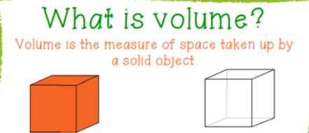 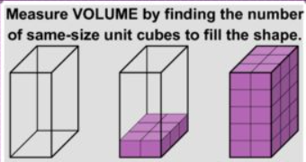 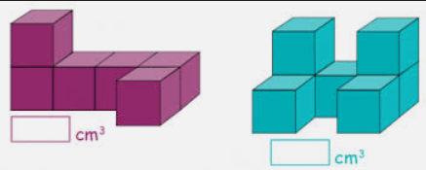 Volume is how much space a 3D object takes up. You can measure volume using cubes. What is the volume of these two shapes?
How many cubes will I need to fill this box? Can you count the cubes to find out?

Find the volume of these 3D shapes by counting the cubes. Circle the shape with the largest volume. Cross out the shape with the smallest volume.
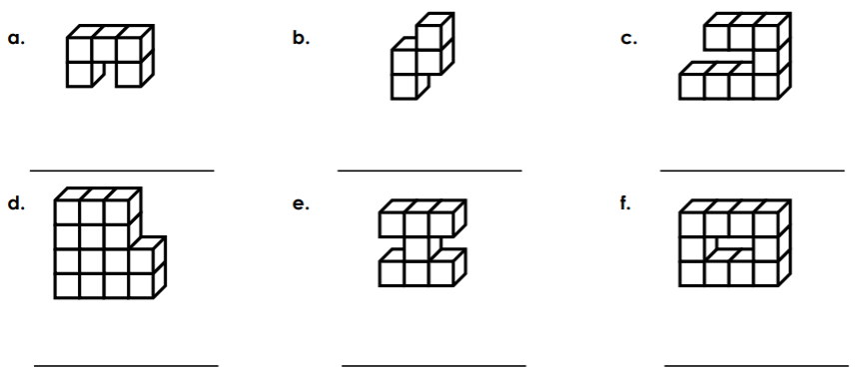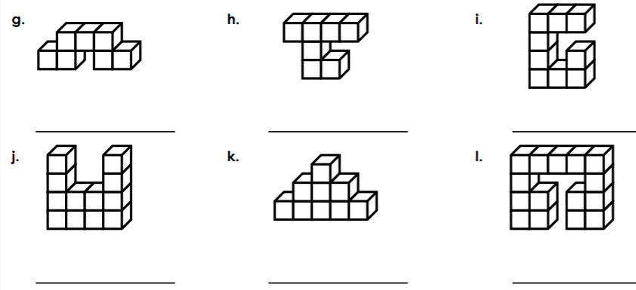

P.E We all love Disney movies and today we are combining music, dance, yoga and Disney characters together. Enjoy this fun workout by yourself or with your family. Who can hold the pose for 10 seconds?

Disney+ Yoga Freeze Dance Brain Break Click this link
Break – Time to stop and refuel. Eat, play, have fun. Self-directed outside activities where possible.
Creative Art: Can you use natural objects from your garden to make a minibeast (insect) collage? You could use flower petals, leaves, sticks and feathers. Make your creepy crawly by sticking your items onto a piece of cardboard or paper.
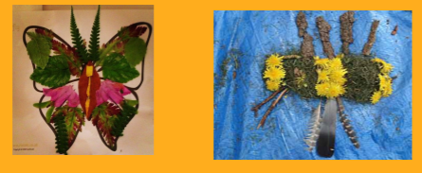

Friday - Week 2, Term 4 – Stage 1 Daily Task – Clean up your room.
English:

Reading Choose a book to read from you book selection at home or on Seesaw or PM readers online. Read a few pages and write down the plurals you came across. Remember with plurals, it is when there is more than one item. 1 dog, 2 dogs. Some plurals end in s, others in es or ies. Some are different altogether, like 1 mouse, 2 mice.

Spelling Read through your spelling words for this week. Write your spelling words in rainbow writing and underline the plural letters.
For example: ladies, cars, boxes

Writing As a fun Friday activity, write a shopping list of the food that you would buy for your family if you were in charge of the shopping for the week. But the catch is, you need to have some healthy options – such as fruit or vegetables.

For example: sliced cheese, yogurt, milk, bread, choc chip ice cream, strawberries, chicken chips, carrots, potatoes. Write the list going down the page using the template attached.

Break – Time to stop and refuel. Eat, play, have fun. Self-directed outside activities where possible.
Maths: Using the rounding chart to help, round these numbers to the nearest 10. 27 82 91 55 68 97 6
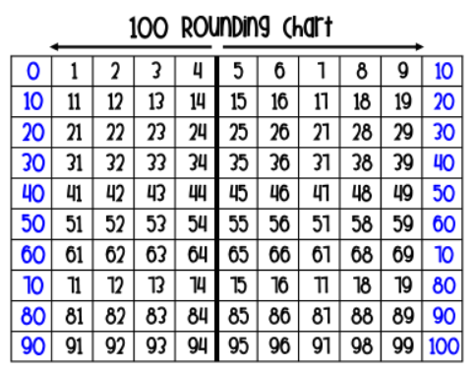
Volume and Capacity:
Listen to Mr Archimedes Bath
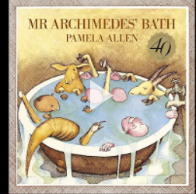 Think about why the water kept rising and falling. Tell a family member what you think was happening.

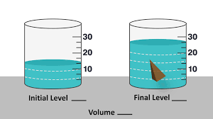 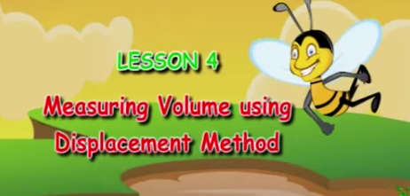 Watch this video about measuring the volume of your hand.
One way to measure the volume of an object is to measure how much water is displaced when you submerge the object in water. Objects with large volumes will displace large amounts of water. Objects with small volumes will displace small amounts of water.

Volume and Water Displacement Activity

- Find a plastic see-through container and fill it up half-way with water.
- Ask a parent to help you find some things around the house that you can submerge in the water (They will need to be things that will sink. Here are some ideas.... a spoon, a fork, a rock, a plastic toy, a marble, some coins.
- Before you put each object into the water, look at the water level. Think about:
- What is going to happen when I put this object into the water? What will happen when I take it out?
- Estimate how much you think the water will rise when you put each object into the water.
- Can you order the objects from the smallest volume to the largest? You will need to compare how much the water rises for each object.
- How many coins or rocks will it take to make the water in your container overflow?

Extension: Can you measure the volume of your hand using the method explained in the video? How many millilitres of water is equal to the volume of your hand? Can you use this method to measure the volume of some other objects?

P.E As a fun Friyay PE activity let's play Would you rather? See if you can get your family to join in. You will need closed in shoes, space and a computer/table to watch the video. Enjoy!
Click this link

Break – Time to stop and refuel. Eat, play, have fun. Self-directed outside activities where possible.
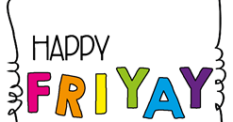
Pick an activity that you enjoy and have some fun! This may be by yourself or with an adult.
Take some photos and send them to your Teacher on Seesaw to show you how to celebrate your Fri-Yay!
Enjoy an activity outside or even get creative at home.
Have a great weekend!

List 1 - jumbled | List 1 - Unjumbled | List 2 - jumbled | List 2 - Unjumbled
sligr |  | dsferni
ssega |  | rsca
thcmase |  | xeboncuhls
sgod |  | xtesa
sidale |  | veswi
sseub |  | rrsiebe
vesli |  | hswise
hspis |  | sselcas
hsdies |  | ksrtuc
ockos |  | sseski

My Shopping List

