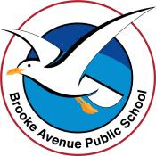
Learning from Home Program – Brooke Avenue Public School
Kindergarten – Week 2, Term 4
The following timetable can be used by students to support learning at home. All tasks have been linked to syllabus outcomes. If technology is available at home, please use the attached links to support learning.
Monday - Week 2, Term 4 - Kindergarten
Daily Task – Make your bed and tidy your room.

English
Phonics: You will need a piece of paper and a pencil. Access Seesaw. Watch the video by Mrs Rex and follow her instruction. If unable to access Seesaw, review all sounds on Jolly Phonics. If unable to watch the video, focus sound is ay/ai. Ask your child to write the following words: rain, hail, snail, main, pay, play, day, stay.
Reading: Log on to ePM readers and read a book or read a book from home.
Writing: Next week we will come back to school in our new classrooms. Write a list of all the things you would like to see or what you think we need in the new classroom.
Break – Time to stop and refuel. Eat, play, have fun. Self-directed outside activities where possible.
Sight words: Practise reading your sight words. Create your sight words using playdough, magnetic letters, natural items or chalk.
Optional: Reading Eggs or Mathseeds

Maths
Warm up: Play a game of guess the number. Write a number down on a piece of paper and ask a family member to guess the number. Give them clues such as: Can you guess the number I have written down it is between 1-20. The number is higher / lower. It is an odd / even number.
We are learning to: Use the language of money. E.g. coins, notes, cents, dollars
Activity: Ask someone in your family if you could look at some notes and coins. Talk about what you can see on the notes and coins and how much each piece is worth. Create a coin creature by tracing and rubbing over a $1 coin. If you do not have a $1 coin at home any coin will work.
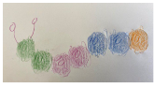
Extension: Write a list of items that cost approximately 50c, $50 and $500.

Break – Time to stop and refuel. Eat, play, have fun. Self-directed outside activities where possible.
PDHPE:

Draw a picture or write about:
- How does your body feel before you are active?
- Participate in an active activity, it may be a walk, bike ride, star jumps or playing outside with a pet.
- How does your body feel after you’ve been active?
- What do you enjoy about being active?

Tuesday - Week 2, Term 4 - Kindergarten
Daily Task - Wash the dishes.

English
Phonics: You will need a piece of paper and a pencil. Access Seesaw. Watch the video by Mrs Rex and follow her instruction. If unable to access Seesaw, review all sounds on Jolly Phonics. If unable to watch the video, focus sound is ue. Ask your child to write the following words: clue, argue, rescue, true, statue, blue, glue,
Reading: Log on to ePM readers and read a book or read a book from home.
Writing: Complete two pages of the handwriting booklet from Week 1 resources.
Break – Time to stop and refuel. Eat, play, have fun. Self-directed outside activities where possible.
Sight words: Memory: create pairs of sight words and play memory.
Optional: Reading Eggs or Mathseeds

Maths
Warm up: Play a game of heads and tails. Flip a coin and have a guess which way the coin will land. Use tally marks to keep track of your score.
We are learning to: Use the language of money
Activity: You will need a selection of coins and notes OR cut out the coins and notes in the resources. Talk about one feature of each coin; e.g. the 20c coin has a platypus on it; David Unaipon, a Ngarrindjeri man is on the $50 note; the $1 coin is gold etc.
Extension: How many ways can you make $1 using coins?
Break – Time to stop and refuel. Eat, play, have fun. Self-directed outside activities where possible.
Creative Arts
You will need: a pencil, your workbook.
Watch the video https://youtu.be/7-xjPIUbUEg
- Draw or write what happens when Max wears the wolf suit.
- Do you know any other books that have a wolf in the story? Is the wolf a good or bad character?
Wednesday - Week 2, Term 4 - Kindergarten
Daily Task – Help make a nutritious meal.

English

Phonics: You will need a piece of paper and a pencil. Access Seesaw. Watch the video by Mrs Rex and follow her instruction. If unable to access Seesaw, review all sounds on Jolly Phonics. If unable to watch the video, focus sound is or/ore. Ask your child to write the following words: sport, short, sort, fort, corn, horn, shore, store, more
Reading: Log on to ePM readers and read a book or read a book from home.
Writing: Select one animal from the picture. You can either write an imaginative story about that animal or write 4-5 facts about that animal.

Break – Time to stop and refuel. Eat, play, have fun. Self-directed outside activities where possible.
Sight words: Write your sight words in rainbow writing.
Optional: Reading Eggs and Mathseeds
Maths

Warm up: Write down the numerals 1-30. Check to see each number is formed correctly with the numbers on the resource pack.
We are learning to: Exchange money for goods in a play situation
Activity: You will need a partner to play this game. Cut out money from the resource pack. One player will be the shop attendant and the other will be the customer. Give the customer the toy catalogue and ask them to select a toy to purchase. They will need to pay using the toy money. As the shop keeper you will need to give the customer change and write them a receipt for their ‘online order’. Take turns of being the shop attendant and the customer.
Extension: Create a shop using your own toys

Break – Time to stop and refuel. Eat, play, have fun. Self-directed outside activities where possible.
Speaking and Listening
Watch the short story
https://www.youtube.com/watch?v=Y3cpV_dnN_I
Discuss the story with an adult.
Describe the man’s character? Why do you think he was this way?
What changes did the man go through and why?
What challenges may the man have been through prior to watching the clip?
Have you ever been this way?
How are you similar to the man?
What things can you do differently now?
Thursday - Week 2, Term 4 - Kindergarten
Daily Task – Help an adult with an activity such as washing a car, vacuuming, or watering the garden.

English
Phonics: You will need a piece of paper and a pencil. Access Seesaw. Watch the video by Mrs Rex and follow her instruction. If unable to access Seesaw, review all sounds on Jolly Phonics. If unable to watch the video, focus sound is oi/oy. Ask your child to write the following words: joy, toy, boy, coin, boil,
Reading: Log on to ePM readers and read a book or read a book from home.
Writing: Complete 2 pages of your handwriting booklet from the Week 1 resources pack.

Break – Time to stop and refuel. Eat, play, have fun. Self-directed outside activities where possible.
Sight Words: Build your sight words out of lego 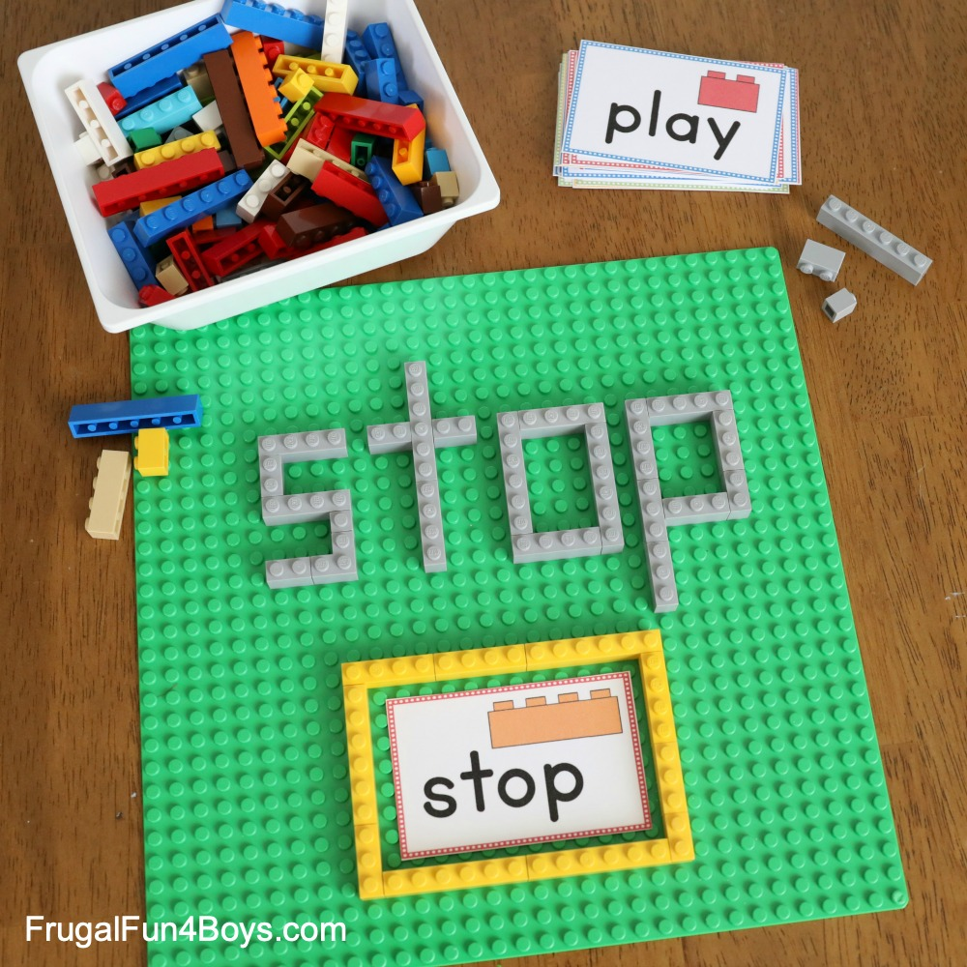
Optional: Reading Eggs and Mathseeds

Maths
Warm up: Fill in the missing numbers on the grid in the resources
We are learning to: Exchange money for goods in a play situation
Activity: Create a Kinder Rainbow Café. You might like to design your own menu OR use the resources attached to play. See if a family member will play a game of pretend cafes with you.
Break – Time to stop and refuel. Eat, play, have fun. Self-directed outside activities where possible.
PDHPE
Hopping https://vimeo.com/422700861
Friday - Week 2, Term 4 - Kindergarten
Daily Task – Clean up your room and tidy your toys

English

Phonics: You will need a piece of paper and a pencil. Access Seesaw. Watch the video by Mrs Rex and follow her instruction. If unable to access Seesaw, review all sounds on Jolly Phonics. If unable to watch the video, focus is syllables. Ask your student to say the following words and then say how many syllables each word has: bus, rabbit, echidna, turtle, emu, dinosaur, egg, marble, engine, mouse, table.
Reading: Log on to ePM readers and read a book or read a book from home.
Writing: Write 2 things you would like to do when you return to school next week. What would you like to learn? Who do you want to see?
Break – Time to stop and refuel. Eat, play, have fun. Self-directed outside activities where possible.
Sight words: Tic Tac Toe: Play tic tac toe (using two sight words instead of x and o).
Optional: Reading Eggs and Mathseeds

Maths
Warm up: Move and count. Count as high as you can and each time you reach a new decade change movements. E.g. 1-10 hopping, 11-20 lunges, 21-30 star jumps.
We are learning to: Exchange money for goods in a play situation.
Activity: Design a lunch menu and pretend to sell it to your family members.
Break – Time to stop and refuel. Eat, play, have fun. Self-directed outside activities where possible.
FriYay Fun Afternoon

Use the ‘Scavenger Hunt List’ to find items outside. Tick them off as you find them!
