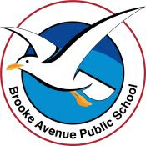
Learning from Home – Brooke Avenue Public School
Stage 1– Week 3, Term 4
Please upload work marked with the camera icon to Seesaw
The following timetable can be used by students to support learning at home. All tasks have been linked to syllabus outcomes. If technology is available at home, please use the attached links to support learning.
Monday - Week 3, Term 4 – Stage 1
Daily Task - Match socks and sort washing.
English:
Reading: Choose a book to read from the PM Readers or a book from home to read. Before you get started, have a look at the cover and predict what it might be about. When you have finished reading, discuss with an adult at home if your prediction was correct or not, and why.
Spelling: This week for spelling we will be looking at doubling the consonant when adding suffixes to the end of words and dropping the e when you add ing. Choose list 1 or 2 or maybe even both and write out your words after you watch the videos below.
Watch the videos below to learn about our spelling rules for this week.
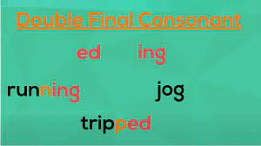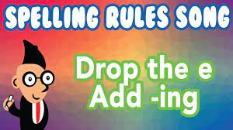
https://video.link/w/j7hEc https://video.link/w/N9hEc
Spelling List Term 4 - Week 3
List 1 | List 2
bat | spot
batted | spotted
batting | spotting
hop | chop
hopped | chopped
hopping | chopping
bake | flake
baking | flaking
live | strike
living | striking

Writing: Since this week is our last week of learning from home, we thought it would be nice to write a letter. You are going to write a letter to your parents, carers or teacher for all the hard work they have done in helping you to learn at home. The first task to start your letter, is to do some planning. You will need to create a mind map to record your ideas and reasons as to why the person you are writing to has been such an amazing help to you during learning from home and lockdown. Put the person's name in the middle of the mind map and list as many reasons as you can as to why they are so amazing and how they have helped you. We would like to see at least 3 ideas. Over the course of the week, each day you will expand on one or two of your ideas and write them in a sentence or paragraph.

Break – Time to stop and refuel. Eat, play, have fun. Self-directed outside activities where possible.
Maths:
Number sense activity:
Your finished product should look something like the one below:
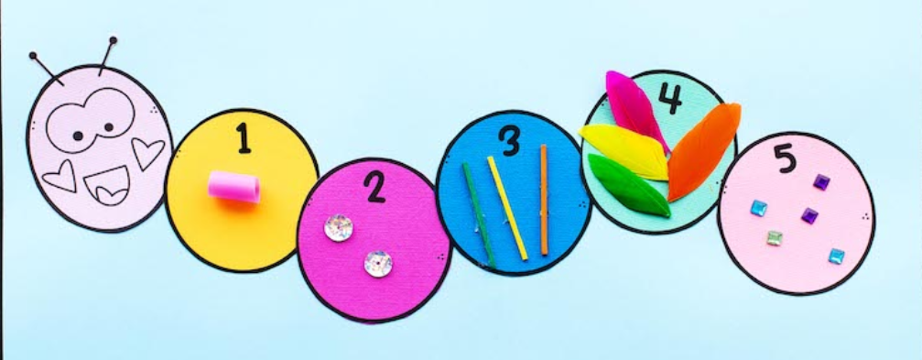

These are your resources for this activity:

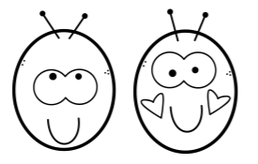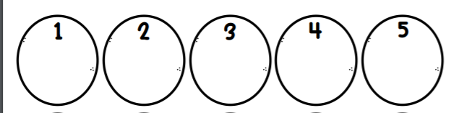

Complete the following activity involving Australian money.
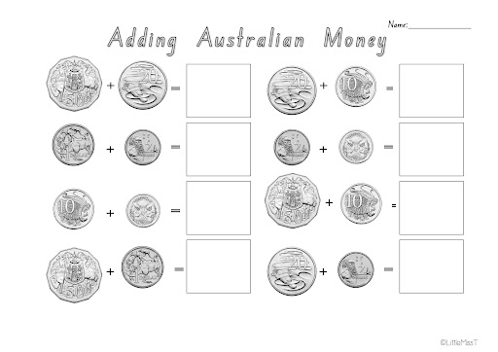

Break – Time to stop and refuel. Eat, play, have fun. Self-directed outside activities where possible.
PDHPE: Remember to move your body for at least 30 minutes per day, you might like to go for a walk, run or ride with an adult.
Or, follow the link to complete an online workout: https://video.link/w/iWkEc

Tuesday - Week 3, Term 4 – Stage 1
Daily Task – Wash the dishes.
English:
Reading: Today for reading you are going to summarise the story you read. Choose a book to read, you can find this on Seesaw, the PM eCollection or at home and read it with an adult. When you have finished reading, summarise the story to the person you read the story to and then use the template provided, to help you record your summary.
Spelling: Write out your spelling words. After you have done that, complete the ‘spelling- adding ed or ing’ worksheet that is attached.
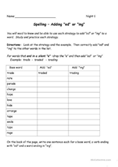
Writing: Today you are going to start writing your letter. You need to start off with “Dear............. (put the person’s name here). On a new line, tell them why you are writing them a letter. Eg Dear Mum, I’m writing this letter to you because........ (list the first reason why they have been such an amazing help to you during learning from home).
Break – Time to stop and refuel. Eat, play, have fun. Self-directed outside activities where possible.
Maths:
Number sense activity: Your number is 804
Complete a number of the day activity. Follow the link: https://mathsstarters.net/numofthedayjunior/3digit
Or, complete your own on the template provided:

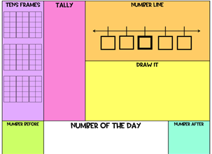

Activity: What different combinations of notes and gold coins could you use to pay for something that costs $15?
Think about:
- What amounts of money are there in notes?
- What amounts of money are there in gold coins?
- Which of these notes are unlikely to be used to buy something for $15
- Is there more than one way to make up $15 using these notes and coins?
- Is it possible to make $15 with just notes or just coins?
Extension activity:
Have a go at finding different combinations of notes and coins to pay for something that costs:
- $65
- $42
- $186
- $39.80
- $81.75
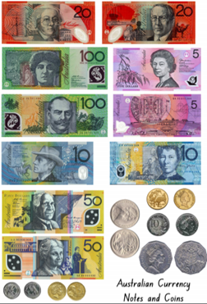

PDHPE:
Remember to move your body for at least 30 minutes each day, you could go for a walk, run or ride to the park with an adult.
Or, you can follow the link for some spooky yoga!
https://video.link/w/kXkEc

Break – Time to stop and refuel. Eat, play, have fun. Self-directed outside activities where possible.
Dance:
With someone in your household play the game ‘musical statues’ you can follow the link: https://video.link/w/OWkEc Or, you can play with your own music.
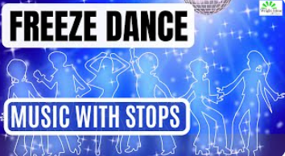

Wednesday - Week 3, Term 3 – Stage 1
Daily Task – Make your bed.
English:
Reading: Choose a book to read, you can find this on Seesaw, the PM eCollection or at home. After you read your book, decide what you think the main idea of the story is. It might be something like sharing, friendship, happiness or telling the truth. Using the worksheet ‘What’s the Main Idea?’, write or draw 3 details from the book that demonstrate the main idea of the story.
Spelling: Read your spelling words to someone at home and then write them out. After you have done that, complete the suffixes worksheet that is attached.
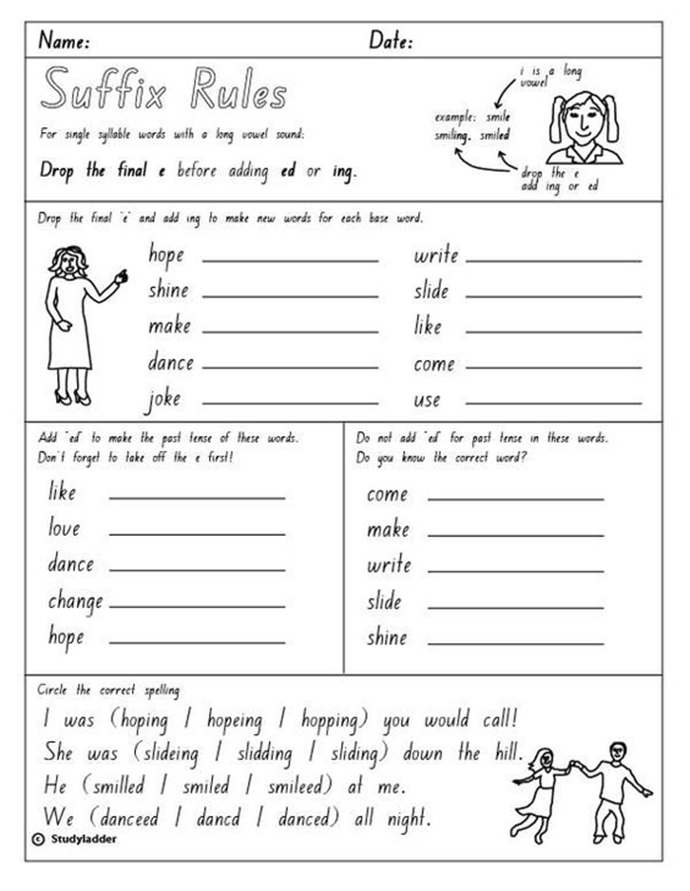
Writing: Following on from yesterday, starting on a new line, write another reason or reasons why you are so grateful for their help. Try to make your sentences interesting and use conjunctions (joining words) to join two ideas together eg I am so grateful for all that you have done for me because....

Break – Time to stop and refuel. Eat, play, have fun. Self-directed outside activities where possible.
Maths:
Number sense activity:
Set yourself a timer for 1 minute and count by 3’s. Record your time and do it a second time, this time, try and beat your first recorded time. 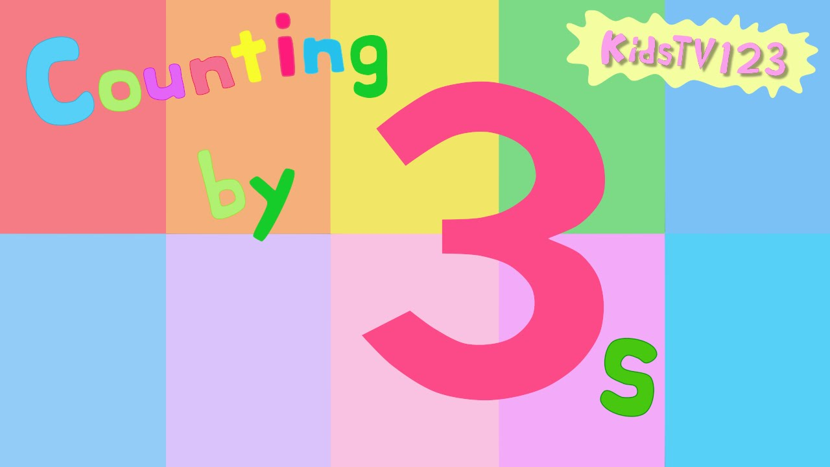

Activity:
Using the below price list of items, create a shopping list. You have a budget of $20 maximum to spend.

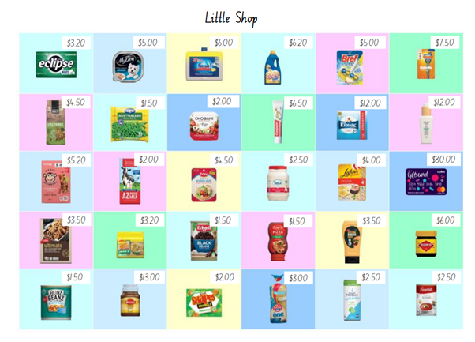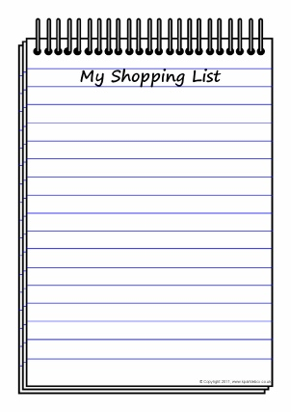

Creative Arts:
Follow the link to create an origami dog: https://video.link/w/sVuEc
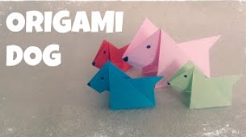
Break – Time to stop and refuel. Eat, play, have fun. Self-directed outside activities where possible.
Dance: Create a dance sequence worth 32 counts (4 lots of 8). You may choose to do this on your own or with someone in your household.
Film your completed dance sequence and send it through to your teacher on Seesaw. Within your dance sequence, you should have movements which involve appropriate use of space. Your three ‘space levels’ are: high (above your head), middle (torso level) and low (below your hips- can be something on the floor). Have fun creating!

Thursday - Week 3, Term 4 – Stage 1
Daily Task – Help an adult with an outside activity.
English:
Reading: Choose a book to read, you can find this on Seesaw, the PM eCollection or at home. After you read your book, you are going to go on a word hunt to find any words that could have suffixes added to them, just like in your spelling words. Write down the words you find and then change them to have a suffix on the end. Take a picture of the words you found and added suffixes to and upload to your Seesaw journal.
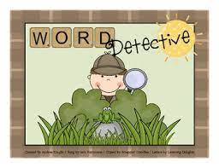
Spelling: Todays spelling activity is to put each of your spelling words into a sentence. As you do this, you will be able to notice how the meaning and tense changes when suffixes are added to a word.
Writing: Continue writing your letter. Again, starting on a new line, write another reason or reasons, explaining how they have helped you. Today you are going to finish off your ‘draft’ letter. Make sure you have used all the reasons you had on your planning page. Start a new line for a new reason or join 2 reasons/sentences together by using a conjunction (joining word).
Break – Time to stop and refuel. Eat, play, have fun. Self-directed outside activities where possible.
Maths:
Number sense activity:
Follow the link to play the game ‘Guess the Number’ https://www.abcya.com/games/guess_the_number
Or, play this game with someone at your home.
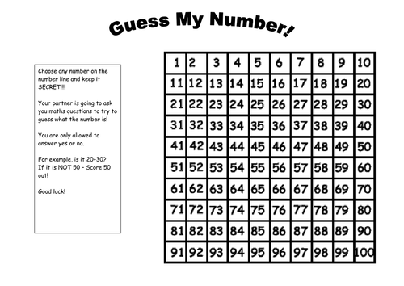

Complete the following worksheets:

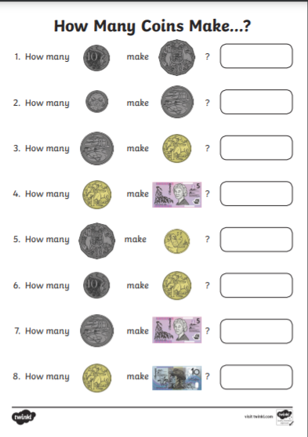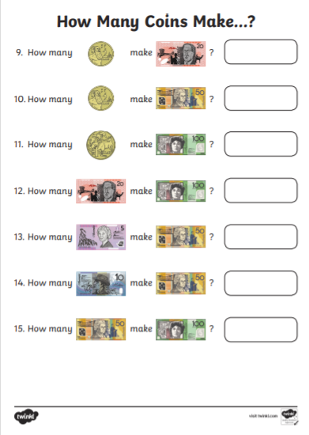

Creative Arts:
Follow the link to create your very own ‘Spooky Spaghetti’ https://video.link/w/NkhEc

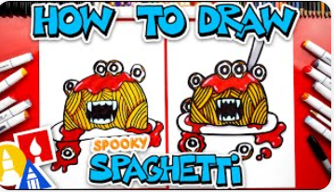

Break – Time to stop and refuel. Eat, play, have fun. Self-directed outside activities where possible.
Geography:
This term, we will be focusing on a Geography unit. This unit will go into detail about ‘people and places’.
Complete the following worksheet called ‘My Home’
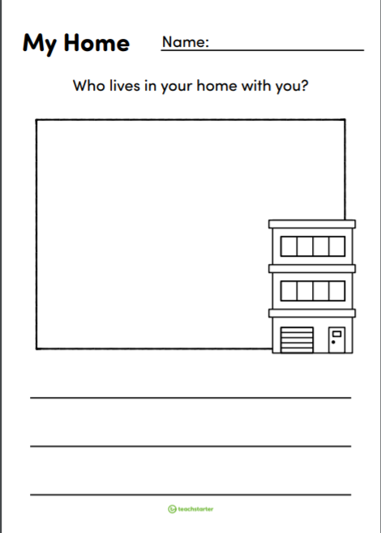

Friday - Week 3, Term 4 – Stage 1
Daily Task – Clean your room.
English:
Reading: Choose your favourite book from the ones you have read this week. Choose 2 pages to read aloud and film or record yourself. Listen to yourself read and then try again, this time improving your expression and fluency. That means make your reading nice and smooth.
Spelling: Let's have some Friday fun with our spelling words. You can choose any way you wish to write out your list. You might do bubble writing, rainbow writing, you might even write them backwards, it is up to you today, just have some fun with it.
Writing: Today you are going to edit your letter. After you have finished all your editing, you are going to write your “good copy” on the letter template provided. When you have finished your good copy, find the person you have written the letter to and give it to them, along with a big hug and say thank you. You might like to even read the letter to them.
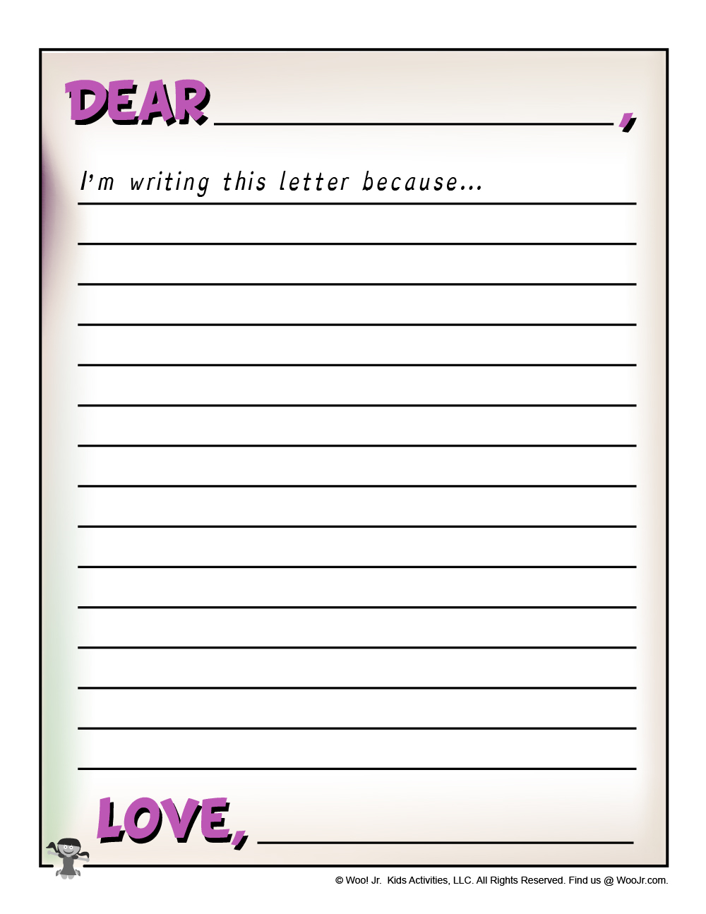
Break – Time to stop and refuel. Eat, play, have fun. Self-directed outside activities where possible.
Maths:
Number sense activity:
Workout and skip count: https://video.link/w/HHYDc
Or,
Set a timer for 1 minute and count by 2’s, record what number you get up to when your timer goes off. Try again and see if you can beat your first attempt.

Complete the following worksheet on Australian money:
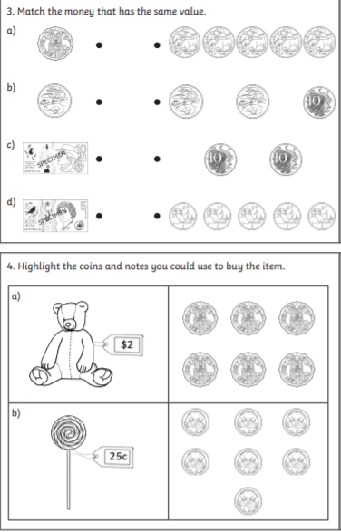

Geography:
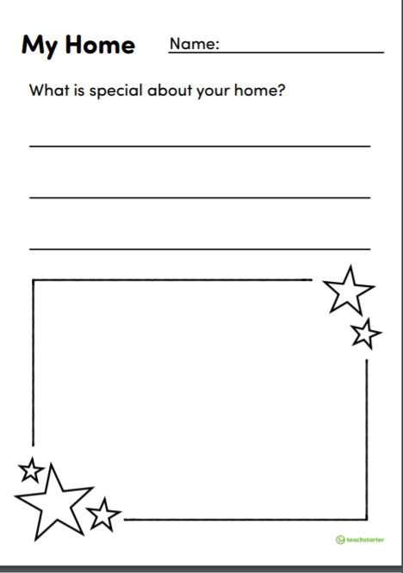
Complete the following worksheet called ‘My Home- What is special about your home?’

Break – Time to stop and refuel. Eat, play, have fun. Self-directed outside activities where possible.
Take a photo of what you are choosing to do to celebrate Fri-yay and send it through to your teacher on Seesaw!
We are so excited to see you all at school on the 25th of October!

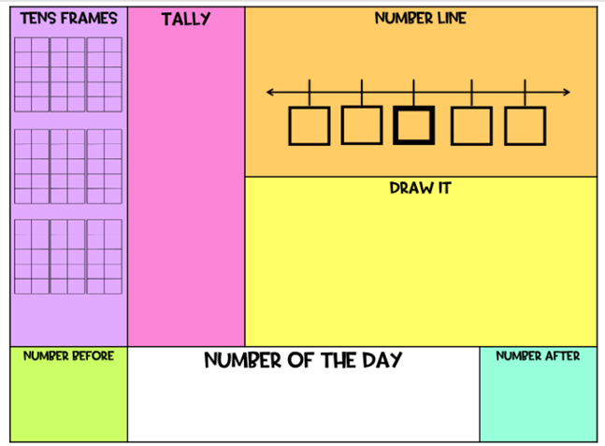

31
Mind map
