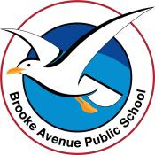
Collect the Countdown Magazine with this Learning Pack.
Learning from Home – Brooke Avenue Public School
Stage 2 (Years 3 and 4) – Week 1, Term 4
The following timetable can be used by students to support learning at home. All tasks have been linked to syllabus outcomes. If technology is available at home, please use the attached links to support learning.
Tuesday 5th October
Daily Task – Help with washing the dishes
English:

Reading - Read ‘126 Scoops’ (Countdown Magazine p.12)

Writing - Write a summary of the story ‘126 Scoops’ in your own words. This should be at least 1 paragraph.

Grammar - Complete the first page of the Grammar Review Attached.

Spelling - Write out your spelling list neatly.

Break – Time to stop and refuel. Eat, play, have fun. Self-directed outside activities where possible.
Maths
Today's number is 200. Write as many facts as you can about the number 200. (Think of all 4 operations.)
Complete Stage 2 – Whole Numbers

Science
Introduction to our Science Unit – Physical World
Inquiry and Focus Question 1:
How do heat, light and electrical energy make things happen?
Draw all the items in your house that create a kind of heat.
Freeze a coloured ice cube ready for a scientific investigation on Wednesday.
Creative Arts
Physical Science Colouring

Wednesday 6th October
Daily Task – Make your bed
English:

Reading - Read ‘The Scoop on Ice Cream’. (Countdown Magazine p.16)

Writing - Write 5 facts about ice cream that you learned from the text.

Grammar - Complete page 2 of the Grammar Overview attached.
Spelling - Look, Cover, Write, Check- Look at the spelling word, try to write it without looking and then check to see if you had it right.

Break – Time to stop and refuel. Eat, play, have fun. Self-directed outside activities where possible.
Maths
Complete Relationship Between Numbers and Understanding Place Value worksheets that are attached.

Science
Investigation on the ways heat is transferred.
- Heat is transferred from object to object or place to place or system to system in a variety of ways. You are going to explore two of these ways – conduction and convection
  - Conduction activity –Place an ice cube in a plastic resealable bag. Hold the bag in your hands and measure the time it takes for the ice cube to melt.
  - Convection activity –Place your coloured ice cube in a clear-plastic cup of warm water. Observe what happens to the colour from the melting ice cube in the warm water.
  - Record your observations to discuss with your class.

PDHPE - Your choice of Physical activity for an hour.
Thursday 7th October
Daily Task – Help with the washing
English:

Reading
Read ‘Make your own Ice Cream’ from page 20 of the Countdown Magazine.

You may like to try making your own Ice Cream at home in the next few weeks.

Writing - Write an acrostic poem on Ice Cream

Handwriting - Complete the attached Handwriting work sheet.

Spelling - Have a family member ask you to spell your spelling words. Are there any that you need to practise more?

Break – Time to stop and refuel. Eat, play, have fun. Self-directed outside activities where possible.

Maths
Using dice or playing cards, create 10 (four or five digit) numbers and then partition each number into the standard form.
For example, 16352 is the same as 10000 + 6000 +300 + 50 +2.

Then rearrange the numbers into ascending order and descending order.

Science
Read the letter from Apprentice Chef Pierre. Write a short letter back to Pierre to tell him about heat from conduction and convection.
PDHPE
Visit a park with your family if you can. As you use the play equipment there, think about the ways some of the equipment works. For example, what forces help a swing and seesaw work?

Friday 8th October (Friyay)
Daily Task – Tidy your bedroom.
English:

Reading
Read the play ‘The Story of the Chinese Horoscope’. (Countdown Magazine p.25)
Complete half an hour of Reading Eggs.
Spelling
Complete the Find A Word on p.22 of the Countdown Magazine.
You may also like to complete the crossword on page 34.
Break – Time to stop and refuel. Eat, play, have fun. Self-directed outside activities where possible.
Math - Complete whole Number Maths games for Year 3 or Year 4 https://www.abcya.com/

PDHPE - https://youtu.be/364hLkdOXXc or your choice of fitness
Creative Arts
Look at this Link to gain ideas for your own art making. https://childhoodbynature.com/the-beauty-of-ephemeral-nature-art/

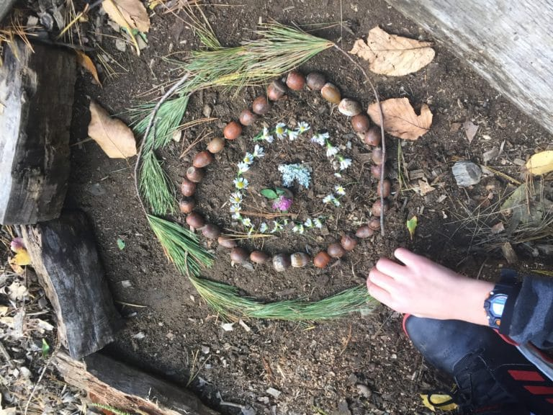
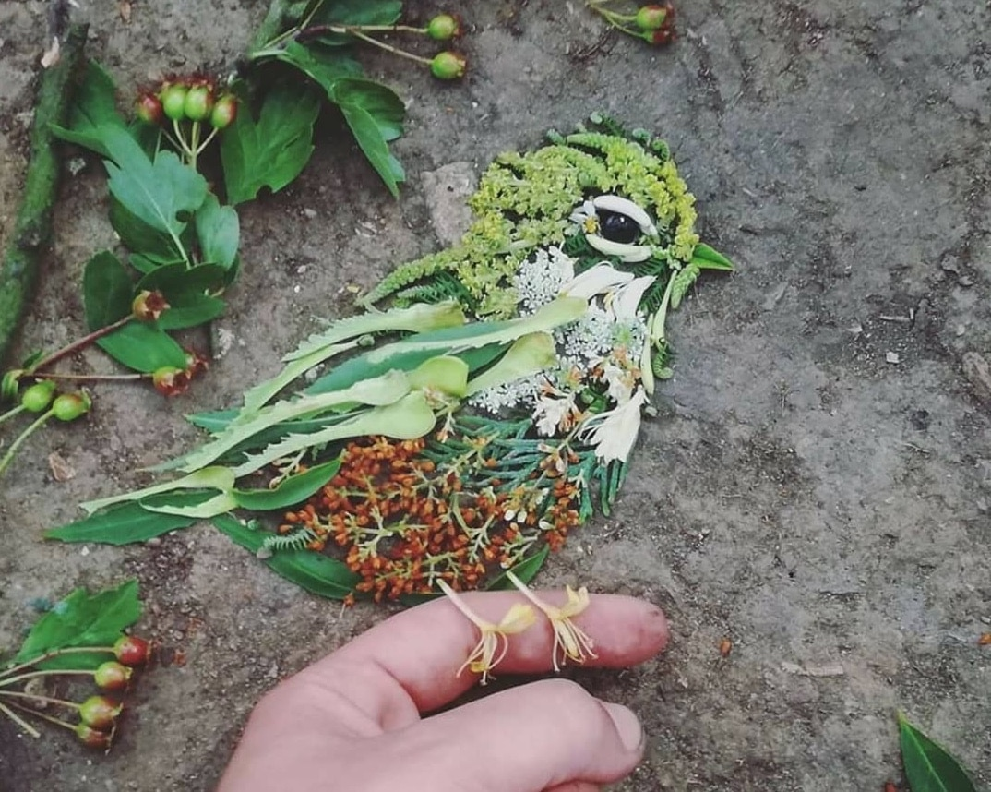

“Ever since humans started to create art, nature has been our muse. We are inspired by nature, moved to emotion by it, and have attempted to capture its essence in our own works. It's only natural that children are also moved by nature to create art.”

Using natural materials from outside your house or your local area, create your own artwork.

