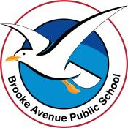
Learning from Home – Brooke Avenue Public School
Stage 1– Week 1, Term 4
The following timetable can be used by students to support learning at home. All tasks have been linked to syllabus outcomes. If technology is available at home, please use the attached links to support learning.
Please upload work marked with the camera icon to Seesaw
Tuesday - Week 1, Term 4 – Stage 1
Daily Task – Wash the dishes.
English:

Reading

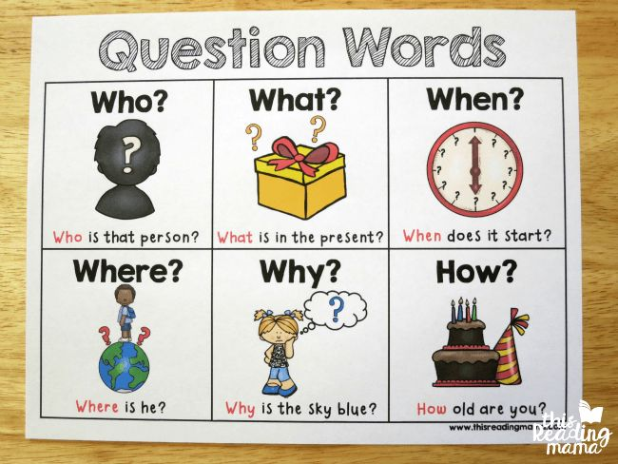
Choose a book to read, you can find this on Seesaw, the PM eCollection or at home. Today you will be asking questions about the book you have read. When you have read the whole book, are there any questions that you would like to ask the character, author or someone else that could help you understand it better? Write down 3 questions.

Spelling:
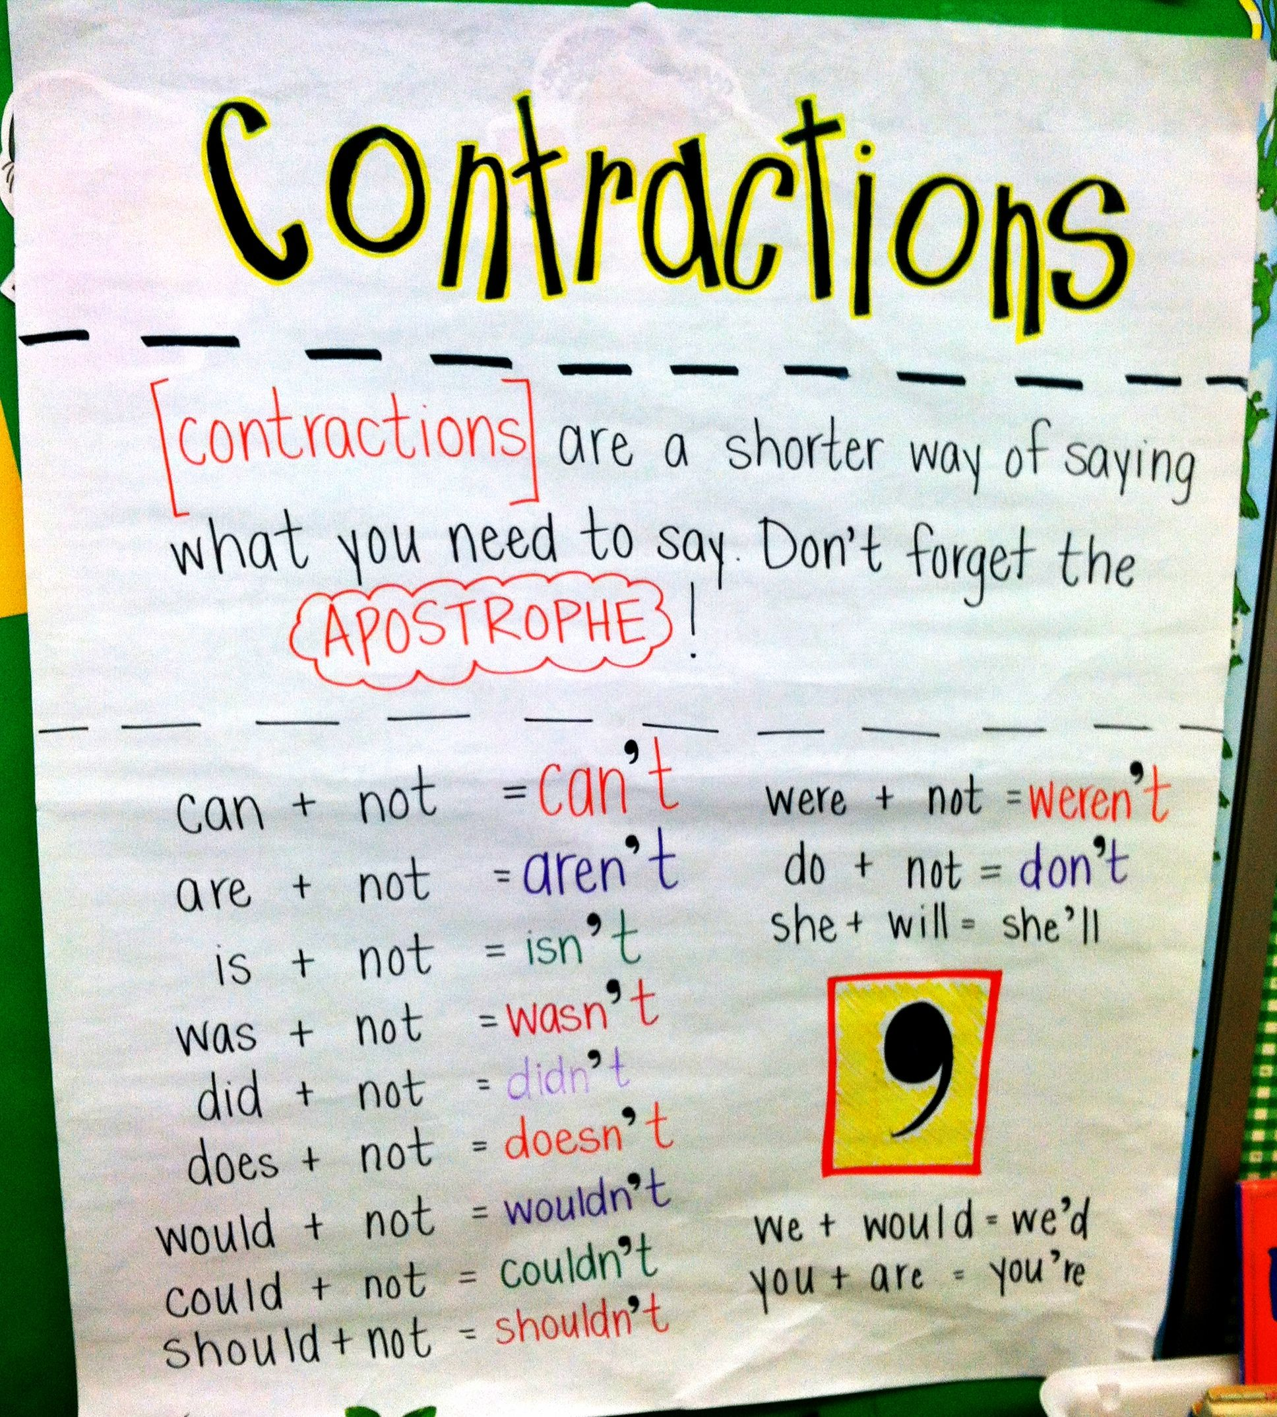
This week we are learning about contractions. Click on this link for a video about contractions https://video.link/w/aP79c
Choose a list and write out each word. Next to each word, write the two words that you think make up the contraction.

List 1 | List 2
it's  I’m  I’ve  don't  can't  aren't  doesn't  she'll | shouldn't  couldn't  wouldn't  haven't  weren't  you're  you'll  wasn't

Writing

This week you will be writing about spies and secret missions! Your first mission is to choose your spy name! Use the guide below to help you.
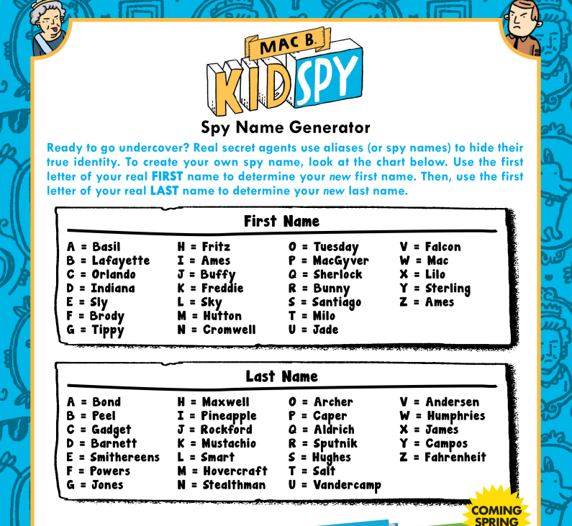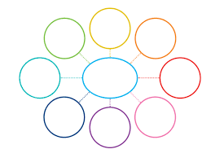

Planning
Time to plan a day in the life of a super spy! You will be writing a journal entry about a secret mission that you have gone on to save the world! Think about where ‘super spy’ went, who you saw, what action packed event took place and how you got out of some sticky situations. Use a mind map to plan the day and include lots of action words for all the exciting moments!
Watch this video for inspiration! https://safeshare.tv/x/lfefYBQg
Break – Time to stop and refuel. Eat, play, have fun. Self-directed outside activities where possible.
Maths:  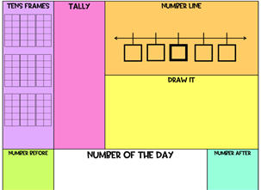  Warm Up – Number of the Day  Roll a dice to create a 2-digit and complete the Number of the Day (template attached). | 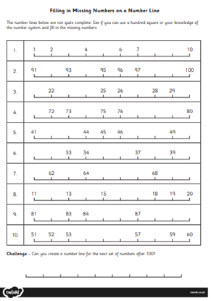  Activity - Fill in the Missing Numbers on a Number Line  Complete the activity sheet below by filling in the missing numbers on each number line (template attached).
 | Extension: take your learning outside and use some chalk to create a number line on the concrete. How long can you make your number line?
Break – Time to stop and refuel. Eat, play, have fun. Self-directed outside activities where possible.
Dance- Bubbles
There are many different ways to make movements using our bodies. Today we are going to use our bodies to show the different movements a bubble makes.
Using a mixture of water and detergent (or bubbles you have brought from the shop), blow some bubbles and watch as the bubbles move through the air. Observe the shapes being made and watch the for the changes in the bubble, from forming to floating to popping.
Things to think about:
- Does my bubble grow in size when forming?
- Does my bubble move fast or slow?
- Does my bubble move in a straight line or float all around?
- What happens when my bubble pops?
Find a space you can move around in. Using your body, start to move like a bubble. Create a simple movement sequence which can be repeated. For example, form your bubble, float around in the air, turn slowly, pop and freeze, repeat.
Follow this link to some music to create your movement sequence to - https://video.link/w/3Kn9c

Wednesday - Week 1, Term 4 – Stage 1
Daily Task – Make your bed.
Mad Hatter Day
Wear a crazy hat to your morning Zoom or send a photo to your teacher on Seesaw!
English:

Reading
Choose a book to read, you can find this on Seesaw, the PM eCollection or at home. Today we will be clarifying words or phrases that we don’t understand. Record these as you read and write a definition of each one in your own words.

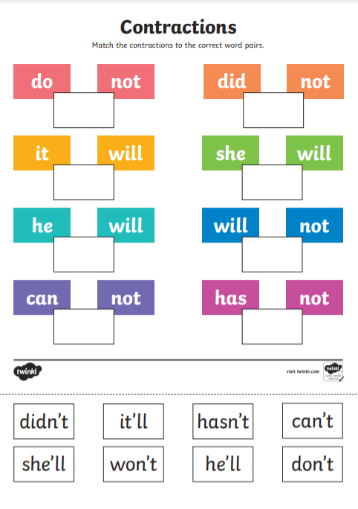
Spelling

Contractions are a shorter way of saying what we need to say. Remember, we need to replace 1 or 2 letters with an apostrophe, so do not becomes don’t. Complete the cut and paste worksheet by matching the contractions with their correct word pairs.

Writing
Composing
Today we will be writing the introduction to our journal entry. Make sure you put the date at the very top of the page. In your first paragraph include your spy name and what your secret mission will be. Remember, a paragraph has 2-3 sentences about the same idea. Make sure you use lots of interesting words to make your secret mission very exciting for the reader.

Example:
Wednesday 22nd September, 2021.
Dear Diary,

My name is Brody Sputnick and I am a first class, internationally known superspy. I have just returned from one of the most exciting and dangerous missions I have ever been on. In Egypt there was a plot to blow up the Great Pyramid of Giza, the oldest of the seven ancient wonders of the world, and I was sent to stop it from happening!

Break – Time to stop and refuel. Eat, play, have fun. Self-directed outside activities where possible.
Maths:  Warm Up – Go Fish! (Relationships)  Watch this video to learn how to play this game. It is different to regular Go Fish! - Go Fish! (Relationships)  You will need a deck of playing cards (Ace to 10).  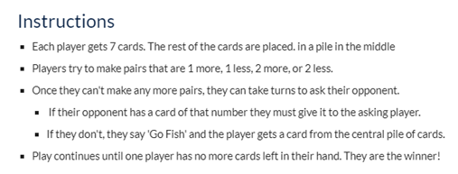 | 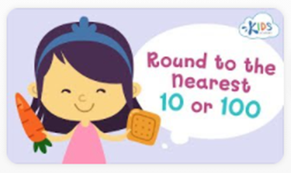  Activity – Rounding to the nearest 10 and 100  Watch this video on rounding numbers to the nearest 10 and 100 - https://video.link/w/lln9c  Here is a rounding rhythm to help you when rounding numbers:  5 to 9 - climb the vine  0 to 4 – slide to the floor
After watching the video, complete one or both activity sheets below (template attached). Make sure you choose an activity sheet that is a little challenging for you.
Extension: use a dice to create some more 2-digit and 3-digit numbers. Can you round these numbers to the nearest 10 or 100?
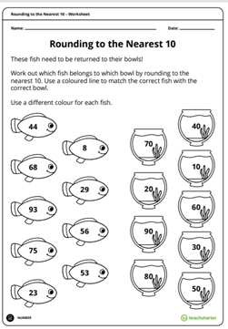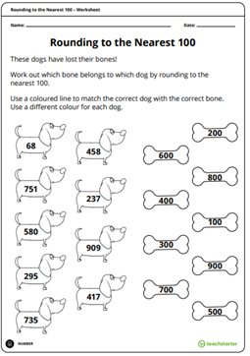
Break – Time to stop and refuel. Eat, play, have fun. Self-directed outside activities where possible.
Creative Art - Guided Drawing Cartoon Turtle
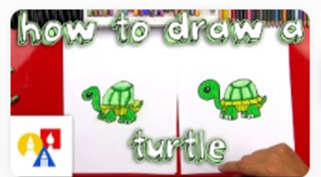
Click the link and follow along to create your very own cartoon turtle! Don’t forget to give your turtle a name.
https://video.link/w/MRn9c

Thursday - Week 1, Term 4 – Stage 1
Daily Task – Help an adult with an outside activity.
English
Reading
Choose a book to read, you can find this on Seesaw, the PM eCollection or at home. After you read your book, decide what you think the main idea of the story is. It might be something like sharing, friendship, happiness or telling the truth. Using the worksheet ‘What’s the Main Idea?’, write or draw 3 details from the book that demonstrate the main idea of the story.
Spelling
Write your spelling words on post its or cut up a piece of paper to make 10 cards (or 20 if you are completing both lists). On 10 more post its/cards write the words that correspond with the contractions in your spelling list. For example, don’t is do not and she’ll is she will. You can also print out the attached ready-made cards. Use the cards to play a matching or memory game.
Writing
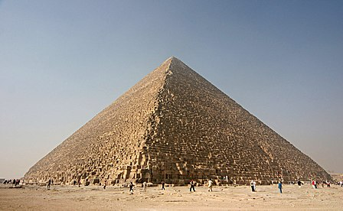
Composing
Today you are writing paragraphs 1 and 2 of your super spy journal entry. This is where the action happens! You will need to use lots of exciting adjectives and action verbs. Use the action verbs below to help. Remember, don’t wrap up the story yet! We will finish it tomorrow.

Example
O3:00 hours, Western Desert, Giza, Egypt.
Mission Objective: Ensure that the Great Pyramid of Giza remains intact for future generations.
Authorities have received intelligence that the evil Dr Fearsome has planted an explosive device at the base of the Great Pyramid. I enter the pyramid, looking for any sign of Dr Fearsome. It seems clear so I continue, searching every corner and crack for clues.
As I move deeper into the pyramid, I hear tumbling rocks and scratchy footsteps on the sand. I run toward the sound and I see Dr Fearsome holding a detonator! Intelligence was right! He is going to blow up the pyramid with us both inside!
Break – Time to stop and refuel. Eat, play, have fun. Self-directed outside activities where possible.
Maths:  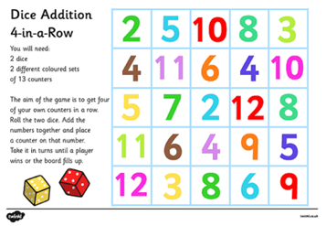  Warm Up – Dice Addition 4-in-a-Row  Play this game with an adult or someone at home (template attached). | 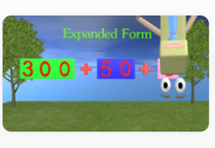  Activity – Roll Write Expand, Draw  Watch this video on expanding numbers - https://video.link/w/gBn9c
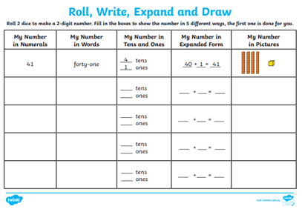
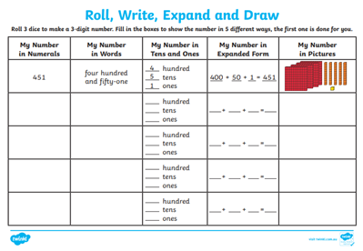
After you have watched the video, complete one or both of the activity sheets by using a dice to create your own 2-digit and 3-digit numbers (template attached). Then fill in the boxes to show each number in 5 different ways.

Extension: Can you think of any other ways to show each number?

Break – Time to stop and refuel. Eat, play, have fun. Self-directed outside activities where possible.
Drama - Mirror! Mirror!
You will need a partner to play this game. Decide who will be Mirror A and who will be Mirror B. Mirror A begins moving very slowly and Mirror B must copy the movement exactly, as if they are the reflection Mirror A sees in the mirror.
Continue for some time, then swap so that Mirror B is leading the movements.
Remember to move slowly, so that the movements are easy to follow and it looks like a reflection.
Some movement ideas you could use:
- Shrug your shoulders
- Wriggle your hips
- Stretch your body
- Stamp your feet

Friday - Week 1, Term 4 – Stage 1
Daily Task – Clean your room.
English:
Reading
Choose your favourite book that you have read this week. Choose 2 pages to read aloud and film or record. Listen to yourself read and then try again, this time improving your expression and fluency. That means make your reading nice and smooth.
Spelling
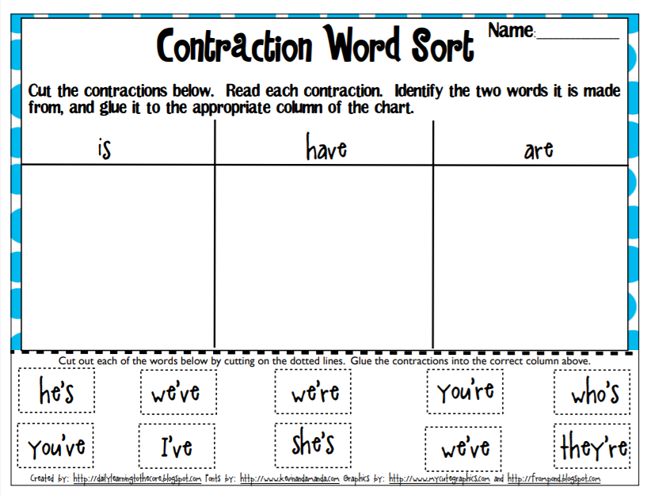
Watch the video about contractions. https://video.link/w/KU79c the contractions sorting activity.
Writing
Conclusion
It is time to wrap up the journal entry. It is time to talk about how you have solved your problem, saved the day or saved the world!
Example
Surely, he can’t be serious! I throw caution to the wind and I leap towards Dr Fearsome and grab the detonator. We both fell to the ground and quick as a flash I handcuff the doctor and move swiftly to where my munitions expert is waiting. I send in my team to extract the bomb and once it is secure, we head home. The Great Pyramid of Giza is safe once again and I am officially the greatest spy there ever was. Until next time...
Break – Time to stop and refuel. Eat, play, have fun. Self-directed outside activities where possible.
Maths:
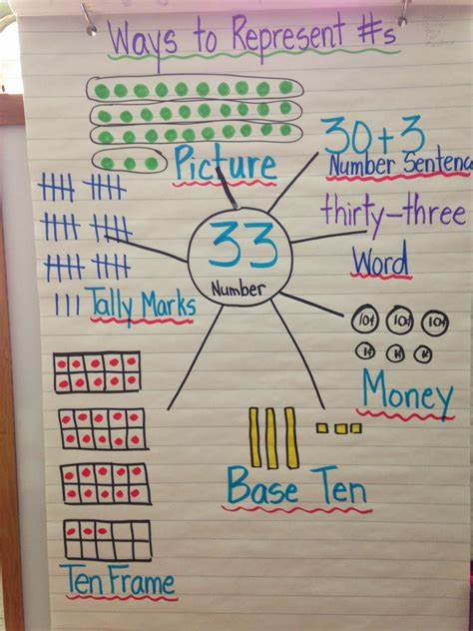
Warm Up – How many ways can you represent 33?

Have a look at the example. You can represent a number using tens frames, MAB blocks, drawings, tally marks, or by a number sentence.
Choose your own 2-digit or 3-digit number and show all the different ways to represent that number.

Activity – Place Value Snakes
For this activity, you will need your activity sheet from yesterday. Use the numbers you made yesterday to create some Place Value Snakes. Follow the instructions below and watch your snake grow from a number into its expanded form. You may need to ask an adult or someone at home for help folding your snakes. You might even like to decorate your snakes as you make them. (Template attached.)
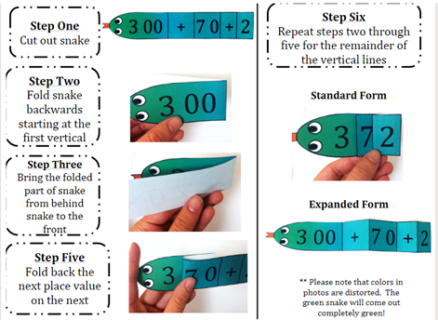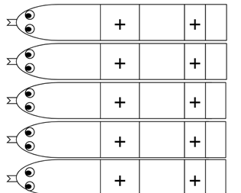

Break – Time to stop and refuel. Eat, play, have fun. Self-directed outside activities where possible.
FRI-YAY
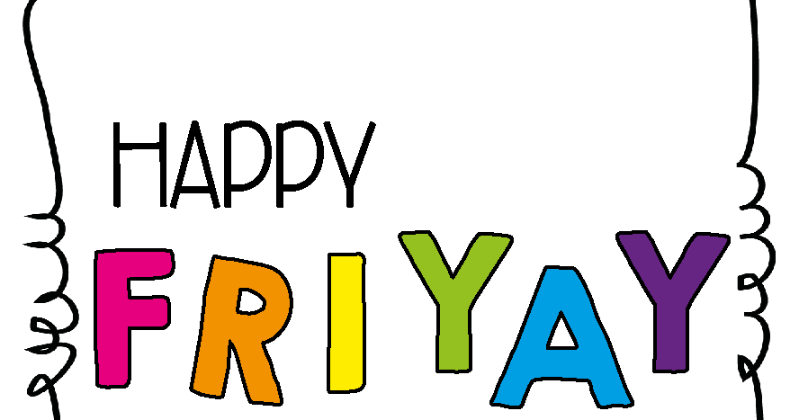
Pick an activity that you enjoy and have some fun! This may be by yourself or with an adult.
Take some photos and send them to your Teacher on Seesaw to show you how to celebrate your Fri-Yay!
Enjoy an activity outside or even get creative at home.
Have a great weekend!

