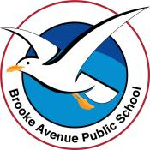
Learning from Home – Brooke Avenue Public School
Stage 2 (Years 3 and 4) – Week 3, Term 4
The following timetable can be used by students to support learning at home. All tasks have been linked to syllabus outcomes. If technology is available at home, please use the attached links to support learning.
The camera symbol shows the work sample we would like to see on Seesaw.
Monday 18th October
Daily Task – Make your bed
Morning -
English:
Reading
Read the text on ‘Sharks’. (attached). Answer the questions.
- Why did the author finish the first sentence with ‘there are some facts that might surprise you’, and add this ‘…’ afterwards?
- Why has the author put (meat eaters) in brackets?
- Why has the author used the phrase ‘would you believe it’ when talking about sharks eating seagulls?
- Why has the author used the double decker bus example when talking about 14m?
- Why has the author used an exclamation make at the end?
- Why has the author used the phrase ‘strangely enough’?

Writing
Write a paragraph of informative text demonstrating what you know about sharks.
Grammar
Complete the attached worksheet ‘Colour Adjectives’. Do you remember what adjectives are? Adjectives are describing words.
Spelling
Write out your list of spelling words.

Break – Time to stop and refuel. Eat, play, have fun. Self-directed outside activities where possible.
Maths
Complete the two pages on Equivalent Fractions. (Following our work on Fractions last week.)

Break – Time to stop and refuel. Eat, play, have fun. Self-directed outside activities where possible.
Science
Investigate the effect of forces on the behaviour of objects. For example- dropping, bouncing or rolling objects
* Isaac Newton is claimed to have said, ‘What goes up, must come down’ when he saw an apple fall from the tree he was sitting beneath. He is one of the scientists who have developed our understanding of forces, including gravity.
Gravity acts on an object regardless of whether the object is moving or not moving. It does not require the object to be surrounded by air or water or anything else and can therefore act in the vacuum of space.
Collect at least 8 different items from around your house. Make sure they a different sizes and shapes, for example, a handball, soccer ball, teddy bear, lego man?? You will also need a stopwatch to record the time. This can be on a phone or iPad if you don’t have a stopwatch.
What do you think will happen if you drop the objects from the same height and the same spot?
Write down your hypotheses (an educated guess based on what you know about gravity) before beginning.
Drop each object, one at a time recording with the stopwatch how long the item takes to reach the ground.
Make sure you record each item and time after each drop.

Answer the following questions.

What object had the slowest time?

What object had the fastest time?

Why do you think different objects fall at different speeds?

Was there anything that surprised you or you are still wondering about?

Creative Arts

Create your own sea theme artwork. It may be a drawing, painting or collage.

Tuesday 19th October
Daily Task - Match socks and sort washing.
Morning
English:

Reading
Read ‘Dogs as Pets’ (attached). Answer the following questions after you have read the text.
- What is the main idea of the whole text and how do you know?
- What is the main idea of paragraph 1?
- Choose a phrase or sentence from paragraph 2 that tells you the main idea from the paragraph.
- What is the main idea from paragraph 3?
- Write down two phrases that mean choosing in paragraph 3.
Writing
Today we are looking at words in poetry. Please read ‘A Family of Dinosaurs’. It uses Neologism. What is that??
Neologism is defined as a new word or a new use for an old word, or the act of making up new words. EG: smooch-osaurus.
After you have read the poem, answer the questions (attached). You can then attempt to write your own poem. You can use the structure of the Dinosaur poem to create your own. You might change a few words to make it yours. Have fun with it. I can’t wait to see your poem.
Grammar
Complete the worksheets ‘Packing in Meaning with Noun Groups’. (attached)

Spelling

Write your spelling words out in ‘rainbow’ writing. Choose 4 words from your spelling list to find the dictionary meaning of.

Break – Time to stop and refuel. Eat, play, have fun. Self-directed outside activities where possible.
Maths
Revision of -
Volume Cubes – see attached page
Multiplication and Division – See attached page

Break – Time to stop and refuel. Eat, play, have fun. Self-directed outside activities where possible.
PDHPE
Fitness Link attached or your choice of fitness.
https://youtu.be/364hLkdOXXc

Wednesday 20th October
Daily Task - Wash the dishes.
Morning
English:
Reading
Read a book or magazine of your choice for half an hour. You may even work on Reading Eggs if you would like to.
Writing
Use the stimulus attached ‘Through the doorway’ to write an imaginative text. Plan the narrative and begin your first draft. .
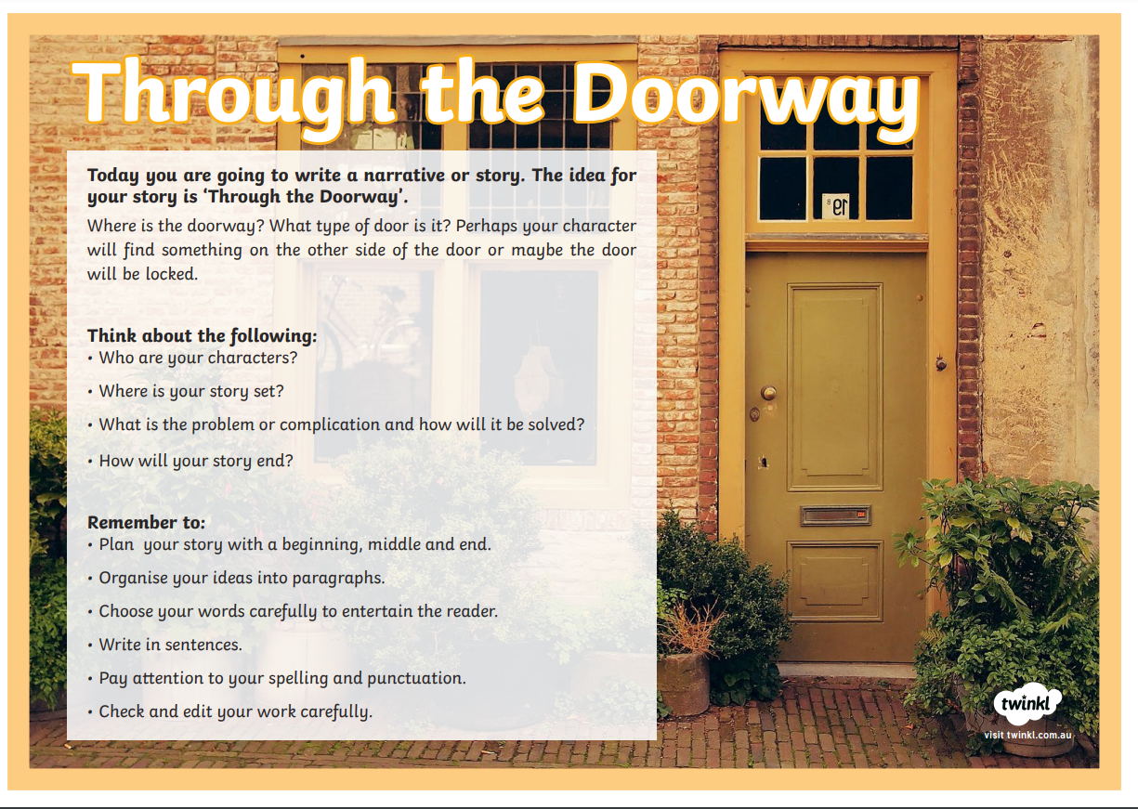
Grammar
Complete the worksheet on Nouns and adjectives. (attached) Do you remember what a noun is and what an adjective is?
Noun = person, place or thing. Adjective = a descriptive word, used to describe something.
Spelling
Use Look, Cover, Write, Check to revise your words.

Break – Time to stop and refuel. Eat, play, have fun. Self-directed outside activities where possible.
Maths
Revision of measuring in centimetres and metres.
Ignition
Think of 5 real world examples of where people measure length.

Complete the attached 2 pages on Measuring Length.

Break – Time to stop and refuel. Eat, play, have fun. Self-directed outside activities where possible.
Wednesday Wellbeing Time
Choose an activity that will put a smile on your mind and make you feel great. For a few minute mediatation session you may like to use the link below.
https://www.youtube.com/watch?v=8NB3ihqPQGw
PDHPE – Yoga Lesson- See attached Link
https://youtu.be/-uKEuikMrRo

Thursday 21st October
Daily Task – Make your bed.
Morning
Reading
Read the story “The Nitpicky Picnickers’
Write 3 questions that you could ask a friend about the text?
Writing
Complete your writing, ‘Through the Doorway’ from Wednesday. Proofread and edit your writing once you have finished it.
Spelling
Write your words in alphabetical order.
Break – Time to stop and refuel. Eat, play, have fun. Self-directed outside activities where possible.
Maths

Revision of Number Patterns. - Complete the attached worksheet.

Enjoy some Maths Revision through games on https://www.abcya.com/grades/3 for Year 3 students or

https://www.abcya.com/grades/4 for Year 4 with more challenging games.

Some of our very clever Year 3 students may like to work on the Year 4 games also.

Break – Time to stop and refuel. Eat, play, have fun. Self-directed outside activities where possible.
Creative Arts-See the attached Dance Link https://youtu.be/LaB9c3kQkfU

Friday 22nd October
Daily Task – Help an adult with an outside activity.
Morning
English
Reading
. Read ‘Polar Animals’ and answer the following questions.
- What is a carnivore?
- What temperatures can it reach in the Arctic in winter?
- From how far away can a polar bear smell an injured animal?
- How are polar bears able to hunt many miles out at sea?
- How have penguins adapted to their life in water? Give two ideas.
- What is the southern hemisphere?
- When do polar bears choose to stay on land?
- Why don’t penguins need to dive deep under water?
- Which penguins spend the winter in the Antarctic?
- Can you name any other birds that don’t fly?

Writing
Write a paragraph to describe the spooky setting. (See attached stimulus). You may like to draw your own spooky setting.
Spelling
Create a Find A Word using your spelling words from the lists for Term 4. See if a friend or family member can solve it.

Break – Time to stop and refuel. Eat, play, have fun. Self-directed outside activities where possible.
Maths (Revision)
What is symmetry?
Watch this short clip to learn about Symmetry.

https://www.youtube.com/watch?v=YFzktJNmnPU

Complete Symmetry in Nature page attached.

Break – Time to stop and refuel. Eat, play, have fun. Self-directed outside activities where possible.
PDHPE- See the attached Aerobic Lesson

https://youtu.be/zM3GZ9RjumU

Friyay

Friday Afternoon Free time – Your choice.

