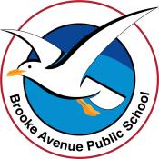
Learning from Home – Brooke Avenue Public School
K-6J, K-6M and K-6S – Week 3, Term 4
The following timetable can be used by students to support learning at home. All tasks have been linked to syllabus outcomes. If technology is available at home, please use the attached links to support learning.
Monday - Week 3, Term 4
Daily Task – Tidy your clothes drawers. Make sure all your socks have a buddy!
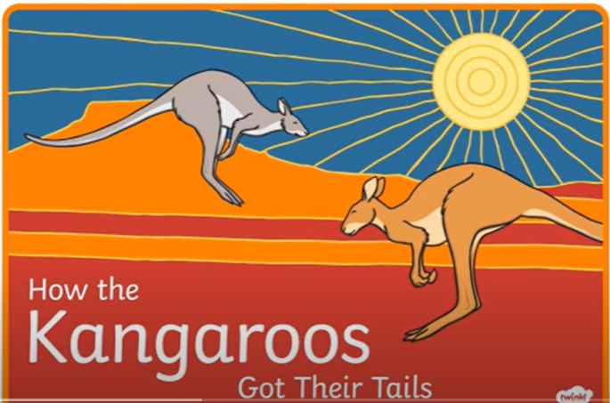
English:

Watch this story called ‘How the Kangaroo’s Got Their Tails’ https://www.youtube.com/watch?v=wzYCf0Cu9Ac

Complete the following activities about this story.
- What was your favourite part of the story? Why? Can you draw and label what was happening in the part of the story you liked?
- Choose 10 nouns (names of things) from the story and make a spelling list from them. Can you write your spelling words in rainbow writing? Can you make a word pyramid from them? Can you write them in a sentence? Can you draw an illustration of them? For example, you could use; kangaroo, stick, sun, bees…
- Would you like to have a tail? Or would you rather have wings? What about claws? Fangs? Draw a picture of yourself with an added body part and tell us what you would do!
- Complete the storyboard about How the Kangaroo’s Got Their Tails in your resource pack.
- Choose one of the activities you have done this morning to post on Seesaw so we can see your work!

Logon to your reading eggs https://readingeggs.com.au/ or your ePM reader account PM eCollection | Guided Reading Re-Imagined | Nelson Cengage Learning Australia and enjoy some down time!

Break – Time to stop and refuel. Eat, play, have fun. Self-directed outside activities where possible.
Maths: Chance and probability

Today we are going to look at the likelihood of things happening. Complete the following activities…
- Watch this clip https://www.youtube.com/watch?v=7XuNVVlD98g
- Use the chance word cards in your resource pack. Think of 4 things that are certain to happen, 4 things that are likely to happen, 4 things that will unlikely happen and 4 things that are impossible. Write your ideas down and draw a picture to represent them. Ask an adult if they agree with you. Did they? Why? Why not?
- Read the ‘Open Ended Scenarios’ from your resource pack and respond to each question. My answers may be different to yours. Why? Once you have completed the sheet, question an adult at home. Where their answers the same as yours? Why? Why not?
- Complete the Jelly Bean Chance sheet in your resource pack. If you ask nicely, maybe you could actually do this activity with real jellybeans, smarties, other colourful lollies or pieces of fruit!

Log on to maths seeds Home - Mathseeds or ABCya ABCya! • Learning Games and Apps for Kids and play some maths games!

Break – Time to stop and refuel. Eat, play, have fun. Self-directed outside activities where possible.
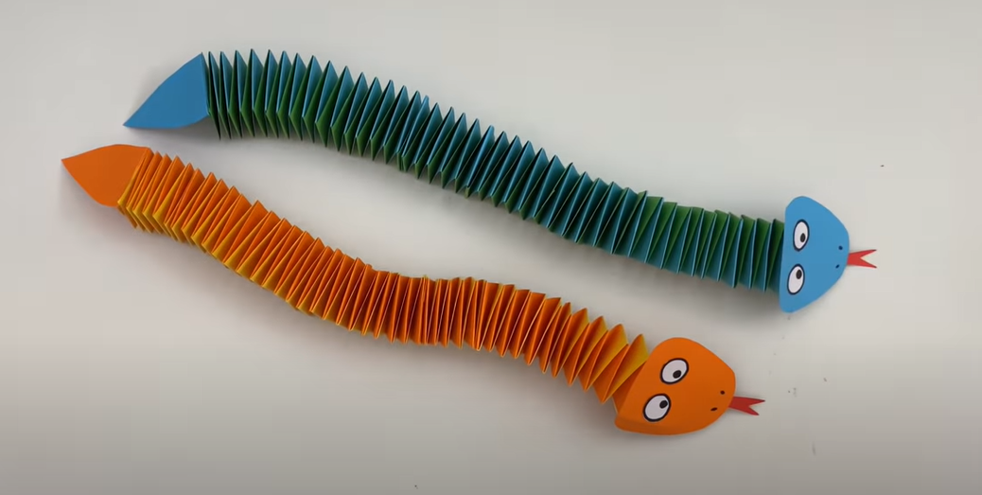
Art: Paper Snakes!
Today you are going to be making a paper snake!
You will need
- Coloured paper
- White paper (for the eyes)
- Scissors
- Glue
- Black Texta
Watch this clip How To Make Easy Paper SNAKE For Kids / Nursery Craft Ideas / Paper Craft Easy / KIDS crafts - YouTube You may need to stop the clip as you watch it so you can keep up with the steps. In this video, a paper cutter is used to make the strips of paper, but scissors will work just as well. Please post an image of you and your snake onto Seesaw so we can sssssssee your sssssssnake!
If you feel like you have a lot of energy after making your snake, you can visit this link for some fun aerobics! https://www.youtube.com/watch?v=5if4cjO5nxo
If you feel relaxed try this yoga clip! https://www.youtube.com/watch?v=Rzw-Oir8UPw

Tuesday - Week 3, Term 4
Daily Task – Can you help with lunch or dinner today? Maybe you can set the table?
English:
Listen to “Hey, That’s My Monster’ Hey That's My Monster read by Lily Tomlin - YouTube
Complete the following activities about this story…
- Tell someone what your favourite part of the book was and why.
- Choose 10 verbs (action words) you heard in the book and write them down (or record yourself saying them). Eg slunk, sniffled, squelched and dripped. Can you put then into a sentence? For example…The dog slunk into his kennel when he was caught chewing the slipper.
- Complete the ‘Describe the Monster’ sheets in your resource pack.
- Create your own monster. You could do an artwork, drawing, make a puppet, make a sculpture or a model, dress up a toy as a monster, or even dress as a monster yourself. What qualities does your monster have? Does it have any special powers? Is it kind? Be as creative as you can!
Practise your letter and blend sounds in this interactive game Phonics Pop || Listen to the sound, then pop as many bubbles as you can - mobile friendly (ictgames.com)
Logon to your reading eggs https://readingeggs.com.au/ or study ladder and complete some of your own tasks.
Break – Time to stop and refuel. Eat, play, have fun. Self-directed outside activities where possible.
Maths:

Watch this video on chance and probability Chance- Stage 1 Mathematics - YouTube

- Ask to look at this Weather website Weather - Australia 7 day forecasts and weather radar - FarmOnline Weather - www.farmonlineweather.com.au You can choose any area of Australia to look at. What is the weather going to be like in Sydney over the coming week? What is the chance of rain? Snow? Sunshine? Compare it to the weather in another area of Australia like Darwin or Perth. Is Sydney’s weather similar or different? What are the chances of rain, snow or sunshine in the area you have chosen?
- Predict the weather for today and the rest of the week. At the end of each day you can check to see if you were correct or not!
- Complete the Chance and Data Dice Roll sheets in your resource pack. If you don’t have dice at home you can use this online version Virtual Dice & Coin Flip (freeonlinedice.com)
- Post some of your maths work onto Seesaw.
Go to Math Seeds, Studyladder or Prodigy to work on your maths skills!
Break – Time to stop and refuel. Eat, play, have fun. Self-directed outside activities where possible.
Science: Rain in a jar!
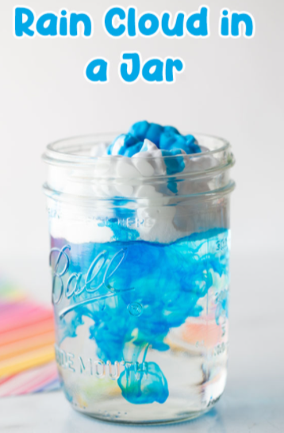
This experiment shows how water holds in a cloud, condenses, and falls to the earth.
You will need…
- Glass jar
- Room temperature water
- Blue food colouring
- Shaving foam
Watch the following clip and then try the experiment yourself…
How to make a Rain Cloud in a Jar | Kids Science Experiment - YouTube
Post an image of your rain cloud in a jar!
Wednesday - Week 3, Term 4
Daily Task – Ask if you can clean out the pantry or a cupboard in the kitchen. Arrange everything neatly!
English: Literacy
Today we are going to be working on creating interesting sentences.
- To make sentences more interesting you may need to add adjectives and extend your sentences. For example, look at this sentence-The dog slept on the mat. The sentence can be made more interesting by adding adjectives- The old, spotty dog slept soundly on the red and green mat.
- Complete the Up-levelling Sentences sheets in your resource pack. There are a lot of these so you can choose the ones which suit you best.
- Open a page on a favourite book of yours. Select a sentence and copy it or say it out loud. Is there anything you can add to the sentence to make it more interesting? Does replacing one of the adjectives change the meaning of the sentence? Why? Why not?
- Can you create some silly sentences eg. One sunny day, the butterfly painted a picture while riding a bicycle. Illustrate your silly sentences!
Take some time to work on Studyladder, reading eggs or ePM readers.
Break – Time to stop and refuel. Eat, play, have fun. Self-directed outside activities where possible.
Maths: Bar Graphing results
Watch this graphing video. You have seen it before but it may be good to have a reminder! Data! | Mini Math Movies | Scratch Garden - YouTube
- Complete the Pets Bar Graph sheets in your resource pack. There are different levels of questioning, so choose the one that is right for you, or you can attempt all of them if you wish.
- Create your own topic eg ‘The colour of cars passing by outside. You can tally your results, then create a bar graph and devise some questions that could be answered by using your results. You could ask questions like; How many blue cars were recorded? How many more white cars were there than green cars? See if someone at home can correctly answer your questions.
- At the end of your resource pack are some Chance Challenge Cards. These are in two different levels. Choose a couple of cards and see if you can solve the problem. Write down your results or record yourself saying the answer.
- Post some of your maths work on Seesaw so we can comment!
Play this online version of snakes and ladders! You can play against the computer if you wish! Have fun! https://toytheater.com/snakes-and-ladders/
Log on to study ladder, maths seeds, ABCya or prodigy and play some games of your choice!

Break – Time to stop and refuel. Eat, play, have fun. Self-directed outside activities where possible.
Science: Motion
- Watch this video on force and motion Force and Motion | Science Video for Kids - YouTube and push and pull Forces, push and pull - YouTube
- Complete the ‘Objects and their Movement’ sheet in your resource pack and make the ‘Objects Move’ book.
- Find objects around your house in in the backyard that correspond with some of the items and movements in the book you have made.
- Group items according to their movements eg Rolling-ball, toy car, round candle, tomato. Sliding-computer mouse, broom, skidding on the floorboards with socks. Take photos or draw the items that you have collected and state the motion that they do. Could some items be in more than one category? A toy car rolls but needs to be pushed in order to move. It can also be turned onto its roof and can slide along the floor.
- Listen to this push and pull song Push and Pull Song - A simple, fun kids song about pushes and pulls! - YouTube Now go and have fun with your toys, games or outside and think…are you pushing something? Pulling something? What other forces and motions are you using? Have FUN!

Thursday - Week 3, Term 4
Daily Task – Give your room a really good clean…make the bed, tidy your toys and put away all of your clothes.
English: 2021!
Today you are going to reflect on the year that has been (so far).
- Halve a piece of paper and draw a line through the middle. One side of the paper will be for the positive things that have happened to you throughout the year and the other will be the negative things. Brainstorm all the things that have happened this year to you, and write them onto the correct side of the paper (you may need an adult to help). An example of a positive thing could be that you learnt to roller-skate and a negative could be that you couldn’t see your cousins.
- Illustrate each of your ideas with a little cartoon character or drawing. Were there more positive things on your list or more negatives? Why do you think this is? Is there anything you could have done to change this outcome?
- Using some of the words you have written, make a spelling list. Can you write your spelling words in a fancy way? Can you type them onto the computer and change the size, font and colour of the text? Can you sing your words in a funny voice? Can you write your words in rainbow writing or trace them into flour on the benchtop?
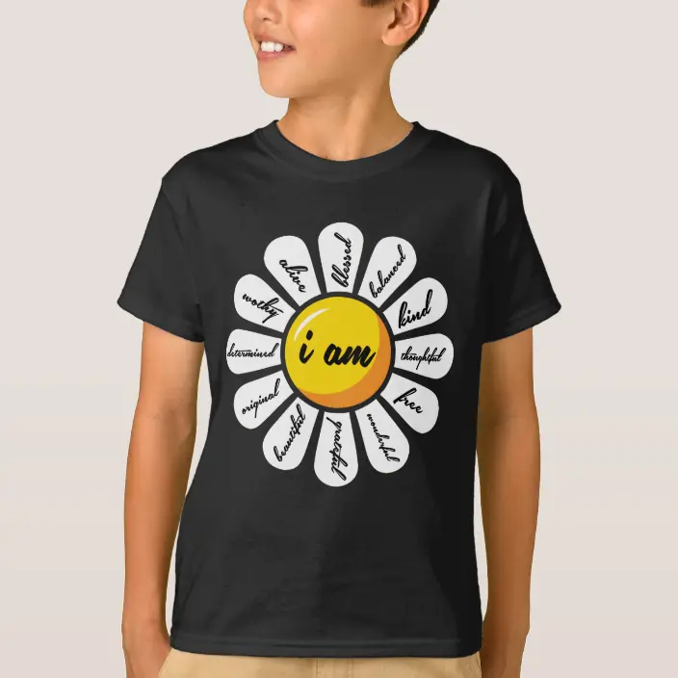
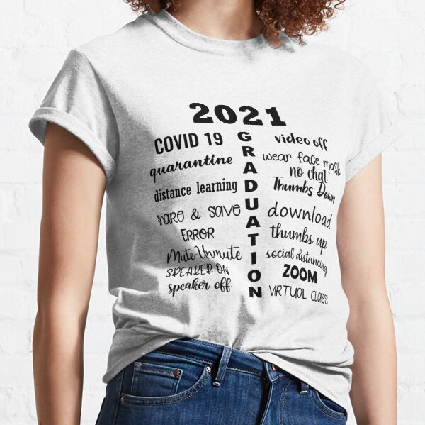
- Use the ‘Class of 2021 T-Shirt’ template in your resource pack and create a commemorative t-shirt for this year. Choose ideas from the positive side of your list for inspiration. You can draw, write or create an artwork on your t-shirt that represents 2021 for you! Have fun and please, post your t-shirt design onto Seesaw!

Visit the https://www.topmarks.co.uk/Interactive.aspx?cat=40 site…find something that suits you!
Log onto Reading Eggs or ePM collection and find some more books and activities to enjoy!

Break – Time to stop and refuel. Eat, play, have fun. Self-directed outside activities where possible.
Maths: Chance
Today you are going to complete 2 chance related investigations.
- Find the ‘Coin Flip Investigation Sheet’ in your resource pack. You will need one coin and a pencil. If you cannot find a coin, use this virtual coin flip link Just Flip A Coin
- Complete the coin flip challenge and answer the questions. You may need an adult to help with some of the reading and recording. Was your prediction correct? Would the results change if you used a different coin? Are the chances of flipping heads or tails equal? Why? Why not?
- Find the ‘Chance and Data Dice Roll’ sheet in your resource pack. You will need a pencil and a die. If you do not have one, use this virtual link Random Dice! (online-stopwatch.com)
- Complete the dice roll activities. Were there more options for different results in this investigation in comparison with the coin flip? Why? Which activity did you find more interesting? Why?
- Choose 2 of the Chance Challenge Cards to complete.
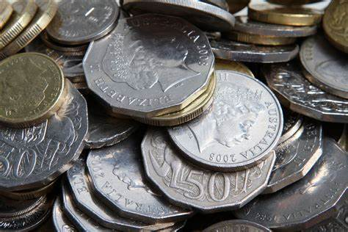
You have worked very hard! You deserve a break! Go to https://www.coolmathgames.com/ and play a game that you like!

Break – Time to stop and refuel. Eat, play, have fun. Self-directed outside activities where possible.
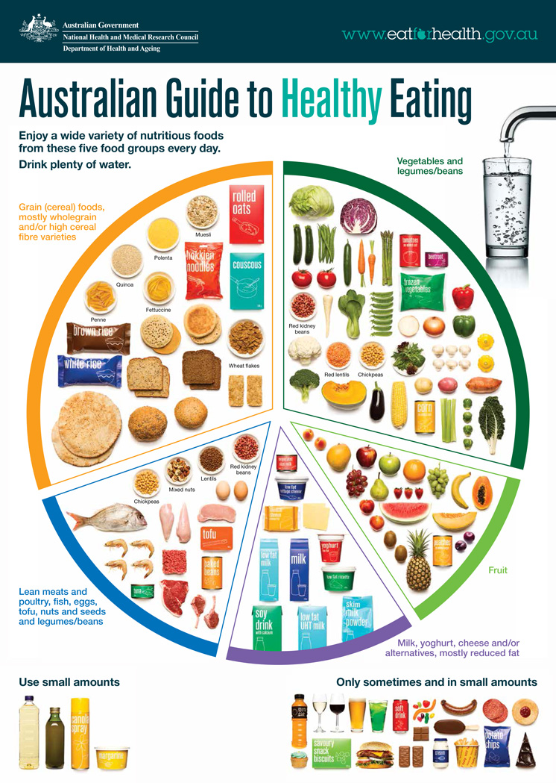
PDH: Healthy eating
Today you are going to be working on eating for a healthy mind and body!
- Watch this short clip on the Australian guide to healthy eating. Overview of the Australian Guide to Healthy Eating - YouTube
- Create a ‘plate’ of foods according to the advice that you heard on the clip. You will need to include foods from each part of the wheel. You can list the foods, draw pictures, or cut foods out of a magazine or supermarket catalogue.
- Ask an adult to look at your healthy plate. Do they agree that your plate covers all food groups? Why? Why not?
- Create a meal plan for a day that uses the food groups you have heard about. You will need to think of a healthy breakfast, lunch, dinner and snacks.
- You could display this by creating a menu, drawing images, or writing your ideas into a list. Have you created a healthy meal plan? Is this something that you are likely to eat yourself? Why? Why not? Would you whole family enjoy this food?
Have a healthy snack and choose one of the following activities to do…
If you feel like you have a lot of energy, you can visit this link for a zumba class! Zumba Dance Party - YouTube
If you feel relaxed, try this meditation clip! Guided Meditation for Children | CRYSTAL HEALING CAVE | Kids Meditation for Happiness - YouTube
Friday - Week 3, Term 4
Daily Task – Clean your school bag, lunchbox and drink bottle and get ready for school next week!
English: vowels and consonants
Today we are going to be looking at vowels and consonants.
- Watch this clip The Vowels and Consonants Song - YouTube Find and complete ‘Alfie Ants Consonants and Vowels’ sheet in your resource pack.
- Watch this clip about when to use ‘a’ or ‘an’ "A and An Song" - English Lesson for "A and An" - Rockin' English - YouTube Complete the ‘Ant Antics’ and ‘Alfie’s Sentences’ in your resource pack.
- Try to complete the “Tricky Words’ and Alfie Ants Story sheets.
Do you think you know when to use ‘a’ or ‘an’ now?
Take some time to work on Studyladder, reading eggs or ePM readers.

Break – Time to stop and refuel. Eat, play, have fun. Self-directed outside activities where possible.
Maths: Chance

- Find the ‘Chance Jar’ activity sheets in your resource pack. Complete these and check your answers on the answer sheets.
- Choose some of the Chance Challenge Cards to complete.

You have worked very hard on chance, probability, and data this week! Well done to you! Now choose some of these fun activities to do for the rest of the maths session!

Play a board game with a family member, for example Checkers. If you don’t have games at home visit this site https://www.safekidgames.com/board-games/ Some of these games you can play against the computer! Good luck!

Play a card game like Snap, Go Fish or UNO. This site has lots of different card games you can play! https://www.kidspot.com.au/parenting/things-to-do/snap-12-classic-card-games-to-teach-the-kids/news-story/1d153893aee53908749c1377c588928c

Go to ABCya https://www.abcya.com/ or Get Smart https://getsmarts.weebly.com/ or Cool Maths Games https://www.coolmathgames.com/ and play some educational games!
Break – Time to stop and refuel. Eat, play, have fun. Self-directed outside activities where possible.
Happy FriYAy!

We are all very proud of you and what you have achieved over this period of ‘Stay at Home’. Please give your parents and carers a big hug from us and say a big THANK YOU to them for helping you at home and keeping you safe!
This is your last FriYay at home so make the most of the afternoon by doing something that you love!

