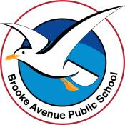
Learning from Home – Brooke Avenue Public School
K-6J, K-6M and K-6S – Week 1, Term 4
The following timetable can be used by students to support learning at home. All tasks have been linked to syllabus outcomes. If technology is available at home, please use the attached links to support learning.
Tuesday - Week 1, Term 4
Daily Task – Can you pick some beautiful leaves and flowers from your garden? Arrange them in a vase…gorgeous!
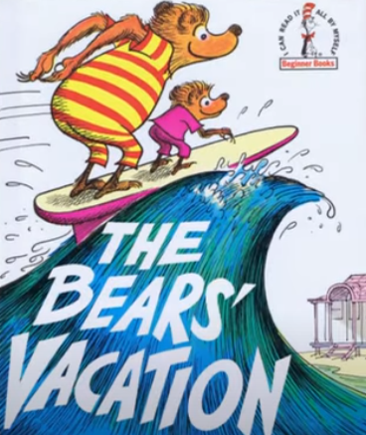
English:
Watch this clip about the Berenstain Bears The Bears' Vacation - Berenstain Bears Summer Kids Books Read Aloud - Bedtime Stories for Kids - YouTube
Complete the following activities about this story…
- What are some of the activities that the Bears did on their holiday? Are any of the activities the same as what you did?
- Brainstorm all the things you did over the holiday break and write them down on a sheet of paper.
- Make a spelling list using some of the words of the things you did e.g., beach, movie, walk, cooking etc. Write your spelling words in a variety of ways. Can you illustrate them too?
- Complete the ‘Holiday Report’ sheet in your resource pack.
- Choose one of the things you did over the holiday and create an artwork about it. You could sketch, draw, paint, make a collage, write a song, write a poem, create a diorama, or write and act in a small play about your favourite part of the holiday! Please post this on Seesaw.
Practise the correct formation of letters in this interactive game Sky Writer - mobile friendly (ictgames.com) or practise your typing skills using Typing Club Learn Touch Typing Free - TypingClub
Logon to your reading eggs https://readingeggs.com.au/ or study ladder and complete some of your own tasks.

Break – Time to stop and refuel. Eat, play, have fun. Self-directed outside activities where possible.
Maths: Patterns

Watch this pattern clip "PATTERNS" A song for children about patterns colour & creativity. All original The Bopalongs - YouTube
Today you are going to go on a pattern hunt around your house. When you find a pattern, take a photo of it, draw it or write about it.
Patterns are EVERYWHERE!
- Look on the calendar for a number pattern, the bathroom walls for tile patterns, your clothes and furniture for colour patterns, you can even find patterns on animals!
- Ask if you can make a colour and shape pattern using something that you can dip in paint and press onto paper like cut up veges/fruit, stones, lego, buttons etc. If you do not have paint, make a pattern using textas or coloured pencils. Display your patterns around the house…your family will be very impressed!
- Complete the pattern worksheets in your Resource pack. Create some of your own patterns that are like these.
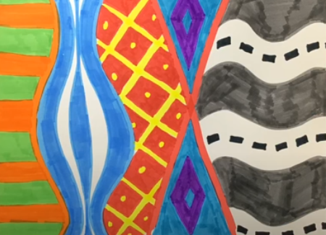
- Watch this clip of a pattern artwork then create your very own! Bold Patterns - Kindergarten Art Lesson #02 - YouTube

Go to Math Seeds, Studyladder or Prodigy to work on your maths skills!

Break – Time to stop and refuel. Eat, play, have fun. Self-directed outside activities where possible.
PDHPE- Fitness
Cut out the Fitness Circuit cards in your resource pack. Use them to create exercise stations in your room or outside if possible.
- How many activities can you do?
- What was the most difficult?
- What was the easiest?
- What was the most fun?
- Can you create some other activities to do?
- Time yourself doing the activities with someone else. Who was the quickest to complete the activity? Why?
Go to https://www.youtube.com/user/CosmicKidsYoga and choose cosmic kids yoga session to do. Relax and enjoy!

Wednesday - Week 1, Term 4
Daily Task – Can you sort through your clothes? Are there any that are too small? Can you give them to a friend or a charity shop?
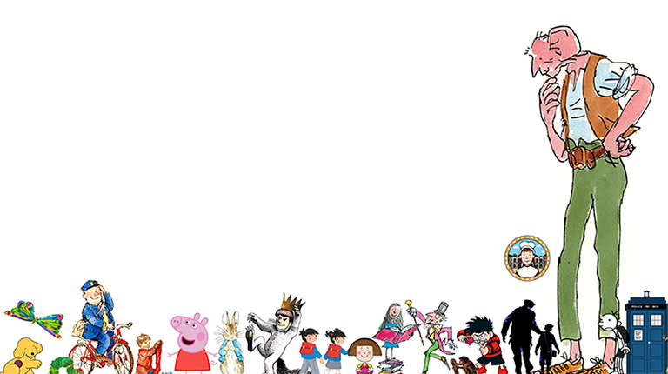
Literacy
Choose a character from a book, story or movie.
- Think about this character and how he or she would have been as a baby, a child, an adult and an old person.
- Brainstorm ideas for what they would have been like in personality, what they looked like, the things they enjoyed doing etc.
- Make posters that correlate to each age group. Include facts about the character and a drawing to support your ideas.
- For example, if you chose Harry Potter; as a baby he may have liked to cast spells to turn his milk into strawberry flavour, played with his toys by turning them into living creatures and wore onesies with witches’ hats and magic wands on them.
- Once completed, display your posters on your bedroom wall or the fridge and ask your parents/carers to offer feedback on your ideas.
Visit the https://getsmarts.weebly.com/ site and choose an activity to do!
Break – Time to stop and refuel. Eat, play, have fun. Self-directed outside activities where possible.
Maths: Number
Your task today is to do some addition and subtraction with dice, playing cards, counters, marbles…in fact anything that you have that you can combine and separate.
If you have dice at home you can roll a number, collect the correct number of counters, roll again and add the next number onto what you had. You can challenge yourself by adding an additional number to your dice making 10’s, 20’s, 30’s etc or you can use a calendar and randomly pick a number or look for numbers around the house to add. Check your answer by using a calculator https://www.online-calculator.com/
When you are subtracting make sure that the largest number that you roll or find is the one that you subtract from! Can you take some photos of your work or draw some of your ideas…you can share them with your classmates when we get back to school!
Complete the addition colour by number sheets in your resource pack.
Play this online version of snakes and ladders! You can play against the computer if you wish! Have fun! https://toytheater.com/snakes-and-ladders/
Log on to study ladder, maths seeds, ABCya or prodigy and play some games of your choice!

Break – Time to stop and refuel. Eat, play, have fun. Self-directed outside activities where possible.
Art/Science
- Do you know where the world’s water comes from? Watch https://www.youtube.com/watch?v=TWb4KlM2vts and The Water Cycle | The Dr. Binocs Show | Learn Videos For Kids - YouTube
- Can you make some arrows and then draw a picture for each part of the water cycle and link them together? Or can you act out each part of the water cycle? Or can you tell a parent/carer about how the water cycle works?
- Complete the Water Cycle cloze activity in your resource pack. You may need some help with this.
- Here is another interesting link to a water cycle information page https://www.kidzone.ws/water/ (you may need a parent/carer to help you with the reading of this information!) This also has activities attached that you can do if you wish.
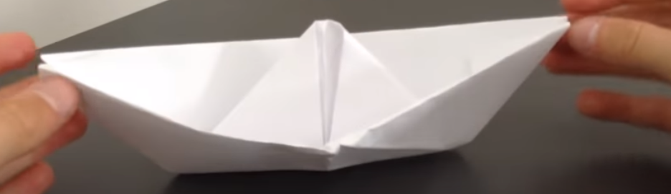
- Water is great! It is also fun to play with! Find some things around the house that you think may float and some things that you think may sink. Fill up a bucket with water, select an item and decide whether it will float or sink. Test it by dropping it into the water. Were you correct?
- Make a boat out of paper. How to make a paper boat Easy to make - YouTube Do you think it will float? Will it carry anything? How much can it hold until it sinks? Have a fun time!
Thursday - Week 1, Term 4
Daily Task – Can you help pulling out some weeds in the garden? Make sure you don’t pull out the flowers! Put your garden waste into the green bin!
Literacy
Make a card for someone! You could choose a friend, your mum, your grandfather, actually…anyone!
- First decide on who will be getting your card and what it will be for, maybe a birthday, get well, thank you…use your imagination!
- Next, decide what you will write on your card and have a practise on a spare piece of paper. You may need your parent/carer to help with this. When you are happy with what you have written, get a fresh piece of paper or cardboard and fold it in half to make a card shape. Write your message inside the card…make sure you use your nicest writing!
- Now you can decorate the front of your card by drawing a picture or cutting out a picture from a magazine or printing an image. Give your card to the special person next time you see them! There are some cards in your Resource pack that you can use for ideas if you wish. You can also make an ecard by following this link….https://www.123greetings.com/
Go to https://www.abcya.com/ and choose an interesting literacy activity to do! Have fun!
Break – Time to stop and refuel. Eat, play, have fun. Self-directed outside activities where possible.
Maths: 2D Shapes

Look at the attached picture of Aboriginal artworks in your resource pack.
- Can you identify, label, and describe the features of the 2D shapes used in the artworks?
- Are there any irregular shapes used? Can you name them?
- Cut the artwork into lots of different 2D shapes to make a jigsaw puzzle. Then, try and put the puzzle back together. Perhaps you could ask someone to do it with you for a bit of fun!
- Using the firework rockets in your resource pack, cut out the shapes and match them to complete the rockets. Can you use the pieces to create your own unique artwork?

Try a maths activity on
ABCYA https://www.abcya.com/
Prodigy https://play.prodigygame.com/
Mathseeds, https://mathseeds.com.au
Cool maths Games https://www.coolmathgames.com/
Break – Time to stop and refuel. Eat, play, have fun. Self-directed outside activities where possible.
PDHPE:
Download the app Smiling Minds https://app.smilingmind.com.au or go to the cosmic yoga site https://www.youtube.com/user/CosmicKidsYoga
- Find a quiet spot that you can relax in. Make sure there are not too many distractions and that you are comfortable. How are you feeling prior to starting your activity? Why? Do you think you will feel differently after your session? Why? Why not? Choose an activity that interests you and begin your session.
- What did you choose? Why? How did you feel after completing your session?
- Ask an adult or someone else that is with you if they would like to do a yoga or meditation session with you. Choose one together. Ask them how they are feeling before you start and once you have finished your session ask them how it made them feel. Did they feel more relaxed or not? Why do you think this happened?
Choose a mini-beasts colouring sheet from your resource pack and enjoy some peace and quiet!
Friday - Week 1, Term 4
Daily Task –Ask if you can help with the dishes today. You may be able to pack or unpack the dishwasher if you have one!
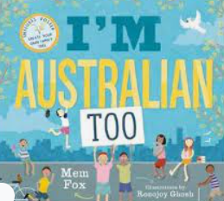
English: Literacy
Listen to…I’m Australian too by Mem Fox I'm Australian Too by Mem Fox - Read Aloud - YouTube
- Talk to an adult about the story. Did you enjoy it? Why/Why not?
- Do you identify any similarities to the characters in the story?
- What is your story? What makes you an Australian?
- Write/draw/create a story that shows how you identify as an Australian. Perhaps you would like to do an animation, a comic strip or a cartoon to demonstrate your heritage. You can use the ‘All about me’ worksheet in the resource pack as a template if you wish.
- Make a spelling list from the words you used to describe yourself. Write your spelling words in bubble writing or type them onto a word document and change the size, font and colour of the text.
- Make plurals from some of your spelling words? E.g. pizza-pizzas, brother-brothers etc.
- Choose your favourite work from todays literacy session to post on Seesaw.
Online: Log on to Reading Eggs and practise your literacy skills. https://readingeggs.com.au/

Break – Time to stop and refuel. Eat, play, have fun. Self-directed outside activities where possible.
Maths: Mass
- Choose 10 items from around the house. Hold them in your hands one by one and try to order them from lightest to heaviest (this is called hefting). Take a photo or sketch your estimate. You can use the hefting worksheet in your resource pack to help you if you would like to.
- Now ask an adult if you can use a set of scales to weigh each item. You could use kitchen scales or bathroom scales.
- Record the weight of each item. Rearrange them in order from lightest to heaviest. Were you correct on your estimation? Is the largest item the heaviest? What do you think the reason for this is?
- Look outside. What do you think is the heaviest thing that you can see? A house, a car, a tree? What about the lightest thing you can see? Is it an ant, a leaf, a bird? Make a list or take some photos. Research how much the items you have seen outside actually weigh (approximately). Were you correct in guessing what was the lightest and heaviest?
- Can you research how much some of the items that you can see outside actually weigh? Record them on your list.
Try these activities…https://getsmarts.weebly.com/mass2.html
Break – Time to stop and refuel. Eat, play, have fun. Self-directed outside activities where possible.
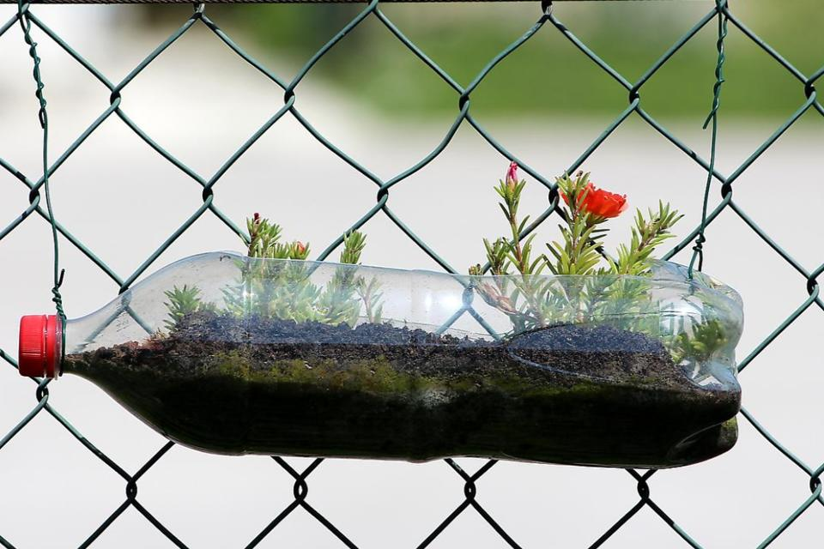
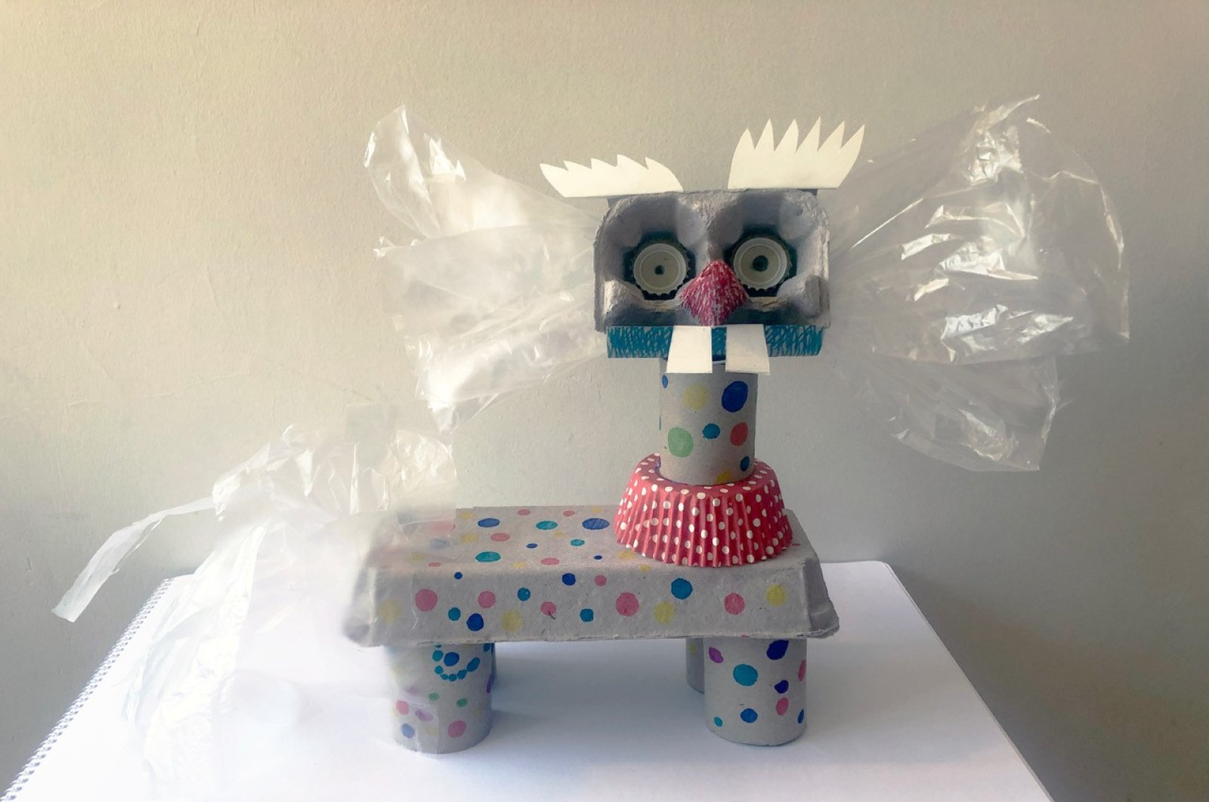
Art/Science
Recycle, reduce, reuse!
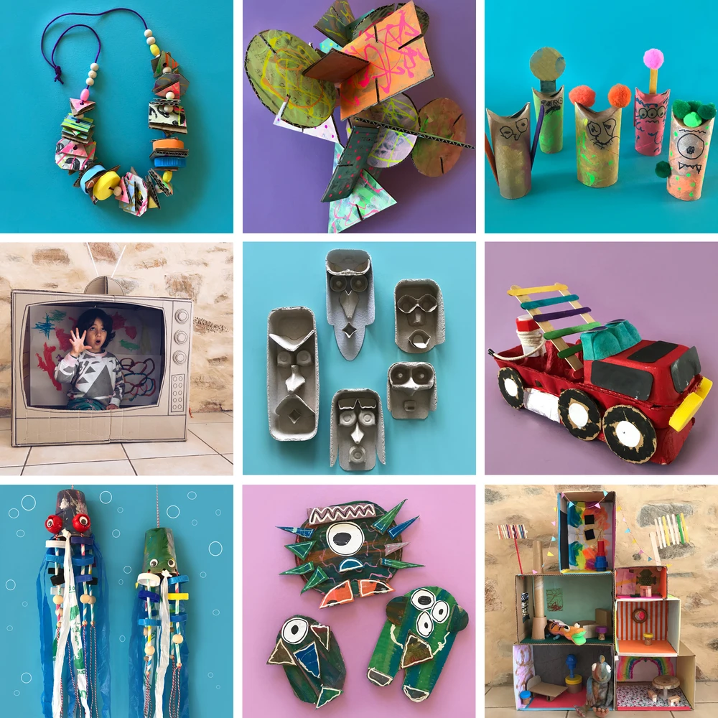
- Today you need to collect ‘stuff’ from around your home that could be used again to create a sculpture, toy or an ornament.
- Find things like an old cardboard box, some tinfoil, old bottle tops, string, pieces of plastic, old containers, and things from the garden like sticks, stones, petals and leaves.
- You may need glue, scissors, string and sticky tape and will probably need an adult to help you with some parts of the activity.
- Make sure your items are clean and spread them out so you can see what you have. What would you like to make? A spaceship, cubbyhouse, proton pack, some dolls furniture? Use your imagination!
- When you have finished, take a photo or draw what you have made. We would love to see you post an image on Seesaw!

