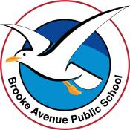
Learning from Home Program – Brooke Avenue Public School
Kindergarten – Week 1, Term 4
The following timetable can be used by students to support learning at home. All tasks have been linked to syllabus outcomes. If technology is available at home, please use the attached links to support learning.

Tuesday - Week 1, Term 4 - Kindergarten
Daily Task - Wash the dishes.

English

Phonics: You will need a piece of paper and a pencil. Access Seesaw. Watch the video by Mrs Rex and follow her instruction. If unable to access Seesaw, review all sounds on Jolly Phonics.
Reading: Log on to ePM readers and read a book or read a book from home. Answer the following comprehension questions based on the book.
- Describe the characters in the story.
- What was the problem in the book?
- What was the solution?
- Has something like this ever happened to you? Explain.
Writing: Handwriting Booklet. See attached.
Break – Time to stop and refuel. Eat, play, have fun. Self-directed outside activities where possible.
Sight words: Practise reading your sight words. Create your sight words using playdough, magnetic letters, natural items or chalk.
Maths
Play a few games of scissors, paper, rock with a family member and keep track of who wins by using tally marks.
Access the Maths Warm Up video online with Mrs Rees.

Optional: Reading Eggs or Mathseeds
Break – Time to stop and refuel. Eat, play, have fun. Self-directed outside activities where possible.
Creative Arts
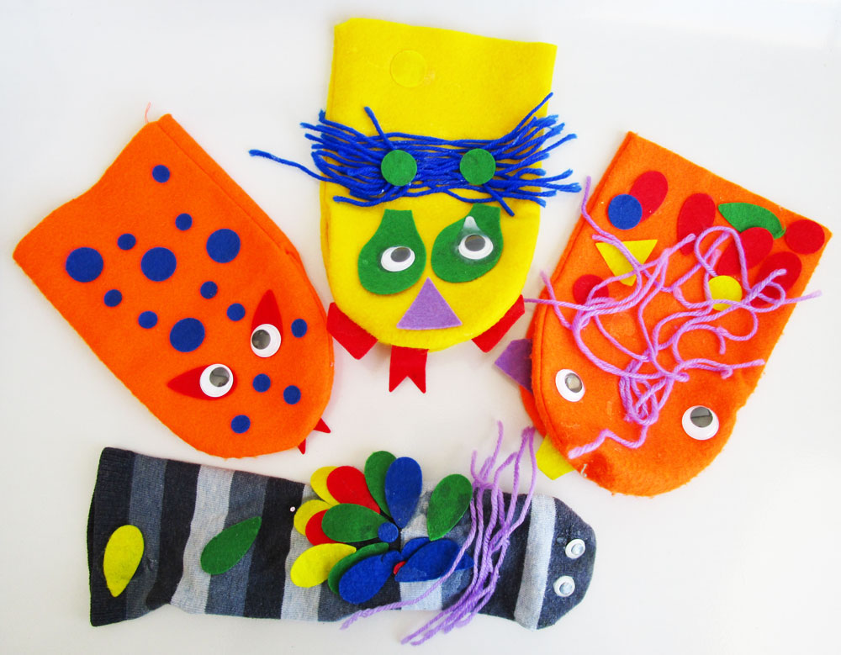Create your own sock puppets! Or finger puppets.
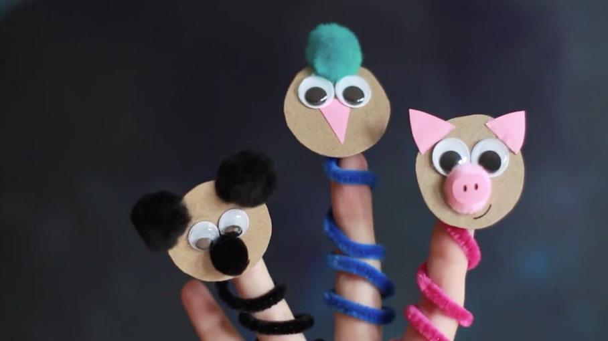Or finger puppets.
https://www.youtube.com/watch?v=1Nh0n2LcU7I

Wednesday - Week 1, Term 4 - Kindergarten
Daily Task – Help make a nutritious meal.

English

Phonics: You will need a piece of paper and a pencil. Access Seesaw. Watch the video by Mrs Rex and follow her instruction. If unable to access Seesaw, review all sounds on Jolly Phonics.
Reading: Log on to ePM readers and read a book or read a book from home. Answer the following comprehension questions based on the book.
- Where is the setting?
- What feelings do you have throughout the book?
- Look for words in the book that are new or challenging and ask an adult what they mean.
- Explain what part of the story made you feel excited and unhappy.
Writing: Handwriting Booklet. See attached.

Break – Time to stop and refuel. Eat, play, have fun. Self-directed outside activities where possible.
Sight words: Practise reading your sight words. Create your sight words using playdough, magnetic letters, natural items or chalk.
Maths
Play a few games of Go Fish or Snap with a family member.
Access the Maths Warm Up video online with Mrs Rees.

Optional: Reading Eggs or Mathseeds

Break – Time to stop and refuel. Eat, play, have fun. Self-directed outside activities where possible.
PDHPE
https://www.youtube.com/watch?app=desktop&v=lGC0zxgRNJQ
Compleet the woksheet ‘Groups I am apart of.’
Thursday - Week 1, Term 4 - Kindergarten
Daily Task – Help an adult with an activity such as washing a car, vacuuming or watering the garden.

English

Phonics: You will need a piece of paper and a pencil. Access Seesaw. Watch the video by Mrs Rex and follow her instruction. If unable to access Seesaw, review all sounds on Jolly Phonics.
Reading: Log on to ePM readers and read a book or read a book from home. Answer the following comprehension questions based on the book.
- Where is the setting?
- What feelings do you have throughout the book?
- Look for words in the book that are new or challenging and ask an adult what they mean.
- Explain what part of the story made you feel excited and unhappy.
Writing: Write a sentence explaining your opinion about this sentence. Kids should be able to drive cars. Try and use the word ‘because’

Break – Time to stop and refuel. Eat, play, have fun. Self-directed outside activities where possible.
Sight words: Practise reading your sight words. Write your sight words on the ground in chalk, use a water pistol to trace the words outside.
Optional: Reading Eggs

Maths
Use two piles of playing cards, one red, one black. Turn a card from each pile over and identify the larger number. Add the two cards together by counting up from the largest card, using the visuals on the smallest card.
Access the Maths Warm Up video online with Mrs Rees.

Optional: Mathseeds

Break – Time to stop and refuel. Eat, play, have fun. Self-directed outside activities where possible.
Art and Drama
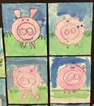
https://www.youtube.com/watch?app=desktop&v=ZN-TcF8O8Zc
Watch the play above and create your own ‘Little Pig’

Friday - Week 1, Term 4 - Kindergarten
Daily Task – Clean up your room and tidy your toys

English

Phonics: You will need a piece of paper and a pencil. Access Seesaw. Watch the video by Mrs Rex and follow her instruction. If unable to access Seesaw, review all sounds on Jolly Phonics.
Reading: Log on to ePM readers and read a book or read a book from home. Answer the following comprehension questions based on the book.
- Where is the setting?
- What feelings do you have throughout the book?
- Look for words in the book that are new or challenging and ask an adult what they mean.
- Explain what part of the story made you feel excited and unhappy.
Writing: Write a sentence explaining your opinion about this sentence. Kids should be forced to set the table at dinner time. Try and use the word ‘because’

Break – Time to stop and refuel. Eat, play, have fun. Self-directed outside activities where possible.
Sight words: Practise reading your sight words. Play sight word snap with a family member. Remember to have two copies of each sight word.
Optional: Reading Eggs

Maths
Use two piles of playing cards, one red, one black. Turn a card from each pile over and identify the larger number. Add the two cards together by counting up from the largest card, using the visuals on the smallest card.
Access the Maths Warm Up video online with Mrs Rees.

Optional: Mathseeds
Break – Time to stop and refuel. Eat, play, have fun. Self-directed outside activities where possible.
FriYay Fun Afternoon

Head outside and enjoy your afternoon, maybe you could go for a bike ride or on a bushwalk.
Happy FriYay!

