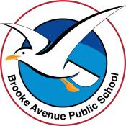
Learning from Home – Brooke Avenue Public School
Stage 2 (Years 3 and 4) – Week 3, Term 3
The following timetable can be used by students to support learning at home. All tasks have been linked to syllabus outcomes. If technology is available at home, please use the attached links to support learning.
Monday 26th July
Daily Task - Match socks and sort washing.
Morning
English:
Reading
Read Problem Pets (attached).
Grammar
See how many verbs you can find in the text and make a list of them.
Writing
Create a plan to write a narrative about a pet. A narrative has a start, middle and end. There is a complication in the middle that is usually resolved at the end. Your planning can be in words or pictures. Your family and I are your audience, so make your story as interesting as it can be. It can be based on a true story or totally from your imagination.
Spelling
Write your list of spelling words as neatly as you can.

Break – Time to stop and refuel. Eat, play, have fun. Self-directed outside activities where possible.
Maths
Learning intention: Learn what a 3D object is.
Video: Watch the You tube video on “How to describe 3D Objects”
https://www.youtube.com/watch?v=3-QwWFkz5hw

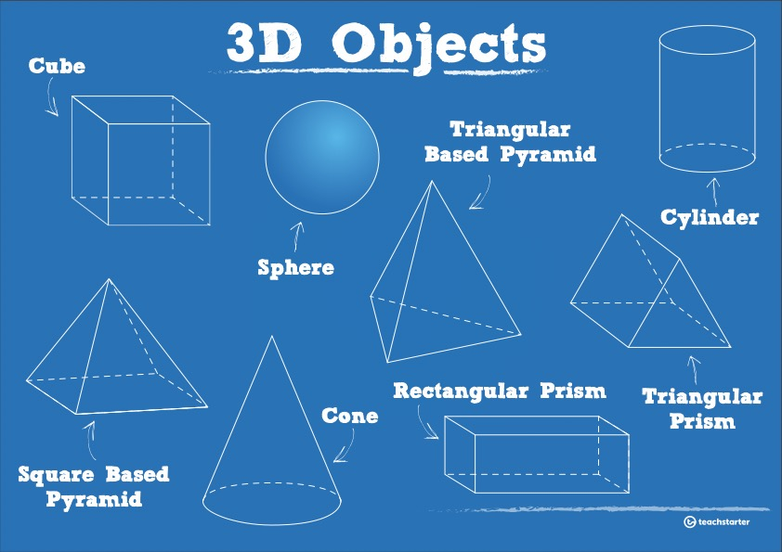
Activity: Brainstorm any 3D objects that you know.
Instructions:
- List and draw any 3D objects that your already know
Activity: Creating a 3D dice from a net of a cube.
Activity: Cube template
Instructions:
- Cut out the dice from the worksheet.
- draw the dots from 1-6 on each of the 6 faces of the cube.
- Fold along all the dotted lines.
- Put glue along the small tabs to begin creating the cube.

Activity: Race to 50 and back.

Instructions:
- Roll the dice and add the numbers together until you reach exactly 50.
- When you have a total of 50, roll the dice and subtract the number until you reach 0.

Extension: Race to 100
- Follow the same steps until you reach a total of 100.
- Subtract from your total of 100 until you reach 0.

Break – Time to stop and refuel. Eat, play, have fun. Self-directed outside activities where possible.
Science
Choose a planet to research. Try to write 10 interesting facts about the planet you have chosen and draw it to show what it looks like.
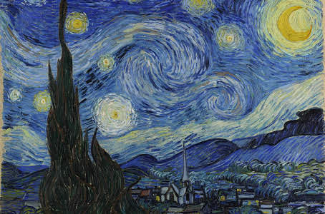
Creative Arts
Artist: Vincent van Gogh
Dimensions: 74 cm x 92 cm
Location: The Museum of Modern Art
Created: June 1889
Medium: Oil Paint
Periods: Modern art, Post-Impressionism

Looking at The Starry Night (Painting by Vincent van Gogh) use coloured pencils to create your own space artwork. Think about where you are looking at space from, (on land or in space).

Tuesday 27th July
Daily Task - Match socks and sort washing.
Morning
English:
Reading
Read Problem Pets. Write 5 questions someone could answer from the text. For example- What did Jess say about training her pet?
Grammar
Adverbials (Sheet attached)
Writing
Use your plan to start writing your narrative. Try to complete the start and middle of your narrative.
Spelling
Complete “Look, Cover, Write, Check” with your spelling words.

Break – Time to stop and refuel. Eat, play, have fun. Self-directed outside activities where possible.
Maths
Learning intention: Describe and compare curved surfaces and flat surfaces of cylinders, cones and spheres, and faces, edges and vertices of prisms (including cubes) and pyramids.
Activity: Play race to 50 (you could take turns racing to 50 with another person to see who wins).
Video:
Watch the You tube link “Learning about faces, edges and vertices”.
https://www.youtube.com/watch?v=BPrVAT_x1f4
Activity: 3D Space worksheet
Instructions:
- Complete the table on the properties of 3D space.
- Write the name of the object, number of faces, number of edges and number of vertices (corners or points).

Extension:
- Create any other 3D objects using paper or material from home.

Break – Time to stop and refuel. Eat, play, have fun. Self-directed outside activities where possible.
PDHPE
Choose a physical activity you would like to do for half an hour. It may be going for a walk, riding a bike, skipping, dancing. Do what you enjoy and improve your fitness level. You may like to tell your teacher what you chose to do on Seesaw.
Technology or Board game.
Go to abcya.com to choose Number or Literacy activities for your Year Level at school. If you are in Year 3, you would usually choose the Year 3 activities.
If you do not have access to technology, you may like to play a board game with a family member. For example, Snakes and Ladders, Monopoly, Chess, Cards. (A Snakes and Ladders Board game has been attached if you are able to print it.)

Wednesday 28th July
Daily Task - Wash the dishes.
Morning
English:
Reading
Read Lions and answer the questions to distinguish between fact and opinion. (attached)
Writing
Complete writing your narrative. Read over to check it makes sense and edit it in a different coloured pencil. Are there any changes you could make to engage your audience more? Read your story to a family member and ask the person what he or she likes about your narrative. Maybe it is funny, maybe he or she likes the interesting words you have used. We are looking forward to reading your stories.
Spelling
Write your list of words in rainbow colours.

Break – Time to stop and refuel. Eat, play, have fun. Self-directed outside activities where possible.
Maths
Learning intention: Describe and compare curved surfaces and flat surfaces of cylinders, cones and spheres, and faces, edges and vertices of prisms (including cubes) and pyramids.
Activity: Create another 6- sided dice.
Instructions:
- Cut out the other net of a cube
- Label each side with number or dots from 1-6.
- Fold along the dotted lines.
- Glue the small tabs to join the net to make a cube.
Activity: Race to 50 or 100 using 2 dice.
Instructions
Using the two dice, play race to either 50 or 100 and back.
Activity: Finding and comparing 3D objects around the home.
Instructions:
- Using the properties worksheet from yesterday, find any 3D objects around your home or in the classroom. For example, a soccer ball is the same as a sphere.
- List and draw the everyday 3D objects that you have found.
Activity: Draw 3D objects using the isometric paper worksheet.
Instructions:
- Using the isometric dotted worksheet, draw and label the name of the 3D objects that you found around the home or in the classroom.
- Remember to use the dots to correctly draw the objects
- Colour the objects when you have finished.
Extension:
- Label the number of faces, vertices and edges of the objects you have drawn.

Break – Time to stop and refuel. Eat, play, have fun. Self-directed outside activities where possible.
Science
Watch https://www.abc.net.au/btn/classroom/planet-nine/10523444
What does this tell you about Pluto? How has information changed about Pluto over time?

Creative Arts
You may like to finish your space artwork that you started on Monday, design your own space page or colour the attached space design.
Thursday 29th July
Daily Task – Make your bed.
Morning
English
Reading
Read a book of your choice for 15 minutes.
Writing
Publish a copy of your narrative either digitally or in your neatest handwriting. You may like to include some illustrations to go with it.
Spelling
Write your words in alphabetical order. Choose 5 words to find the dictionary meaning of.
Break – Time to stop and refuel. Eat, play, have fun. Self-directed outside activities where possible.
Maths

Learning intention: Students can sketch 3D objects from different views, including top, front and side views.

Activity: Race to 100

Instructions:
- Use both dice to roll and add the two numbers together to reach 100.
- Once at a total of 100, roll the dice and subtract the number from the total.

Activity: Create a city scape using a variety of 2D shapes and 3D objects.

Instructions:
- Using a blank piece a of paper, draw a range of 2D shapes and 3D objects that you know to design and create a city scape drawing.
- Try your best to include as many 2D shapes and 3D objects as you can.

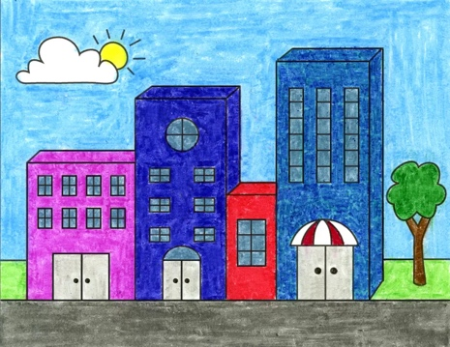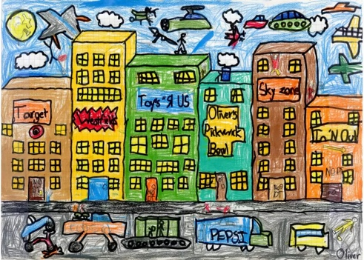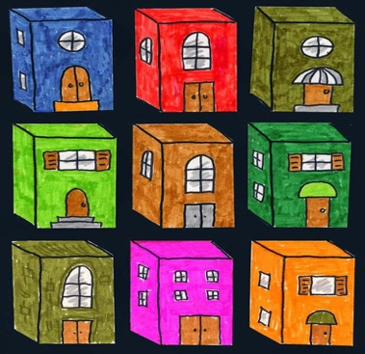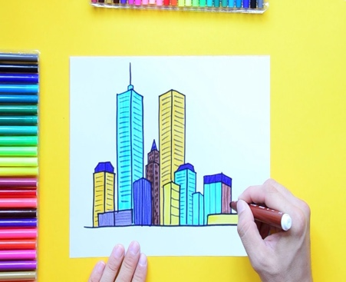
Extension:
- Try and include the following:
- Rectangular prism.
- Cube.
- Sphere.
- Triangular based pyramid.
- Square based pyramid.
- Cylinder.

Break – Time to stop and refuel. Eat, play, have fun. Self-directed outside activities where possible.
PDHPE
Choose a physical activity you would like to do for half an hour. It may be going for a walk, riding a bike, skipping, dancing. Do what you enjoy and improve your fitness level. You may like to tell your teacher what you chose to do on Seesaw.
Complete the Water Safety Word Search (attached).
Friday 30th July
Daily Task – Help an adult with an outside activity.
Morning
English:
Reading
Read a Dragonfly’s Surprise (attached)
Writing
Summarise the story - Write what the narrative a bout in your own words. Briefly explain what happens in the story.
Spelling
Ask a family member to test you on your spelling words.
Break – Time to stop and refuel. Eat, play, have fun. Self-directed outside activities where possible.
Maths
Learning intention: Consolidate understanding of 3D space.
Activity: Complete 3D Space quiz from worksheet.
Instructions:
- Complete 3D Space quiz 1 and 2 to the best of your ability.
Activity: Finish city scape art.
Instructions:
- Finish and colour the 3D and 2D shapes city scape art.
- Add as many 3D and 2D shapes into your art as possible.

Break – Time to stop and refuel. Eat, play, have fun. Self-directed outside activities where possible.
Friyay

Your choice of activity. For example, you may decide to do sport, art, technology or building with Lego. You may like to take a photo of what you decided to do as your Friyay end of week activity. Maybe your family could go on a bush walk or explore the shore at the beach. Maybe you go bike riding beside the lake.

