Learning from Home – Brooke Avenue Public School 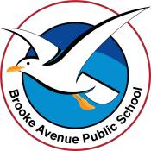
Stage 1– Week 3, Term 3
The following timetable can be used by students to support learning at home. All tasks have been linked to syllabus outcomes. If technology is available at home, please use the attached links to support learning.
Monday - Week 3, Term 3 – Stage 1
Daily Task - Match socks and sort washing.
English:
Reading:
Choose a book to read aloud with family.
Before you read your chosen book, what do you predict the book will be about?

Spelling :
Read your spelling words aloud. Write your spelling words on paper.

Writing :
Use the visual prompt below to write a story.

Speaking and Listening:
Read your writing to a family member.

Break – Time to stop and refuel. Eat, play, have fun. Self-directed outside activities where possible.
Maths:
Collect data using symbols: Watch out the window, go for a walk or look in the car park and record the colours of cars that you see.

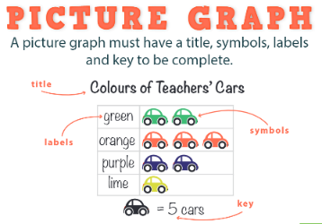

Physical Activity

Complete thirty minutes a day of physical activity. Go for a walk, run or ride with an adult.

Follow the link below to watch the episode and join in the skipping fun with Michelle and Teresa GetActive@Home – Episode
( https://vimeo.com/416347791 )
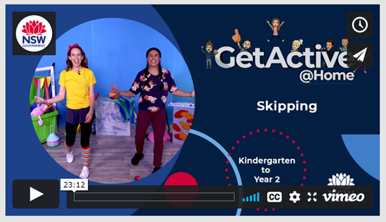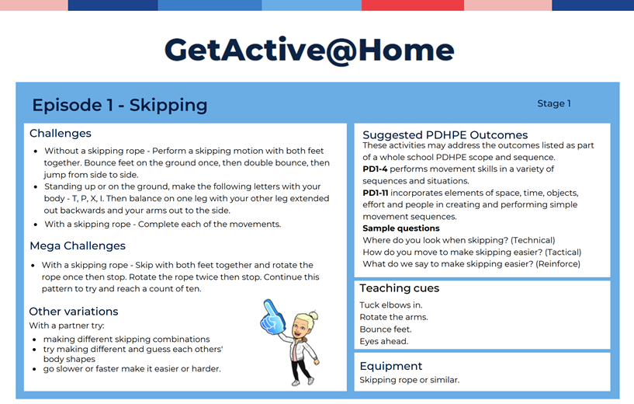

Break – Time to stop and refuel. Eat, play, have fun. Self-directed outside activities where possible.
Creative Arts
Zen-tangle art
Trace your hand on a blank piece of paper and create small patterns all over the hand to create something similar to the image below.
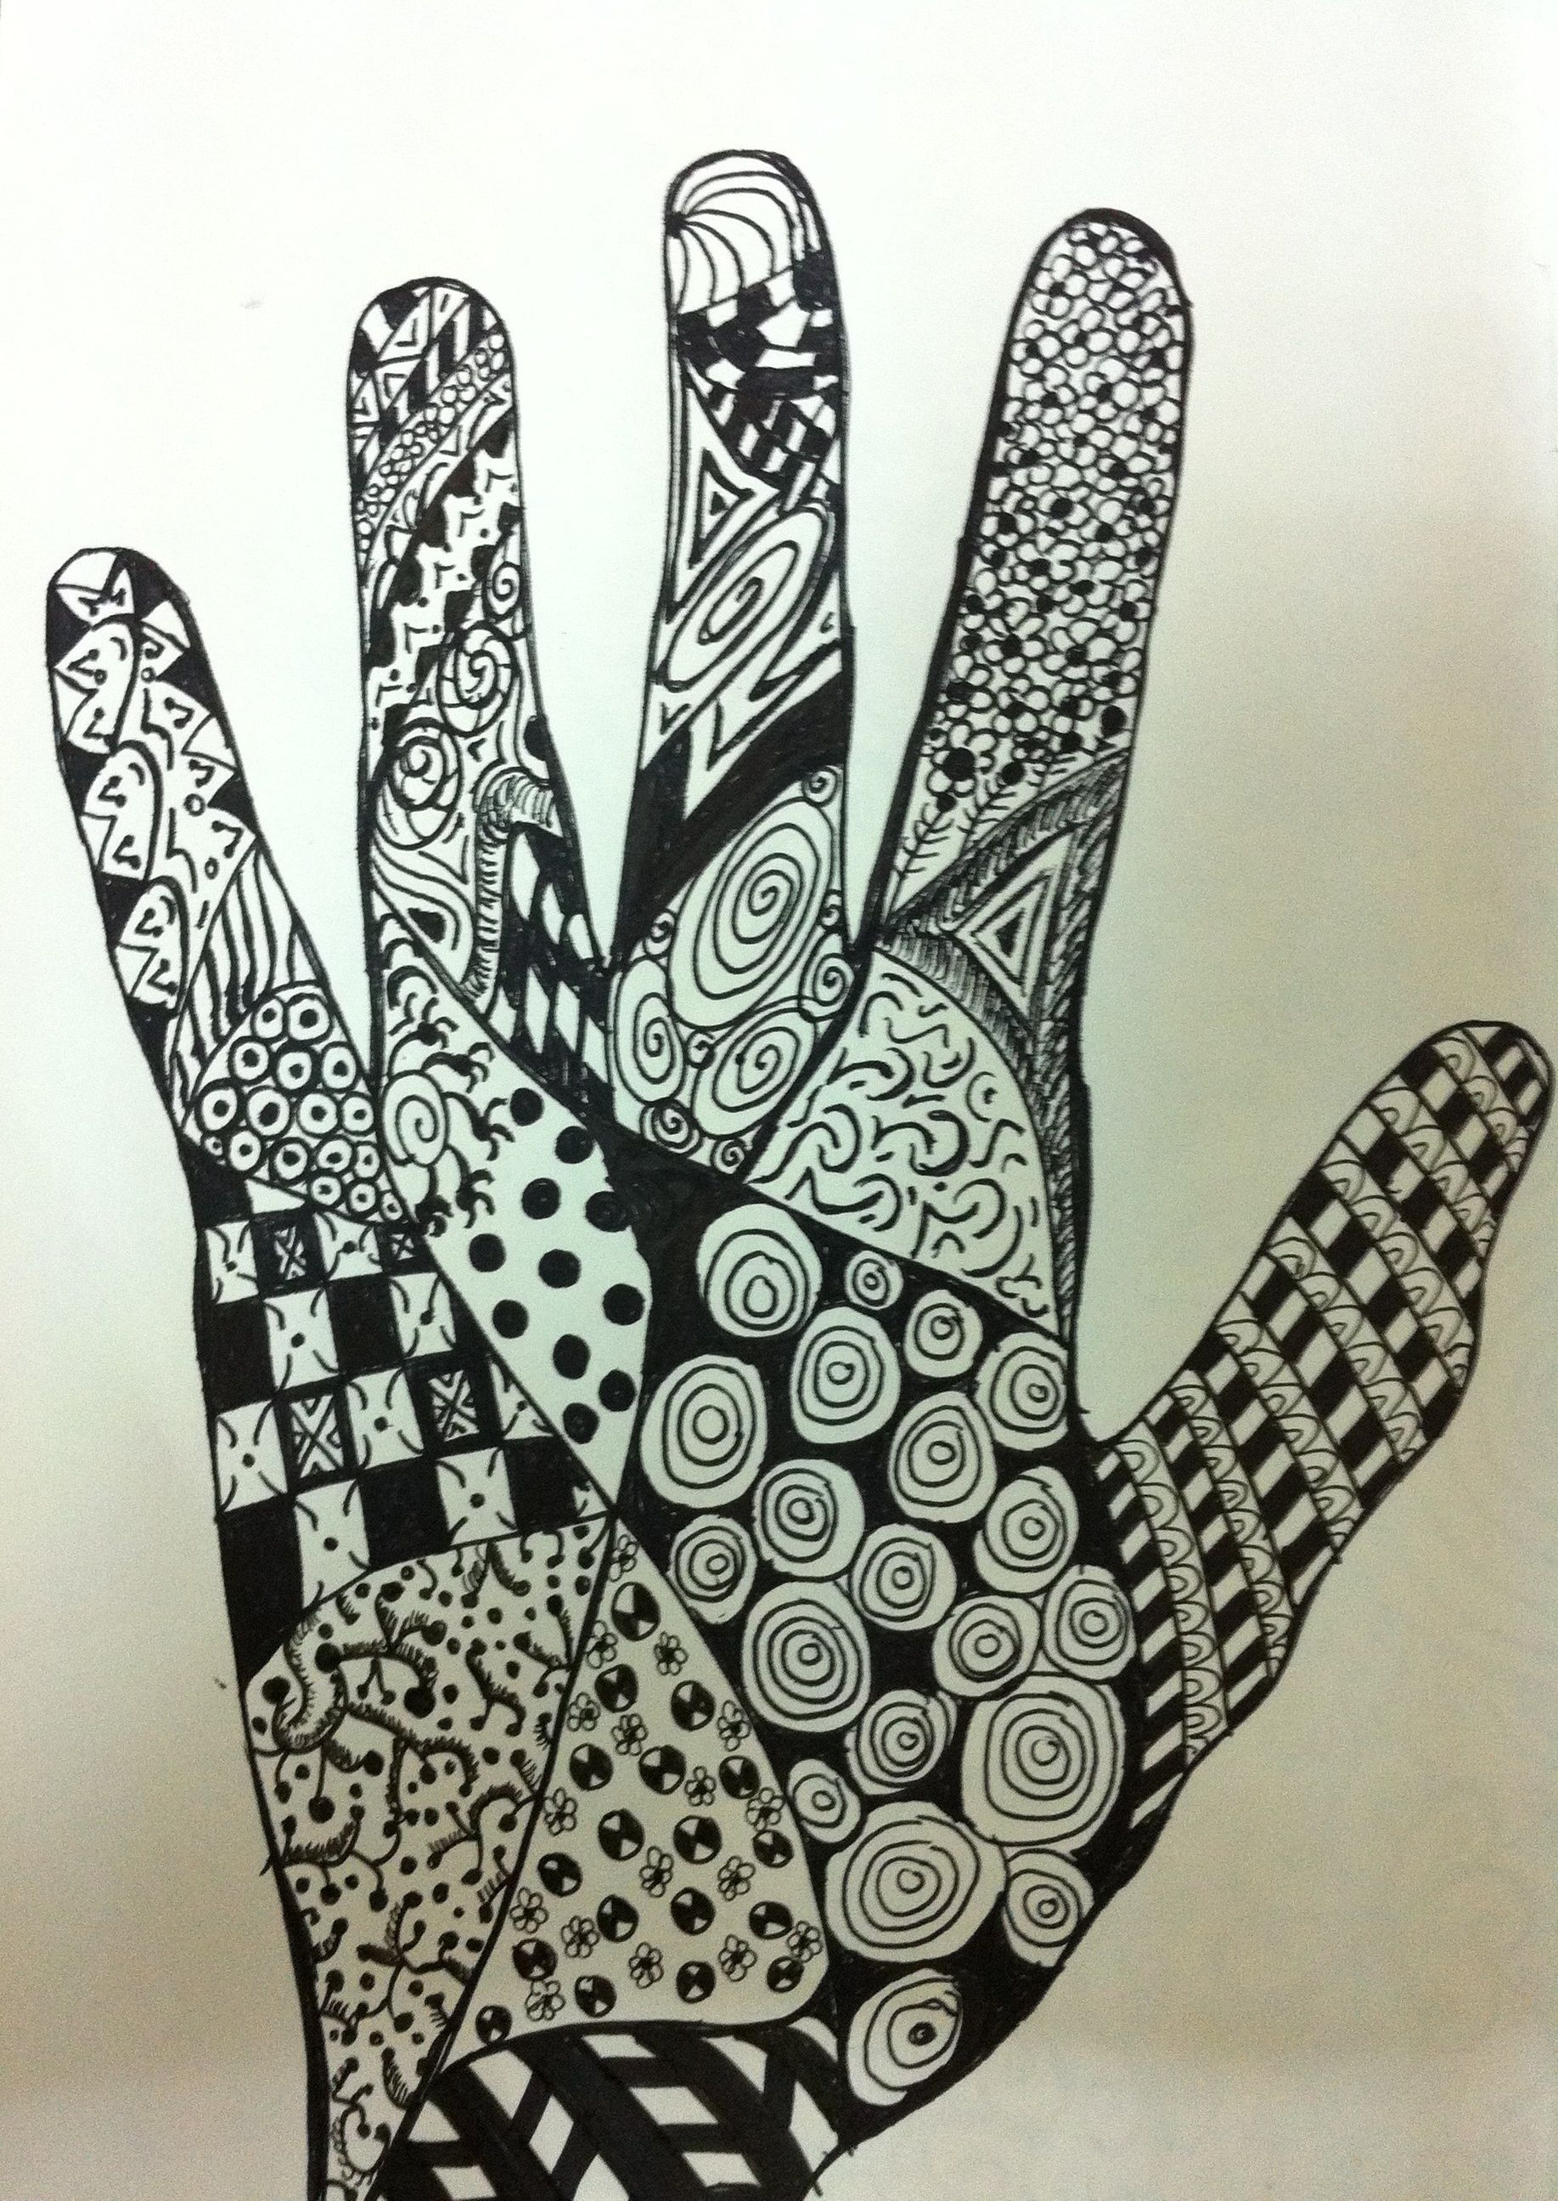

Tuesday - Week 3, Term 3 – Stage 1
Daily Task - Wash the dishes.
English:
Reading:
From the book you read yesterday, choose a page to practise reading aloud.
After reading, discuss what the book was about.

Spelling:
Read your spelling words aloud. Put each of your spelling words into a sentence. Try making your sentences longer by using a joining word (and, but).

Writing:
Using the story starter and the image below to write a narrative (story).

"Follow me!" she whispered.

**Reminder: A narrative usually has a start, a problem in the middle and then the problem is solved at the end e.g. in ‘The Three Little Pigs’, the pigs finally get rid of the wolf.

Speaking and Listening:
Read your writing to a family member.
Break – Time to stop and refuel. Eat, play, have fun. Self-directed outside activities where possible.
Maths:
Walk around the room and collect data on colours. In a table, tally how many things in the room are red, green, blue, yellow and orange. At the bottom of each colour, record the totals
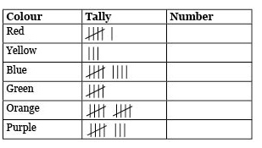

Physical Activity:

Complete thirty minutes a day of physical activity. Go for a walk, run or ride with an adult.

Follow the link below to watch the episode and join in the hopping fun with Michelle and Teresa GetActive@Home – Episode
https://vimeo.com/422700861
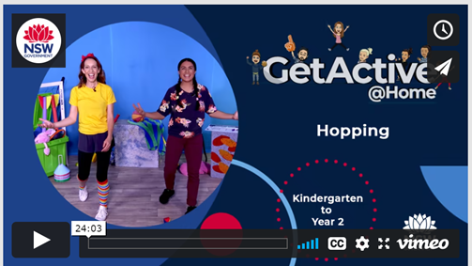

Break – Time to stop and refuel. Eat, play, have fun. Self-directed outside activities where possible.
Creative Arts:
Talk to your family about ideas for creating an underwater themed artwork.

Find things around the house that you could use to create your artwork e.g. a shoe box could be turned into an aquarium.
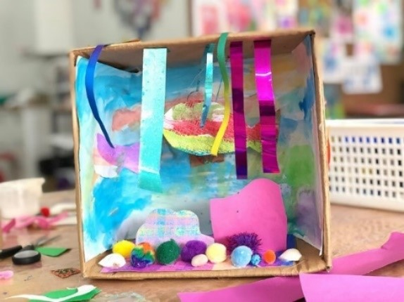
Wednesday - Week 3, Term 3 – Stage 1
Daily Task – Make your bed.
English:
Reading:
Practise reading the page you read yesterday, making sure you use expression.

Discuss the characters. What makes the characters interesting?
Spelling: Read your spelling words aloud. Make word boxes using your words.
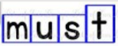
*Remember that tall letters will need a taller box, and long letters will need a longer box.
Writing: Pick a ‘Would You Rather’ prompt and write why you would prefer one thing over the other. Use more than one sentence to say what you would rather AND why.
Speaking and Listening: Talk to your parent/friend and explain why you would rather one of the choices over the other. This can be the one you wrote about or a different card. We are practicing explaining ‘why’. You may like to record yourself and upload to seesaw.

Break – Time to stop and refuel. Eat, play, have fun. Self-directed outside activities where possible.
Maths: Complete the worksheet on Chance.
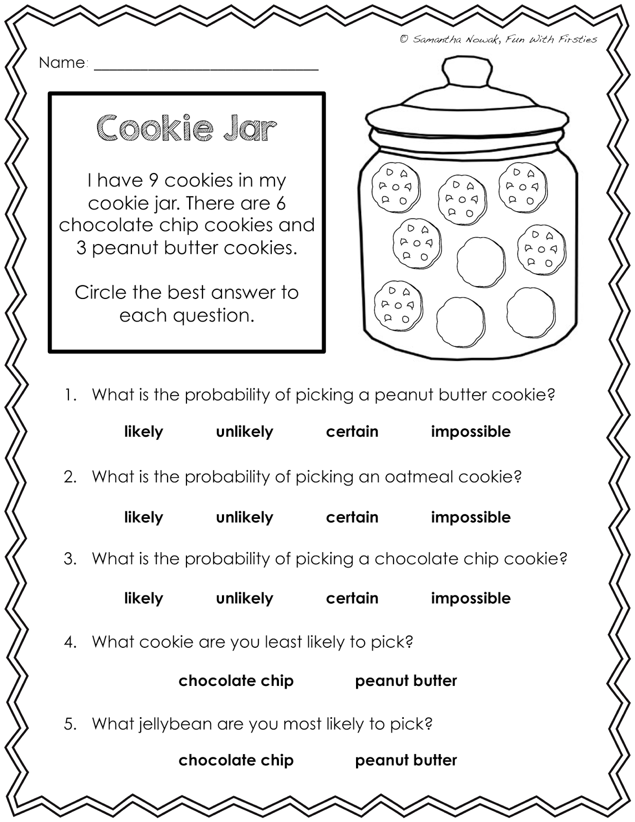
Physical Activity:
Complete thirty minutes a day of physical activity. Go for a walk, run or ride with an adult.

Cosmic kids Yoga: https://www.youtube.com/watch?v=AuOBmMCwxLM

Play a game outside (tip, hide and seek, ship/shark/shore, hopscotch, skipping or make up a dance).

Break – Time to stop and refuel. Eat, play, have fun. Self-directed outside activities where possible.
Creative Arts:
Start to create your underwater artwork. It might take you a few days to complete.

If you are finished, create an artwork out of recycled materials at home.

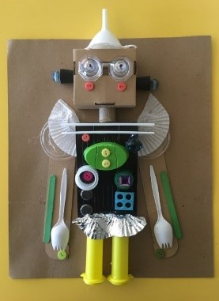

Thursday - Week 3, Term 3 – Stage 1
Daily Task – Help an adult with an outside activity.
English:
Reading:
Video yourself reading a page. Watch the video to see if there are ways you could make the reading sound better.
You may like to upload it to Seesaw.
Spelling: Write your spelling words. Draw a picture of each of the words to show you know what they mean.
Speaking and Listening: Choose 3 topics that you are interested in and write them down. Ask a parent/friend to pick one of the topics and time you to see how long you can talk about it. Aim for close to 1 minute!
Writing: Write about the same topic or choose one of the others to write about. Some things you can include in your writing:
- What it is?
- Why you like it?
- How you do it/play with it?
Draw a picture to go with your writing.
Break – Time to stop and refuel. Eat, play, have fun. Self-directed outsid activities where possible.
Maths:
Play ‘Hit the Button’ - https://www.topmarks.co.uk/maths-games/hit-the-button
Pick a maths topic and answer as many questions as you can before time is up!
Race someone in your house.
Using a deck of cards (or homemade flash cards to 10) create subtraction problems to answer. Take the chosen card away from 10, 15 or 20.
Extension:
- Try taking away from a larger number e.g. 28.
- Year 2 – solve these subtraction problems using the split strategy e.g. 36 – 11 = ? 30 – 10 = 20 --> 6 – 1 = 5 --> 20 + 5 = 25
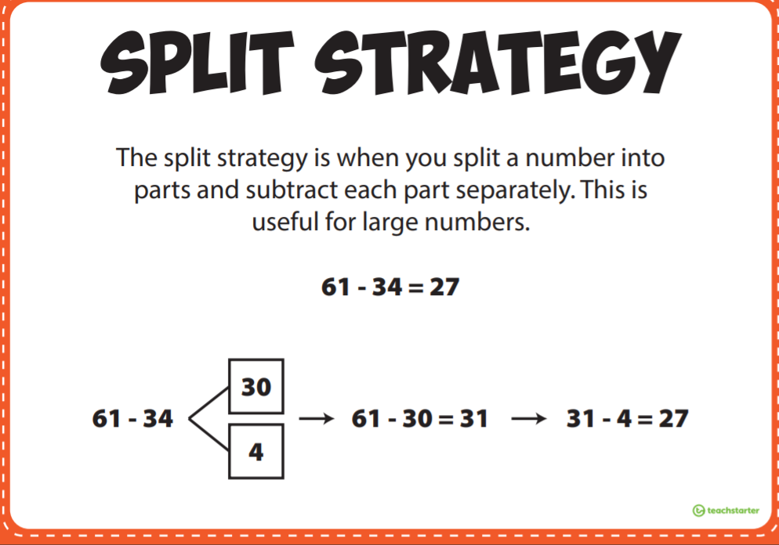
69 – 23 =
99 – 35 =
72 – 36 =
Physical Activity
Complete thirty minutes a day of physical activity. Go for a walk, run or ride with an adult.
The Olympics are on TV. Practice your favourite sport skills
OR
Design your own Olympic Obstacle Course in your backyard/lounge room. Remember to include different movements e.g.
- Running
- Jumping
- Skipping
Draw your course or get an adult to film you completing your course. How fast can you do it?

Break – Time to stop and refuel. Eat, play, have fun. Self-directed outside activities where possible.
Science
Walking Rainbow
With an adult follow the instructions to create your own colourful rainbow https://funlearningforkids.com/rainbow-walking-water-science-experiment-kids/
You will need:
- Jars, glasses or plastic cups.
- Paper towel
- Food colouring
- Water
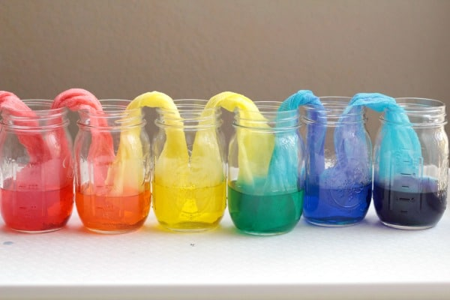
Friday - Week 3, Term 3 – Stage 1
Daily Task – Clean up your room.
English:

Reading and Writing:

Read ‘The Beach’ out loud to a parent/friend. Discuss what the passage was telling you. Take your time to answer the questions using FULL SENTENCES. Include as much information as you can. Draw a picture of what you like to do at the beach.

Spelling:

Write your spelling words in bubble writing or a font of your choice. Remember to make them colourful!

Speaking and Listening:

Talk with an adult about school. Ask them about when they went to school. What is different from when they went to school? What is the same? How do they feel about being your teacher at home?

Break – Time to stop and refuel. Eat, play, have fun. Self-directed outside activities where possible.
Maths:
Find items around the house/classroom to use as counters (cars, pencils, pasta, lego, playdoh). Collect a group of 15 of the same item. Break into 2 groups. Write down the addition number sentences you can make using these materials. E.g.
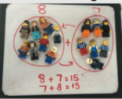
How many different number sentences can you make?
Extension:
- Larger number of the item e.g. 25
- Create subtraction number sentences e.g. 15-7=8
- Year 2 – use the split strategy to add two-digit numbers together e.g. 25 + 14 = ? --> 20 + 10 = 30 --> 5 + 4 = 7 --> 30 + 9= 39
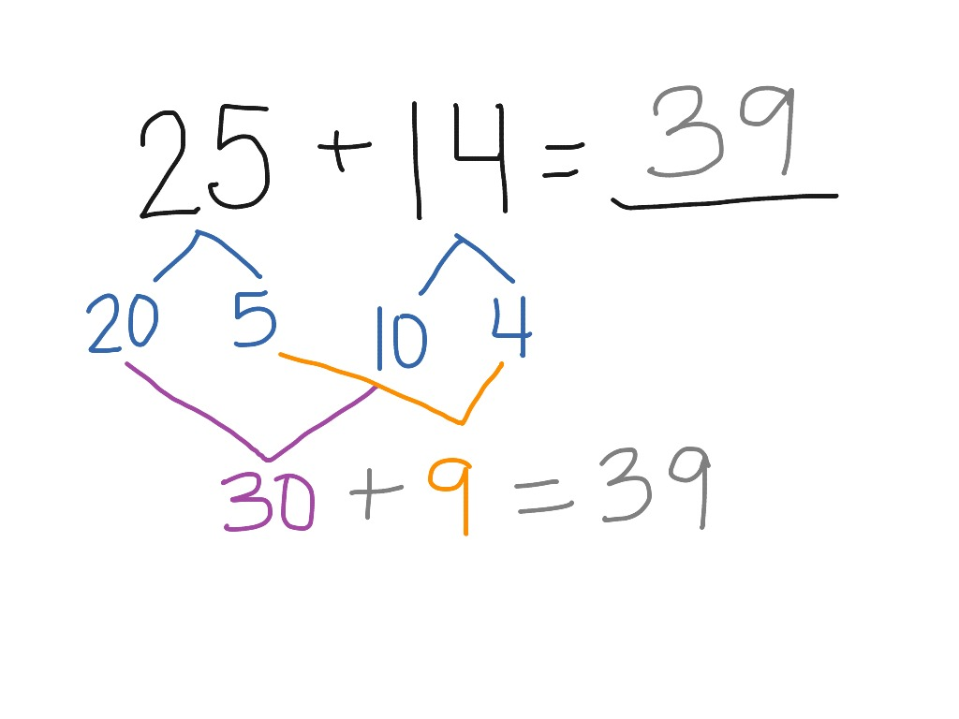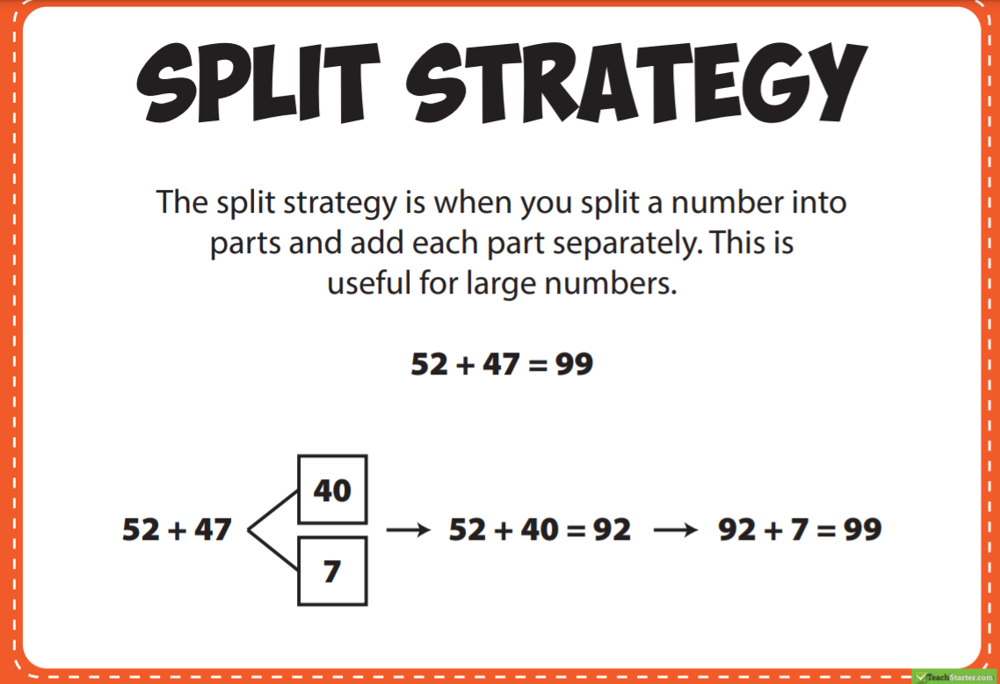
Physical Activity
Complete thirty minutes a day of physical activity. Go for a walk, run or ride with an adult.
Star Wars Tabata https://www.youtube.com/watch?v=3h9am97W4Rc
OR
Do each exercise for 20 seconds each, with a 10 second rest in between:
- Star jumps
- Mountain climbers
- Plank
- Skipping on the spot

Break – Time to stop and refuel. Eat, play, have fun. Self-directed outside activities where possible.
Friday fun time.
Pick an activity that you enjoy and have some fun!
This may be by yourself or with an adult.
Make sure you share your activity with your teacher on SeeSaw!

