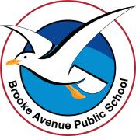
Learning from Home – Brooke Avenue Public School
K-6J, K-6M and K-6S – Week 3, Term 3
The following timetable can be used by students to support learning at home. All tasks have been linked to syllabus outcomes. If technology is available at home, please use the attached links to support learning.
Monday - Week 3, Term 3
Daily Task - Match socks and sort washing.
This week, BAPS is celebrating NAIDOC week!
We would like to acknowledge all Aboriginal and Torres Strait Islander people learning from school or learning from home on traditional lands. We pay our respects to our elders, past, present and future and thank them for sharing their wisdom of the past. Our NAIDOC theme this year is Heal Country, so we would also like to acknowledge, celebrate and give our respects to Country.
“Country is inherent to our identity. It sustains our lives in every aspect - spiritually, physically, emotionally, socially, and culturally. It is more than a place. When we talk about Country it is spoken of like a person. Country is family, kin, law, lore, ceremony, traditions, and language. For Aboriginal and Torres Strait Islander peoples it has been this way since the dawn of time. Through our languages and songs, we speak to Country; through our ceremonies and traditions we sing to - and celebrate Country – and Country speak to us.” https://www.naidoc.org.au/get-involved/2021-theme
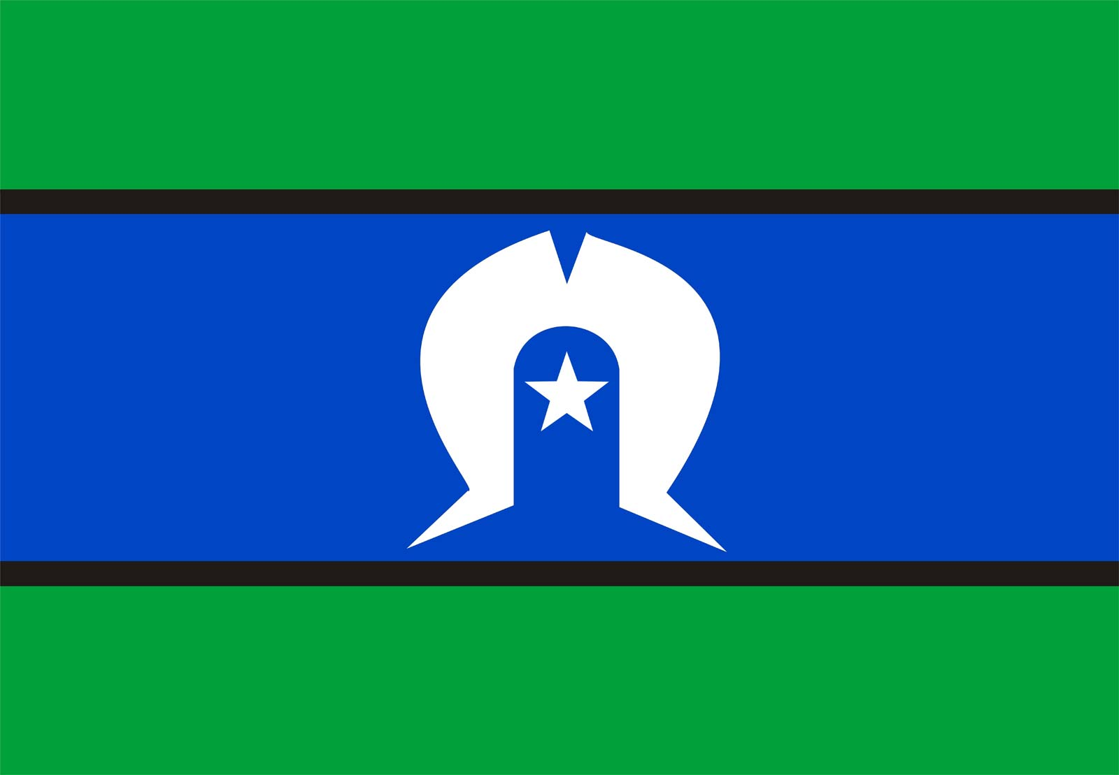
English:

Watch: https://www.youtube.com/watch?v=phrYlsxLB5I or search “Hello and Welcome” By Gregg Dreise on Youtube.
Hold a family Yarning Circle and discuss what you learnt about what Aboriginal and Torres Strait Islander peoples mean by Country and why it is so important to everyone.
- Research and discuss the 2021 theme for NAIDOC week Heal Country. https://www.naidoc.org.au/get-involved/2021-theme
- What do you think the word Country means?
- Why is Country important to you?
- Why would it be important to protect Country?
- Discuss ways you can protect and look after Country. Write these down and post on SeeSaw or record yourself being a news reporter sharing your news about this to others.
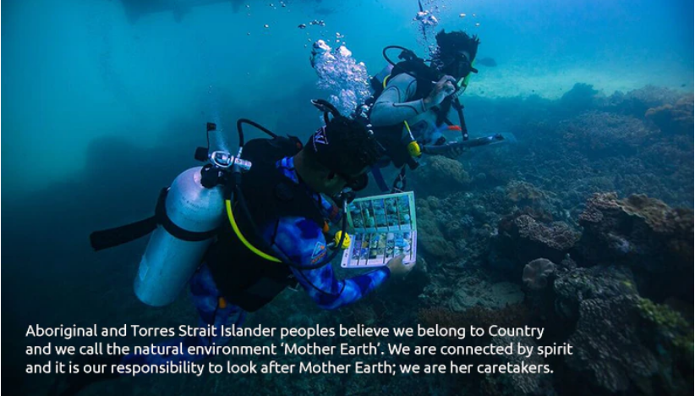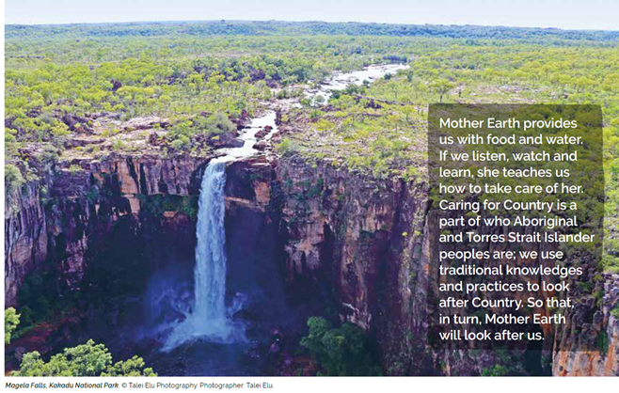
Read your spelling list/ single sounds with a parent/carer. Record yourself saying them or writing them in a sentence if you can. Challenge yourself and see how many spelling words you can fit in the one sentence. Try use joining words (and, but, so). Discuss any words that you do not know the meaning of.

Choose a book to read aloud with a parent/ carer (You can access books online and even through Seesaw).
Before reading the book, make a prediction about:
- What you think will happen by looking at the front cover.
- What do you think will happen at the end of the story?
- What do you think is going to happen next in the story based on what you already know.
It’s always important to make sure you have understood what you have read, talk about what you have just read. If you forgot, maybe read a second time for meaning.

Practise your literacy skills and log on to:
- Reading Eggs. https://readingeggs.com.au/
- ABCYA https://www.abcya.com/
- Studyladder,
- https://www.studyladder.com.au/

Break – Time to stop and refuel. Eat, play, have fun. Self-directed outside activities where possible.
Maths:
Practise skip counting patterns that you know. Count by 2’s, 5’s, 10’s, 100’s as high as you can go.
Already know how to skip-count? Challenge yourself by skip-counting backwards or try skip-counting by any other number pattern you can think of.
- Watch scratch garden skip-counting on Youtube and sing along.
- Want something harder? Count by 10’s from any chosen number.. eg, 8, 18, 28, 38, 48. What is the pattern?
- If you have some chalk, make a skip-count hopscotch on your pavement or driveway!

Play ‘I’m thinking of a number’.
Student and parent/carer take turns to think of a number and describe it as best as they can without saying the number.
Eg “I’m thinking of a number and you can make it by adding 10 + 10” …. “I’m thinking of a number between 20 and 30” etc…

Practise 10 more, 10 less, 1 more, 1 less on any random selected number. You can make these numbers by picking up random cards from a deck or by rolling dice. You can make this as hard or as easy as you’d like making 1, 2, 3 or 4-digit numbers!
Use the hundreds chart in last week’s Home Learning Pack to help you if you need it.

Choose any maths activity using:
- MathSeeds
- Prodigy
- StudyLadder
- ABCYA

Science: Do you know what your 5 senses are?
Watch ABC iView video ScienceXplosion, Episode 32: Sensational Senses: https://iview.abc.net.au/video/ZW2194A032S00
After the video, play a game with your parents where you have to use your sences to guess objects without looking at them.

Please remember, these are all suggestions and options, not every activity is required to be completed. Choose what you like and can do!
Break – Time to stop and refuel. Eat, play, have fun. Self-directed outside activities where possible.
Physical activity/ Creative arts: Google the music video Feel the Fire by Josh Arnold from Small Town Culture or copy this link https://youtu.be/4e54HKlBDx0
Talk to your child about what the children in the clip are singing about and how much they love and connect to Country.
Ask them how they feel about the land they live on and what it means to them.
You might extend this by writing a song about your own connection to Country and perform this song for family members, or post on Seesaw.

If you don’t feel like making your own song up, you can listen to any appropriate songs of your choice. Or even sing and dance to
Go Noodle or Just Dance. Once finished, enjoy a session of Smiling Minds to find your calm and wind down.

Tuesday - Week 3, Term 3
Daily Task - Wash the dishes.
English:
Explore your own family heritage and write a letter or record yourself speaking about your own culture.
Does your culture have any similarities to someone with an Aboriginal or Torres Strait Islander culture?

Visit Storyline Online and select any book you would like to listen to. Retell the story to a family member who did not watch it. What was the main message? Who was your favourite character? What was the problem of the story? What was the ending? Could you change the ending?

Use your “Spelling Menu” from Week 1 (or make up your own spelling list) and complete it.

Head to the kitchen and bake a cake/ slice/ brownie with your family members. Make sure you read the instructions together and enjoy!

Practise your literacy skills and log on to:
- Reading Eggs. https://readingeggs.com.au/
- ABCYA https://www.abcya.com/
- Studyladder,
- https://www.studyladder.com.au/

Break – Time to stop and refuel. Eat, play, have fun. Self-directed outside activities where possible.
Maths:
Explain that capacity is the full amount of liquid that a container can hold.
Find lots of empty plastic tubs/cups/ jars/containers that could be filled with water.
Count the number of times the smaller container can be filled and emptied into the largest container being measured. Your container may have a capacity of 10 jars or 10 cups etc...
- Discuss key words such as full, empty, nearly full, quarter full, half full, nearly empty etc.
- Discuss why would it be more appropriate to use cups or jars, rather than teaspoons?
- Explore lots of different shaped containers and see how their capacities are different by pouring water directly from one to the other.
- Can you think of other ways you could measure capacity?
- Play with kitchen measuring cups, pour water into each and discuss their capacity.
- How much capacity is your milk carton in the fridge?
  - Want something harder?
If you have a measuring jug at home, try fill it to different levels and have a go at reading how many millilitres are in the jug.

Complete a dot-to-dot from the resource pack that suits you.

Choose any maths activity using:
- Mathseeds
- Prodigy
- StudyLadder
- ABCYA

Break – Time to stop and refuel. Eat, play, have fun. Self-directed outside activities where possible.
Creative arts:
Research Land art.
It is all about using what is in the environment only.
Go outside and see how creative you can become by making a sculpture or artwork with only the things you can find.
You won’t have to worry about making a mess or tidying up your house afterwards as you can leave it to enjoy.
Look at some of the pictures below for inspiration and please post your creations on Seesaw!

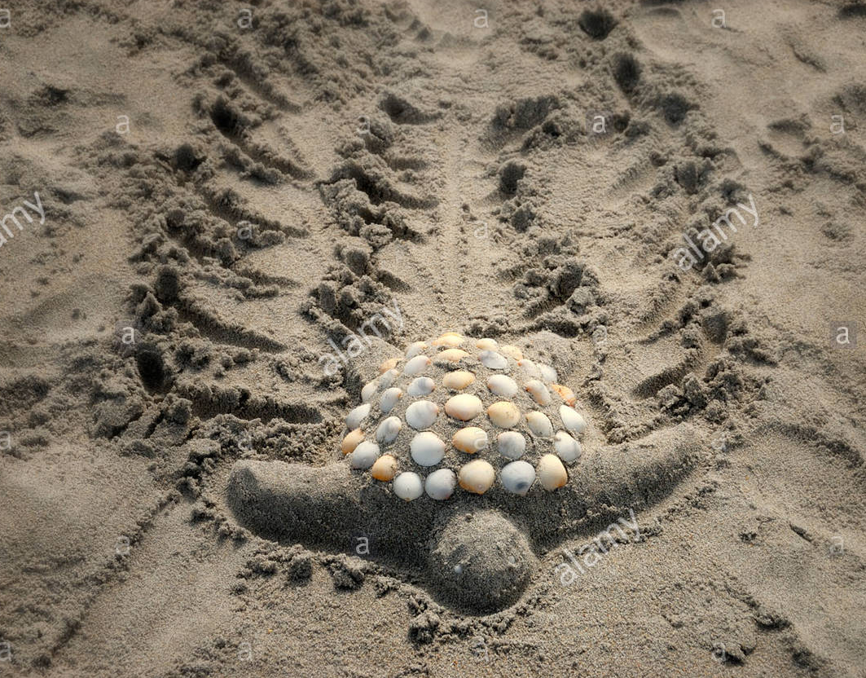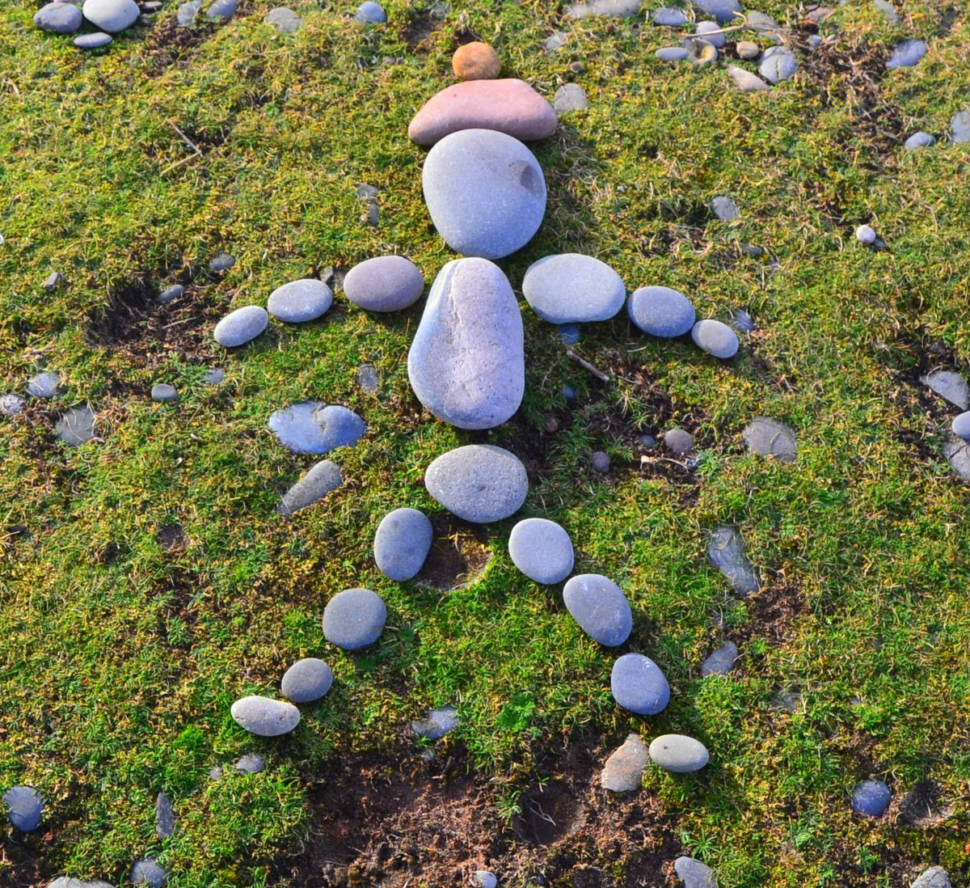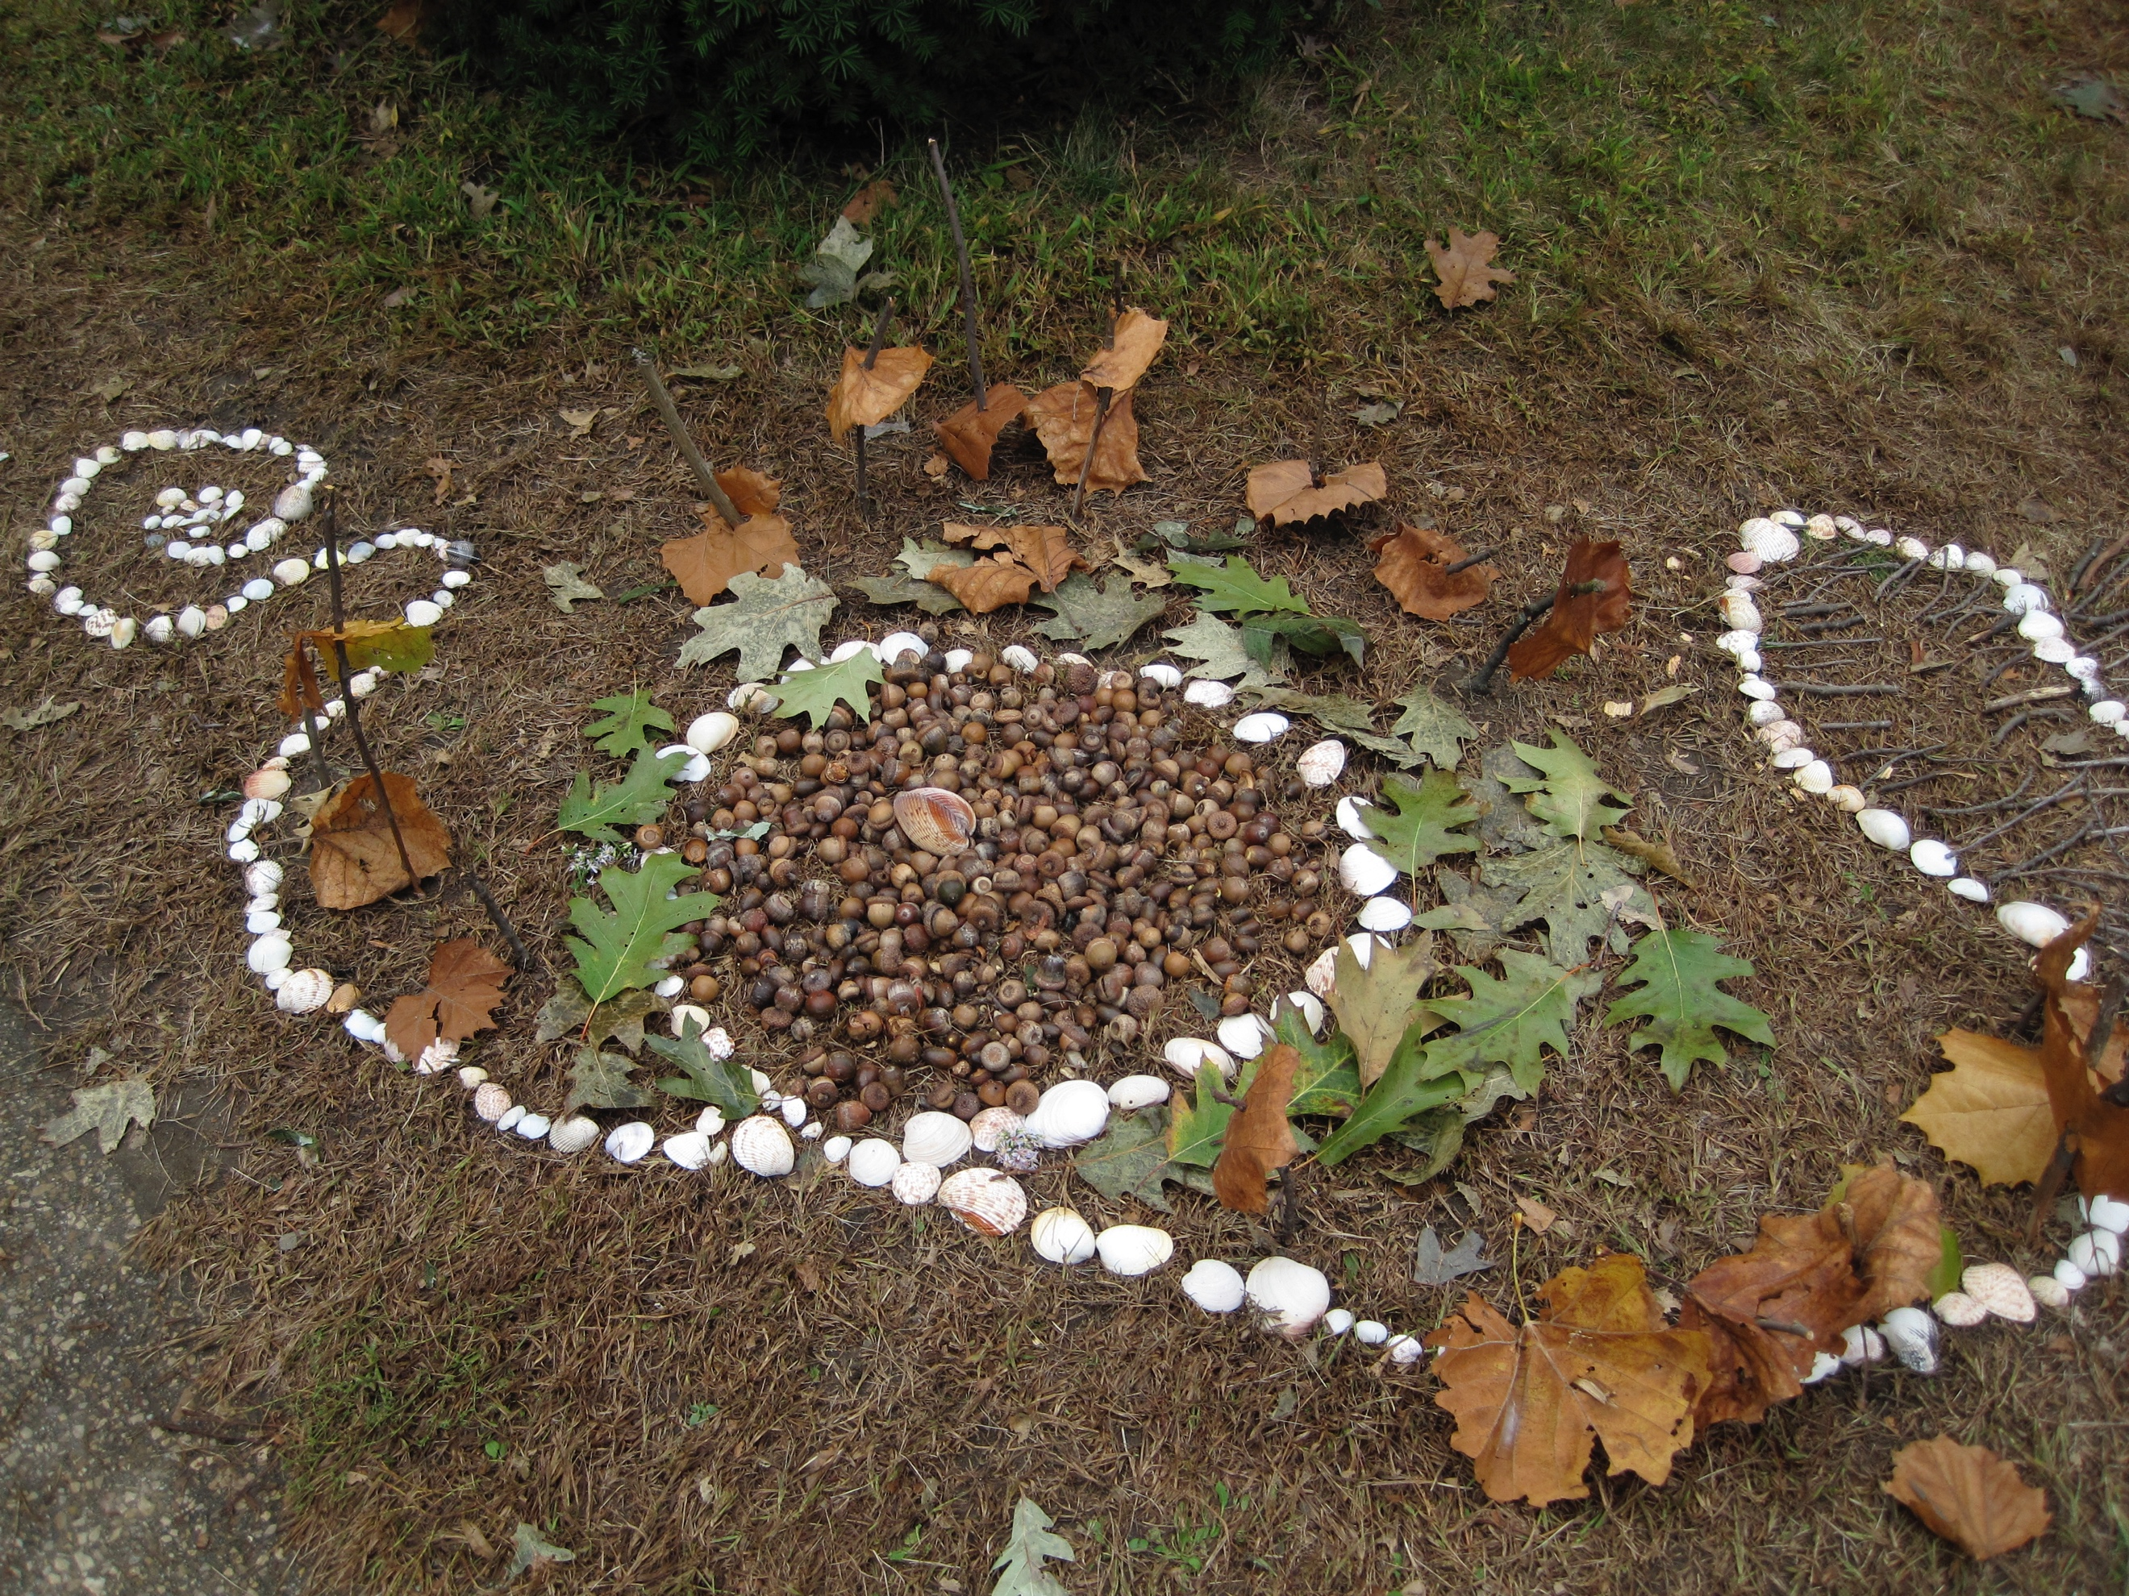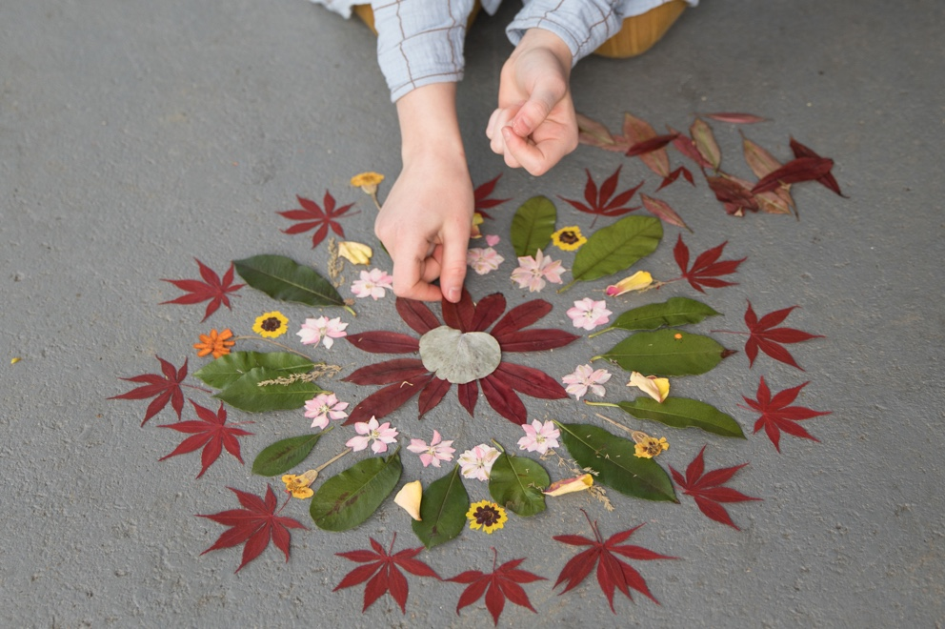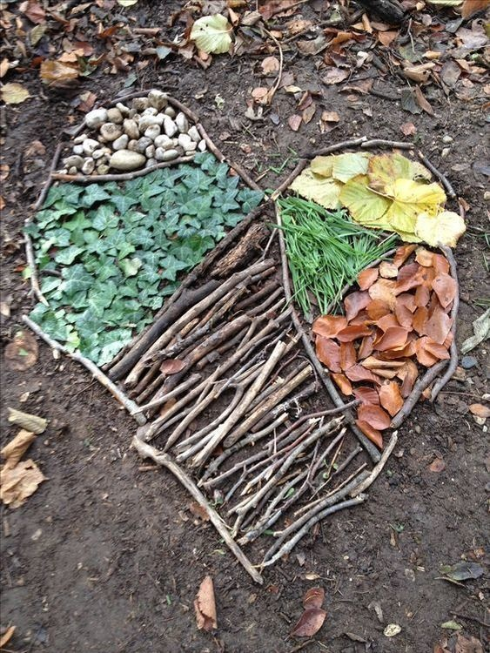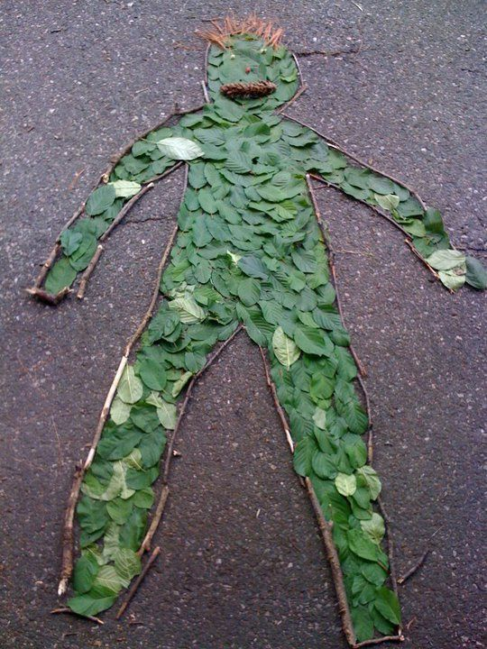

Wednesday - Week 3, Term 3
Daily Task – Make your bed.
English: Explore the Reptile Park education hub website:
https://www.reptilepark.com.au/educationhub/
Watch a video stream about any animal of your choice.
Talk to a family member about what you saw, describe the animals, what they eat, what was your favourite?

Choose one of the following:
- Make a poster/picture about the animal you just watched.
- Write down some facts you learnt, paint/draw it, type it.
- Would you be able to have that animal as a pet? Write a story about owning this animal as a pet.
- Write, draw or paint this animal at home with you and write a list of things you would need from the pet shop to look after it.

Read a book to a sibling or parent/carer.

With a texter and cardboard/ spare paper, make flash cards and create doubles of each word/ letter/ sound you would like to learn (add in words you already know so it isn’t super challenging).
Play memory with these words by turning over two cards each until you find a pair. Make sure you say each word/sound you turn over!
You could also play snap with the cards you make. How fun!

Practise your literacy skills and log on to:
- Reading Eggs. https://readingeggs.com.au/
- ABCYA https://www.abcya.com/
- Studyladder,
- https://www.studyladder.com.au/

Break – Time to stop and refuel. Eat, play, have fun. Self-directed outside activities where possible.
Maths: Go outside and collect sticks, leaves, or pebbles.  Use what you have collected to make equal groups that are fair.  - “Make me _ groups of _”  - “Are the groups fair?”  - If done with ease, change your collections into rows and columns. “Can you make me _ rows of _?” - These are called arrays.  After making equal groups, or an array always state the total.  Remember, each row and each column should not change sizes.  Try and rearrange the same number in a different way. Do you notice the total stays the same?  Write your numbers 1-120 or 120-220. You can write these in chalk, in dirt with a stick, or in a book with rainbow colours! Want it trickier? Write them in order from largest to smallest.  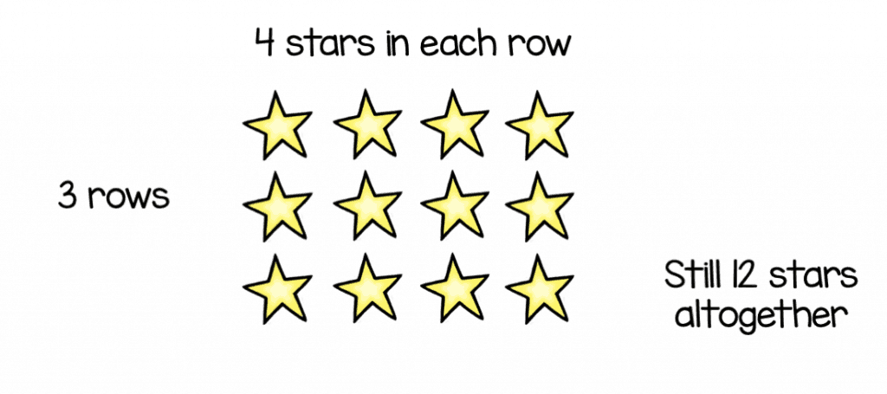  Can you double numbers? Look at the attached worksheets and see if you can learn your double number facts.  Choose any maths activity using:  - Mathseeds  - Prodigy  - StudyLadder  - ABCYA | An example of equal grouping:  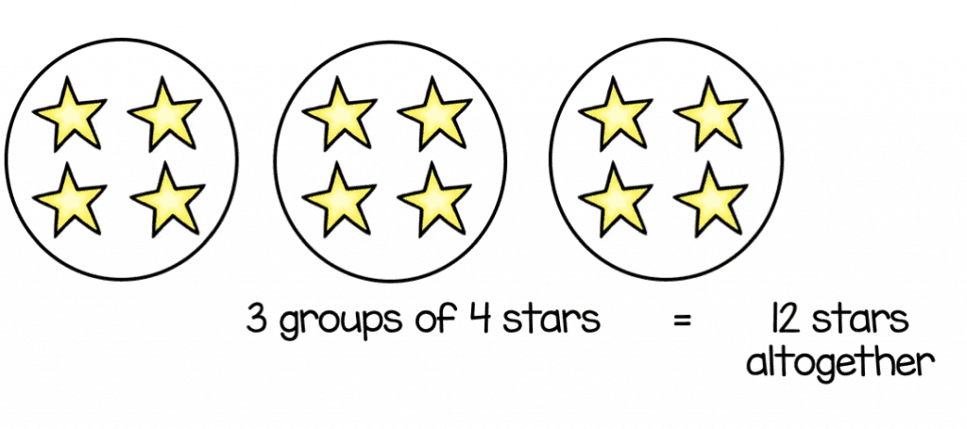  An example of an array:
Break – Time to stop and refuel. Eat, play, have fun. Self-directed outside activities where possible.
PDHPE: Feeling like you need a break?
Try any activity from Cosmic Kids Yoga or Smiling Minds.

Thursday - Week 3, Term 3
Daily Task – Help an adult with an outside activity.
English:  Write a letter or create a drawing for a family member that you miss. Put a stamp on it and post it in the mail to them, it will make their day! If you can’t physically post it, take a photo and send a digital copy.  Choose one word you would like to learn to spell and make it in five different ways. It could even be practising your full name or home phone number! Write it in chalk, paint, bubble writing, draw it in the air, use lego, scratch it in the dirt etc.  Have fun and play Eye Spy using the letter sounds that you know! If you are up for a challenge, try playing eye spy with blends like ch, sh, wh, th.  Consolidate how many words you know that start with th.  Read a book to a sibling or parent/carer or listen to a book on Epic! Or Seesaw.  Practise your literacy skills and log on to:  - Reading Eggs. https://readingeggs.com.au/  - ABCYA https://www.abcya.com/  - Studyladder,  - https://www.studyladder.com.au/ | 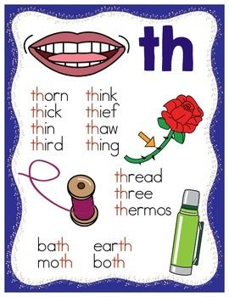
Break – Time to stop and refuel. Eat, play, have fun. Self-directed outside activities where possible.
Use regular playing cards or create your own numbered cards.  Place 1, 2,3, or 4 cards in a row and see if you can read it as a whole number. For example, your four cards are 3, 5, 7, 8 it would be read as three thousand, five hundred and seventy-eight.  - Can you rearrange your cards to make it a larger/smaller number?  - Play with a partner and see who can create the larger number. Whoever makes and reads the largest number collects the cards, whoever has the most cards at the end of the game wins!  Collect clothes pegs or pencils. Can you count these and record how many you have by using tally marks? Remember every fifth item ‘shuts the door/gate’. Great way to revise counting by 5’s! What else can you tally around the house?  Set a timer for one minute! See how high you can count during this time. Can you challenge yourself to beat this record? If this is too easy, see how far backwards you can count down from 100! Good luck! | 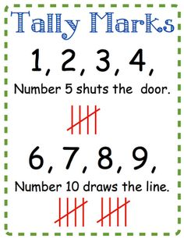
Break – Time to stop and refuel. Eat, play, have fun. Self-directed outside activities where possible.
PDHPE
Race against time challenges
- Estimate how long it will take you to run the distance of your driveway/ to your backyard fence etc. Estimate how long it will take you to do 20 star jumps/ squats/ burpees/ frog jumps.
- Time yourself running/completing an activity.
- Did you make it in time? Do you think you can beat your previous time?
- Challenge yourself with each activity at least three times. If you managed to beat your first score, share it with your teacher!

Friday - Week 3, Term 3
Daily Task – Clean up your room.
English:  Interview someone in your home.  Try think of some interesting questions you would like to know about them that you don’t already know.  - When were they born?  - Who are their parents?  - What did they like playing when they were a kid?  - Can you think of some questions on your own?  Can you write the full alphabet? Can you sing the alphabet?  - Check which letters you may need to master. Use the sheet attached to see how to properly form your letters and practise drawing in the air, in the dirt, painting, or drawing in flour, sugar or shaving cream (with permission!).  Do you know the ch sound?  Talk about ch and what words you know that start or end with ch. How many can you think of?  Visit the ABC website and find a show that suits you to watch.  Recount to your parent/carer what happened at the beginning, middle and end of the story, try to remember as much detail as you can!  Pretend you are a teacher and film yourself reading a book to your class. We would love to see this on Seesaw! | 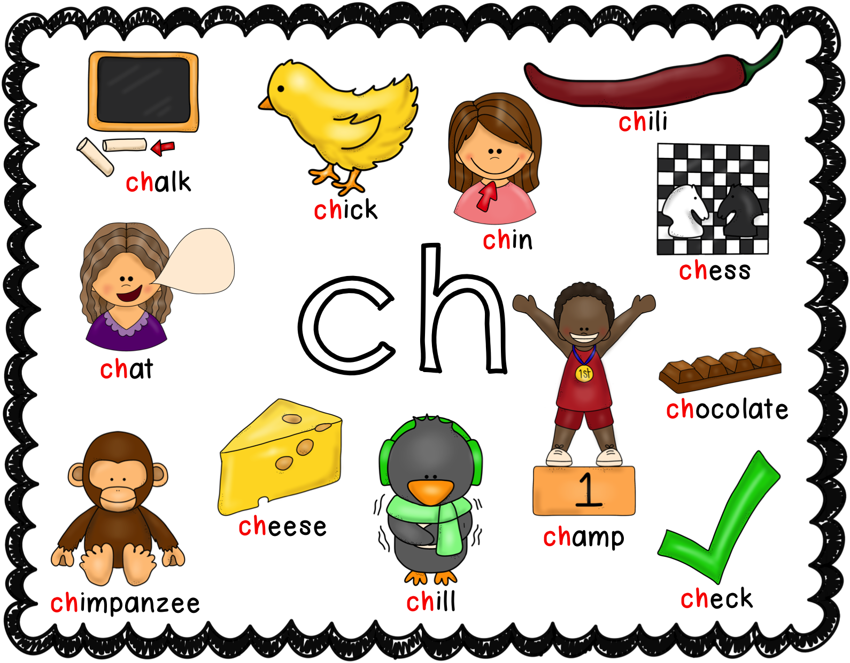
Break – Time to stop and refuel. Eat, play, have fun. Self-directed outside activities where possible.
Maths:
Now is a great time to test yourself and make sure you can write your numbers with proper formation. Have a look at the examples below starting on the green dot and ending at the red dot.
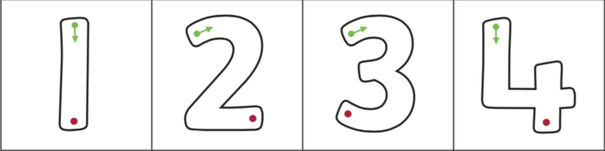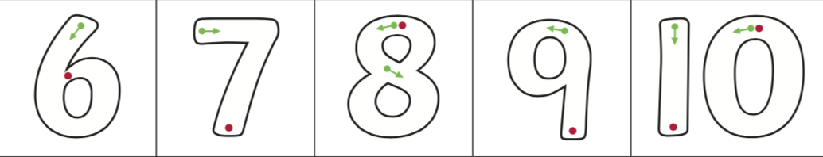
Write your numbers in a thin layer of rice in a tray, in the dirt, in shaving cream on a window, in the sky, in paint with ear cleaners, with your eyes closed! The options are endless, have fun!

Consolidate telling the time to the hour/ half-past or quarter to/quarter past.

Using a deck of cards, place four cards facing up in a row. Collect cards that are make the sum of ten and place them aside. Replace the cards facing up with cards from the deck and repeat. How many different ways can you make ten?

Choose any maths activity using:
- Mathseeds
- Prodigy
- StudyLadder
- ABCYA

Movement Break: Rock Paper scissors Run! Watch this video and play the game with a family member.
https://www.yout-ube.com/watch?v=mTqkENcjPmQ&list=PL0H94qyJzFmpTWFyuQ-ruKapQHyNl--zB&index=5

Relax and Google SBS NITV, Jarjums.
This is where you can watch many episodes of Little J and Big Cuz. It provides a young Indigenous audience with ‘relatable’ characters as well as offers an insight into traditional Aboriginal culture, country and language.
https://www.sbs.com.au/nitv/jarjums

Break – Time to stop and refuel. Eat, play, have fun. Self-directed outside activities where possible.
Friyay Freetime! Congratulate yourself on such an awesome week of learning from home!

