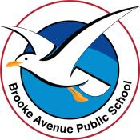
Learning from Home – Brooke Avenue Public School
Kindergarten – Week 3, Term 3
The following timetable can be used by students to support learning at home. All tasks have been linked to syllabus outcomes. If technology is available at home, please use the attached links to support learning.
Monday - Week 3, Term 3 - Kindergarten
Daily Task - Match socks and sort washing.
English:
Phonics
Trigraph sounds
- Listen to Youtube video Jolly Phonics and review sounds from last week ‘w, ng, ai, ee’.
- Today, we are learning ‘igh’. Sounds like ‘I’.
- Practise writing ‘igh’ sound. Say the sound ‘igh’ as you write it. Focus: tall letters reach the sky, long letters go down to the dirt, other letters stay in the grass.
Rhyming Words:
Say or create a list of rhyming words with the ‘igh’ sound.
sigh (high, thigh) - night (light, sight)
Extension: Write the following words in rainbow colours and use a different colour for each sound. (EG: right)
high, fight, might, sigh, tight, night
Reading
- With a family member or by yourself, read the story ‘Bob’s Pets’ and answer questions on the worksheet.
Extension: Read a book on https://wushka.com.au/login/ Complete the quiz and the ‘after the book is read’ activity.
Writing
- Draw or write some information you know about your favourite sport. You might write about what it is called, what you need to play it and add in any rules. Take a photo of you with your writing and show your teacher on Seesaw.
Extension: Complete the same activity but add in more information about the sport. Where is it played? Why it is your favourite sport? Do you know someone famous who plays this sport? Is this sport played in the Olympics?
Sight Words
- Using your sight word flashcards (W1 resource), play a game of memory.
Extension: Write 3-5 sentences using your sight words.

Break – Time to stop and refuel. Eat, play, have fun. Self-directed outside activities where possible.
Maths:
- Count forwards to 30 and backwards from 20 to a family member. Record your counting and upload to Seesaw.
- Play “Bunny Ears” with a family member. The family member gives you a number from 2-9 and you have to use both hands to show this number, with your fingers on top of your head as ‘Bunny Ears”. Do this with 3 different numbers. Discuss the different way you could make that number with two hands.
Addition & Subtraction
- Today we are learning to add and subtract numbers using different materials.
- Collect 10 small toys (EG: Ooshies, cars, marbles, counters, lego bricks) and a Ten Frame from the resources section or you can make one like the picture.
- Put 3 toys on the ten frame (one for each square). Add another 2 to the ten frame. How many toys altogether? Put 6 toys on the ten frame. Now take away 5. How many were left? Complete the following with your tens frame: 5 and 3, 5 take away 2, 6 and 4, 10 take away 6. Did you notice anything about the addition and subtraction number sentences? Tell a family member.
Extension: Complete the activity above using 2 ten frames and numbers higher than 10. (EG 11 and 4, 15 take away 11).
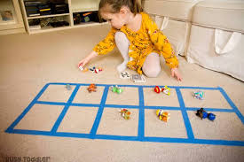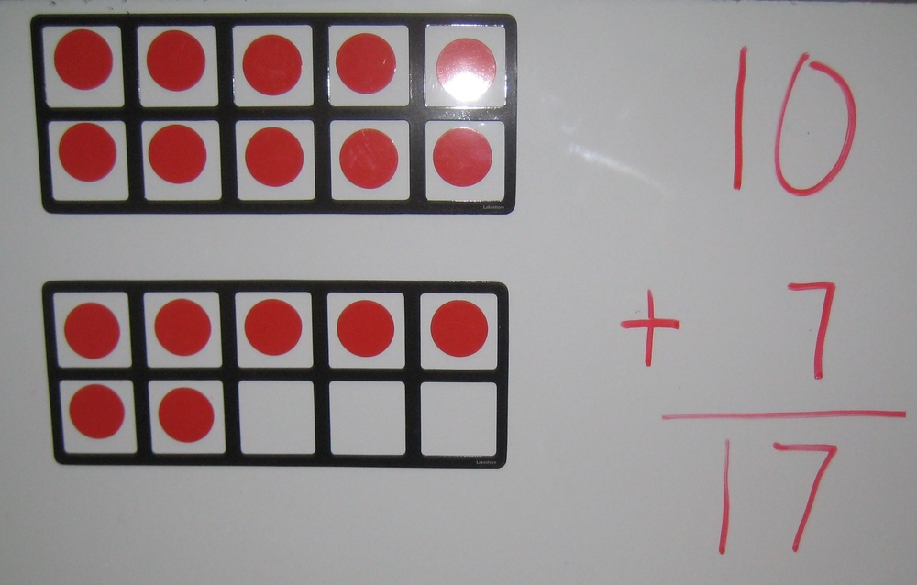
Complete some Mathseeds activities for 10 minutes.

Break – Time to stop and refuel. Eat, play, have fun. Self-directed outside activities where possible.
PDHPE:
https://app.education.nsw.gov.au/sport/File/4363
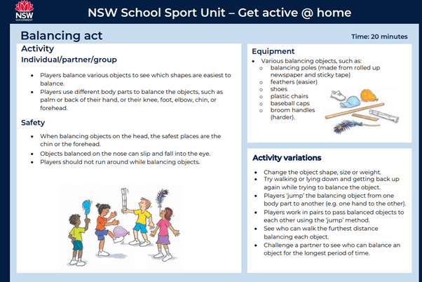

Science:
Orange Fizz Experiment
https://video.link/w/pUp4c

Materials:

An Orange
- 1/2 Teaspoon Baking Soda
Instructions:
- Cut the orange into slices or peel separate into sections
- Dip a slice or section into the baking soda
- Take a bite! As you chew, it should start to bubble in your mouth

Tuesday - Week 3, Term 3 - Kindergarten
Daily Task - Wash the dishes.
English:
Phonics
Digraph sounds
- Listen to Youtube video Jolly Phonics review sounds from last week ‘wh, ng, ai, ee’.
- Today we are learning ‘oo’. The letters ‘oo’ together can make 2 different sounds. The short ‘oo’ sound as in look and the long ‘oo’ as in food.
Sort these words into two groups; short ‘oo’ sound and long ‘oo’ sound.
book, food, broom, cook, foot, roof, room, shook, too, zoo, wool, shoot
Example:
short ‘oo’ | long ‘oo’
book  good | zoom  food

- CCVC words review (consonant, consonant, vowel, consonant eg. bang, ping etc.)
Please use known sounds to practise (If this is too challenging with digraph sounds, review CVC words)
Focus is on hearing individual sounds.
Example:
F-l – a – g
Change to f-l – a – p
Change to f-l – o – p
Change to f -l – i – p
For beginning, middle sounds and ending sounds. See CCVC Wordlist Attachment for more examples.
Extension: Add ‘ed’ or ‘s’ to these ‘oo’ words. Film yourself reading the words you have made and post to seesaw.
cook look hook smooth loop swoop

Reading and Writing
- Listen to a story online from https://storylineonline.net/ and draw or write about the beginning, middle and ending of the story. Take a picture and post it on SeeSaw to your teacher.
Extension: Write a different ending to the above story OR read a book on https://wushka.com.au/login/ Complete the quiz and the ‘after the book is read’ activity.

Sight Words
- Listen, read and write words from: https://video.link/w/91j4c OR write down 10 words from your butterfly card
Extension: Say sentences to a family member using your sight words.
Optional - Complete Reading Eggs Activities
Break – Time to stop and refuel. Eat, play, have fun. Self-directed outside activities where possible.
Maths
- Ask a family member to play a card game called “Card Add”. Find a set of playing cards or make a set of number cards 1-10 (2 of each number and you may wish to draw circles to show how many for each number). If you are using playing cards, remove the king, queen, jack and joker cards. Shuffle and place in a pile. You and a family member pick a card each and turn it over. Add the two numbers together. The first person to get the answer correct gets a point. The first person to 5 points is the winner!
Addition and Subtraction
- Today we will be learning how to use fingers to solve addition number sentences.
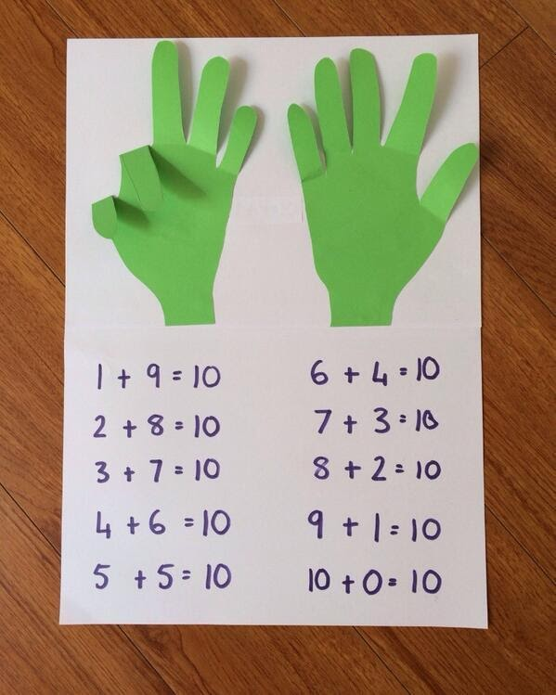
- Trace your hands on a piece of paper (or ask a family member to help you). Cut out the hands and paste the palms only onto another piece of paper (see picture). Make sure you can still move the fingers. On another piece of paper ask a family member to write 5 addition number sentences and use the fingers to help solve these.

Extension: Complete above activity and use them to solve number sentences to 20 (see picture). Say the biggest number first in your head and then count on the smallest number.

Break – Time to stop and refuel. Eat, play, have fun. Self-directed outside activities where possible.
PDHPE:
https://app.education.nsw.gov.au/sport/File/4322
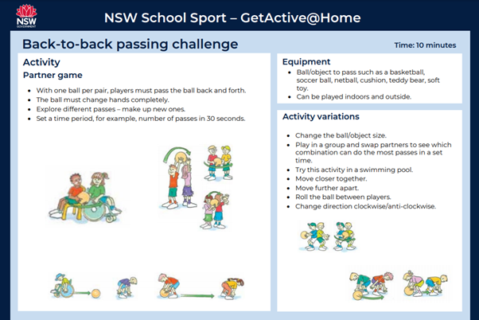
Creative Arts:
Finger Paint Art
See attached for lesson

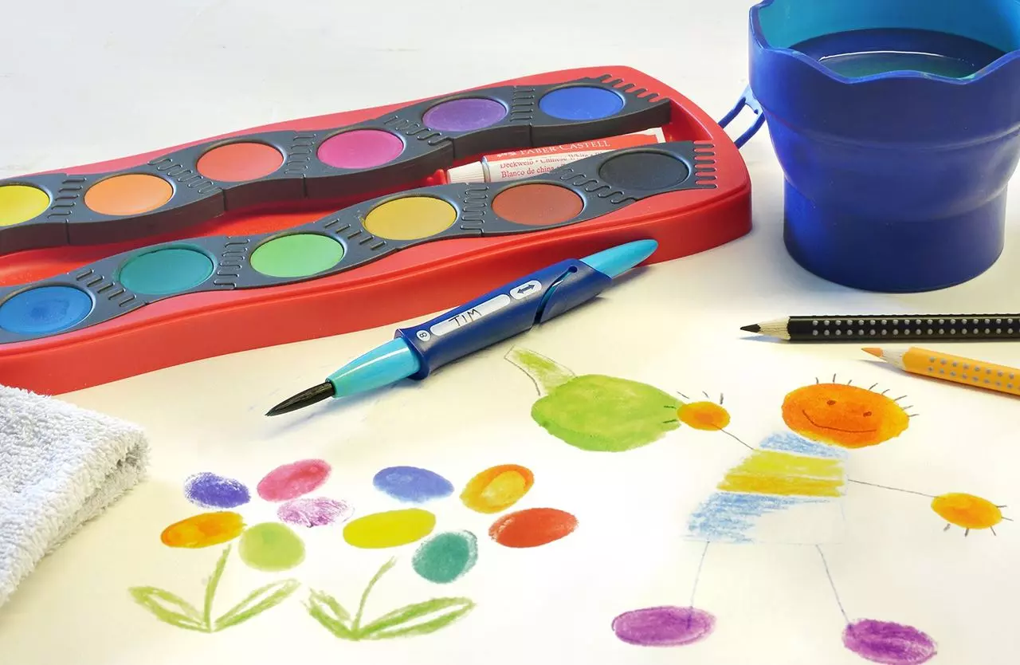

Use textas or paints and coat your finger. Then press your finger onto a piece of paper. Use these finger prints to make a picture. Take a photo and show your teacher on seesaw!

Wednesday - Week 3, Term 3 - Kindergarten
Daily Task – Make your bed.
English:
Phonics
Digraph sounds
- Listen to Youtube video Jolly Phonics and review all sounds learned. Watch ‘ar’.
- Practise saying and writing the ‘ar’ sound.
- Write the following ‘ar’ words. Circle the ‘ar’ sound. Take a photo and post to your teacher in Seesaw.
far car yard dark charm march start
Extension: Draw a line to separate the following words into syllables. Clapping out the word can assist with this. Example: bar/king
starting sharpen starving farmer forward

Reading
- Read the story and questions on the worksheet ‘Nat the Cat Can Rap’ with a family member or by yourself.
Extension: Write a sentence or a rap about a cat OR Read a book on https://wushka.com.au/login/ Complete the quiz and the ‘after the book is read’ activity.

Writing
- Write the letters of the alphabet https://video.link/w/19g4c
- Watch the story ‘Dear Zoo’ https://video.link/w/U9g4c OR think about animals that live at the zoo.
- Write a letter to the zoo asking for a pet. Think about why you would like this pet, where you would keep it and how you would take care of it.
Extension: Write a letter to a family member telling them about the pet you want. Describe what it looks like, where it will live and what you will feed it.

Sight Words
- Ask someone to flash the sight words cards to you. Collect the ones you get correct and try again for the ones you are still learning.
Extension: Watch and read https://video.link/w/2Ag4c OR find a book and try to find some of your sight words within the story.
Optional - Complete Reading Eggs Activities for 10 minutes.
Break – Time to stop and refuel. Eat, play, have fun. Self-directed outside activities where possible.
Maths
- On a piece of paper write down as many ways you can think of to make the number 12. Take a picture of your work and post to your teacher on Seesaw.
Addition and Subtraction
- Ask a family member to play the game “Subtraction Bowling. You will need a toy bowling set or:
- 10 plastic cups/drink bottles or 10 objects that can be stood up and then knocked over without breaking.
- A ball.
- Use worksheet “Bowling for Subtraction” and write the number 10 at the beginning of each number sentence. Roll the ball and count how many pins you knocked over. Write this in the next space on your worksheet. Count how many are left and write this at the end of the number sentence. Repeat until worksheet complete.
Extension: Complete above activity and double each number (EG write 20 in the first space in number sentence. Roll ball and count how many knocked over, double it and record on worksheet. Solve number sentence and record.)

- If you were unable to find the resources to play subtraction bowling, you can use worksheet with a 6 sided dice or online dice https://www.calculator.net/dice-roller.html
- Write the number 10 at the beginning of each number sentence. Roll the dice and take away that number from 10. Record your answer. Repeat until worksheet complete.
Extension: Complete above activity, starting with numbers bigger than 11.

Break – Time to stop and refuel. Eat, play, have fun. Self-directed outside activities where possible.
PDHPE:
https://app.education.nsw.gov.au/sport/File/4339
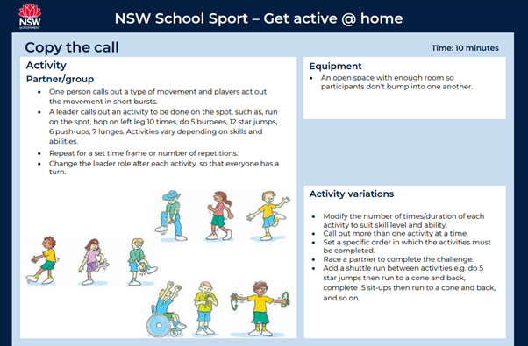

Science:
Paper Plane Challenge Part 1
Follow these templates to create two paper planes. Which design do you think will go further?
Test it out by making both aeroplanes and flying them both.
https://sydneylivingmuseums.com.au/sites/default/files/Paperplane_1.pdf
https://sydneylivingmuseums.com.au/sites/default/files/Paperplane_2.pdf

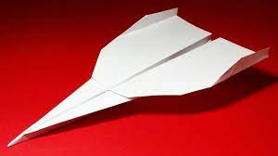

Thursday - Week 3, Term 3 - Kindergarten
Daily Task – Help an adult with an outside activity.
English:
Phonics
Digraph sounds
- Listen to Youtube video Jolly Phonics including the ‘er’ video
- Practise writing the ‘er’ sound. Tell your child that ‘ir’ and ‘ur’ can also make the ‘er’ sound.
- Ask your child to write down the sounds they hear in the following words. You can remind them which ‘er/ir/ur’ sound to use.
‘er’ - fern, her, germ, herd Extension: dinner, after, tiger, concert
‘ir’ - bird, sir, stir, chirp Extension: birth, shirt, first, third
‘ur’ - burn, fur, turn, turf Extension: disturb, burst, nurse, spurt
CCVC words review
Read and draw CCVC words worksheet.
Extension: Create a list of CCVC words you know
Reading
- Read a book from home OR Read a book on https://wushka.com.au/login/ Complete the quiz and the ‘after the book is read’ activity.
Extension: Send a video to your teacher or tell a family member about the story. Think about the title, who was in the story, what happened and did you enjoy reading it
Writing (A Dictation)
- Have a family member read out these sentences word by word and see if you can write the sentence. You might like to emphasise the sounds we have been learning this week.
It is dark in this room. Can you see the bird up high?
Extension: complete the same activity with the following sentences:
Look at the cool fur on that tiger. I might go and see it at the park.
Optional - Complete Reading Eggs Activities for 10 minutes.
Break – Time to stop and refuel. Eat, play, have fun. Self-directed outside activities where possible.
Maths:
- Play the game “Race to Zero’ with a family member. You will need:
- 2 x 100s charts.
- 2 x 6 sided dice https://www.calculator.net/dice-roller.html
- 2 x counters/small toy
- Each person has a 100s chart, dice and counter/small toy. Small toy is placed on number 100. Someone says “Ready, Set. Go” and each person rolls their dice and moves their counter/small toy back that many spaces. They keep going until someone reaches zero. The person who reaches zero first is the winner!
Addition and Subtraction
- Today we are learning how to tell the difference between addition and subtraction number sentences.
- Draw a plus and take away sign on a piece of paper ( t and - ). Tell a family what each sign means.
- Use a highlighter or texta and highlight the plus and take away signs on the worksheet.
- Using your finger resource (from past lesson) or your own fingers, answer the addition and subtraction number sentences. Ask a family member to check your work and have them practise any of the ones that are incorrect. Post a picture to Seesaw for your teacher.
Extension: Complete the above activity with the extension worksheet.
Break – Time to stop and refuel. Eat, play, have fun. Self-directed outside activities where possible.
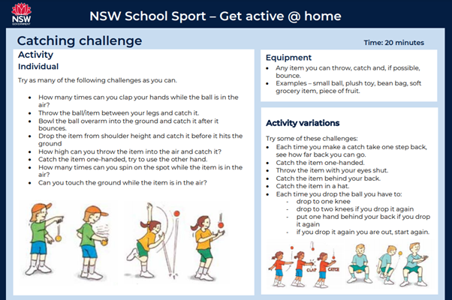
PDHPE:
https://app.education.nsw.gov.au/sport/File/4366

Science
Paper Plane Challenge part 2.
Follow the templates to create paper planes number 3 and 4.
Which of these two will go further?
https://sydneylivingmuseums.com.au/sites/default/files/Paperplane_3.pdf
https://sydneylivingmuseums.com.au/sites/default/files/Paperplane_4.pdf

Friday - Week 3, Term 3 - Kindergarten
Daily Task – Clean up your room.
English:
Phonics
Sound Review
- Ask a family member to read out the sounds from this week and you write them – ‘igh’ as in high, ‘oo’ as in look, ‘oo’ as in zoom, ‘ar’ as in car, ‘er’ as in her, ‘ir’ as in ‘bird’ and ‘ur’ as in fur.
CCVC words review (consonant, consonant vowel, consonant eg. chop, chin etc.)
CCVC Cut and Paste Worksheet Attached
Extension: Write sentences using the words from the CCVC sheet
Reading
- Ask a family member to read you a story. After listening, talk about the story. What happened? Where was the story? Did something exciting happen in the story?
Extension: Read a book on https://wushka.com.au/login/ Complete the quiz and the ‘after the book is read’ activity.
Writing
- Watch your favourite television show and then write about your favourite part.
Extension: Write about a character in the show and then draw a picture of them.
Sight Words
- Ask a family member to test you on the Butterfly card words you have been learning this week. Practise any you did not remember.
Extension: complete same activity as above with the challenging words you have learned this week.
Optional - Complete Reading Eggs Activities for 10 minutes.
Break – Time to stop and refuel. Eat, play, have fun. Self-directed outside activities where possible.
Maths
Addition and Subtraction
- Complete the Maths Assessment in the resource pack ALL BY YOURSELF. You may use your finger resource, your fingers or counters/small toys to help you. Take a picture and post to Seesaw. (Parents/Carers we would love to see what they are able to complete independently. If at any point it is too overwhelming for them, provide support but please indicate this on the worksheet so your teacher is aware).

Extension: complete above activity but set a timer for 10 minutes. See how many you can do. Put a star next to the question you got up to. Then complete the rest of the assessment.
- Complete Mathseeds activities for 10 minutes.

FRI YAY FUN TIME
Do a fun activity to celebrate Fri-Yay with a family member. Make sure you post a picture and post to Seesaw. You could:
- Make a fort
- Bake a cake
- Make and play with playdough.
- Free choice activity.

Break – Time to stop and refuel. Eat, play, have fun. Self-directed outside activities where possible.
PDHPE:
https://app.education.nsw.gov.au/sport/File/4327

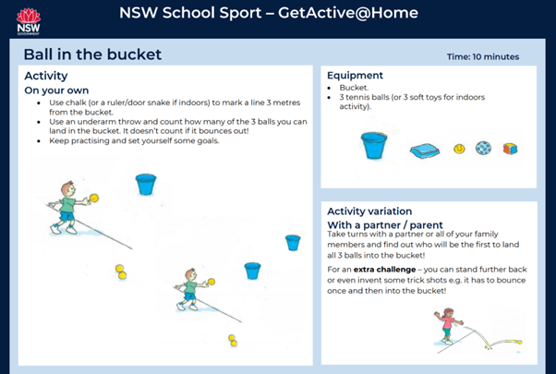

Science
Paper Plane Finals
Take all four paper planes that you created on Wednesday and Thursday. Have a paper plane contest and see which design will travel the furthest?

Happy Friday!

