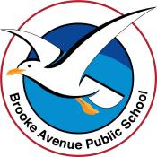
Learning from Home – Brooke Avenue Public School
Stage 1– Week 6, Term 3
The following timetable can be used by students to support learning at home. All tasks have been linked to syllabus outcomes. If technology is available at home, please use the attached links to support learning.
Please upload work marked with the camera icon to Seesaw.
Monday - Week 6, Term 3 – Stage 1
Daily Task - Match socks and sort washing.
English

Reading
Choose a book to read or find a story on Seesaw from your teacher. After reading, answer the following questions.
- What are 3 things you enjoyed about this book?
- What do you think might happen to the characters after this story?
- Have you experienced anything that the characters have? Discuss.

Spelling
Choose List 1, List 2 or BOTH. Write each of your words on a post it note or flashcard and stick on the wall or fridge so that you can see them while you are learning this week.
List 1 - y says i/igh | List 2 - igh/eigh/eight
cry | weigh
fly | sleigh
why | neighbour
try | eight
high | weight
sigh | weightless
night | bright
tight | mighty
light | nightmare
might | height

Writing
Watch ‘The Dreamgiver’. https://www.literacyshed.com/dreamgiver.html
OR use these pictures to think about who the dreamgiver is and what he does.

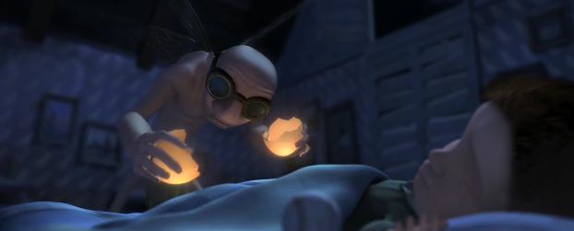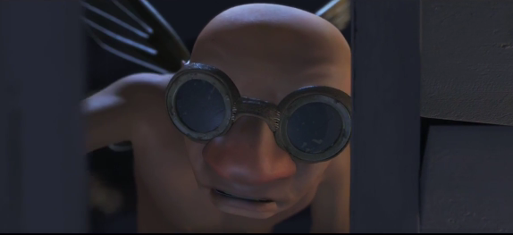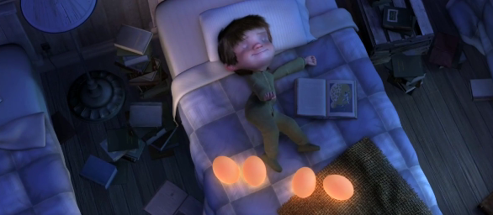

PLANNING
Plan a narrative about the dream you have after the Dreamgiver visits you by creating a mind map. Remember, narratives (even dreams) have a problem that must be solved! You might also include ideas for characters, names, exciting words, places OR special details.

Speaking and Listening
Tell an adult or friend about the Dreamgiver. Describe what he looks like and what you saw him do in the video.

Break – Time to stop and refuel. Eat, play, have fun. Self-directed outside activities where possible.
Maths

Number Sense
Starting at 56 skip-count backwards by 2 to 10 (Don’t forget to use the 100’s chart if you need to)
Skip-count by 3 from 0 up to 39.

Activity
Review friends of 10 by playing make 10
Addition with bridging to 10 (or the decade) watch https://video.link/w/XMj5c
Complete the following addition problems using bridging to the decade.
7+8, 9+5 , 14+ 8 , 16+7 , 13+9 , 23+8 , 48+7 , 77+6

Extension – 123+9 , 345+8 , 436+8

PDHPE
Complete thirty minutes a day of physical activity. Go for a walk, run or ride with an adult.
Work out with the Froggy Coach! https://safeshare.tv/x/ss61109c4883ab2#

Break – Time to stop and refuel. Eat, play, have fun. Self-directed outside activities where possible.
Creative Arts
Book Week is next week
Think of your favourite character from a book- Design, draw, label and colour a possible costume that you could dress up in for Book Week next week.
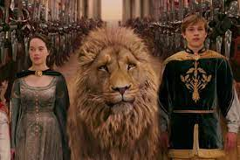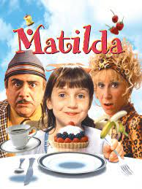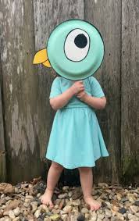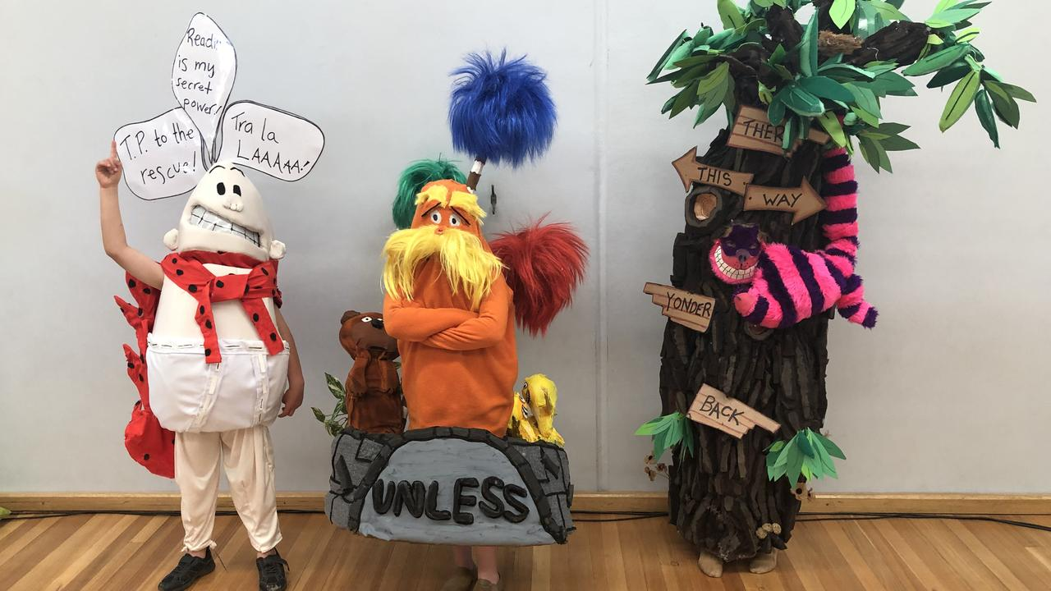

Tuesday - Week 6, Term 3 – Stage 1
Daily Task – Wash the dishes.
English

Reading
Choose a book to read, find a story on Seesaw from your teacher or check the PM ecollection. While you are reading look for the following sight words (choose just one list) and record how many times you find it throughout the book.

List 1 – are, here, with
List 2 – going, their, very

Spelling
Read your spelling words aloud. Write each word and circle the sounds that you can hear. But, be careful because sometimes those tricky letters might join to make new sounds!

Example

GRAMMAR
Verbs
Verbs are action words. They describe what someone is doing. For example; The woman clapped when the movie finished.

Complete the following activity. Look at what each person is doing and write the verb (action word) that describes it.
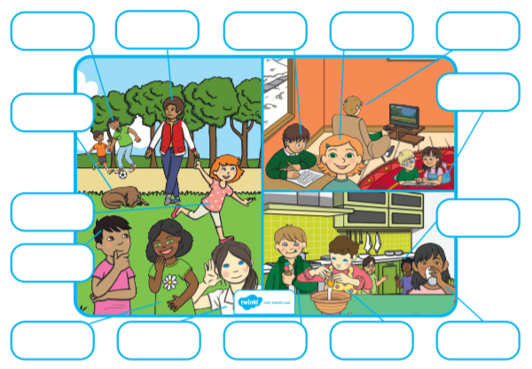

Writing
The Dreamgiver COMPOSING

Have your mind map from yesterday ready to go!
Write the beginning/introduction of your story. This should be between 2-5 sentences. Include the following details;
- Introduce the characters – names, appearance, jobs, family, friends.
- The location or setting of the story - where is this happening?
- Descriptive or interesting words – LOTS of adjectives and LOTS of action words.

Break – Time to stop and refuel. Eat, play, have fun. Self-directed outside activities where possible.
Maths

Number Sense
Esti-mystery 104
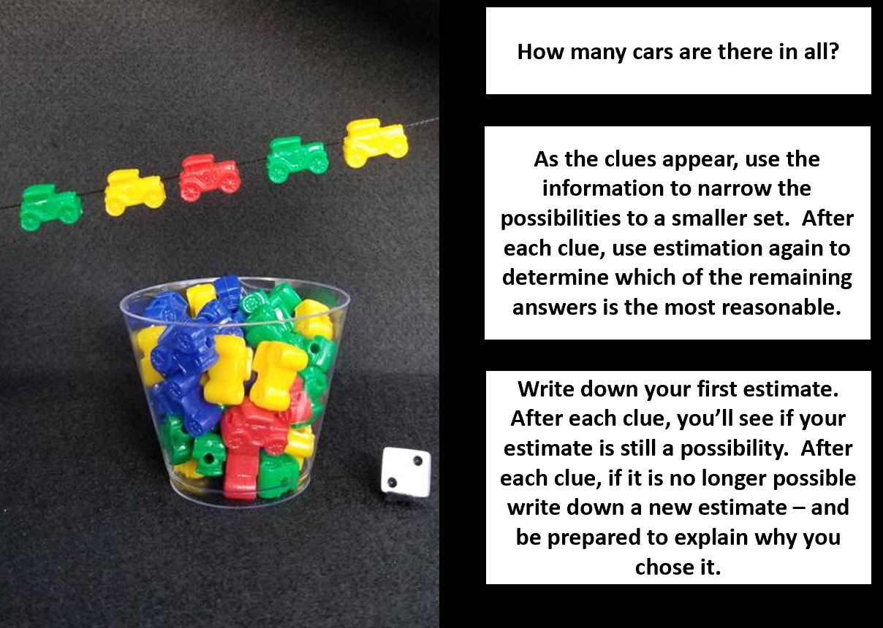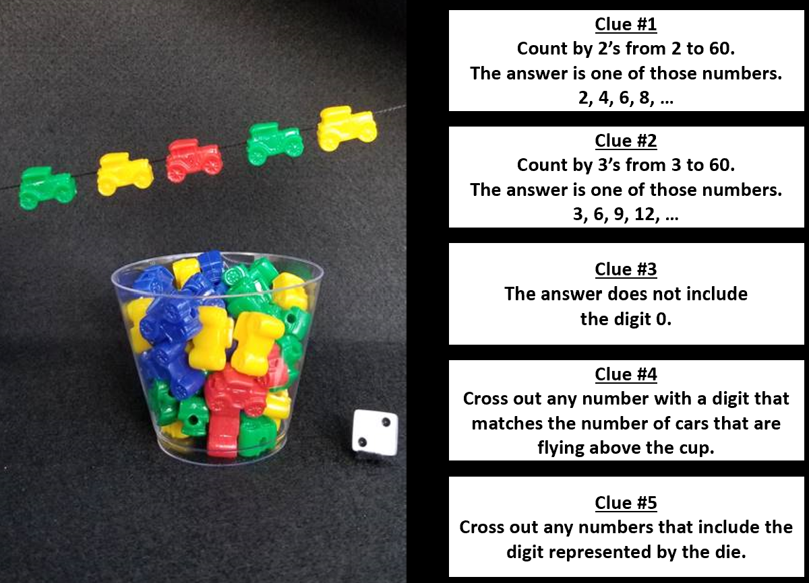

Activity  Watch https://video.link/w/DVj5c to help explain inverse operations  Addition and subtraction families  Complete worksheet - use a dice to create the number sentences.  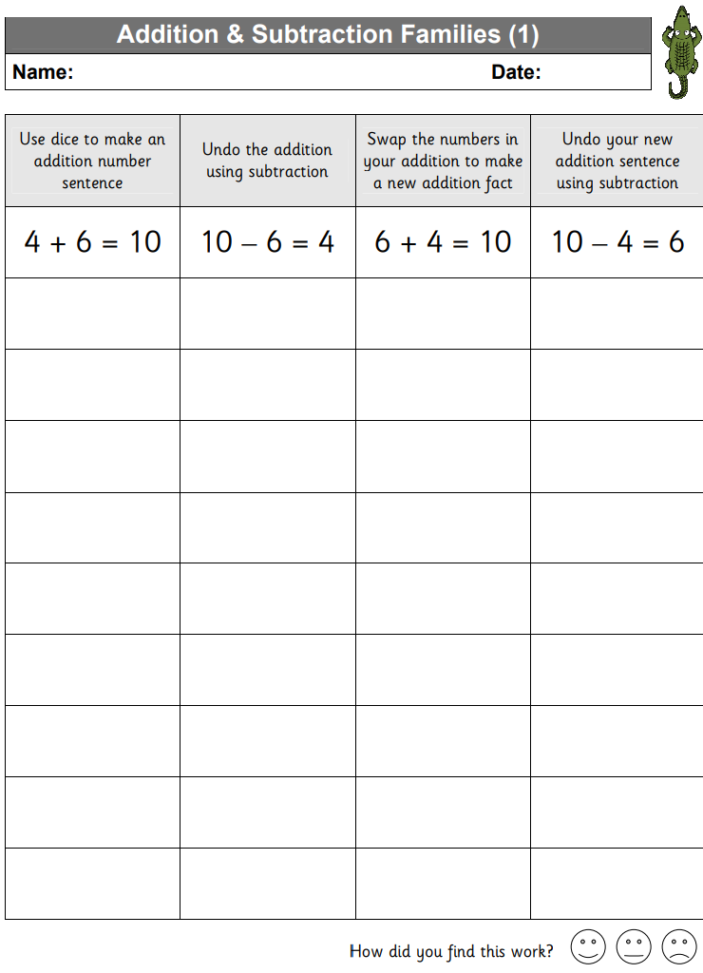  Ext use 2 die to create a 2-digit number to place into the number sentence | Complete the inverse addition and subtraction problems  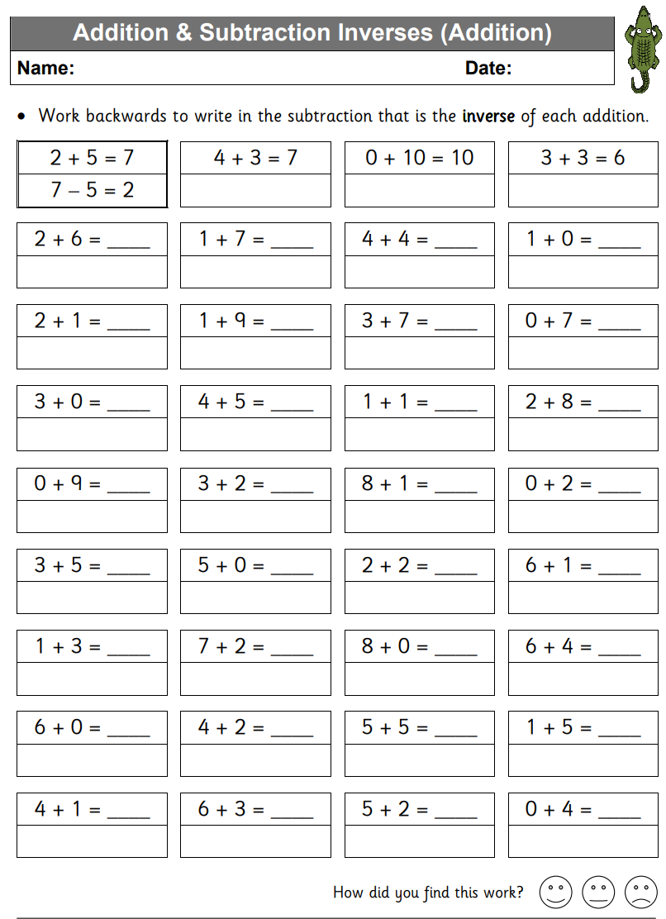
PDHPE
Complete thirty minutes a day of physical activity. Go for a walk, run or ride with an adult.
Who doesn’t like a good dance party? Shaking it to a few favourite jams is a surefire way to get off the couch. To brush up on listening skills, try freeze dance. The rules are simple: dance when the music plays and when the designated DJ stops the music, everyone freezes.
Try this playlist https://safeshare.tv/x/ss610cc68dd7881#

Break – Time to stop and refuel. Eat, play, have fun. Self-directed outside activities where possible.
Science
This week, students will be exploring how energy can come in different forms by using their senses. For example, sound, light, heat and movement. Before completing the following experiment think about what might happen when salt is sprinkled over the balloon and then again when you bang an object above it or place a speaker next to it, discuss this with an adult. This is called making a prediction. Record on the recording sheet.
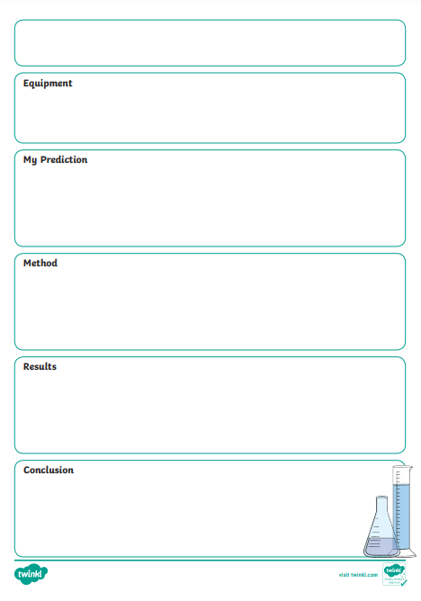
Salt/rice and sound
Materials needed:
- A plastic cup
- A balloon
- Salt or rice
- Scissors
- A speaker and drum
Step 1: Cut the neck of the balloon and stretch it tight over the cup opening so that it is flat (like a drum).
Step 2: Once the balloon is secure on the cup, sprinkle salt over the top of the balloon.
Step 3: Bang a drum or above the cup and observe what happens.
Step 4: Place a speaker next to the cup. Play a variety of sounds and observe what happens.
*Step 5: Students record what they observe and describe what they think may be occurring.

Wednesday - Week 6, Term 3 – Stage 1
Daily Task – Make your bed.
English

Reading
Choose a book to read, find a story on Seesaw from your teacher or check the PM eCollection.
Before reading PREDICT what the story will be about. Use the book title, front and back covers to assist you.
During reading CLARIFY any words you don’t understand. Ask an adult if you are not sure.
After reading SUMMARISE what the happened in the book. This means retell the story! You can write this down OR record yourself speaking so that you can check how well you did.

Spelling
Stand in front of your spelling words that you wrote out on Monday! Each time you read one do a star jump. Do this again, but spell each word this time. Do a star jump for each letter.

Speaking and Listening
Speak to an adult about learning from home. Tell them your OPINION or how you feel about learning from home.

Writing
The Dreamgiver COMPOSING

Have your mind map from yesterday ready to go!
Write the problem in your story today. This should be between 2-5 sentences. What has happened to the character? Remember, to make your writing interesting you can use any of the following tools;
- Similes – the water shone like a star at night.
- Alliteration – the dog dug down deep into the dirt.
- Adjectives – describing words.

Break – Time to stop and refuel. Eat, play, have fun. Self-directed outside activities where possible.
Maths

Number Sense
Play race to 100 with someone in your home or a friend in class (2 dice and adding together to be the first person to reach 100)
https://video.link/w/kWk5c (watch for instructions on how to play race to 100)

Activity
Calendar addition.
Find today's date on the calendar, count how many days until the end of the month. Also work out the date 10 days later from today’s date.
Find your birthday on the calendar, count how many days until the end of the month. Also work out the date 10 days after your birthday.
Find Christmas on the calendar, count how many days until the end of the month. Also work out the date 5 days after Christmas.
Find another date on the calendar (ANZAC day, Australia Day, talk like a pirate day). Count how many days until the end of that month.

PDHPE
Complete thirty minutes a day of physical activity. Go for a walk, run or ride with an adult.
Starting from the front door of your house, follow the instructions below very carefully. Make sure to open doors if they are blocking your way but remember to keep safe! Check with an adult before you leave the house or yard. Where did you find yourself?
Directions
- Take 4 steps forward.
- Turn to your left and hop on one foot. Hop forwards 2 times.
- Star-jump 6 times to the right.
- Take 3 steps back.
- Skip forward 10 times.
- Turn to the right and lunge 5 times.
- Tiptoe forwards 4 times and 2 times back.
- Turn to your left and sidestep 7 times.
Where are you????

Break – Time to stop and refuel. Eat, play, have fun. Self-directed outside activities where possible.
Science
Students will be exploring how energy can come in different forms. For example, sound, light, heat and movement. Before completing the following experiment think about what might happen when you bang the fork on a hard surface then move it to the water. Discuss this with an adult. This is called making a prediction. Record on the recording sheet.
Water and sound
Materials needed:
- A fork
- A wide bowl of water
Step 1: Bang the fork on a hard surface.
Step 2: Immediately hold the fork close to the surface of the water in the bowl, without touching the surface.
Step 3: Students record what they observe and describe what they think may be occurring.
- What did you notice?
- Why did that happen?

Thursday - Week 6, Term 3 – Stage 1
Daily Task – Help an adult with an outside activity.
English

Reading
Choose a book to read, find a story on Seesaw from your teacher or check the PM ecollection.
After reading, draw the main character in 3 ways;
- A baby
- As they are in the book
- In the future – much older
Write about what you think the character might be doing 20 years from now.

Spelling
Write a brief GOOFY SPELLING STORY. Your character’s name is Kevin and he needs to go an adventure one day. Include all of your spelling words and don’t worry if it sounds strange because it is meant to be GOOFY!

Speaking and Listening
Read your GOOFY SPELLING STORY to an adult or film/record yourself reading and send it to your teacher.

Writing
The Dreamgiver CONCLUSION and EDITING
See Seesaw for Writing lesson.

Write the conclusion of your story today. The conclusion is the part of your story where you can solve problems, wrap up events and even tell the reader what happens to the character in the future!
Don’t forget to send a picture of your finished story to your teacher on Seesaw.

Break – Time to stop and refuel. Eat, play, have fun. Self-directed outside activities where possible.
Maths

Number Sense
During this activity you will need to think like a mathematician to solve the following problem and find multiple solutions.
Heads and feet
On a farm there were some hens and sheep.
Altogether there were 8 heads and 22 feet.
How many hens were there?
Show your working out on a piece of paper so your teacher can see your mathematical thinking. Remember there is more than one correct answer to this question.

Activity
Practise your addition skills by playing Greedy Pig
https://video.link/w/uWk5c
Take a photo of your score card and post it on seesaw for your teacher to see.

PDHPE
Complete thirty minutes a day of physical activity. Go for a walk, run or ride with an adult.
Check out Andy’s Wild Workouts! Today, he is at the beach searching for turtles! https://safeshare.tv/x/ss61109e855e2f7#

Break – Time to stop and refuel. Eat, play, have fun. Self-directed outside activities where possible.

Friday - Week 6, Term 3 – Stage 1
Daily Task – Clean your room.
English

Reading
Choose a book to read, find a story on Seesaw from your teacher or check the PM ecollection. While reading your book, write down any verbs you find (verbs are action words). Then choose 3 verbs and complete the following activity. You will need to write a sentence for each of the 3 verbs and draw a picture to match.
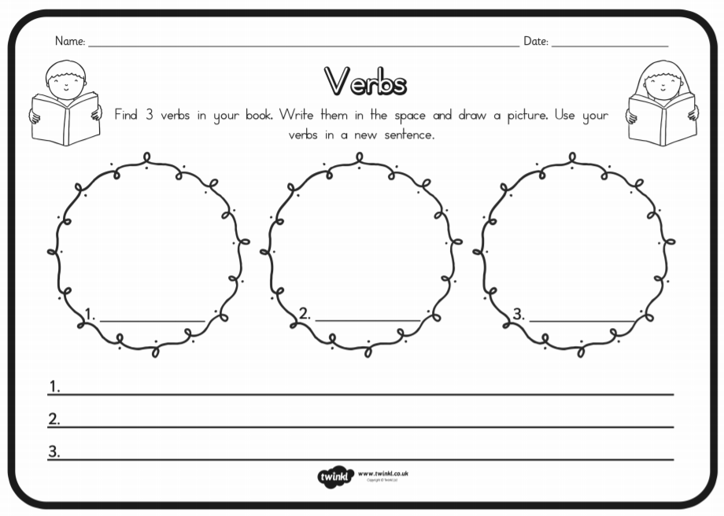

Spelling
Read your spelling words aloud. Now, COVER them up and try to write them from memory. How many could you remember?

Speaking and Listening
Go on a listening walk. This could be a walk around your house, yard or maybe an adult can take you for a longer walk somewhere closeby. Make sure you are very quiet on your walk and pay attention to the different sounds. When you are finished quickly write down everything you heard. Chat with an adult about what you found. Were there any sounds that were unexpected?

Writing
Tongue Twisters
Try reading one of these tongue twisters!
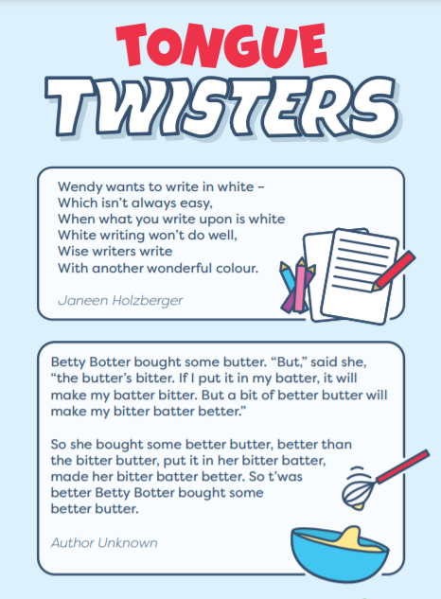

Watch this tongue twister! Can you say it? https://safeshare.tv/x/ss610cb4d245e5f#

Can you write your own tongue twister? Use words that are tricky to say, like tyrannosaurus or potato. Try to use words that start with the same sound or have lots of syllables! It doesn’t have to be as long as the tongue twisters above, but it has to be hard to say!

Break – Time to stop and refuel. Eat, play, have fun. Self-directed outside activities where possible.
Maths

Number Sense
Complete Miss Ritchie’s number of the day activity https://video.link/w/1Fk5c

Activity

Your given numbers are 26, 100, 32, 76 and 14.
Find five ways you can make these numbers using addition.
Eg- 30 = 15 +15, 10 + 20, 1 + 29, 12 + 18, 23 + 7
Now try and find 5 ways to make the numbers with subtraction

Eg – 30 = 70-40, 100-70, 39-9, 50-20, 45-15.

PDHPE
Complete thirty minutes a day of physical activity. Go for a walk, run or ride with an adult.
Time to party! It is time get up from your desk and move your body! Try these Just Dance videos!
https://safeshare.tv/x/ss6110907ce9983# https://safeshare.tv/x/ss6110998d9c7e7#
Break – Time to stop and refuel. Eat, play, have fun. Self-directed outside activities where possible.
Friyay
Here is a Friyay Fun extra – try making oobleck! It is both a solid and a liquid. You will need 2 cups of corn starch, 1 cup of water and some food colouring. For a smaller amount of oobleck, use 1 cup of cornstarch and ½ cup of water. Mix together in a large bowl or tub.
Be warned – this is a HUGE amount of fun and a HUGE amount of mess. Make sure you clean up!
Check Seesaw for video instructions.
Visit this link to listen to Bartholomew and the oobleck by Dr Seuss. https://safeshare.tv/x/ss6110af526abf7#
