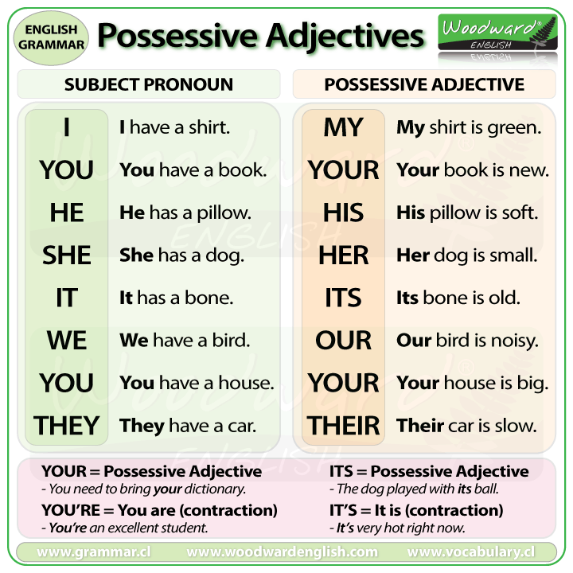
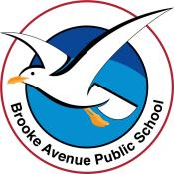
Learning from Home – Brooke Avenue Public School
Stage 2 (Years 3 and 4) – Week 2, Term 3
The following timetable can be used by students to support learning at home. All tasks have been linked to syllabus outcomes. If technology is available at home, please use the attached links to support learning.
Monday 19th July
Daily Task - Match socks and sort washing.
English:
Reading
Read Sequential Events (Attached Sheet) and answer the questions about it.

Writing
Have fun creating your own comic strip using one of the attached proformas.

Grammar - What is a possessive adjective?
Look at the table which helps to explain this and shows examples.

Complete the Possessive Pronoun Worksheet attached below
Spelling
Write your spelling list once. Choose the list most suited to your ability.
Break – Time to stop and refuel. Eat, play, have fun. Self-directed outside activities where possible.

Science

Our solar system
Summary
Discuss with a family member and put your thoughts on the attached “What I already know” sheet

What features make up a solar system?
§ What is a planet and how does it differ from other features of a solar system (eg. a star)?
§ What are some familiar planets and what do you know about them? What makes them distinguishable? What is the difference between a solar system and a galaxy?
Thinking of our most important factors, let’s narrow down our thinking!

See, think, wonder – The moon.
§ See: Look at the images and write down everything that you see.
§ Think: Write down your thoughts about why and how in relation to the moon, its surface and connection to humans.

The Sun – Write down your thoughts about the following points.

§ How is the sun different to the planets?
§ What is the sun’s role in our solar system?
§ What gives the sun its colour?
§ What is important about the sun’s position in relation to the Earth?
Maths
Learn the time rhyme ‘Thirty days has September …. etc
Thirty days has September, April, June and November. All the rest have thirty-one, excepting February alone, and that has twenty-eight days clear and twenty-nine in each leap year. https://www.youtube.com/watch?v=BYshA2ybFdY
Learning Intention: Tell time to the minute and investigate the relationship between units of time
Revise hands of a clock. What do the short/long hand represent? Hour /Minute How many minutes around the clockface-count around by 1 minute, then 5 minute intervals on the clockface. Revise minute intervals on the clock. Discuss the terms past and to, including half past and quarter past/to. Using display clock provide examples
What is an o’clock time?
Make o’clock times on the clockface. Write this time digitally.
Complete Monday Time worksheet
PDHPE
Fitness and hand eye co-ordination:
Jogging on the spot for 5 mins.
Find a wall or fence. Throw a ball right-handed against the wall and try to catch it 20 times in a row. Move further back to make this challenge harder. How many times were you able to catch the ball? Repeat with your left hand.
Creative Arts:
Pop Art is a movement that began in the 1950’s trying to make art more fun and for every person. There are many types of pop art, but the one thing that they all have in common is bright, contrasting colours.
Some pop art using sculpture, some using collage (cutting out different pictures to glue into something else) and some just use one central theme.
Have a look at the link online. https://www.youtube.com/watch?v=DhEyoDCTSDQ
In the 1960s Andy Warhol became known as one of the leading artists of the pop art movement.
Pop artists felt that art should reflect modern life and so they made art inspired by the world around them – from movies, advertising and pop music to comic books and even product packaging.

DESIGN YOUR OWN SOUP CAN
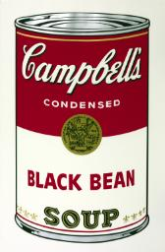
Andy Warhol
Black Bean 1968
Tate
© 2021 The Andy Warhol Foundation for the Visual Arts, Inc. / Licensed by DACS, London
Warhol was famous for exploring everyday and familiar objects in his work, using brands such as Coca-Cola, Brillo and Campbell’s Soup.
He liked the idea of taking ordinary things, for example cereal or bananas, and turning them into art.
He did this with his famous print of a tomato soup can. He also made a print of every type of soup that Campbell's made! Including the one above, Black Bean.
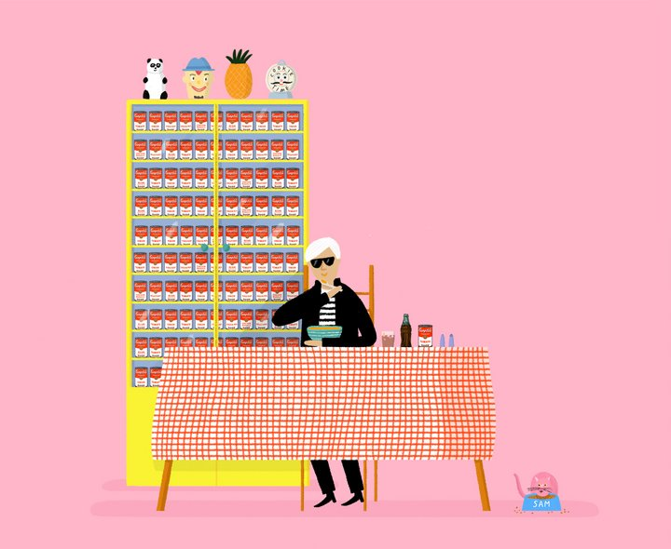
Have a go at designing your own! It can be a real soup flavour or an imaginary one!

things to think about
- What ingredients will go in your soup? How does it taste?
- What will it be called?
- Should the can be bright and bold or cool and dark?
- How would it look in the supermarket?
Have a look below at some of the other pop art food and drink that Warhol created.
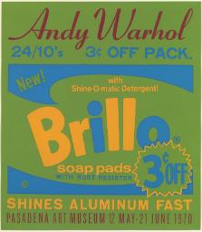
Andy Warhol
Brillo
ARTIST ROOMS Tate and National Galleries of Scotland
© 2021 The Andy Warhol Foundation for the Visual Arts, Inc. / Licensed by DACS, London
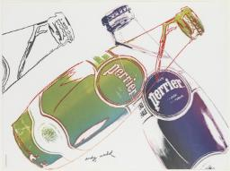Andy Warhol
Perrier
ARTIST ROOMS Tate and National Galleries of Scotland
© 2021 The Andy Warhol Foundation for the Visual Arts, Inc. / Licensed by DACS, London

Tuesday 20th July
Daily Task – Help with washing the dishes
English:
Reading
Read Timeline- History of TV (Attached Sheet) and answer the questions about it.

Writing
Write about your favourite television program. Tell your teacher what is called and why you like it. Describe one of the characters / people in the program.

Grammar – Visual Grammar
Complete the Visual Grammar Worksheet attached

Spelling
Look, Cover, Write, Check- Look at the spelling word, try to write it without looking and then check to see if you had it right.

Break – Time to stop and refuel. Eat, play, have fun. Self-directed outside activities where possible.
Maths
https://mathsstarters.net/numofthedayjunior/3digit
Today's number is 608
1. In words …………….
2. The number before 608
3. Is 608 less than or greater than 617?
4, Count off the decade increasing by 10s:
608, _618__, ___, ___, ___.
5. Odd or even?
6. Partition 608 using place value.
7. Round to nearest 10
18. Arrange in ascending order:
603, 608, 611
Learning Intention: Know the hands of a clock and how to make ¼ past and ¼ to times on the clockface.
Draw your own clockfaces to show these times.
2.15pm
Quarter to 5
9.45am
Quarter past 1
Complete Tuesday Time worksheet.

Science
Write 2 facts from this information about the Sun and the Earth that you didn’t know.

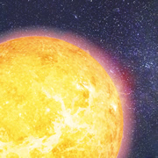
Sun
The Sun is the centre of our Solar System. It is a star and like all stars, it does not have a solid surface. Instead it is a ball of gas held together by its own immense gravity and generates heat and light.
Our Sun is a medium-sized star, and its yellow colour indicates its temperature is in the medium range for stars: really hot stars appear blue/white in colour, while the coolest stars are red.

Earth
- Earth is the largest of the ‘terrestrial’, or rocky, planets (12,742 km in diameter), and has the greatest density of any planet in the Solar System.
- Earth is the only world in the universe where life is currently known to exist.
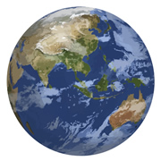
- The atmosphere is composed mainly of nitrogen (78 percent) and oxygen (21 percent).
- With surface temperatures ranging from -88 to 58°C, Earth is the only place in the Solar System where water exists in all three forms – solid, liquid and gas.
- Our planet only has one moon, with a radius about one quarter of the Earth’s, making it the largest moon compared to its parent planet.

PDHPE
Last week, we looked at reasons for wearing a helmet when bike riding, this week we will look at road safety near buses.
Complete the attached close passage- “Safety Town”.

Wednesday 21st July
Daily Task – Make your bed
English:
Reading
Read First Aid and Emergency Procedures (Attached Sheet) and answer the questions about it.

Writing
Write 5 “lifeguard top tips” for either swimming at the beach or being safe in and around a pool.

Grammar – Use a different coloured pencil to edit your tips. Ensure you have capital letters and full stops where they are needed.

Spelling
Choose 5 of your spelling words to find the dictionary meaning of (either using a dictionary or the internet to research the meaning of the word). Write the meaning of the word and then use the word in a sentence of your own. Try to make each sentence a compound sentence rather than a simple sentence.
Break – Time to stop and refuel. Eat, play, have fun. Self-directed outside activities where possible.
Maths
Learning Intention: Make and record time in 5 minute intervals.

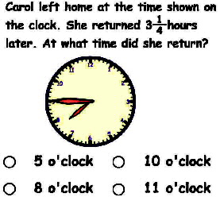

Complete Wednesday worksheet on Reading and Interpreting Timetables.

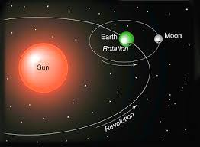
Science

The Moon

- The Moon is the Earth’s only natural satellite. A natural satellite is a space body that orbits a planet, a planet like object or an asteroid.
- It is the fifth largest moon in the Solar System. Learn more about the other moons in the Solar System.
- The average distance from the Moon to the Earth is 384403 kilometres (238857 miles).
- The Moon orbits the Earth every 27.3 days.
The side that we can see from Earth is called the near side while the other side is called the far side (it is sometimes called the dark side despite the fact
that it is illuminated by the Sun just as much as the near side). If you have access to the internet, you may like to look at some of these resources;
Resources
- NASA website - http://solarsystem.nasa.gov/planets/
- Space facts - space-facts.com/
Over Wednesday and Thursday - Create your own model of the sun, the earth, and the moon, send a photo to your teacher. You could draw it, use different sized balls (tennis/golf etc) to create a model.

Thursday 22nd July
Daily Task – Help with the washing
English:

Reading
Read “If I Rode A Whale”. (attached)

Writing
Have fun creating your own poem about an animal of your choice.

Handwriting – Complete the attached Handwriting work sheet.

Spelling
Have a family member ask you to spell your spelling words. Are there any that you need to practise more?

Maths
https://mathsstarters.net/quickquiz
1. Write in digits, three hundred and sixty four: _________
2. Write in words, 238: _________
3. Write in digits, six hundred and eighty six: _________
4. Write in words, 512: _________
5. Write in words, 949: _________
6. Write in words, 731: _________
7. Write in digits, eight hundred and sixteen: _________
8. Write in digits, eight hundred and one: _________
9. Write in words, 181: _________
10. Write in words, 426: _________
Learning Intention: Make and record time to the minute.
Create a clock face and show several different times with 1minute intervals.
Science
Continue to work on your model for Science. (see Wednesday afternoon information)

PDHPE
Complete the Safe Living Find A Word

Friday 23rd July
Daily Task – Tidy your bedroom.

English:

Reading
Read a book or magazine of your choice for 15 minutes.

Writing
Watch Behind the News- https://www.abc.net.au/btn/classroom/. If you don’t have access to the internet, you can look at a news item of your choice in a newspaper or on television instead.

Summarise one news item in your own words. Write what it is about. You may like to write any ideas that you have about it.
Spelling
Create a find a word using this week and last week’s words. (Use the blank Find A word Attached if possible) Give it to a family member to try to solve. Remember, to use the alphabet to fill any blank spaces.

Break – Time to stop and refuel. Eat, play, have fun. Self-directed outside activities where possible.
Maths
Complete the Time Worksheet on reading a calendar.
PDHPE
Complete half an hour of exercise doing an activity you enjoy. It may be riding your bike, dancing, surfing, jumping on your trampoline. The idea is to have fun and improve your fitness on “Friyay”.
Creative Arts
Have your family help you research a musician, singer or band. Listen to the music and see how you like the music.

