Learning from Home – Brooke Avenue Public School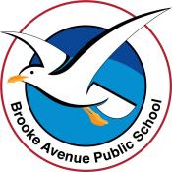
Stage 1– Week 2, Term 3
The following timetable can be used by students to support learning at home. All tasks have been linked to syllabus outcomes. If technology is available at home, please use the attached links to support learning.
Monday - Week 2, Term 3 – Stage 1
Daily Task - Match socks and sort washing.
English:
Reading
Choose a book to read with an adult or visit the Seesaw app to watch a story from our Stage 1 teachers.
Before reading: What do you think will happen in the book? What clues are there that make you think this?
After reading: Draw a picture of your favourite character from the book. Write a description of the character. Explain what you like about them.
Students can film their response to the questions on Seesaw or write/illustrate their response.
Spelling - ‘oo’
Read your spelling words aloud to an adult. Discuss what the words mean.
Write your list in rainbow colours! Make the ‘oo’ sound red!
Speaking and Listening
Read your description of your favourite character to an adult to see if it makes sense.
Break – Time to stop and refuel. Eat, play, have fun. Self-directed outside activities where possible.
Maths:
Count forwards and backwards by ones from any two-digit or three-digit number,
e.g. 42, 43, 44…
or 327, 326, 325… Record yourself on Seesaw counting aloud.
Determine a missing number in a number pattern, eg 3, 5, 7, __, 11. (This can be completed as a Seesaw activity or Parents/Carers to create missing number patterns for students to fill in).

Draw and label as many regular 2D shapes that you know

Science – Earth and Space
In our environment, what changes and what stays the same? For example; trees grow and change over time (living things) and desks or tables don’t change (non-living).
Go for a walk around your house and yard to observe the environment around you and fill in a t-chart (resource attached or draw your own) with the headings change and same. Encourage students to think about the sky, moon, ocean, stars. Keep this chart handy for tomorrow!
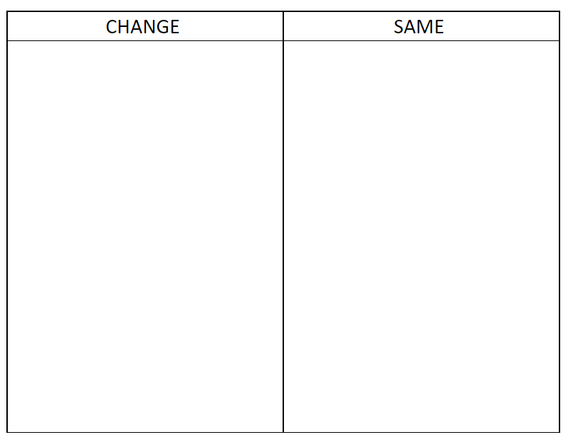

Break – Time to stop and refuel. Eat, play, have fun. Self-directed outside activities where possible.
Physical Activity
Level up video game workout (Level 1)
Level Up! (Video Game Workout For Kids) - YouTube
Create an obstacle course in your backyard or lounge room. You can use cushions, toys, baskets, hula hoops or cones to build it. How long does it take you to complete it? Can you beat your time?

Tuesday - Week 2, Term 3 – Stage 1
Daily Task - Wash the dishes.
English:
Reading
Choose a book to read with an adult or visit the Seesaw app to watch a story from our Stage 1 teachers.
Spelling - ‘oo’
Read your list words aloud to an adult. Brainstorm words that have the ‘oo‘ sound in it. How many can you think of? Can you find some in books you have at home?
Writing
Look at the following picture and write down your observations.
Bubble Planets
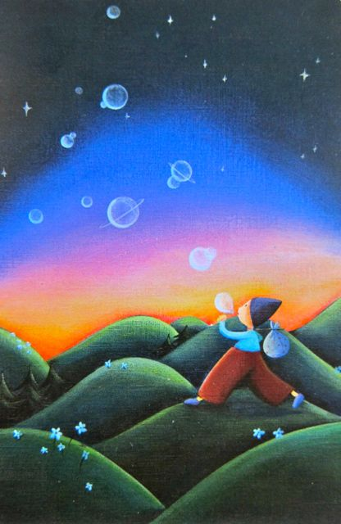
- What is this person doing?
- How old are they?
- What are they carrying in their sack?
- Where did he/she come from? Where is he/she going?
- Did they just discover how to make bubble planets or have they been doing this for a long time?
- What happens to the bubble planets after they are formed?
- Are they real planets? Is there life on any of them?
Keep your observations handy for tomorrow.
Break – Time to stop and refuel. Eat, play, have fun. Self-directed outside activities where possible.
Maths:
Challenge: Set a timer for a minute – see what number you can count to in this time (Don’t forget you can use the 100’s chart for help)

Cut or draw a variety of shapes to create a town. You could even try to make one on Seesaw using the shapes.
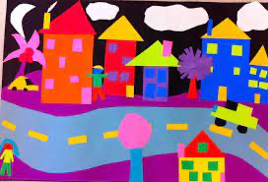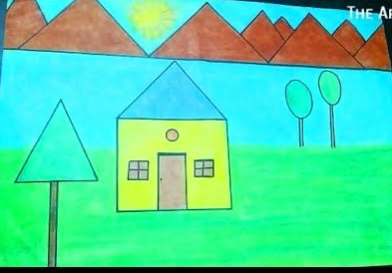
Write down a list of the 2D shapes you used.

Movement Break: Go noodle ‘Rainbow Breath’ https://www.youtube.com/watch?v=O29e4rRMrV4

Science
Get your t-chart out from yesterday. You will also need a pencil and a highlighter or texta.
Think about what makes these natural things change. Responses could include, seasons, wind, rain, heat, cold, day, night. List one or more of these factors next to each of the things that ‘Change’ in the T-chart.
Highlight the things that change in the sky (clouds, sun, moon, stars).
Break – Time to stop and refuel. Eat, play, have fun. Self-directed outside activities where possible.
Creative Arts
Design a bubble planet that might have been created by the bubble maker from your writing. You can create this by drawing with anything you choose OR you might like to collect some things from around the house or yard to make a 3D planet! Make sure you get permission to use what you find.
Wednesday - Week 2, Term 3 – Stage 1
Daily Task – Make your bed.
English:
Reading
Choose a book to read with an adult or visit the Seesaw app to watch a story from our Stage 1 teachers.
Spelling - ‘oo’ sound
Choose 5 ‘oo’ words and put them into silly sentences. e.g. The spoon danced happily around the giggling moon.
Writing – Bubble Planets
Have your observations ready from yesterday.
Write a story about the bubble maker using some of the observations you made. Make sure you include lots of interesting words!
Break – Time to stop and refuel. Eat, play, have fun. Self-directed outside activities where possible.
Maths:
Challenge: Set a timer for a minute – see what number you can count to in this time. (See if you can beat your number from yesterday)

Look at the piece of art by W. Kadinsky
Make a list of all the 2D shapes you can see. Now make a chart and tally how many of each shape you can count.

Creative Arts
Create an alien that might live on your bubble planet. You can create the alien by drawing with anything you choose OR you might like to collect some things from around the house or yard! Don’t forget to send a photo to your teacher on Seesaw!
Break – Time to stop and refuel. Eat, play, have fun. Self-directed outside activities where possible.
Physical Activity
Cosmic Kids Yoga https://www.youtube.com/user/cosmickidsyoga
Animal Walk – move like an animal. You could be a horse, snake, bird, monkey, etc.
Power Walk – walk as fast as you can around your yard without running. How many laps can you do?
Walk in slow motion – walk as slowly as you can, as if you are in slow motion!
Thursday - Week 2, Term 3 – Stage 1
Daily Task – Help an adult with an outside activity.
English:
Reading
Choose a book to read with an adult or visit the Seesaw app to watch a story from our Stage 1 teachers.
After reading, talk about the book with an adult. What happened at the beginning, middle and end? Draw a picture to explain your answers.
Spelling: Rhyme Time
Find words that rhyme with each of your spelling words. Challenge: Can you think of words that rhyme with peach, fair, love, ring, slug, catch, plate and snail.
Writing
Plan a menu for the day. Include lunch, dinner, drinks and snacks. Students can draw their menu up like a restaurant menu or draw pictures to represent each item. Don’t forget a healthy snack!
Break – Time to stop and refuel. Eat, play, have fun. Self-directed outside activities where possible.
Maths:

Challenge: Set a timer for a minute – see what number you can count to in this time. (See if you can beat your number from yesterday)

Create your own shape art like W.Kadinsky
Eg.
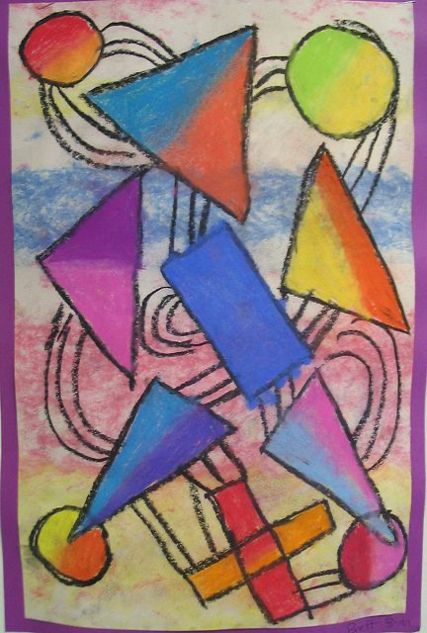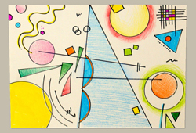
Make a list all the shapes you used
Creative Arts
Go outside and collect leaves and sticks and make a name collage.
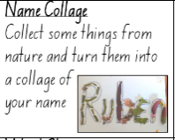
Break – Time to stop and refuel. Eat, play, have fun. Self-directed outside activities where possible.
Physical Activity
Crab Walk Races
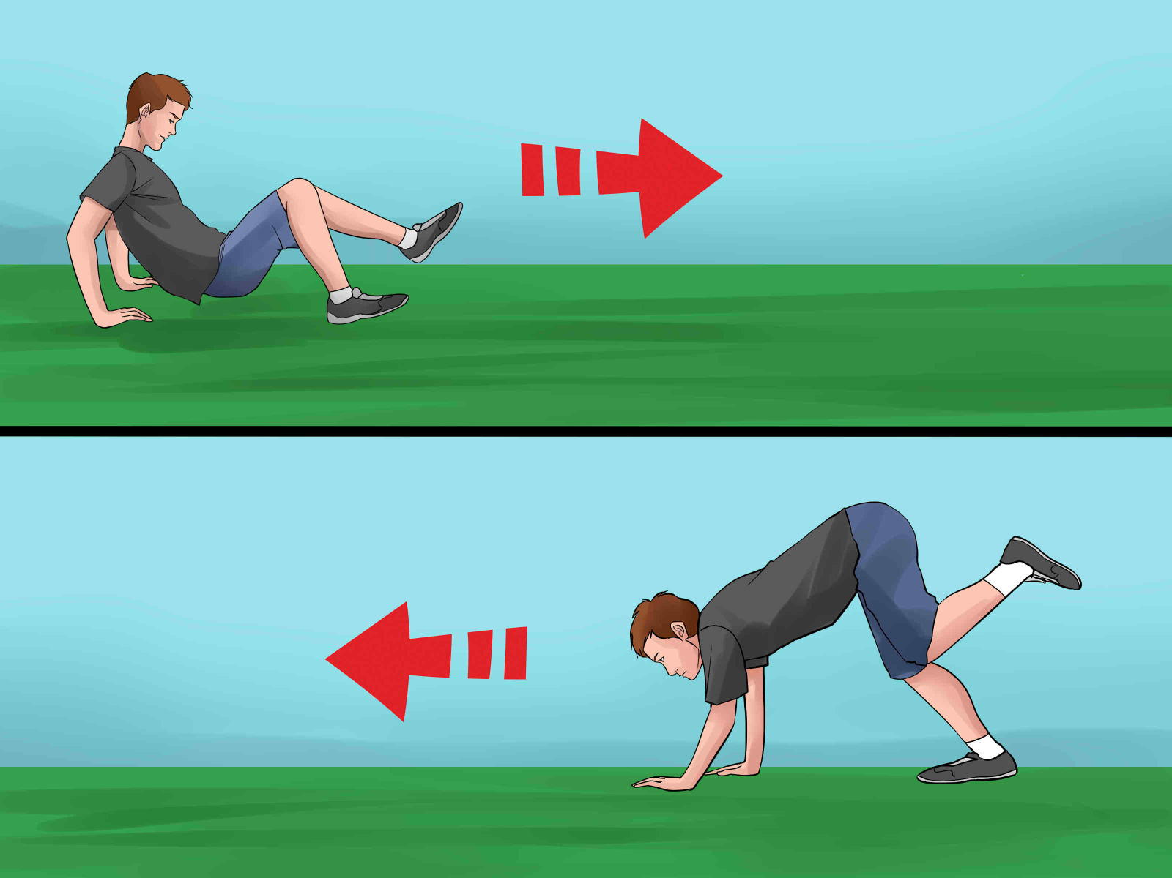
Set up start and finish lines in the front or backyard. Crab walk against a family member and see who wins! You could also time your race and see if you can beat your personal best.
Friday - Week 2, Term 3 – Stage 1
Daily Task – Clean up your room.
English:
Reading
Choose a book to read with an adult or visit the Seesaw app to watch a story from our Stage 1 teachers.
Watch Bluey: Bad Mood
https://iview.abc.net.au/video/CH1903Q043S00
List as many words as you can that describe what Bingo might be feeling when she is in a bad mood. Discuss what Bingo does to make her bad mood go away.
What do you do to make your bad mood disappear? Write about what helps you when you are in a bad mood OR video yourself talking about it on Seesaw.
Spelling: ‘oo’ sound
Whisper read your spelling words.
After asking for permission, get some salt, flour or sugar from the cupboard. Pour it onto a coloured plate or tray. Using your finger, write your spelling words in the flour.
Break – Time to stop and refuel. Eat, play, have fun. Self-directed outside activities where possible.
Maths:
Challenge: Set a timer for a minute – see what number you can count to in this time. (See if you can beat your number from yesterday)

Students trace their hand and cut it out. Place the cut-out hand on a piece of paper and trace it then turn it a quarter-turn and trace it. They continue turning the shape around a point until the shape is in its original position. Students discuss the picture that they made. (see Seesaw for video instructions.)
Physical Activity
Rock Paper Scissors Run! Watch the video and play the game with a family member.
https://www.youtube.com/watch?v=mTqkENcjPmQ&list=PL0H94qyJzFmpTWFyuQ-ruKapQHyNl--zB&index=4

Break – Time to stop and refuel. Eat, play, have fun. Self-directed outside activities where possible.
Friday Fun Time!
Choose your favourite activity from the week and have another go! Share your photos or videos on Seesaw!

