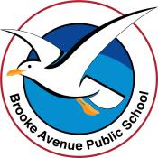
Learning from Home – Brooke Avenue Public School

K-6J, K-6M and K-6S – Week 2, Term 3
The following timetable can be used by students to support learning at home. All tasks have been linked to syllabus outcomes. If technology is available at home, please use the attached links to support learning.

ATTENTION PARENTS: please note that we have tried to vary the learning to give options for all students. Please note that you only need to choose 1 from each of the suggested learning activities in each session i.e. 1 for English, 1 for Maths.
Monday - Week 2, Term 3
Daily Task - Match socks and sort washing.
English: Captain Starlight reads Aaron Blabey’s “Busting” - https://www.youtube.com/watch?v=a8rnTky6hrs
Can you hear rhyming words? How many? Can you write these rhyming words? Can you think of any other words that rhyme with the ones you’ve found?
Reading: Read by yourself, to someone or have someone read to you. What is your favourite story? Why do you like it?
Activity: Word Search – There are a variety of word search activities to choose from this week. You can do one or more. You might like to choose the one that matches the story “Busting.”
Spelling: Make a list of spelling words from the word search you have chosen (Parents please note: this is optional. Please vary to suit your child).
Speaking and Listening + Writing –Look at the attached writing stimulus – “If you could change anything in the world, what would it be, and why?”
Fine Motor: What would your world change look like? Draw it and maybe share your artwork on Seesaw.
Technology: Log in to Reading Eggs and complete an activity.
Break – Time to stop and refuel. Eat, play, have fun. Self-directed outside activities where possible.
Maths: Week 2 focus – Addition.
Warm up: Here’s a video for you to get you in the mood: When you add with a pirate https://www.youtube.com/watch?v=WT_wvvEvkw4
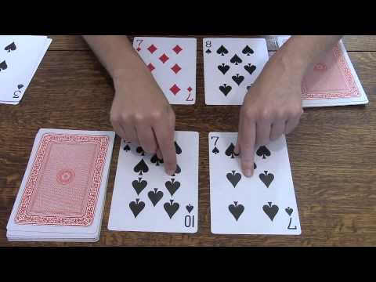
Activity: Get a deck of cards (start with Ace (value = 1) to 9) and turn over 2 cards add them together and see how many you have altogether. (Variation 1: turn over 2 (or 3) cards and make a 2-digit (or 3-digit number) and add them together. What strategy did you use? Jump Strategy? Split Strategy? Something else?
(Variation 2): add the picture cards and make them wild cards. Play with a partner and see if you can find bigger/smaller numbers.

Parents/Carers: if you feel like a challenge, this link will give you some addition games to play. There is certainly NO EXPECATION to do so, this is simply a suggestion for you. https://www.gamesforyoungminds.com/blog/war-card-game
Option: You may also log in to Studyladder to complete activities set for you.
Remember, choose 1 only.
Break – Time to stop and refuel. Eat, play, have fun. Self-directed outside activities where possible.
Just Dance: Here are some of our favourites? You could choose one of these, or one of your own.
That’s what makes you beautiful: https://www.youtube.com/watch?v=Zr4jwxXP04w
Dance Monkey: https://www.youtube.com/watch?v=6X683tNMGxQ
Ghostbusters: https://www.youtube.com/watch?v=RYgIVc5Jvjg
Here’s a new one! Space Cat: https://www.youtube.com/watch?v=axg8H89xZ_w

Tuesday - Week 2, Term 3
Daily Task - Wash the dishes.
English: Jolly Phonics Phase 1 https://www.youtube.com/watch?v=2Xy2e78qxNg Listen to the song and do the actions. Can you find the sounds 1 (1 only) on the butterfly card? Can you write the letters too? Maybe you can also write the uppercase letter to match!
I love hearing the ‘e’ sound because it makes me think of eggs! I love eggs.
Jolly Phonics Phase 3 https://www.youtube.com/watch?v=ZXgfO1jSljQ Listen to the song and do the actions. Then think of “ch” words.
Jolly Phonics Phase 1-6 https://www.youtube.com/watch?v=VmMoFbhpFk4 What did you notice about the sounds? Were there silent letters? Can you think of any words with silent letters?
Speaking and Listening + Writing Do you like eggs? What’s your favourite way to eat eggs? Scrambled, fried, poached? Write about your how you like your eggs and why you like them that way.
Fine Motor: Draw them and share on Seesaw.
If you don’t like eggs, tell us about your favourite food and why it is your favourite. Perhaps its mango (YUM!) or maybe it’s pizza!
Here’s a video on different ways to have eggs. https://www.youtube.com/watch?v=yVet62zLTyw
Reading: Read to someone or have someone read to you.
Activity: Spelling – use the words from yesterday’s word search and practice writing them in triangle writing (see the attached Spelling Menu).
Variation: write your spelling words into a sentence.
Technology: Log in to Reading Eggs and complete an activity. Maybe you could even do a drawing tutorial like this one. How to draw eggs and bacon
Break – Time to stop and refuel. Eat, play, have fun. Self-directed outside activities where possible.
Maths: Week 2 focus – Addition.
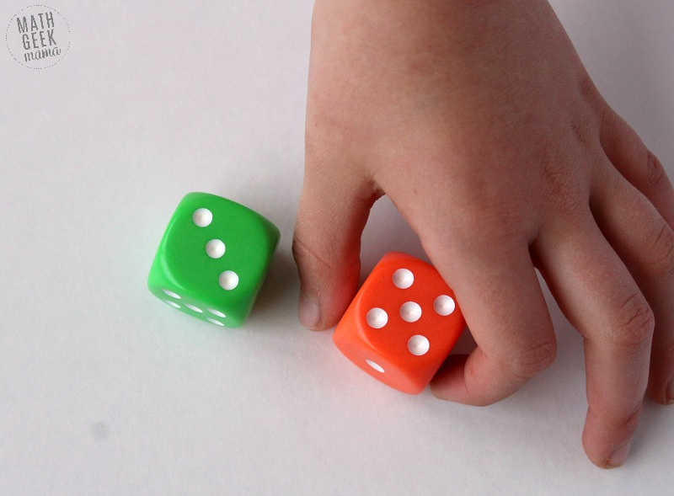
Warm up: Here’s a video for you to get you in the mood: Adding with Jack Hartman https://www.youtube.com/watch?v=uONIJ5TQ2DA
Activity: Grab some dice (or use online dice: https://freeonlinedice.com/). Roll the dice and add them together.
Parents/Carers: The above link will allow you to choose the numbers that appear on the dice, up to 100, so you can vary the activity to suit the individual needs of your child.
Option: You may also log in to Studyladder to complete activities set for you.
Remember: choose 1 only.
Break – Time to stop and refuel. Eat, play, have fun. Self-directed outside activities where possible.
Smiling mind: It’s so important that we get a chance to relax. Here are some Smiling Mind videos on Youtube for you.
Sleep Meditation: https://www.youtube.com/watch?v=VxYC_UcQ0PI
Emotions: https://www.youtube.com/watch?v=8NB3ihqPQGw
Practice your own with this music on in the background: https://www.youtube.com/watch?v=QN-xeGXarD8
Draw: Complete one of the attached ‘how to’ drawings below.
Wednesday - Week 2, Term 3
Daily Task – Make your bed.
English: Here’s a story we love! The Gingerbread Man. https://www.youtube.com/watch?v=pckuS--UlV4
Speaking and Listening: Can you name the characters who were chasing the Gingerbread Man? Tell someone who your favourite character is and explain why?
Writing: Draw and label your new character, then write a sentence about them.
Variation: Make a new character(s) to add to the story. Would it change the story? How? Can you re-write a part of the story (or the whole story) including your new character?
Reading: Read your favourite story or log on to Reading Eggs.
Activity: Spelling – write your spelling words in bubble writing.
Variation: write your spelling words in alphabetical order and choose 5 to write into separate sentences.
Technology: Log in to Reading Eggs and complete an activity.
Break – Time to stop and refuel. Eat, play, have fun. Self-directed outside activities where possible.
Maths: https://www.youtube.com/watch?v=hekgNQyP7uU Can you quickly add the dice together? Say and write the number.
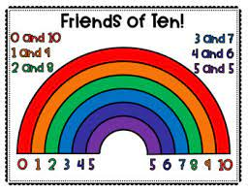
https://www.youtube.com/watch?v=QS5w8LRnnp0 How many “Friends of ten can you make?
Activity: Grab some pegs. Put your hand in and pull some out. Count them, then see if you can think of how many more you need to make ten (variation: 20). See if you can complete the “11 ways to make 10” or the “Roll to 20” worksheet below.
Variation: Choose one of the alternate activities attached e.g. roll to 100
Option: Log in to Studyladder to complete addition activities set for you.
Remember, you only need to choose one a day from the topic we are focusing on.
Break – Time to stop and refuel. Eat, play, have fun. Self-directed outside activities where possible.
HSIE: Past and Present – Find the “Biplane” image attached and follow the procedures to draw the plane.
Next: see if you can draw your own modernised aeroplane. What are the similarities and differences between the two planes? Take a photo and share your plane with your friends on Seesaw.
Variation: research biplanes and share some interesting facts about them.

Thursday - Week 2, Term 3
Daily Task – Help an adult with an outside activity.
English: Read a book of your choice or listen to Zombies don’t eat veggies! https://storylineonline.net/books/zombies-dont-eat-veggies/
Speaking and Listening: What’s your favourite vegetable? Why? What is your least favourite? Why? Describe your vegetable. What colour is it? How small/large is it? Can you eat it whole or do you need to cut it up? Can you eat it raw? Do you like it raw or cooked? Are there different ways to cook your vegetable? What is your favourite way to eat it?
Writing: Find a recipe that includes vegetables or make up your own. Write/type out the recipe and post it to seesaw to share with your friends.
Maybe you would like to make your recipe with your family.
Variation: write a persuasive text about why we should/shouldn’t eat vegetables). Alternatively, you could make your own veggies out of playdough and label each one.
Spelling: Choose an activity from the “Spelling Menu” and complete it.

Technology: Log in to Reading Eggs and complete an activity or try ABCYA for some different activities.
Break – Time to stop and refuel. Eat, play, have fun. Self-directed outside activities where possible.
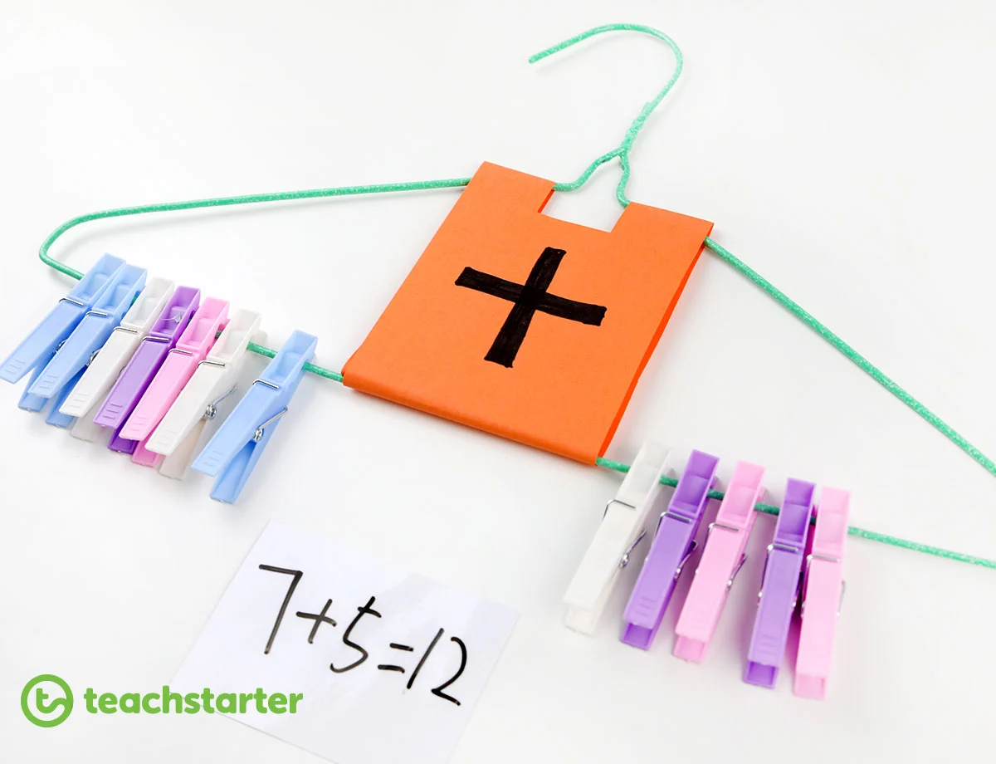
Maths: Peg Addition – You will need a coat-hanger and some pegs (preferably 2 different colours).
Grab a handful of pegs and sort them into two colours. Count each colour as you peg them onto the coat-hanger in colour order e.g. all red together and all blue together. Add the two colours together to determine how many altogether. Then write the number sentence e.g. 5+2=7.
(Variation: Make the two colours tens or ones to represent 2-digit addition (e.g. red=10s and blue =1s or use three different colours to make 100s, 10s and 1s).

Technology: Log on to Studyladder and complete one of the addition activities.
Break – Time to stop and refuel. Eat, play, have fun. Self-directed outside activities where possible.
Go Noodle: Here are some of our favourites for you.
Fabio’s Meatballs: https://www.youtube.com/watch?v=JU0ETGd5dgk
Monster Mash: https://www.youtube.com/watch?v=GxKb_VHCYdc
Pizza: https://www.youtube.com/watch?v=Hl5dRW4E9hc
Dinostomp: https://www.youtube.com/watch?v=Imhi98dHa5w
Draw: Complete one of the attached ‘how to’ drawings below.
Friday - Week 2, Term 3
Daily Task – Clean up your room.
English: Watch Carla’s Sandwich https://storylineonline.net/books/carlas-sandwich/
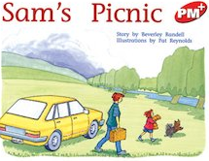
Speaking
& Listening: What do think about Carla’s sandwiches? Would you eat them? Why? Why not? Do you have a favourite sandwich? My favourite is peanut butter and Jam! YUMMY!! Have you ever been on a picnic? Was it fun? What would you like to take on a picnic?
Writing: Write about a time that you have had a picnic and tell us what you had to prepare or take with you. If you haven’t been on a picnic before, maybe you could plan what you would do if you could go on a picnic. Maybe you could even plan to have an indoor, television picnic like Sam and Bingo have in our reader, Sam’s Picnic.
Variation: make a list of words associated with a picnic and make your own find a word. See if an adult can find all the words you’ve hidden. You can even use the template below.
Spelling: Choose an activity from the “Spelling Menu” and complete it.

Technology: Log in to Reading Eggs and complete an activity.
Break – Time to stop and refuel. Eat, play, have fun. Self-directed outside activities where possible.
Maths: Here are some of our favourite skip counting songs – Counting by 2s https://www.youtube.com/watch?v=GvTcpfSnOMQ
Counting by 5s - https://www.youtube.com/watch?v=EemjeA2Djjw
Counting by hundreds - https://www.youtube.com/watch?v=l3R6wdHs9n8
Can you count by any other numbers? Write out your numbers e.g. 2, 4, 6, etc. or 100, 200 etc. or even off the hundred e.g. 112, 212, 313 etc.
Variation: Choose your favourite Maths activity from the week and do it again. Alternatively, play a game of snakes and ladders or something similar, where you are adding numbers on as you play.

Congratulations on all of your hard work this week! Take some time to relax, maybe watch BTN or another educational show.
Break – Time to stop and refuel. Eat, play, have fun. Self-directed outside activities where possible.
Creative Arts: Make your own paint using Food Colouring (be sure to ask an adult for help).
Note: You may prefer to do this outside.

You will need: old clothing (or paint shirt), paper or cardboard, food colouring (1, 2 or more colours), water, paintbrush (or an old toothbrush).

Method: Add a small amount of water to a small bowl/paint tray. Slowly add a drop or two of food colouring until you get the colour you like.

Next, you paint! Try dipping the toothbrush in and flicking the bristles to create a splatter painting.
BE CAREFUL: It may stain your clothes to make sure you seek adult assistance and wear an apron/or old clothes when painting!

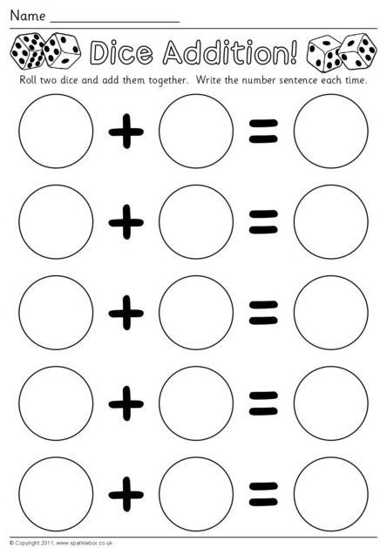
Spelling Menu
Name: ____________________
Write your spelling words……
in rainbow letters | with vowels in red | and find the definition in the dictionary
Write each spelling word into a sentence. | in CAPITAL letters | In play dough
with write and swipe sleeves | In fancy letters (e.g. graffiti, bubble etc.) | In chalk  (inside or outside)
In the sand | In paint | Triangle writing  d  do  dog

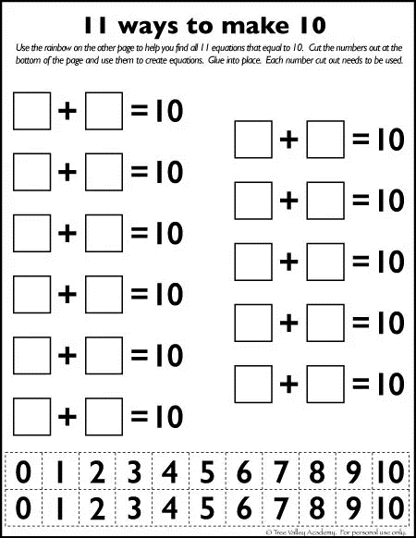

Word Search
Make your own word search using this template!
Word list
Remember: you can make it as easy or tricky as you like.

