Learning from Home – Brooke Avenue Public School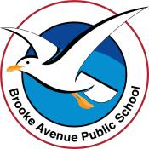
Kindergarten – Week 2, Term 3
The following timetable can be used by students to support learning at home. All tasks have been linked to syllabus outcomes. If technology is available at home, please use the attached links to support learning.
Monday - Week 2, Term 3 - Kindergarten
Daily Task - Match socks and sort washing.
English:
Phonics
Digraph sounds
- Listen to Youtube video Jolly Phonics and review digraphs from last week ‘ch, sh, th’.
- This week we are learning ‘wh’. It makes the same sound as ‘w’.
- Practise writing ‘wh’ sound. Say the sound ‘wh’ as you write it.
CCVC words (consonant, consonant, vowel, consonant)
Practise saying these words slowly (like you are stretching them) then practise breaking them up into their individual sounds. Write the following words using rainbow colours on a piece of paper.
when (wh – e – n) whip (wh - i- p) wham (wh – a-m) whim (wh-i-m)
Extension: Write the following words in rainbow colours and use a different colour for each sound. (EG: whimper)
whimper, which, wheel, whiskers, white
Reading
- Read the story and questions on the worksheet ‘See the Cat’ with a family member or by yourself. Finish the statements by colouring in the correct word.
Extension: Complete above activity with the worksheet ‘His or Her’s’
Writing
- Draw or write some information you know about your favourite animal. You might talk about what it is called, where it lives and what it eats. Take a photo of you with your writing and show your teacher on Seesaw.
Extension: complete the same activity but add in more information about how it moves, how it reproduces (does it lay eggs or have live babies) and why it is your favourite animal.
Sight Words
- Use the flashcards you made last week with your sight words and play ‘Snap’ with a family member. Or you can make some new flashcards with 6 new words from the Butterfly Card.
Extension: complete same activity as above with the challenging words you have learned this week. Or find 6 new challenging words to make flashcards with and play ‘Snap’ with a family member.
Break – Time to stop and refuel. Eat, play, have fun. Self-directed outside activities where possible.
Maths:
- Subitising Tutorial
(follow the prompts on the video below)
https://sites.google.com/education.nsw.gov.au/get-mathematical-early-stage-1/targeted-teaching/subitising-match-my-collection
Extension: Subitise two collections and calculate the total. Use up to 20 items.
- Play Dotty 6 with a family member.
https://sites.google.com/education.nsw.gov.au/get-mathematical-early-stage-1/contexts-for-practise/dotty-six
- Create a weekly calendar and draw a picture of what you did today. Share it on SeeSaw. It’s Monday!
- Write your numbers 0-20 in your book. Draw a subitised representation next to each number
See example to the right.
Break – Time to stop and refuel. Eat, play, have fun. Self-directed outside activities where possible.
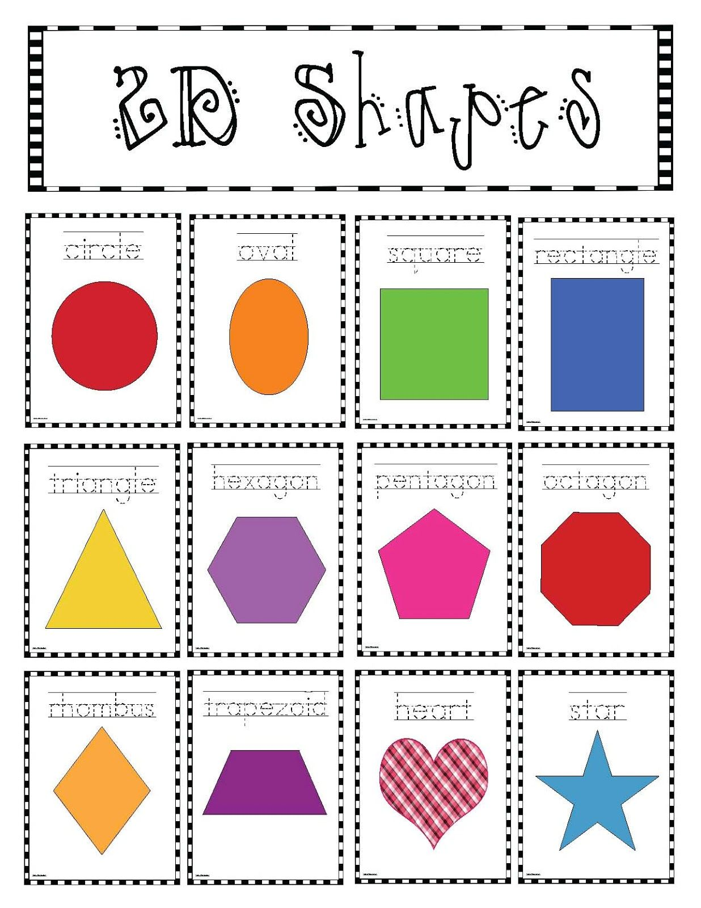
Creative Arts:
Note: The Creative Arts unit of work for Mon, Tues & Wed can be found at https://sites.google.com/education.nsw.gov.au/tau-home-chicken-challenge/student
- Each step can also be followed below.
Learning Intention: I am learning to identify 2D shapes in the environment.
- Watch the shapes clip https://video.link/w/lAU3c or look at the 2D shapes attached.
- Go on an adventure around your house or outside. How many different 2D shapes can you find?
Extension- Draw 6 different, 2D shapes down one side of the paper and practise tally marks to help with your counting.

Science: See ‘Science for Families – Pet Project’ attached (4 pages). Note: continued on Tuesday.

Tuesday - Week 2, Term 3 - Kindergarten
Daily Task - Wash the dishes.
English:
Phonics
Digraph sounds
- Listen to Youtube video Jolly Phonics and review digraphs from last week and this week ‘ch, sh, th, wh’. Watch the video for the ‘ng’ sound. See if you can be strong and show your muscles while you say the ‘ng’ sound.
- Practice writing the ‘ng’ sound. Remember to say it each time you write it.
CVCC words review (consonant, vowel, consonant, consonant eg. bang, ping etc.)
Please use known sounds to practise (If this is too challenging with digraph sounds, review CVC words)
Focus is on hearing individual sounds.
Example:
b – a - ng
Change to s - a - ng
Change to s– i – ng
For beginning, middle sounds only.
Extension: Add ‘ing’ or ‘s’ to these ng words. Film yourself reading the words you have made and post to seesaw.
sing bang fling swing sting

Reading and Writing
- Listen to a story online from www.storyonline.com.au and draw or write your favourite part of the book on a piece of paper. Take a picture and post it on SeeSaw to your teacher.
Extension: Complete above activity. On the back of your work make up a new ending to the story you have read. Don’t forget to show your teacher both sides of the paper.

Sight Words
- Pick 3 new words from the Butterfly Card and write them 3 times each. You could write them outside on your driveway with chalk, write them in the dirt or even make them with playdoh.

Optional - Complete Reading Eggs Activities for 10 minutes.
Break – Time to stop and refuel. Eat, play, have fun. Self-directed outside activities where possible.
Maths:
- Dice Patterns
(follow the prompts on the video below)
https://sites.google.com/education.nsw.gov.au/get-mathematical-early-stage-1/targeted-teaching/dice-patterns-a-1-4?authuser=0
Extension: Represents larger numbers. See example to the right. 14
You could use coins, cutlery, pebbles, leaves etc.
- Add to your weekly calendar. Draw a picture of what you did today. It’s Tuesday!
- Mathseeds (available through Reading Eggs website/app).

Break – Time to stop and refuel. Eat, play, have fun. Self-directed outside activities where possible.
Creative Arts:
Note: The Creative Arts unit of work for Mon, Tues & Wed can be found at https://sites.google.com/education.nsw.gov.au/tau-home-chicken-challenge/student
- Each step can also be followed below.
Learning Intention: I am learning to explore how shapes are used in art.
- Look at some pictures in your home readers or your old artwork and explore the different shapes used.
Extension – Add the shapes you discovered in the art to your tally from yesterday.

Science:
- See ‘Science for Families – Pet Project’ attached (4 pages). Continued from Monday.

Wednesday - Week 2, Term 3 - Kindergarten
Daily Task – Make your bed.
English:
Phonics
Digraph sounds
- Listen to Youtube video Jolly Phonics and review all sounds learned. Watch ‘ai’.
- Practise saying and writing the ‘ai’ sound.
- Write the following ‘ai’ words in Rainbow Colours. Circle the ai sound. Take a photo and post to your teacher in Seesaw.
bail sail train paint
Extension: Complete same activity as above but with the following words: painting, faints, saint, drain, trained etc.

Reading
- Read the story and questions on the worksheet ‘The Van’ with a family member or by yourself. Finish the statements by colouring in the correct word.
Extension: Complete above activity with the worksheet ‘Pink Rocks’ or logon to wushka.com and complete a book and comprehension quiz.
Writing
- Watch the following video on Echidnas https://video.link/w/8DU3c
- Write 2 things you have learned about echidnas with a family member.
Extension: Write 5 facts you learned about echidnas. Make a video for your teacher on Seesaw explaining what a ‘monotreme’ is and if you know of any other animal that is a ‘monotreme’.
Sight Words
- Select 3 new Butterfly cards to learn. Read them and then make them with something in your house (sticks, playdoh, toys etc..).
Extension: complete same activity as above with 3 new challenging words.

Optional - Complete Reading Eggs Activities for 10 minutes.
Break – Time to stop and refuel. Eat, play, have fun. Self-directed outside activities where possible.
Maths:
- Create your own number flashcards ranging from 1-30. Arrange them in order backwards or forwards.
- Get your book or paper ready. Have your parent/carer call out a number between 1-20 (you could use the flashcards you just created). Your job is to create that same number in dot form (just like dice or dominoes).
- Card Games (take out the picture cards)
Level 1 - Students turn over a card, count dots and create that number using fingers. They then point to the numeral on a number chart or around the room.
Level 2 - Students turn over 2 cards and say numbers. Cover one card and add on.
Level 3 - Use a deck of cards with numbers from 5 up. Students take 2 cards and ask their partner to add them together without looking.
- Add to your weekly calendar. Draw a picture of what you did today. It’s Wednesday!
- Mathseeds (available through Reading Eggs website/app).

Break – Time to stop and refuel. Eat, play, have fun. Self-directed outside activities where possible.
Creative Arts:
Note: The Creative Arts unit of work for Mon, Tues & Wed can be found at https://sites.google.com/education.nsw.gov.au/tau-home-chicken-challenge/student
- Each step can also be followed below.
Learning Intention – I am learning to create an artwork using 2D shapes.
- Using 2D shapes create your own chicken drawing. Colour your artwork and use leaves, feathers, tissue, foil, ribbon or other craft material to add texture to your artwork.
Extension - Use your skills by drawing other animals using 2D shapes. Look at the examples or follow these links
Cat - https://youtu.be/1BAIIpdlRY4
Pig - https://youtu.be/P2ChB9Hs2_w
Elephant - https://youtu.be/eHChXO0cApo

PDHPE:
- ‘Get Active at Home’ https://app.education.nsw.gov.au/sport/Bodycontrol
- Click on Episodes, Kindergarten-Year 2, and click on the video below.

Thursday - Week 2, Term 3 - Kindergarten
Daily Task – Help an adult with an outside activity.
English:
Phonics
Digraph sounds
- Listen to Youtube video Jolly Phonics including the ee/or video
- Practise writing the ‘ee’ sound.
CCVC words review
Focus is on hearing individual sounds and using the new sound ‘ee’.
Example:
S - ee
Change to b - ee
Add a letter to make bee say bee –p
See if you can make any other ‘ee’ words. (teeth, weep, queen, deep, sheep, screen)
Reading
- Listen to a story online www.storyonline.com.au and write or draw about your favourite character in the book and why you like this character. Take a photo and post to your teacher on SeeSaw.
Extension: Select a book you can read from home (or wushka.com). Video yourself reading this book and tell us about the text (who, when, where, problem, solution, characters).
Writing (A Dictation)
- Have a family member read out these sentences word by word and see if you can write the sentence.
A cat was in a van. It had a nap.
Extension: complete the same activity with the following sentences:
A cat slept in a van at sunset. He was woken up with a bang.

Optional - Complete Reading Eggs Activities for 10 minutes.
Break – Time to stop and refuel. Eat, play, have fun. Self-directed outside activities where possible.
Maths:
- Numberblocks Stampolines https://video.link/w/2pN3c
- Follow on ‘Stampolines’ https://sites.google.com/education.nsw.gov.au/get-mathematical-early-stage-1/targeted-teaching/numberblocks-stampolines-follow-up
Extension: Represents teen numbers. Write the numbers as a number sentence e.g. 11 + 6 = 17 or 10 +3 + 4 =17.
- Card Games (take out the picture cards)
Level 1 - Students turn over a card, count dots and create that number using fingers. They then point to the numeral on a number chart or around the room.
Level 2 - Students turn over 2 cards and say numbers. Cover one card and add on.
Level 3 - Use a deck of cards with numbers from 5 up. Students take 2 cards and ask their partner to add them together without looking.
- Add to your weekly calendar. Draw a picture of what you did today. It’s Thursday!
- Mathseeds (available through Reading Eggs website/app).

Break – Time to stop and refuel. Eat, play, have fun. Self-directed outside activities where possible.
Science and Technology:
- See ‘Science for Families – Push-Pull Pursuit’ attached (4 pages). Continue on Friday.
- Before the task you may like to view the video ‘Pushing and pulling’ with your child - https://www.stem.org.uk/resources/elibrary/resource/32044/pushing-and-pulling

Friday - Week 2, Term 3 - Kindergarten
Daily Task – Clean up your room.
English:
Phonics
Digraph sounds
- Ask a family member to read out these words and you write them by yourself – chop shin thud when bang mail see. Take a picture and post to your teacher on SeeSaw. Practise any of the sounds you couldn’t remember.
CCVC words review (consonant, consonant vowel, consonant eg. chop, chin etc.)
Please use known sounds to practise (If this is too challenging with digraph sounds, review CVC words)
Focus is on hearing individual sounds.
Example:
sh – o – t
Change to sh– o- p
Change to ch– o– p
Change to ch- i –p
Change to ch- i – n
Complete with other sounds you have learnt.
Extension: Revise words using all sounds that have been taught. Include endings on the words (banging, sings etc...).
Reading
- Read the story and questions on the worksheet ‘Bob’ with a family member or by yourself. Finish the statements by colouring in the correct word.
Extension: Complete above activity with the worksheet ‘Harry’ or logon to wushka.com and complete a book and comprehension quiz.
Writing
- Write a letter to a friend or your teacher from school. Tell them something you have done and tell them something nice about them. Take a photo of your letter and post to SeeSaw so your teacher can share it with the person you wrote to.
Sight Words
- Ask a family member to test you on the Butterfly card words you have been learning this week. Practise any you did not remember.
Extension: complete same activity as above with the challenging words you have learned this week.

Optional - Complete Reading Eggs Activities for 10 minutes.
Break – Time to stop and refuel. Eat, play, have fun. Self-directed outside activities where possible.
Maths:
- Count to 20 https://video.link/w/5rN3c
- Maths ‘Around the house’ https://www.education.vic.gov.au/school/teachers/teachingresources/discipline/maths/Pages/maths-and-numeracy-at-home.aspx
(Click on the image to go to the website)
- Play Skittles (see link above)
- Add to your weekly calendar. Draw a picture of what you did today. It’s Friday!
- Write or draw in your/a Journal the exciting things you did in Maths this week.
Break – Time to stop and refuel. Eat, play, have fun. Self-directed outside activities where possible.
Science and Technology:
See ‘Science for Families – Push-Pull Pursuit’ attached (4 pages). Continued from Thursday.

PDHPE:
- ‘Get Active at Home’ https://app.education.nsw.gov.au/sport/Bodycontrol
- Click on Episodes, Kindergarten-Year 2, and click on the video below.

Happy Friday!

